1. First the screen will display a list of vehicles and their attributes, in a tabular format

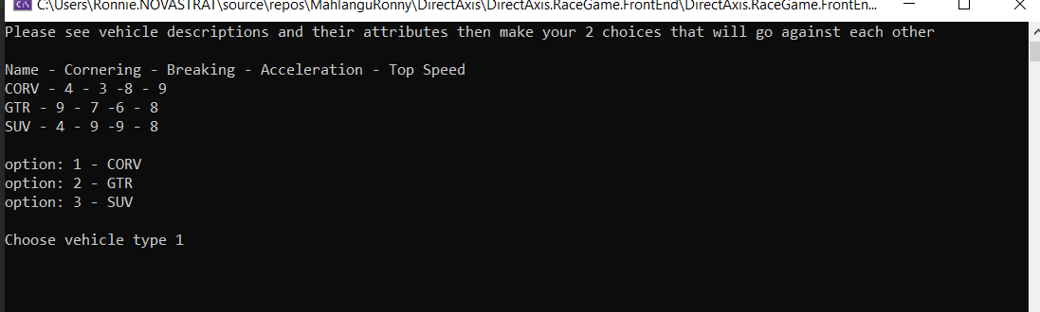

1. Use chose each type and press enter after picking each potion

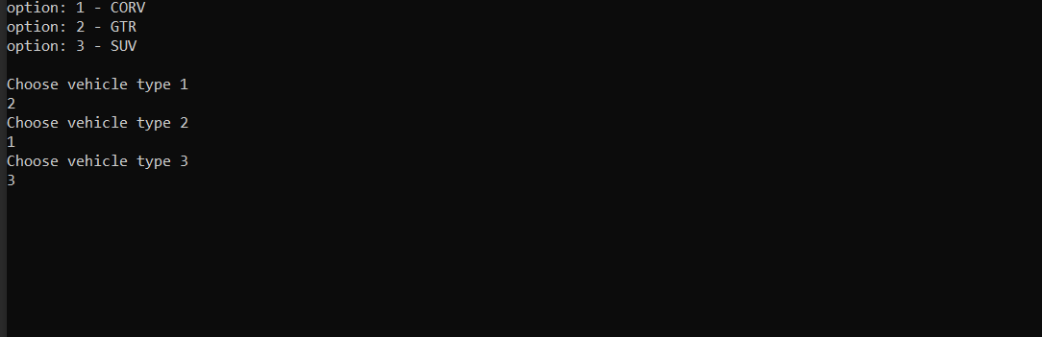

1. A message gets displayed information the user of the cars they selected, also options to chose one type of race-track are presented

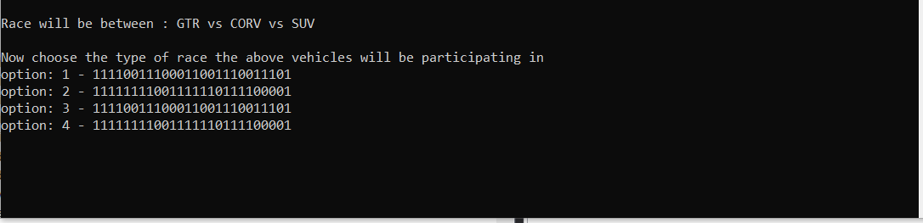

1. A user gets notified of their chosen option and results are displayed in order (from highest to lowest)

