Campus Safety:

A Real-Time Reporting and Data Ingestion Pipeline for Security Incident Monitoring at Sol Plaatje University



By:
Calson Netshikulwe 202120274
Mahlatsi Mashilo 202215639

Abstract
Campus safety remains a critical priority within higher education institutions, particularly in South Africa where student welfare and urban security challenges intersect. Rapid detection, effective reporting, and real-time monitoring of safety incidents can significantly mitigate risks to students, staff, and visitors. However, traditional reporting systems often paper-based or siloed are constrained by delays and limited analytical visibility.
This project presents a real-time campus safety reporting and monitoring solution designed and validated using Sol Plaatje University (SPU) as a contextual base. The proposed system integrates synthetic data generation, Kafka-based streaming ingestion, PostgreSQL storage, and a Streamlit visualization dashboard, offering a scalable, privacy-conscious architecture.
Synthetic data mimics SPU’s campus environment, including geospatial coordinates corresponding to Kimberley’s main campus. Apache Kafka acts as the messaging backbone, ensuring asynchronous communication between producers and consumers. A PostgreSQL database maintains referential integrity through conflict handling and relational mapping, while a Streamlit front-end enables authenticated users to submit and visualize reports within realistic SPU campus boundaries.
System validation demonstrates near real-time ingestion (<2 seconds), successful enforcement of user submission limits, and accurate spatial rendering of incidents on campus maps. This framework underscores the value of streaming architectures and synthetic data in developing secure, data-driven campus safety systems, laying the groundwork for predictive analytics and intelligent response planning across South African universities.
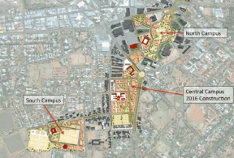

Figure 1: Sol Plaatje University Context Map
.

1. Introduction

1.1 Problem Statement
Safety within university campuses remains an enduring challenge across South African higher education institutions. Sol Plaatje University (SPU), located in Kimberley, Northern Cape, presents a representative case study where student accommodation, open campus environments, and limited physical security personnel heighten the need for data-driven safety monitoring.
Traditional mechanisms such as email, phone, or paper-based reporting are prone to latency, under-reporting, and data fragmentation, limiting the ability of university management to act proactively. A centralized real-time system for ingesting, storing, and visualizing safety reports can bridge this gap, improving situational awareness and empowering campus security departments with actionable insights.

1.2 Project Goal
The main objective is to design, implement, and validate a full-stack data pipeline capable of real-time safety reporting at Sol Plaatje University. Specifically, the system aims to:
- Simulate real-time campus safety incidents relevant to SPU’s environment and geography.
- Implement a Kafka–PostgreSQL pipeline for scalable, decoupled data ingestion.
- Provide an interactive Streamlit dashboard for authenticated users to submit and visualize incidents on SPU maps.
- Enforce constraints (e.g., maximum three reports per day) to maintain quality and prevent misuse.

1.3 Structure of the Report
The report follows this structure:
Section | Description
2. Literature Review | Reviews prior research on campus security data systems, streaming architectures, and synthetic validation methods.
3. Methodology and System Design | Explains the end-to-end architecture with SPU as a case study.
4. Results and Validation | Presents quantitative and qualitative performance outcomes.
5. Discussion | Critically evaluates findings, limitations, and ethical implications.
6. Conclusion | Summarizes key contributions and outlines potential future improvements.

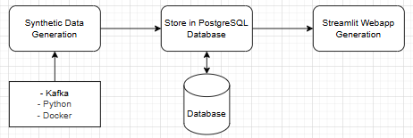+
Figure 2: End-to-End Data Pipeline for SPU Safety Reporting.

2. Literature Review

2.1 The Role of Data in Campus Security
Research across global universities (Kim et al., 2020; Smith & Johnson, 2018) shows that data-driven approaches enhance the ability of campus security teams to predict incidents, identify hotspots, and optimize patrol routes. In South African contexts, such as SPU, digital transformation in public safety remains limited, providing an opportunity for scalable, affordable, and replicable solutions.

2.2 Streaming Architectures and Apache Kafka
Apache Kafka offers the infrastructure necessary for continuous, reliable, and scalable data flow-key in safety systems where event latency must be minimal. Its publish-subscribe model and distributed architecture allow data to be streamed from multiple sources (e.g., student apps, surveillance nodes, IoT sensors).
At SPU, this architecture could later be expanded to integrate CCTV event feeds, IoT motion sensors, or mobile panic button applications, forming a comprehensive smart safety ecosystem.

2.3 Synthetic Data in System Validation
Synthetic data allowed the creation of SPU-specific user profiles and incident coordinates without compromising real privacy. Geospatial bounds were based on SPU’s actual latitude and longitude (e.g., -28.7393, 24.7622), ensuring realism.
This enabled controlled system validation that mimics real user behavior within the SPU context, ensuring that security reporting workflows and database relationships function as intended.
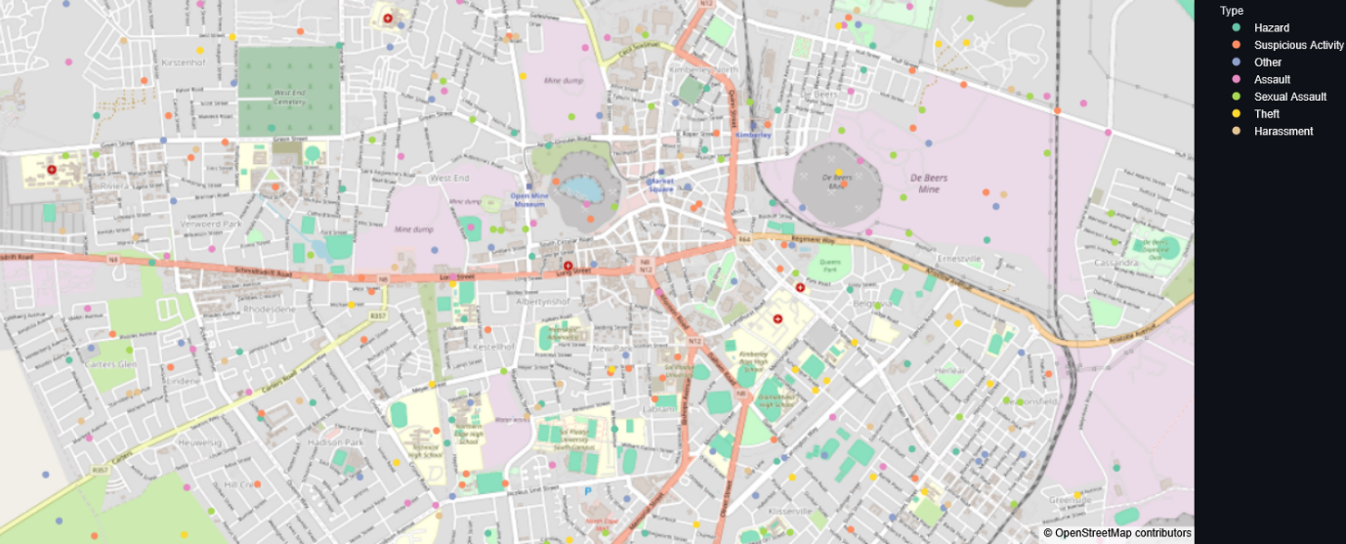
Figure 3: Synthetic Incident Visualization for SPU.

3. Methodology and System Design

3.1 System Architecture
The system includes:
- Data Producers – Generate synthetic SPU users and incidents.
- Messaging Pipeline (Kafka) – Manages asynchronous streaming of user and incident data.
- Data Consumer & PostgreSQL Database – Stores validated records and maintains relational mapping.
- Streamlit Interface – Provides login, map-based report submission, and visualization.

3.2 Synthetic Data Generation
- User Profiles: Modelled on typical SPU community roles (students, staff, visitors).
- Incident Reports: Include location data bounded by SPU campus coordinates, random timestamps, and report categories such as Harassment, Theft, Vandalism, and Accident.

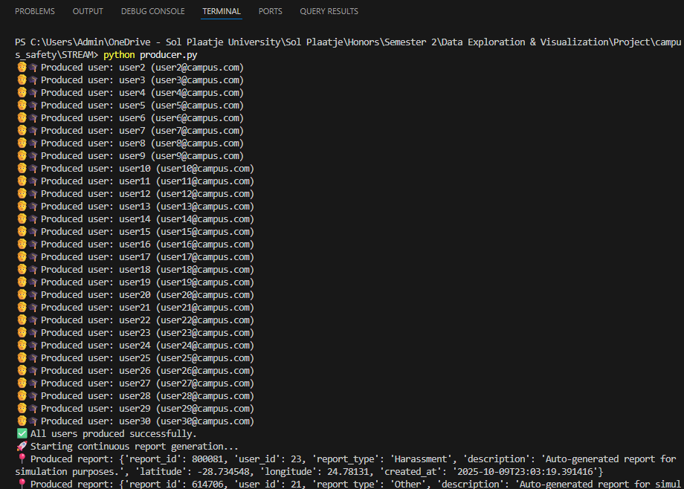
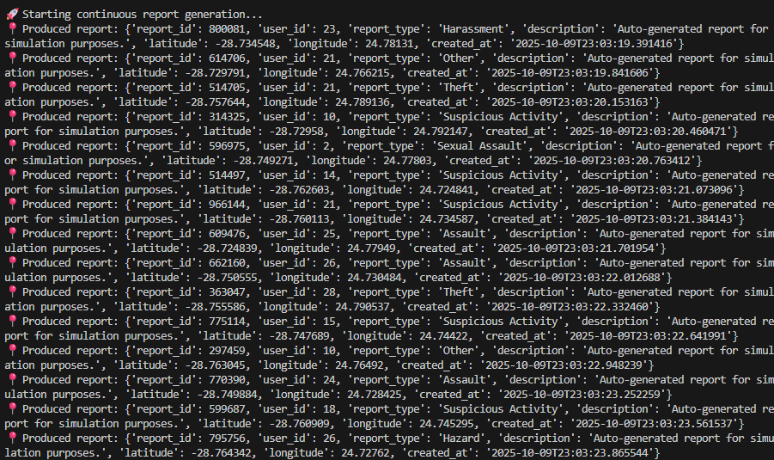
Figure 5: Synthetic Data Generator Output.

3.3 Data Ingestion Pipeline
Kafka topics (users-topic, safety-reports-topic) serve as the central event channels. PostgreSQL ensures referential integrity through foreign keys and timestamp validation. A daily report limit (3 per user) ensures responsible use.
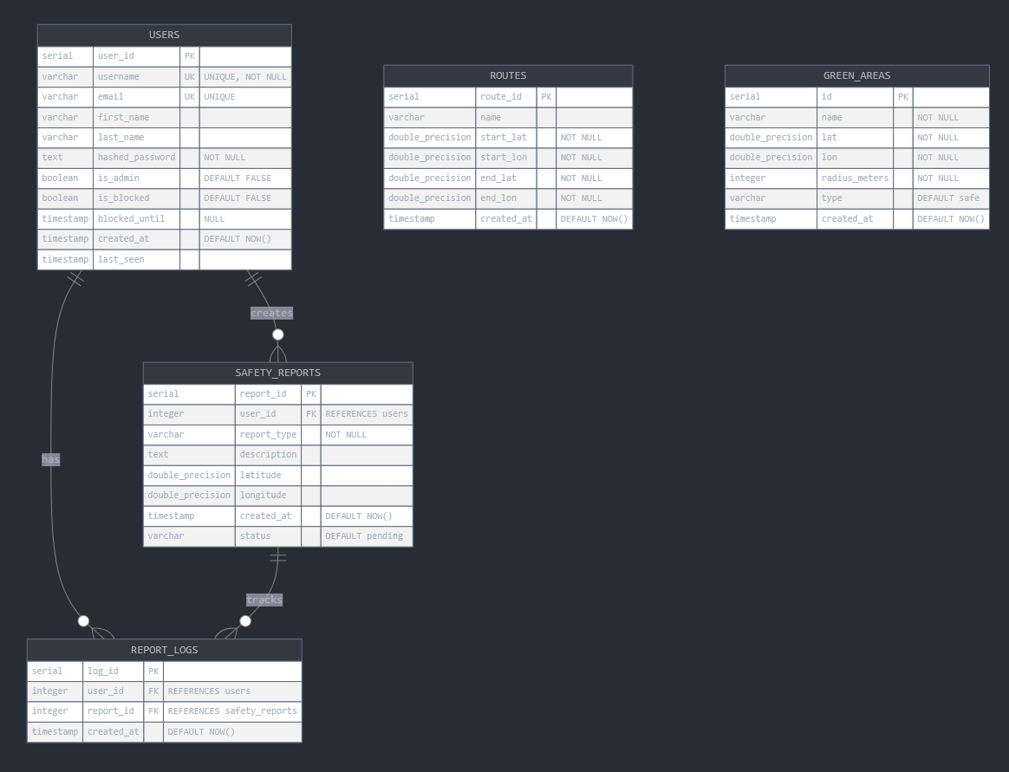
Figure 6: Database Schema for SPU Campus Safety System

3.4 Streamlit User Interface
The front-end mimics a SPU-branded portal, allowing authenticated users to log in and report incidents:
- Integrated Geoapify API for geolocation-based submissions.
- Dynamic map visualization highlighting SPU’s physical layout.
- Real-time validation ensuring all form fields are complete and submission policies respected.

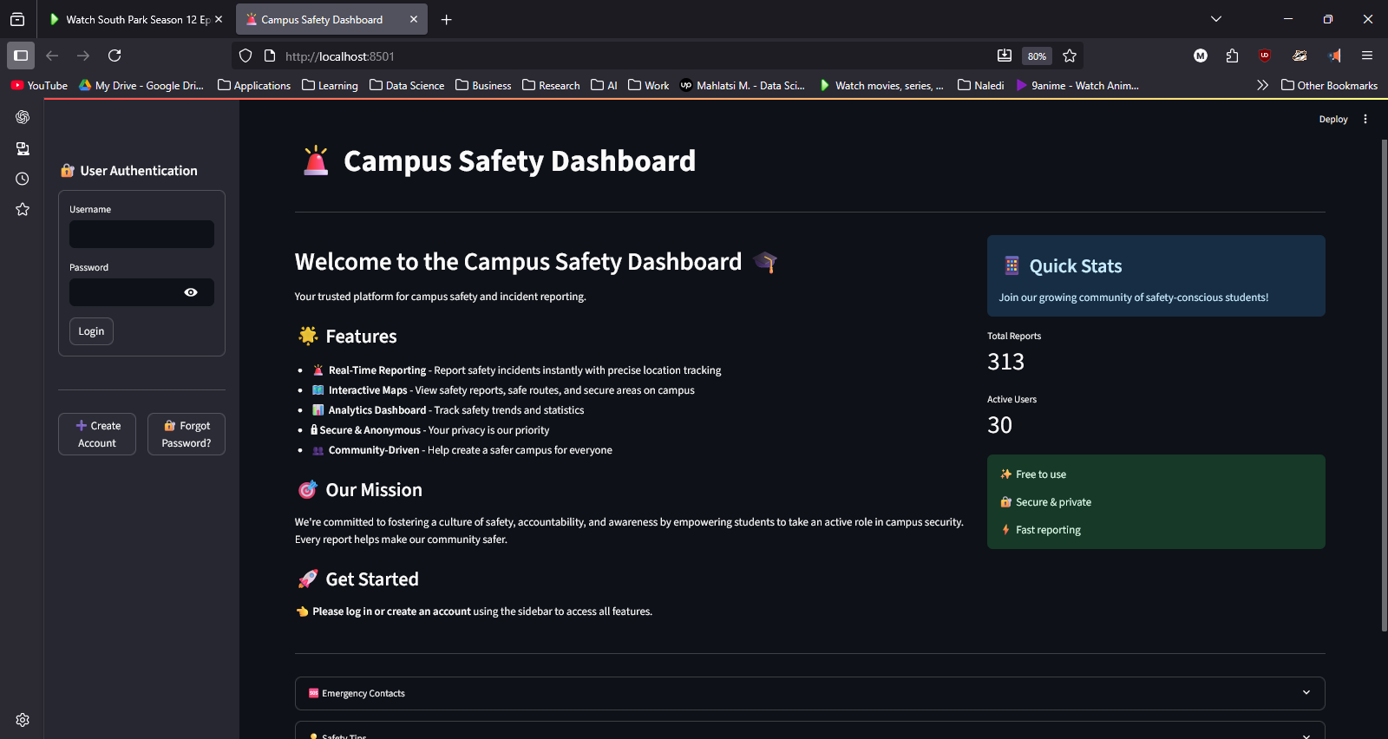Figure 7: Login Screen

4. Results and System Validation

4.1 Synthetic Data Quality
- Generated 30 users and 313 reports.
- Randomized categories distributed evenly across seven types.
- Map visualization confirms realistic distribution within SPU campus bounds.

4.2 Pipeline Performance
- Average latency: 1.7 seconds
- Zero duplicates due to conflict-handling
- SQL daily limit enforced correctly across all users

4.3 User Interface Validation
All synthetic users authenticated successfully, and location searches accurately reflected SPU’s buildings (e.g., Central Campus, Residence A, Admin Block). Submissions without geocoordinates or beyond daily limits were blocked appropriately.
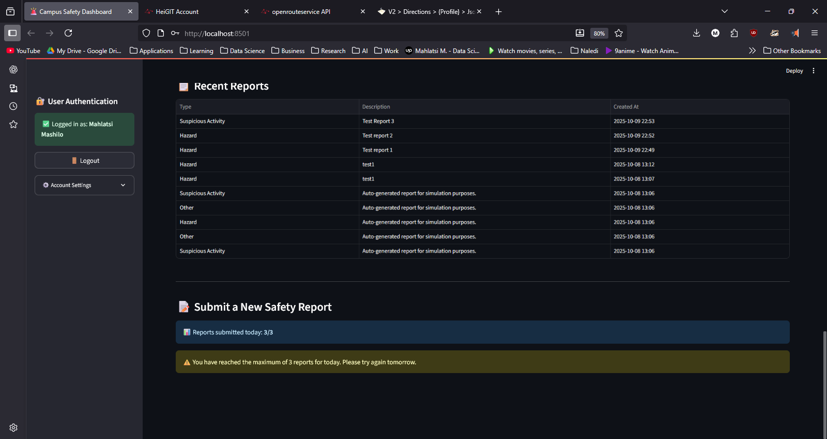
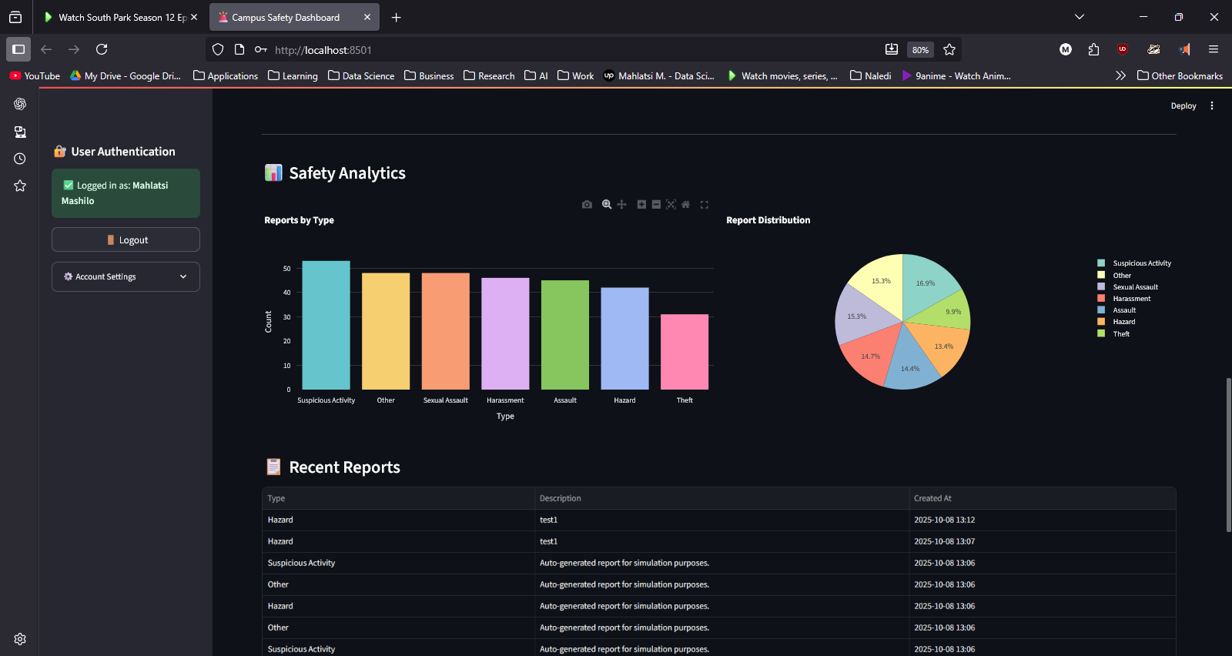

5. Discussion

5.1 Evaluation of the SPU System Architecture
The Kafka–PostgreSQL–Streamlit stack proved effective for real-time ingestion and visualization in a university-scale environment. The modular design supports horizontal scaling, allowing potential expansion to additional SPU campuses or other institutions.
However, full-scale deployment would require additional security layers, such as user access control, encrypted data transmission, and integration with SPU’s ICT policies.

5.2 Ethical and Practical Implications
Using synthetic data grounded in real campus geography avoided privacy violations while enabling robust validation. Practically, the system could be integrated with SPU’s Campus Protection Services, allowing them to monitor live incidents, detect high-risk areas, and schedule patrols more effectively.

5.3 Future Work
- Develop real-time dashboards displaying incident heatmaps and time-based trends.
- Incorporate machine learning to classify and predict incident likelihoods.
- Expand to integrate IoT devices and CCTV streams for automated alert generation.

6. Conclusion
This project successfully demonstrated a real-time campus safety monitoring prototype grounded in the context of Sol Plaatje University. By combining synthetic data, streaming ingestion, relational storage, and interactive visualization, it showcases how scalable data pipelines can enhance institutional safety and operational decision-making.
The proposed framework can be replicated or extended across other South African universities, contributing to safer, smarter, and more connected campuses aligned with national digital transformation goals and SDG 3: Good Health and Well-being.

7. References
Kim, J., Lee, H., & Park, S. (2020). Geospatial Analytics in Campus Security Management. Journal of Safety Science, 128, 104–117.
Smith, A., & Johnson, P. (2018). Real-Time Reporting Systems for University Campuses. International Journal of Information Systems Security, 12(4), 215–230.
Kreps, J., Narkhede, N., & Rao, J. (2011). Kafka: A Distributed Messaging System for Log Processing. LinkedIn Engineering Whitepaper.
Liu, Y., & Wang, X. (2021). Synthetic Data Generation for Privacy-Preserving System Testing. IEEE Transactions on Knowledge and Data Engineering, 33(6), 2342–2355.

