Supplementary Materials:

Follow-up Bias in Tumor Dynamic Modeling: A Comparison of Classical and Neural-ODE Approaches

Data Summary 0
Tumor Dynamic Pattern Categorization 4
Model Development and Evaluation 4
Tumor Growth Inhibition (TGI) models 4
Tumor Dynamic Neural-ODE (TDNODE) Model Development 6
Data Preprocessing 6
Tumor Dynamic Neural-ODE (TDNODE) Model Architecture 6
Model Training 7
All Model Evaluation (additional details) 7
Additional Results 8
References 20

Data Summary
Below is a brief description of the data included by study:

- IMPower130: This is a Phase III trial that compared the combination of atezolizumab (Tecentriq) plus chemotherapy (carboplatin and nab-paclitaxel) against chemotherapy alone in patients with advanced non-squamous non-small cell lung cancer (NSCLC). Treatment arms included A: Atezolizumab + Carboplatin + Nab-Paclitaxel, and B: Carboplatin + Nab-Paclitaxel.
- IMPower131: This Phase III study evaluated the efficacy and safety of atezolizumab in combination with chemotherapy (carboplatin and nab-paclitaxel or carboplatin and paclitaxel) in patients with squamous NSCLC. Treatment arms included A: Atezolizumab + Carboplatin + Nab-Paclitaxel, B: Carboplatin + Nab-Paclitaxel, and C: Atezolizumab + Carboplatin + Paclitaxel.
- IMPower132: The goal of this Phase III trial was to assess the impact of atezolizumab in combination with cisplatin or carboplatin and pemetrexed in patients with advanced non-squamous NSCLC. Treatment arms included A: Atezolizumab + Cisplatin + Pemetrexed, B: Atezolizumab + Carboplatin + Pemetrexed, C: Cisplatin + Pemetrexed, and D: Carboplatin + Pemetrexed.
- IMPower150: This is a Phase III clinical trial designed to evaluate the efficacy and safety of atezolizumab in combination with chemotherapy (carboplatin and paclitaxel) and the angiogenesis inhibitor bevacizumab, vs standard of care chemotherapy and bevacizumab in individuals with advanced non-squamous NSCLC.

Table S1 Summary of trial data cutoff dates and determination of data truncation by study.
Study | Study  ID | First  recruitment date | Last scan  date | Time span (days) | 25% Follow up | 50%  Follow up | 75% Follow up
IMpower 150 | 29436 | 2015-04-03 | 2018-01-22 | 1025 | 250 days | 500 days | 750 days
IMpower 131 | 29437 | 2015-06-12 | 2018-04-19 | 1042 | 260 days | 520 days | 780 days
IMpower 132 | 29438 | 2016-04-08 | 2018-05-22 | 744 | 180 days | 360 days | 540 days
IMpower 130 | 29537 | 2015-04-17 | 2018-03-15 | 1063 | 260 days | 520 days | 780 days

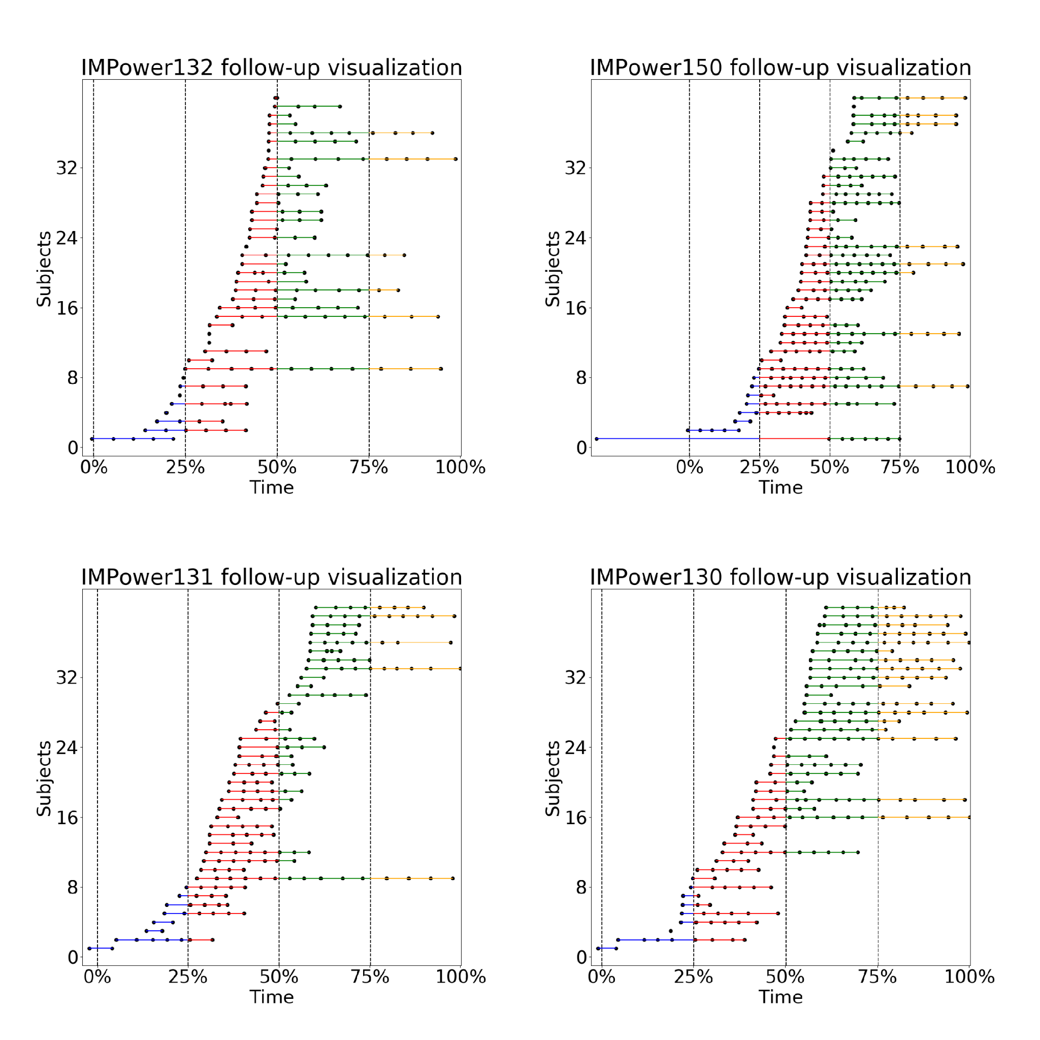
Figure S1: Illustrative samples of tumor measurement times observed across patients at different follow-up times within the respective clinical trials. For each of the four NSCLC trials (IMPower130, IMPower131, IMPower132, IMPower150), the trial duration corresponds to the difference between the time of the last SLD measurement and the time of first dose for the first patient. Times are shown as a percentage of the trial duration from the first dose given. The line colors denote data that fall within the following time intervals: blue denotes between [0, 25%) time, red denotes between [25%, 50%) time, green denotes between [50%, 75%) time, orange denotes between [75%, 100%) time; note that not all subjects in the trial are shown, only a representative subset for illustrative purposes. SLD: sum-of-longest-diameter.

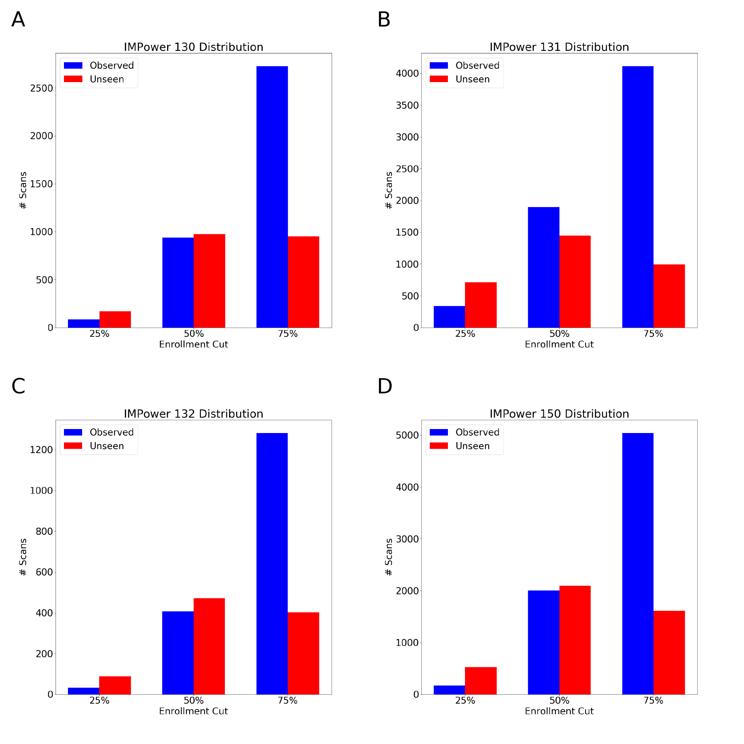
Figure S2: Distributions of seen (observed) and unseen data for each study at 25%, 50%, and 75% enrollment cuts. (A) IMPower130 (B) IMPower131 (C) IMPower132 dataset (D) IMPower150 dataset.

Tumor Dynamic Pattern Categorization
To understand how predictive performance may vary across different treatment response patterns, we categorized patients into groups based on modified RECIST 1.1 criteria [1]. Standard RECIST assesses treatment response by classifying a patient's best overall response, typically Complete Response (CR), Partial Response (PR), Stable Disease (SD), or Progressive Disease (PD).
While our method uses the established RECIST thresholds for CR, PR, and PD, it fundamentally differs in its objective. Rather than capturing the best response, our goal was to classify the entire longitudinal trajectory of a patient's tumor. This distinction is critical for evaluating predictive models, as forecasting ability may likely differ between a patient who responds and maintains that response versus one who responds and then progresses. Therefore, we explicitly separated these distinct trajectories.
Based on this trajectory-focused approach, patients were classified into the following seven subcategories:
- Immediate Progression/ Refractory (IPR): Defined as PD at the first follow-up assessment (≥120% of baseline tumor measurements) or all subsequent measurements remaining above baseline. Patients who met this criteria but remained on study for over 26 weeks were instead classified as having stable disease. Note, patients who discontinued at the 1st on-study scan and had no additional data were not considered prediction-evaluable and were excluded altogether.
- Stable Disease then Progression (SDP): Initial SD followed by PD (≥120% of nadir measurements).
- Stable Disease Maintained (SDM): SD maintained throughout the observation period with no evidence of progression.
- Partial Response then Progression (PRP): Initial achievement of PR (a decrease of ≥30% from baseline) followed by subsequent PD (≥120% of nadir measurements).
- Partial Response Maintained (PRM): Achievement of PR with no subsequent disease progression during the study period.
- Complete Response then Progression (CRP): Initial achievement of CR (disappearance of all target lesions) followed by PD (≥120% of nadir measurements).
- Complete Response Maintained (CRM): Achievement of CR with no evidence of subsequent disease progression throughout the observation period.
This categorization enabled a differential analysis of predictive performance across a spectrum of longitudinal treatment response patterns.

Model Development and Evaluation

Tumor Growth Inhibition (TGI) models
Five published tumor growth/inhibition models (Moore, Bonate, Claret, Stein, and Wang) [1], [2], [3], [4], [5] were developed using the non-linear mixed effects approach and were evaluated using the same procedure with appropriate adaptations based on the model parameters. For each model, a fixed effect for each study arm (e.g., different chemotherapy/immunotherapy combinations), capturing differences in growth- and shrinkage-related parameters by arm. All models were estimated using each of the four datasets representing 25%, 50%, 75%, and 100% of the original data. The model estimated using 100% of the data was used to establish “ground truth” parameter estimates. Parameter estimates from the 25%, 50%, and 75% data cuts were then compared against those from the 100% dataset to assess how much information is needed to stabilize model parameters. All nonlinear mixed effect models were estimated using NONMEM v7.5.1 and post processing was done in R (v4.3.1).

Table S2 Summary of TGI Models

Author | Functional Forms | Treatment | Comments
Stein | SLD = BSL · (e^(-kd·t) + e^(kg·t - 1)) | Thalidomide, thalidomide + docetaxel, bevacizumab... | Metastatic castration resistant prostate carcinoma; model PSA ratio to baseline (prostate-specific-antigen)
Moore | SLD = BSL · e^(-kd·t) + Y1 · (1 - e^(kg·t)) | Durvalumab, Durvalumab+ tremelimumab | Metastatic head and neck squamous cell carcinoma
Claret | dSLD/dt = kg · SLD - kd · SLD  kd = kd0 · e^(-λ·t) | Capecitabine; fluorouracil | Colorectal cancer; Take into account the emergence of drug resistance due to cell mutations
Wang | SLD = BSL · e^(-kd·t) + kg · t | Paclitaxel and carboplatin; paclitaxel, carboplatin, and bevacizumab; pemetrexed; vinorelbine and cisplatin. | NSCLC
Bonate | SLD = BSL · e^(-kd·t) + kg · t + h · t^2 | Pazopanib | Renal cell carcinoma; Modification for Wang’s model to ensure smooth curvature at nadir

Tumor Dynamic Neural-ODE (TDNODE) Model Development

Data Preprocessing
SLD measurements were Z-score normalized using the mean and standard deviation derived from the training cohort. To enhance the diversity of observed tumor dynamic profiles and augment the training dataset, a patient-dependent data augmentation scheme was applied. This involved truncating temporal data traces and rescaling time for individual patients within the training set. This is a form of up-sampling at the individual patient level. Models were trained and evaluated using four distinct datasets, representing 25%, 50%, 75%, and 100% of the original patient cohort, as described in the methods and shown in Supplementary table S1.

Tumor Dynamic Neural-ODE (TDNODE) Model Architecture
The TDNODE model utilizes an encoder-decoder architecture designed for longitudinal tumor dynamic modeling. The architecture comprises four main components: an Initial Condition Encoder, a Parameter Encoder, a Neural-ODE decoder, and a Reducer.
The Initial Condition Encoder, implemented as a Gated Recurrent Unit (GRU) recurrent neural network (RNN), processes pre-treatment tumor size data and corresponding observation times. Its output is a 4-dimensional latent vector representing the initial tumor state.
The Parameter Encoder, an attention-based Long Short-Term Memory (LSTM) network followed by linear layers, processes post-treatment tumor size data and observation times. This encoder produces a 2-dimensional representation corresponding to tumor kinetic parameters. The output is subsequently scaled by the last observed time for a patient to ensure the parameters have units of inverse time, interpretable as kinetic rates.
The Neural-ODE decoder forms the core of the dynamic model. It takes the outputs from the Initial Condition Encoder (as the initial state) and the Parameter Encoder (as kinetic parameters) to generate continuous predictions of the longitudinal tumor state. This is achieved by numerically integrating an ordinary differential equation (ODE) system defined by a neural network, denoted as fθ​. The ODE solver used was the Dormand−Prince 5(4) method (dopri5), employing continuous adjoint sensitivity for efficient backpropagation during training. The vector field fθ​ was specifically designed to satisfy a generalized homogeneity condition, which facilitates the interpretation of the learned parameters as kinetic rates.
Finally, the Reducer, composed of fully connected layers, maps the 4-dimensional latent tumor state output from the ODE solver at specific time points to a scalar value representing the predicted SLD at those times. More details on the TDNODE architecture can be found in Laurie M. et. al 2023 [6].

Model Training
The TDNODE model was trained for 150 epochs using the ADAM optimization algorithm. A learning rate of 5×10−5 and an L2 weight decay of 1×10−3 were applied. Training was performed using a batch size of 8 and an observation window corresponding to the “seen” data and evaluated on the “unseen” SLD observations based on the respective data truncation. The loss function minimized during training was the root-mean-squared error (RMSE) between the predicted and observed SLD values at the recorded measurement times. A masking mechanism was incorporated into the loss calculation to properly handle the variable number of measurements available for each patient.

All Model Evaluation (additional details)
After fitting each model on the observed portion of the data, model performance was evaluated using a comprehensive set of metrics comparing predicted versus observed target lesion SLD measurements. The primary metrics included measures of prediction bias, error magnitude, and model explanatory power. To assess prediction accuracy, we calculated both the mean and median Relative Percent Error (RPE). The mean RPE was computed as the average percentage difference between predicted and observed values, incorporating a small correction factor (ε = 1 mm) to accommodate SLD measurements with a zero value observed in patients achieving a complete response:
$Mean RPE = \frac{1}{n}\sum_{i=1}^{n}{}(100×\frac{{\hat{y}}_{i}-y_{i}}{y_{i }+ ϵ})$
where n represents the total number of observations, ${\hat{y}}_{i}$ represents the model-predicted SLD value and $y_{i}$ is the observed SLD value. The median RPE was calculated analogously using the median of the percentage differences.
To quantify the magnitude of prediction errors we calculated the root mean squared error (RMSE):
$RMSE = \sqrt{\frac{1}{n}\sum_{i=1}^{n}{}({\hat{y}}_{i}-y_{i})^{2}}$
Unlike RPE which is primarily a measure of prediction accuracy, RMSE provides a measure of prediction precision. Additionally, we calculated R² to assess the proportion of variance in observed values explained by the model:
$R^{2} = 1 - \frac{\sum_{i=1}^{n}{}(y_{i}- {\hat{y}}_{i})^{2}}{\sum_{i=1}^{n}{}(y_{i} - \bar{y})^{2}}$
where $\bar{y}$ represents the mean of all observed values.
To account for potential bias introduced by patients with shorter follow-up (e.g. those who progressed and discontinued early), we implemented a weighted bootstrap resampling of the prediction errors. In each of 500 iterations, we resampled the patient population with replacement, assigning higher sampling weights to patients with fewer observations (i.e., up-weighting early progressors). This is analogous to an inverse probability weighting approach. It increases the influence of subjects who would otherwise be underrepresented in error calculations. For each resample, we drew a fixed number of tumor measurements per patient (with replacement) and recalculated all performance metrics.
Final results were summarized using the mean, standard deviation, median, and median absolute error, providing robust estimates of model performance and associated uncertainty. In essence, this bootstrap scheme upweights patients who drop out early (often due to progression), preventing long-term responders (with many data points) from dominating the error metrics.

Additional Results

Figure S3 Longitudinal Tumor Size Reduction by Immunotherapy Status. The solid lines represent the mean tumor size for the observations across time with the shaded region representing the 95% confidence interval. To visualize the longitudinal trend, continuous time points were grouped into bins based on a quantile method which divides the data into time bins with approximately equal number of points per time bin.
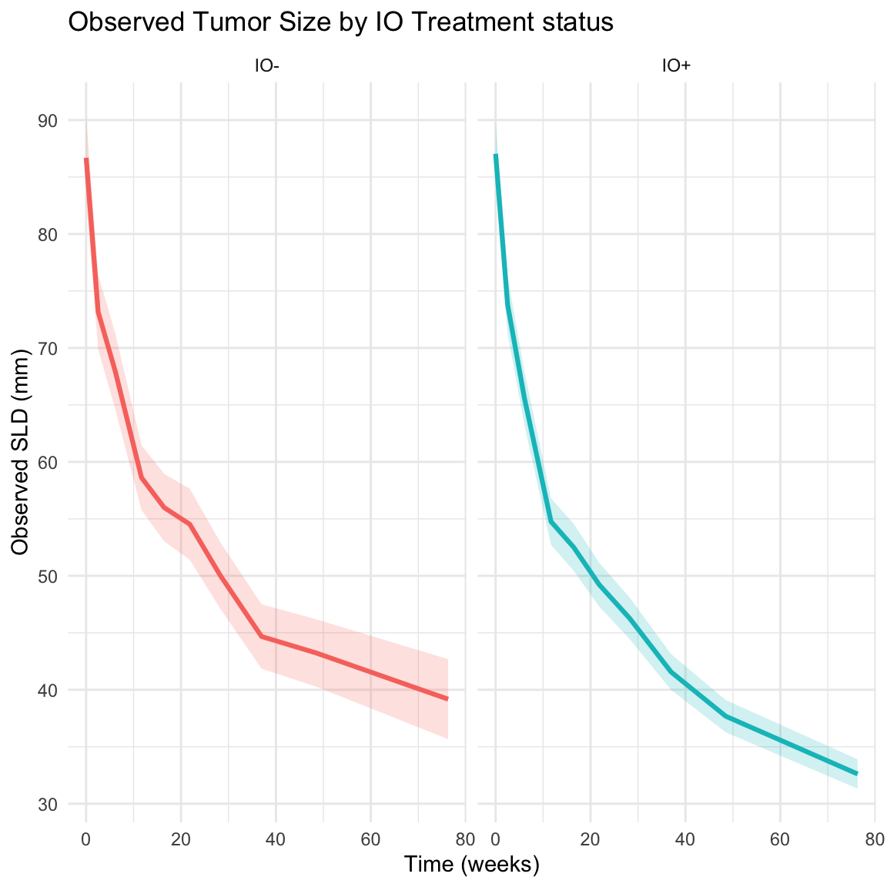

Figure S4 Sample of longitudinal patient trajectories by tumor dynamic cluster. Random Sample of 500 subjects demonstrating the qualitative trends captured in each response category.
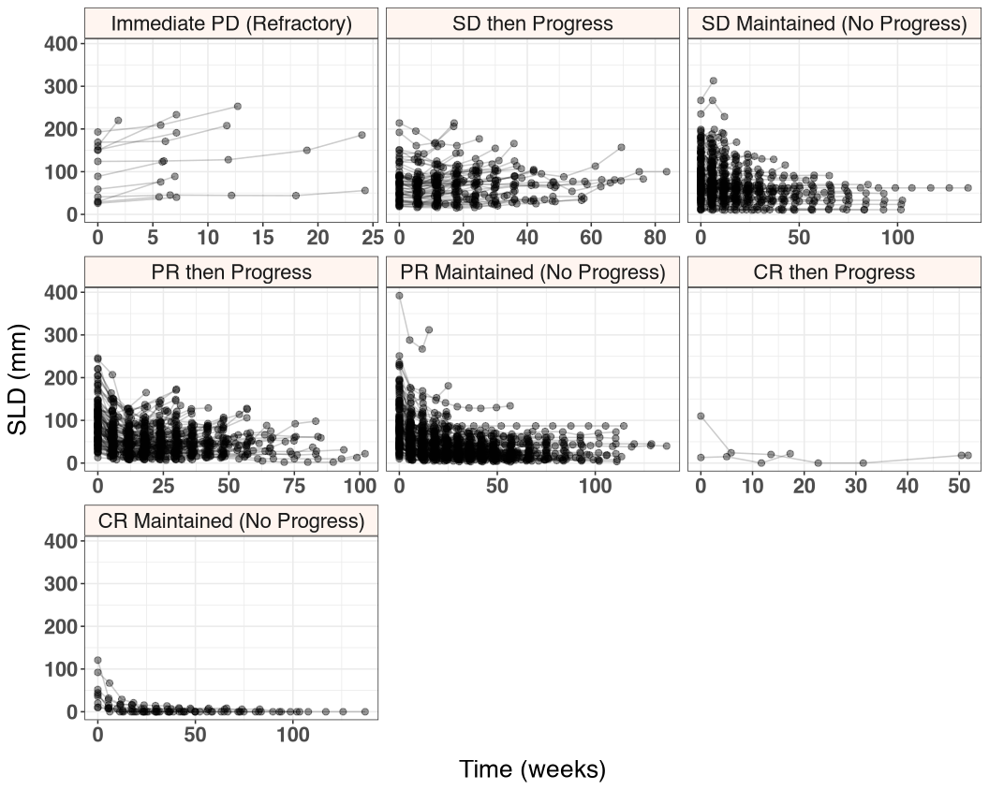

Table S3 Quantification of error for TGI and TDNODE models on unseen data assessed at various values of follow-up times based on inclusion of an immune checkpoint inhibitor (IO+/IO-). For each value of follow-up time (25%, 50% and 75% of total trial duration), all models were fitted or trained with the corresponding “seen” data, and subsequently evaluated on the remaining unseen data. The predictive performance was evaluated using several evaluation metrics based on the unseen data. To derive the predictive performance statistics, 500 bootstraps were performed from which the respective metric was computed.

 | IO+ |  |  |  | IO-
 | Mean RPE (%)¹ | Median RPE (%)¹ | R2¹ | RMSE¹ | Mean Bias (%)¹ | Median Bias (%)¹ | R2¹ | RMSE¹
25% Enrollment
claret | 133.26 (38.42) | 4.64 (1.67) | 0.20 (0.26) | 325.23 (278.73) | 15.64 (5.92) | 1.66 (2.51) | 0.65 (0.07) | 23.86 (3.06)
stein | 447.61 (91.87) | 24.33 (4.95) | 0.06 (0.03) | 169.87 (40.92) | 100.31 (36.19) | 10.06 (3.68) | 0.25 (0.10) | 56.26 (11.47)
moore | 247.52 (53.31) | 10.24 (3.01) | 0.31 (0.06) | 51.62 (6.27) | 72.94 (29.02) | 8.67 (2.66) | 0.50 (0.09) | 32.86 (4.55)
wang | 315.20 (60.41) | 26.77 (4.22) | 0.22 (0.05) | 54.75 (5.43) | 59.29 (21.78) | 5.32 (2.98) | 0.48 (0.10) | 27.73 (3.81)
bonate | 612.30 (124.62) | 39.85 (6.05) | 0.03 (0.02) | 153.88 (36.53) | 108.47 (38.54) | 12.55 (5.39) | 0.19 (0.13) | 56.11 (16.22)
tdnode | 84.50 (19.49) | -2.92 (1.36) | 0.82 (0.02) | 17.44 (1.01) | 11.81 (8.58) | -4.01 (2.35) | 0.80 (0.04) | 15.16 (1.45)
50% Enrollment
claret | 56.61 (7.88) | 5.72 (0.75) | 0.52 (0.16) | 41.41 (14.11) | 16.73 (3.96) | 0.10 (1.12) | 0.61 (0.08) | 27.69 (4.79)
stein | 169.42 (18.05) | 19.44 (1.74) | 0.33 (0.05) | 59.89 (6.79) | 67.21 (10.57) | 9.55 (2.37) | 0.36 (0.06) | 51.11 (8.17)
moore | 96.59 (10.56) | 8.95 (1.01) | 0.77 (0.02) | 20.98 (0.69) | 38.94 (7.46) | 2.90 (1.10) | 0.71 (0.06) | 20.80 (2.74)
wang | 142.44 (14.94) | 19.01 (1.80) | 0.53 (0.03) | 33.93 (1.62) | 54.78 (9.27) | 8.48 (1.75) | 0.52 (0.08) | 30.52 (4.88)
bonate | 152.41 (14.99) | 19.89 (1.91) | 0.51 (0.04) | 34.71 (1.58) | 56.79 (10.00) | 8.64 (1.73) | 0.51 (0.07) | 30.84 (4.81)
tdnode | 42.86 (6.77) | 1.04 (0.71) | 0.86 (0.01) | 15.39 (0.56) | 7.96 (4.28) | -4.74 (0.97) | 0.86 (0.02) | 14.13 (0.80)
75% Enrollment
claret | 38.24 (9.57) | 6.26 (0.54) | 0.35 (0.39) | 189.75 (181.51) | 16.46 (3.10) | 4.56 (0.78) | 0.60 (0.18) | 42.25 (19.14)
stein | 87.35 (7.03) | 25.19 (1.36) | 0.59 (0.05) | 32.08 (3.39) | 57.64 (6.39) | 16.10 (1.34) | 0.42 (0.13) | 71.90 (29.34)
moore | 51.86 (5.10) | 7.60 (0.64) | 0.84 (0.01) | 13.75 (0.47) | 31.72 (4.79) | 6.31 (1.05) | 0.86 (0.02) | 15.06 (1.21)
wang | 75.92 (6.11) | 23.73 (1.16) | 0.70 (0.02) | 22.31 (0.82) | 47.40 (5.54) | 13.86 (1.73) | 0.66 (0.08) | 30.64 (7.56)
bonate | 76.27 (5.93) | 23.76 (1.11) | 0.70 (0.02) | 22.27 (0.76) | 47.43 (5.50) | 13.86 (1.72) | 0.66 (0.07) | 30.83 (7.41)
tdnode | 22.88 (3.15) | 2.41 (0.39) | 0.89 (0.01) | 11.15 (0.47) | 10.63 (2.56) | 0.51 (0.60) | 0.93 (0.01) | 10.41 (0.83)
¹Values represent the boostrapped mean (std) unless indicated otherwise; std = standard deviation

Table S4 Quantification of error for TGI and TDNODE models on unseen data assessed at various values of follow-up times based on tumor dynamic cluster. For each value of follow-up time (25%, 50% and 75% of total trial duration), all models were fitted or trained with the corresponding “seen” data, and subsequently evaluated on the remaining unseen data. The predictive performance was evaluated using several evaluation metrics based on the unseen data. To derive the predictive performance statistics, 500 bootstraps were performed from which the respective metric was computed.

 | Mean Bias (SD) |  |  | Median Bias (SD) |  |  | R2 (SD) |  |  | RMSE (SD)
 | 25 | 50 | 75 | 25 | 50 | 75 | 25 | 50 | 75 | 25 | 50 | 75
claret
Immediate PD (Refractory) | 12.31 (4.75) | 0.04 (5.06) | -14.61 (0.00) | 12.93 (4.05) | -0.32 (5.35) | -14.61 (0.00) | 0.79 (0.26) | 0.96 (0.05) | NaN (0.00) | 19.53 (6.96) | 9.95 (1.51) | 8.33 (0.00)
SD then Progress | -2.93 (3.10) | 0.30 (2.48) | 2.79 (3.70) | -6.31 (1.80) | -3.57 (1.67) | -4.41 (1.18) | 0.85 (0.05) | 0.86 (0.03) | 0.56 (0.23) | 19.13 (3.13) | 20.23 (2.75) | 60.86 (33.63)
SD Maintained (No Progress) | 17.72 (3.61) | 24.38 (7.57) | 10.79 (0.69) | 6.91 (2.10) | 6.93 (1.12) | 8.17 (0.64) | 0.60 (0.12) | 0.43 (0.26) | 0.97 (0.01) | 41.20 (15.87) | 69.25 (36.54) | 9.29 (0.67)
PR then Progress | 11.20 (10.25) | 0.64 (2.41) | 23.48 (29.67) | -9.20 (3.28) | -8.30 (1.29) | -9.46 (1.83) | 0.46 (0.07) | 0.49 (0.05) | 0.28 (0.34) | 23.08 (1.64) | 27.14 (2.08) | 351.67 (338.73)
PR Maintained (No Progress) | 119.29 (62.15) | 29.92 (3.38) | 22.87 (1.64) | 15.49 (2.55) | 10.75 (1.16) | 9.72 (1.05) | 0.18 (0.24) | 0.57 (0.07) | 0.79 (0.02) | 498.84 (433.99) | 28.40 (5.03) | 14.64 (1.06)
CR then Progress | 942.43 (488.58) | 563.87 (246.37) | 236.08 (72.75) | 538.77 (815.04) | 139.48 (203.57) | 127.09 (152.74) | 0.21 (0.23) | 0.14 (0.17) | 0.10 (0.11) | 17.82 (4.01) | 25.09 (5.05) | 18.19 (4.17)
CR Maintained (No Progress) | 1040.52 (355.06) | 625.00 (84.40) | 293.13 (42.18) | 274.80 (225.39) | 239.30 (75.22) | 69.53 (28.19) | 0.09 (0.11) | 0.12 (0.08) | 0.33 (0.12) | 22.68 (6.79) | 12.50 (1.55) | 5.43 (0.78)
stein
Immediate PD (Refractory) | 7.16 (4.87) | -9.58 (3.99) | -9.74 (0.00) | 8.48 (4.33) | -7.10 (2.42) | -9.74 (0.00) | 0.80 (0.24) | 0.99 (0.01) | NaN (0.00) | 15.64 (3.96) | 8.68 (1.59) | 5.55 (0.00)
SD then Progress | 12.18 (8.96) | 13.49 (4.93) | 16.22 (5.14) | -4.15 (2.56) | -0.26 (1.49) | 2.69 (1.76) | 0.47 (0.20) | 0.68 (0.08) | 0.45 (0.20) | 85.10 (61.99) | 38.20 (7.28) | 99.88 (54.57)
SD Maintained (No Progress) | 47.44 (17.02) | 35.19 (5.50) | 24.00 (1.60) | 8.43 (3.43) | 9.14 (2.00) | 15.06 (1.22) | 0.18 (0.14) | 0.38 (0.13) | 0.90 (0.02) | 109.38 (45.38) | 68.61 (20.29) | 19.14 (1.60)
PR then Progress | 88.50 (20.29) | 31.17 (4.15) | 21.31 (2.95) | 10.17 (4.75) | 6.79 (1.93) | 7.54 (1.90) | 0.08 (0.04) | 0.36 (0.05) | 0.46 (0.11) | 82.80 (16.70) | 38.53 (3.24) | 37.83 (9.44)
PR Maintained (No Progress) | 297.89 (74.58) | 110.36 (8.82) | 67.13 (3.18) | 52.08 (11.76) | 39.13 (4.16) | 37.79 (1.78) | 0.06 (0.03) | 0.19 (0.03) | 0.49 (0.04) | 215.40 (66.76) | 71.72 (7.74) | 35.56 (2.36)
CR then Progress | 4245.34 (1771.54) | 1136.77 (453.25) | 437.89 (118.88) | 2948.81 (2613.77) | 440.15 (398.17) | 306.02 (210.13) | 0.20 (0.24) | 0.18 (0.24) | 0.09 (0.12) | 76.92 (18.38) | 31.57 (9.43) | 16.50 (3.70)
CR Maintained (No Progress) | 3654.81 (1092.24) | 1759.02 (234.44) | 767.55 (65.67) | 1509.20 (678.87) | 878.98 (133.15) | 614.16 (44.27) | 0.04 (0.04) | 0.00 (0.01) | 0.26 (0.14) | 68.13 (21.48) | 31.00 (4.16) | 11.59 (1.50)
moore
Immediate PD (Refractory) | 0.36 (5.04) | -11.22 (3.14) | -16.03 (0.00) | 1.77 (4.87) | -9.75 (3.39) | -16.03 (0.00) | 0.71 (0.33) | 0.99 (0.01) | NaN (0.00) | 16.36 (6.35) | 14.27 (3.67) | 9.13 (0.00)
SD then Progress | -4.32 (3.79) | -5.05 (2.04) | -6.12 (1.89) | -8.46 (2.75) | -6.92 (1.05) | -7.47 (1.23) | 0.73 (0.13) | 0.91 (0.02) | 0.88 (0.03) | 31.43 (14.01) | 15.44 (0.99) | 16.44 (1.88)
SD Maintained (No Progress) | 9.45 (3.36) | 7.16 (1.15) | 6.99 (0.59) | 3.07 (2.44) | 3.62 (0.93) | 5.27 (0.57) | 0.77 (0.08) | 0.89 (0.02) | 0.98 (0.00) | 21.44 (4.70) | 16.36 (1.94) | 7.02 (0.61)
PR then Progress | 43.80 (12.00) | 8.14 (2.17) | -1.64 (1.49) | 3.48 (3.23) | -0.31 (1.42) | -6.63 (1.20) | 0.23 (0.07) | 0.61 (0.04) | 0.77 (0.03) | 40.29 (6.20) | 21.73 (1.12) | 16.70 (1.02)
PR Maintained (No Progress) | 139.96 (29.13) | 49.68 (3.79) | 31.51 (1.76) | 34.81 (7.29) | 25.36 (1.91) | 16.91 (0.91) | 0.24 (0.06) | 0.64 (0.04) | 0.82 (0.02) | 64.83 (10.04) | 23.87 (2.13) | 14.28 (0.63)
CR then Progress | 3066.38 (1046.58) | 848.27 (283.96) | 425.22 (108.73) | 2412.81 (2155.40) | 427.60 (427.28) | 316.11 (235.69) | 0.19 (0.24) | 0.21 (0.26) | 0.08 (0.09) | 50.57 (7.16) | 24.05 (4.48) | 16.93 (3.53)
CR Maintained (No Progress) | 2331.11 (555.27) | 1238.06 (130.57) | 628.55 (46.54) | 1215.54 (447.88) | 771.77 (97.21) | 535.17 (42.56) | 0.02 (0.03) | 0.03 (0.03) | 0.34 (0.15) | 39.23 (8.37) | 19.49 (1.95) | 8.48 (0.87)
wang
Immediate PD (Refractory) | 2.23 (5.05) | -2.36 (2.94) | -9.07 (0.00) | 4.03 (5.39) | -3.94 (3.54) | -9.07 (0.00) | 0.76 (0.28) | 0.99 (0.01) | NaN (0.00) | 15.72 (5.20) | 11.48 (2.68) | 5.17 (0.00)
SD then Progress | 16.39 (5.71) | 10.89 (3.53) | 7.89 (2.93) | 4.51 (5.04) | 2.55 (2.59) | 2.47 (1.77) | 0.64 (0.11) | 0.79 (0.06) | 0.65 (0.12) | 32.01 (8.13) | 22.55 (1.62) | 38.94 (14.90)
SD Maintained (No Progress) | 29.44 (7.21) | 28.11 (3.05) | 24.83 (1.39) | 9.63 (3.49) | 11.66 (1.39) | 17.79 (1.57) | 0.48 (0.11) | 0.66 (0.07) | 0.92 (0.01) | 37.20 (6.80) | 32.65 (4.84) | 14.53 (0.83)
PR then Progress | 60.31 (19.59) | 20.38 (3.35) | 12.98 (2.12) | 6.09 (4.48) | 2.99 (2.04) | 4.23 (1.75) | 0.16 (0.07) | 0.41 (0.05) | 0.63 (0.04) | 35.62 (3.30) | 29.07 (1.44) | 22.50 (1.76)
PR Maintained (No Progress) | 170.88 (30.63) | 82.53 (5.80) | 57.66 (2.66) | 44.18 (11.75) | 36.01 (3.70) | 34.74 (1.66) | 0.11 (0.05) | 0.30 (0.04) | 0.59 (0.03) | 67.24 (10.04) | 39.84 (3.81) | 25.43 (1.21)
CR then Progress | 2774.26 (1218.66) | 982.27 (396.70) | 434.79 (110.86) | 1805.52 (1846.07) | 336.34 (299.88) | 334.05 (213.16) | 0.20 (0.23) | 0.15 (0.19) | 0.10 (0.10) | 44.39 (12.28) | 29.14 (6.58) | 16.95 (3.77)
CR Maintained (No Progress) | 3039.37 (725.59) | 1621.24 (157.92) | 675.32 (58.71) | 1926.32 (713.83) | 1025.04 (153.72) | 517.62 (34.40) | 0.04 (0.05) | 0.01 (0.01) | 0.33 (0.14) | 51.38 (11.34) | 25.07 (2.01) | 10.17 (1.29)
bonate
Immediate PD (Refractory) | 5.95 (4.86) | -2.12 (2.96) | -9.07 (0.00) | 7.79 (5.26) | -3.74 (3.53) | -9.07 (0.00) | 0.84 (0.20) | 0.98 (0.02) | NaN (0.00) | 14.05 (3.31) | 11.22 (2.69) | 5.17 (0.00)
SD then Progress | 42.54 (12.98) | 11.69 (3.92) | 7.92 (2.93) | 13.25 (7.04) | 3.17 (2.66) | 2.41 (1.86) | 0.35 (0.14) | 0.78 (0.06) | 0.66 (0.12) | 78.22 (47.39) | 23.10 (1.74) | 38.34 (15.18)
SD Maintained (No Progress) | 54.23 (14.38) | 29.52 (3.18) | 24.90 (1.34) | 13.87 (4.99) | 11.97 (1.41) | 17.76 (1.53) | 0.21 (0.11) | 0.65 (0.07) | 0.92 (0.01) | 70.50 (15.86) | 33.48 (4.87) | 14.53 (0.85)
PR then Progress | 132.51 (36.02) | 22.00 (3.59) | 12.98 (2.05) | 18.87 (5.74) | 3.19 (1.98) | 4.21 (1.61) | 0.04 (0.03) | 0.40 (0.05) | 0.63 (0.04) | 77.59 (9.71) | 29.57 (1.50) | 22.56 (1.62)
PR Maintained (No Progress) | 373.55 (77.53) | 86.62 (5.58) | 57.53 (2.78) | 61.79 (12.66) | 37.10 (3.54) | 34.71 (1.61) | 0.01 (0.01) | 0.29 (0.03) | 0.59 (0.03) | 201.56 (63.64) | 40.89 (3.74) | 25.36 (1.16)
CR then Progress | 4705.05 (2529.66) | 1049.11 (396.81) | 440.21 (113.13) | 2500.99 (3037.33) | 383.93 (326.09) | 333.69 (220.33) | 0.22 (0.23) | 0.13 (0.17) | 0.10 (0.12) | 86.27 (31.88) | 29.87 (6.66) | 17.21 (3.74)
CR Maintained (No Progress) | 5575.66 (1415.47) | 1721.57 (170.57) | 675.02 (60.55) | 2868.95 (1348.46) | 1138.28 (155.39) | 517.80 (33.38) | 0.07 (0.05) | 0.00 (0.01) | 0.34 (0.15) | 103.65 (24.26) | 26.31 (2.09) | 10.21 (1.32)
tdnode
Immediate PD (Refractory) | -9.90 (3.94) | -16.37 (2.73) | -18.12 (0.00) | -10.17 (4.71) | -14.98 (4.35) | -18.12 (0.00) | 0.91 (0.06) | 0.99 (0.01) | NaN (0.00) | 21.85 (8.31) | 21.70 (7.07) | 10.33 (0.00)
SD then Progress | -12.98 (1.82) | -10.00 (1.93) | -10.79 (1.07) | -12.92 (2.51) | -11.99 (1.34) | -10.88 (1.19) | 0.91 (0.03) | 0.91 (0.03) | 0.90 (0.02) | 19.20 (3.00) | 17.08 (1.14) | 15.90 (1.56)
SD Maintained (No Progress) | -0.47 (1.11) | -0.62 (0.67) | 1.23 (0.47) | -1.39 (1.56) | -0.56 (0.68) | 1.67 (0.50) | 0.95 (0.01) | 0.96 (0.01) | 0.98 (0.00) | 8.22 (0.87) | 8.87 (0.57) | 5.14 (0.39)
PR then Progress | 0.28 (6.54) | -4.26 (1.61) | -8.09 (1.31) | -14.11 (2.54) | -7.80 (1.31) | -9.63 (1.11) | 0.59 (0.07) | 0.69 (0.03) | 0.84 (0.02) | 20.68 (1.49) | 19.74 (1.00) | 15.21 (0.96)
PR Maintained (No Progress) | 29.98 (7.20) | 17.86 (2.41) | 16.53 (1.26) | 5.94 (3.39) | 6.49 (0.93) | 6.12 (0.52) | 0.81 (0.03) | 0.88 (0.01) | 0.91 (0.01) | 14.43 (1.29) | 11.22 (0.52) | 8.48 (0.35)
CR then Progress | 1037.05 (455.29) | 396.15 (242.17) | 252.21 (93.18) | 770.06 (737.72) | 1.14 (67.39) | 75.46 (103.29) | 0.17 (0.22) | 0.32 (0.26) | 0.07 (0.08) | 17.86 (4.86) | 22.34 (4.09) | 18.26 (4.07)
CR Maintained (No Progress) | 983.77 (231.46) | 616.86 (88.43) | 273.92 (36.62) | 558.78 (220.88) | 240.50 (111.73) | 139.19 (10.13) | 0.21 (0.13) | 0.15 (0.09) | 0.44 (0.14) | 16.82 (2.30) | 12.18 (1.50) | 4.84 (0.78)
Summary statistics calculated as Mean (Standard Deviation).

Table S5 Quantification of error for TGI and TDNODE models on unseen data assessed at various values of follow-up times by best overall response. For each value of follow-up time (25%, 50% and 75% of total trial duration), all models were fitted or trained with the corresponding “seen” data, and subsequently evaluated on the remaining unseen data. The predictive performance was evaluated using several evaluation metrics based on the unseen data. To derive the predictive performance statistics, 500 bootstraps were performed from which the respective metric was computed. Patients with progressive disease (PD) were excluded due to very limited unseen scans.

 | SD |  |  |  | PR |  |  |  | CR
 | Mean RPE (%)^{1,2} | Median RPE (%)^{1,2} | R2^{1,3} | RMSE^{1,4} | Mean RPE (%)^{1,2} | Median RPE (%)^{1,2} | R2^{1,3} | RMSE^{1,4} | Mean RPE (%)^{1,2} | Median RPE (%)^{1,2} | R2^{1,3} | RMSE^{1,4}
25% Enrollment
claret | 14.11 (2.08) | 2.64 (1.38) | 0.60 (0.06) | 47.94 (9.18) | 122.29 (26.05) | 14.58 (1.66) | 0.02 (0.02) | 562.58 (201.02) | 1146.03 (159.57) | 160.91 (103.37) | 0.05 (0.03) | 24.72 (2.56)
stein | 80.81 (11.44) | 15.65 (2.99) | 0.21 (0.05) | 185.65 (27.86) | 390.52 (33.68) | 92.55 (7.41) | 0.05 (0.01) | 244.20 (27.78) | 4129.58 (508.85) | 1653.69 (319.66) | 0.01 (0.01) | 76.42 (9.13)
moore | 13.40 (2.19) | 1.45 (2.04) | 0.64 (0.03) | 44.50 (5.78) | 178.19 (13.06) | 55.91 (4.91) | 0.17 (0.02) | 75.54 (3.97) | 2676.93 (251.60) | 1388.82 (229.28) | 0.01 (0.02) | 44.10 (3.18)
wang | 50.69 (4.16) | 24.05 (3.27) | 0.48 (0.05) | 51.63 (4.06) | 215.42 (13.56) | 72.82 (5.22) | 0.08 (0.01) | 74.38 (3.63) | 3350.57 (336.48) | 2086.15 (298.29) | 0.01 (0.01) | 55.57 (4.72)
bonate | 109.21 (10.23) | 38.92 (4.76) | 0.23 (0.04) | 136.08 (18.88) | 491.83 (35.27) | 111.21 (8.99) | 0.01 (0.01) | 231.45 (23.75) | 6227.95 (681.53) | 3375.13 (740.01) | 0.02 (0.02) | 113.74 (10.82)
tdnode | -5.85 (0.76) | -5.25 (0.90) | 0.92 (0.01) | 11.87 (1.20) | 26.74 (3.33) | 1.16 (1.08) | 0.72 (0.02) | 15.29 (0.50) | 974.40 (94.36) | 581.83 (71.98) | 0.19 (0.06) | 17.13 (0.90)
50% Enrollment
claret | 24.66 (4.57) | 8.26 (0.52) | 0.31 (0.16) | 74.89 (23.78) | 30.33 (1.64) | 9.79 (0.70) | 0.51 (0.03) | 27.29 (1.74) | 635.44 (48.14) | 193.34 (31.72) | 0.06 (0.03) | 13.57 (0.86)
stein | 52.99 (3.63) | 19.04 (1.46) | 0.32 (0.06) | 81.36 (11.46) | 124.33 (4.12) | 52.43 (1.87) | 0.19 (0.02) | 71.58 (3.10) | 1778.47 (126.14) | 915.70 (59.73) | 0.00 (0.01) | 32.18 (2.26)
moore | 7.34 (0.64) | 4.55 (0.44) | 0.87 (0.02) | 16.51 (1.03) | 49.43 (1.52) | 25.18 (1.00) | 0.60 (0.02) | 23.17 (0.57) | 1197.78 (70.48) | 743.42 (42.48) | 0.02 (0.01) | 19.74 (1.05)
wang | 40.79 (1.79) | 22.46 (1.04) | 0.60 (0.04) | 37.08 (2.56) | 90.02 (2.73) | 44.19 (1.67) | 0.29 (0.02) | 40.59 (1.11) | 1593.89 (86.79) | 964.76 (80.12) | 0.01 (0.01) | 25.83 (1.11)
bonate | 43.08 (1.89) | 23.33 (1.27) | 0.59 (0.04) | 38.12 (2.59) | 96.37 (2.74) | 46.61 (1.90) | 0.27 (0.01) | 41.89 (1.12) | 1721.37 (88.04) | 1158.28 (83.53) | 0.00 (0.01) | 27.17 (1.13)
tdnode | -4.85 (0.47) | -3.44 (0.50) | 0.93 (0.01) | 11.49 (0.57) | 14.33 (1.10) | 3.78 (0.40) | 0.77 (0.01) | 13.57 (0.34) | 558.34 (48.52) | 113.64 (25.58) | 0.09 (0.04) | 12.95 (0.83)
75% Enrollment
claret | 9.29 (0.70) | 7.59 (0.33) | 0.75 (0.13) | 23.67 (10.25) | 33.18 (8.50) | 8.17 (0.46) | 0.05 (0.12) | 303.69 (149.66) | 286.82 (26.29) | 70.69 (18.54) | 0.10 (0.06) | 7.27 (0.83)
stein | 25.45 (1.23) | 17.85 (1.25) | 0.63 (0.16) | 40.53 (15.75) | 64.30 (1.91) | 38.27 (1.02) | 0.47 (0.04) | 38.56 (3.22) | 723.70 (43.30) | 592.08 (20.98) | 0.09 (0.06) | 11.70 (1.01)
moore | 2.99 (0.47) | 3.22 (0.33) | 0.93 (0.01) | 9.53 (0.64) | 26.28 (1.06) | 13.98 (0.55) | 0.77 (0.01) | 14.47 (0.44) | 593.28 (33.21) | 522.87 (27.83) | 0.12 (0.07) | 9.17 (0.66)
wang | 23.86 (0.91) | 18.66 (0.93) | 0.82 (0.05) | 20.73 (3.76) | 53.93 (1.60) | 33.97 (0.99) | 0.60 (0.02) | 25.01 (0.75) | 644.70 (39.28) | 501.12 (23.32) | 0.11 (0.06) | 10.77 (0.88)
bonate | 23.90 (0.97) | 18.76 (0.97) | 0.82 (0.05) | 20.61 (3.73) | 53.95 (1.61) | 33.97 (0.96) | 0.60 (0.02) | 25.01 (0.75) | 645.18 (41.18) | 503.52 (23.94) | 0.11 (0.06) | 10.74 (0.87)
tdnode | -2.85 (0.41) | -0.75 (0.28) | 0.94 (0.01) | 8.94 (0.68) | 11.70 (0.77) | 4.04 (0.26) | 0.85 (0.01) | 10.20 (0.37) | 259.36 (23.83) | 131.65 (6.57) | 0.13 (0.08) | 6.95 (0.85)
¹Values represent the boostrapped mean (std) unless indicated otherwise; std = standard deviation
²Relative % Error (RPE) = 100 * (Observed SLD - Predicted SLD) / Observed SLD + epsilon
³R2 = R-squared
⁴RMSE: root mean square error

Table S6: Percentage of Subjects by Cluster and IO Treatment Status^{1,2}
Comparison of cluster distribution across groups
 | Cluster^{3,4} | IO+⁵ | IO-⁵ | significance
 | Immediate PD (Refractory) | 55 (2.7%) | 49 (4.4%)
 | SD then Progress** | 229 (11.4%) | 149 (13.4%) | **
 | SD Maintained (No Progress)** | 472 (23.6%) | 373 (33.5%) | **
 | PR then Progress** | 458 (22.9%) | 230 (20.7%) | **
 | PR Maintained (No Progress)** | 707 (35.3%) | 293 (26.3%) | **
 | CR then Progress* | 13 (0.6%) | 4 (0.4%) | *
 | CR Maintained (No Progress)** | 69 (3.4%) | 15 (1.3%) | **
Total | — | 2,003 | 1,113 | —
¹Patients with only 1 SLD measurement are excluded.
²Unclassified subjects excluded; multiple-comparison adjusted (BH).
³* p < 0.05, ** p < 0.01 (Chi-squared test)
⁴**Immediate PD** (Refractory): PD at 1st follow-up or all SLD measurements > baseline with one PD event; ≤26 weeks follow-up **SD then Progress**: No CR/PR, then PD from nadir; or meets Refractory criteria but >26 weeks follow-up **SD Maintained**: No CR/PR and no PD **PR then Progress**: Achieved PR, then PD **PR Maintained**: Achieved PR with no PD **CR then Progress**: Achieved CR, then PD **CR Maintained**: Achieved CR and maintained Where: PD (Progressive Disease) = tumor growth ≥20% from nadir AND SLD increase ≥5mm; PR (Partial Response) = shrinkage ≥30% from baseline; CR (Complete Response) = complete disappearance
⁵n (%): number of subjects in each cluster and treatment group

References
[1] I. González‐García et al., “Early predictions of response and survival from a tumor dynamics model in patients with recurrent, metastatic head and neck squamous cell carcinoma treated with immunotherapy,” CPT Pharmacomet. Syst. Pharmacol., vol. 10, no. 3, pp. 230–240, Mar. 2021, doi: 10.1002/psp4.12594.
[2] P. L. Bonate and A. B. Suttle, “Modeling tumor growth kinetics after treatment with pazopanib or placebo in patients with renal cell carcinoma,” Cancer Chemother. Pharmacol., vol. 72, no. 1, pp. 231–240, Jul. 2013, doi: 10.1007/s00280-013-2191-0.
[3] L. Claret et al., “Model-based prediction of phase III overall survival in colorectal cancer on the basis of phase II tumor dynamics,” J. Clin. Oncol. Off. J. Am. Soc. Clin. Oncol., vol. 27, no. 25, pp. 4103–4108, Sep. 2009, doi: 10.1200/JCO.2008.21.0807.
[4] W. D. Stein et al., “Tumor Regression and Growth Rates Determined in Five Intramural NCI Prostate Cancer Trials: The Growth Rate Constant as an Indicator of Therapeutic Efficacy,” Clin. Cancer Res., vol. 17, no. 4, pp. 907–917, Feb. 2011, doi: 10.1158/1078-0432.CCR-10-1762.
[5] Y. Wang et al., “Elucidation of Relationship Between Tumor Size and Survival in Non-Small-Cell Lung Cancer Patients Can Aid Early Decision Making in Clinical Drug Development,” Clin. Pharmacol. Ther., vol. 86, no. 2, pp. 167–174, Aug. 2009, doi: 10.1038/clpt.2009.64.
[6] Laurie, M., & Lu, J., Explainable deep learning for tumor dynamic modeling and overall survival prediction using Neural-ODE. npj Systems Biology and Applications, 9(1), 58, 2023.

