Impact of event-driven treatment modifications in exposure-response analyses of repeated time-to-event data
Sebastiaan Camiel Goulooze¹, Nelleke Snelder¹, Thomas Eissing², Dirk Garmann²
- LAP&P Consultants BV, Leiden, The Netherlands
- Bayer AG, Pharmaceuticals R&D, Model-Informed Drug Development, Leverkusen, Germany

Supplementary Tables
Table S1. Overview of simulations performed.
Simulation | Effect | Discontinuation | h₀pop  (/year) | Used in:
Linear E-R Scenario A
1 | Slope = -0.25 | Random | 0.10 | Figure 2/S5
2 | Slope = 0 | Random | 0.10 | Figure 2/S5
Scenario B
3 | Slope = -0.25 | Event-driven, after event | 0.15 | Figure 1/3/S6
4 | Slope = 0 | Event-driven, after event | 0.15 | Figure 3/S6
5 | Slope = -0.25 | Event-driven, after event. Down-titration for highest dose. | 0.15 | Figure S8
6 | Slope = 0 | Event-driven, after event. Down-titration for highest dose. | 0.15 | Figure S8
7 | Slope = -0.25 | Event-driven, after event | 0.60 | Figure S9
8 | Slope = 0 | Event-driven, after event | 0.60 | Figure S9
Scenario C
9 | Slope = -0.25 | Event-driven, CPED=0% | 0.15 | Figure 4/S7
10 | Slope = -0.25 | Event-driven, CPED=25% | 0.15 | Figure 4/S7
11 | Slope = -0.25 | Event-driven, CPED=50% | 0.15 | Figure 4/S7
12 | Slope = -0.25 | Event-driven, CPED=100% | 0.15 | Figure 4/S7
13 | Slope = 0 | Event-driven, CPED=0% | 0.15 | Figure 4/S7
14 | Slope = 0 | Event-driven, CPED=25% | 0.15 | Figure 4/S7
15 | Slope = 0 | Event-driven, CPED=50% | 0.15 | Figure 4/S7
16 | Slope = 0 | Event-driven, CPED=100% | 0.15 | Figure 4/S7
17 | Slope = -0.25 | Event-driven, CPED=25% | 0.60 | Figure S10
18 | Slope = 0 | Event-driven, CPED=25% | 0.60 | Figure S10
Non-linear E-R
Scenario A
19 | EC50=0.25, HILL=1 | Random | 0.15 | Figure S1-S3
20 | EC50=0.5, HILL=1 | Random | 0.15 | Figure S1-S3
21 | EC50=1, HILL=1 | Random | 0.15 | Figure S1-S3
22 | EC50=0.25, HILL=5 | Random | 0.15 | Figure S1-S3
23 | EC50=0.5, HILL=5 | Random | 0.15 | Figure S1-S3
24 | EC50=1, HILL=5 | Random | 0.15 | Figure S1-S3
Scenario C
25 | EC50=0.25, HILL=1 | Event-driven, CPED=25% | 0.15 | Figure 5/S4
26 | EC50=0.5, HILL=1 | Event-driven, CPED=25% | 0.15 | Figure 5/S4
27 | EC50=1, HILL=1 | Event-driven, CPED=25% | 0.15 | Figure 5/S4
28 | EC50=0.25, HILL=5 | Event-driven, CPED=25% | 0.15 | Figure 5/S4
29 | EC50=0.5, HILL=5 | Event-driven, CPED=25% | 0.15 | Figure 5/S4
30 | EC50=1, HILL=5 | Event-driven, CPED=25% | 0.15 | Figure 5/S4
- E-R, exposure-response; h_{o}pop, population value of the base hazard rate per year; CPED, conditional probability of early discontinuation (i.e. before the associated event) when an event-driven discontinuation occurs.
- The log-normally distributed frailty (i.e. inter-individual variability of the base hazard) was set to have a standard deviation of 1.0 on the log-scale for all simulations. During simulation of AUC(t), inter-individual variability of clearance was incorporated (typical value of 20 L/h and coefficient of variation of 52%), while AUC(t) was considered known and included in the input dataset during RTTE model estimation. Apart from clearance and frailty, no other inter-individual variability terms were considered for the simulation or re-estimation steps.
- For all simulations with non-linear E-R, the maximum effect parameter (Emax) of the simulation model was set to -0.5, corresponding to a maximum hazard rate reduction of 50%.
- Simulations #9 and #13, due to setting CPED=0%, are the same as their Scenario B counterparts (#3 and #4, respectively), albeit run with a different random seed.

Table S2. Illustration of definitions of DOSE(t) and BlindedStudyTreatment(t)
Treatment arm (i.e. assigned treatment) | Patient on-treatment at time t? (i.e., t<t_{disc}) | DOSE(t) | BlindedStudyTreatment(t) | Comment
Placebo (resembling 20 mg) | Yes | 0 mg | 20 mg | Before treatment discontinuation, the patient received study treatment (so BlindedStudyTreatment(t)=20 mg), but this is placebo treatment (i.e. no active compound), so Dose(t) = 0 mg.
Placebo (resembling 20 mg) | No | 0 mg | 0 mg | After treatment discontinuation, patient receives no treatment
Active treatment (20 mg) | Yes | 20 mg | 20 mg | Before treatment discontinuation, patient received active treatment 20 mg.
Active treatment (20 mg) | No | 0 | 0 mg | After treatment discontinuation, patient receives no treatment
In the simulated studies, patients are randomised to either placebo or active treatment. Due to the possibility of treatment discontinuation (occurring when t=tdisc), patient can be either on-treatment (before discontinuation, when t<tdisc) or off-treatment (after discontinuation, when t≥tdisc). Using the four possible combinations of ‘on-treatment versus off-treatment' and ‘active versus placebo), the values of DOSE(t) and BlindedStudyTreatment(t) are provided in this table to illustrate their definitions,

Supplemental Figures

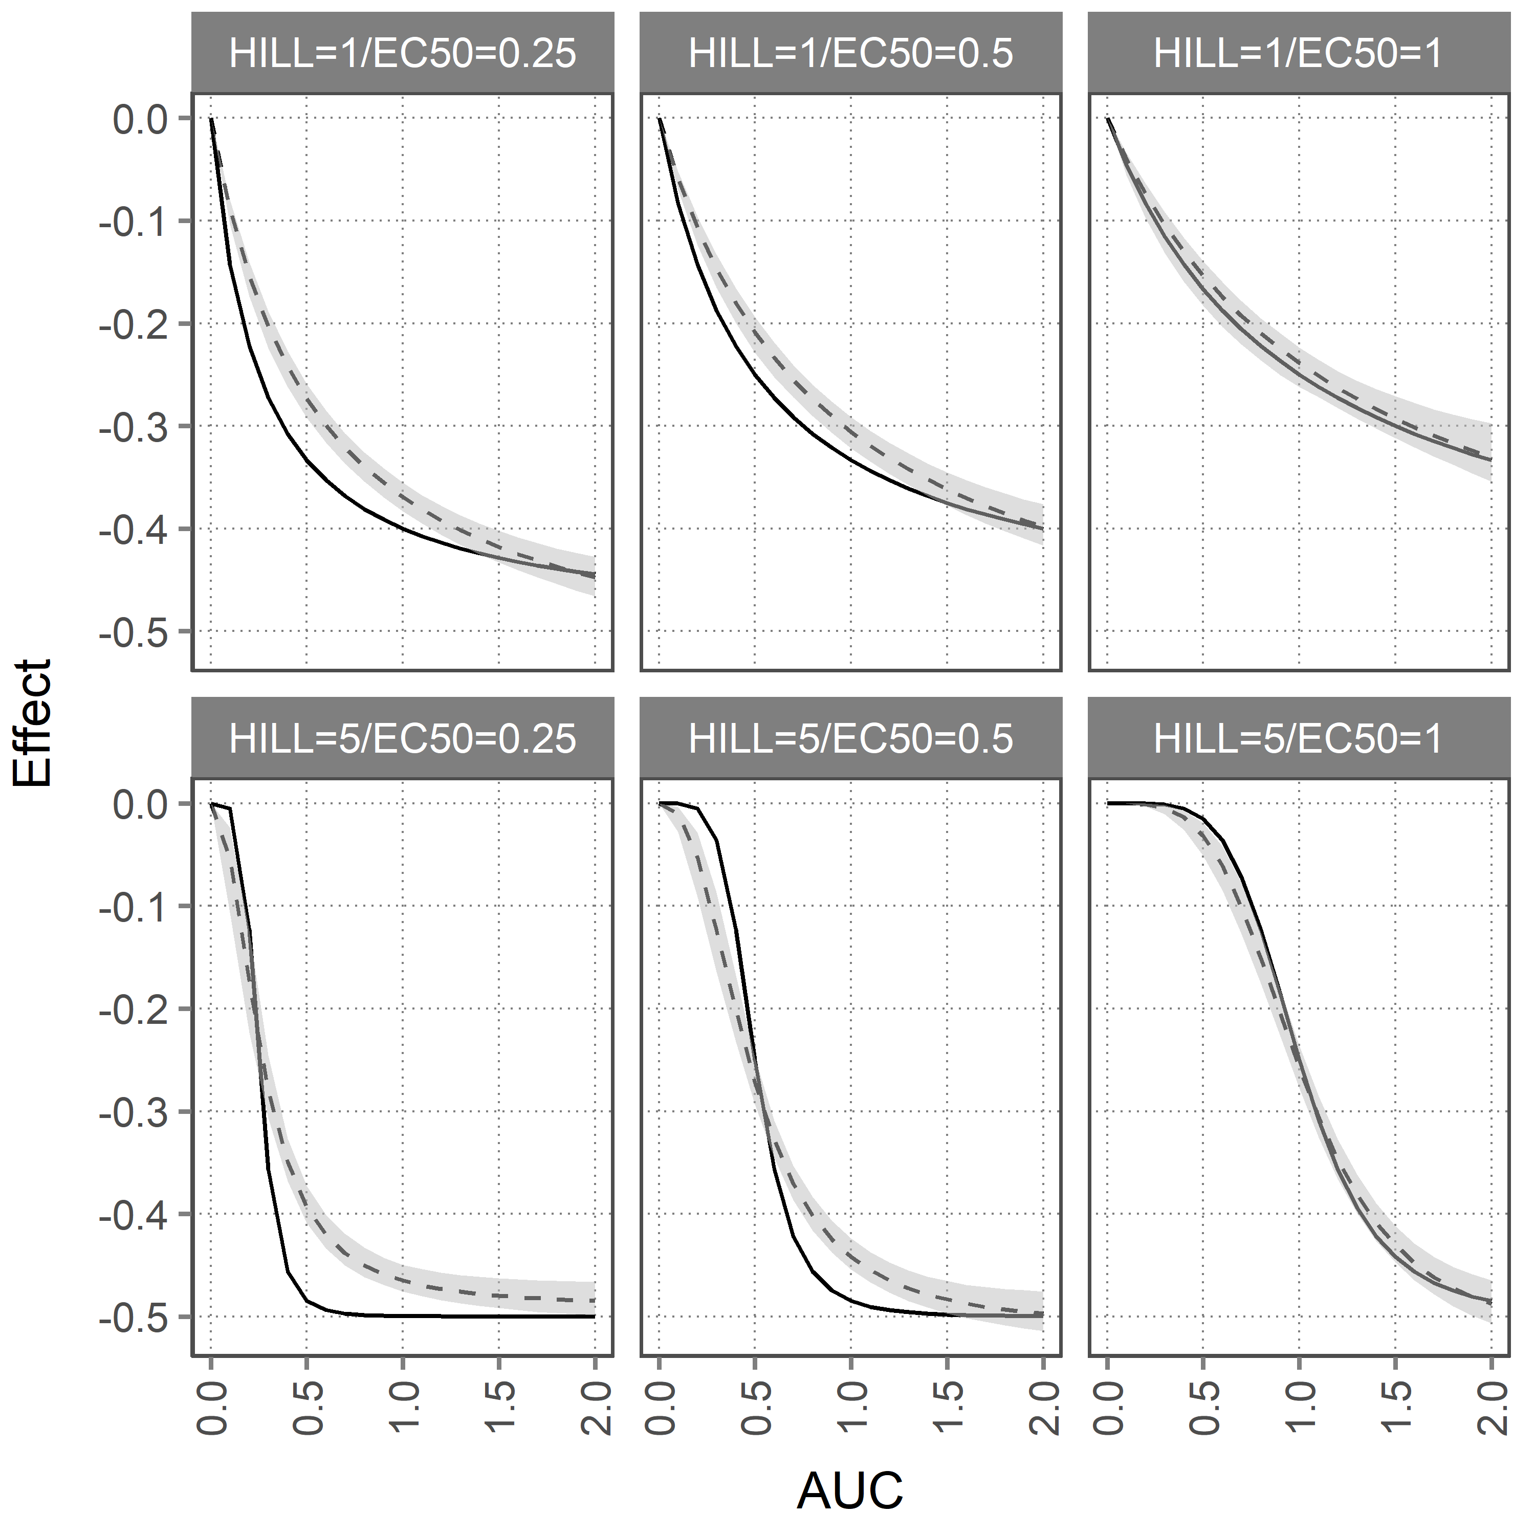

Figure S1. Comparison of the true E-R (solid line) and the estimated E-R (dashed line) and its 95% confidence interval (grey area) for the RTTE model using AUCavg and BlindedStudyTreatment_{rank} as predictors of the hazard in Scenario A, where treatment discontinuation occurs completely random.

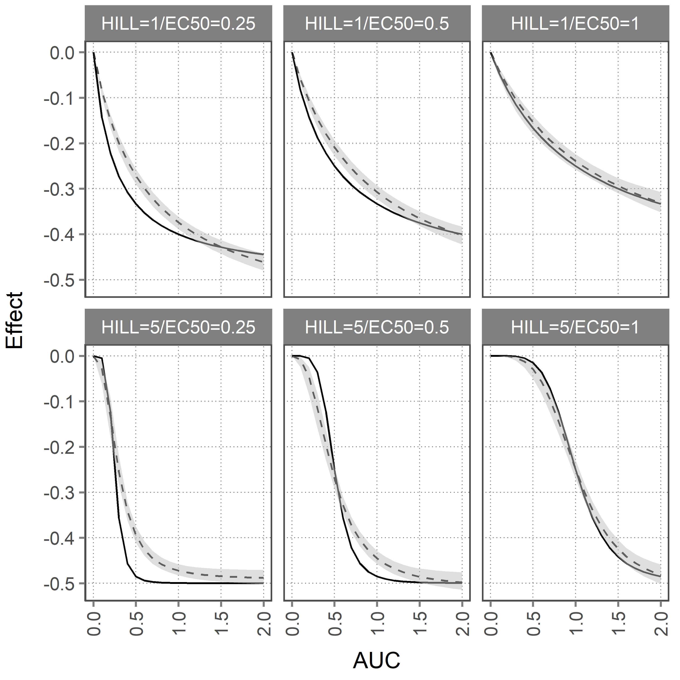
Figure S2. Comparison of the true E-R (solid line) and the estimated E-R (dashed line) and its 95% confidence interval (grey area) for the RTTE model using AUCavg as predictor of the hazard in Scenario A, where treatment discontinuation occurs completely random.

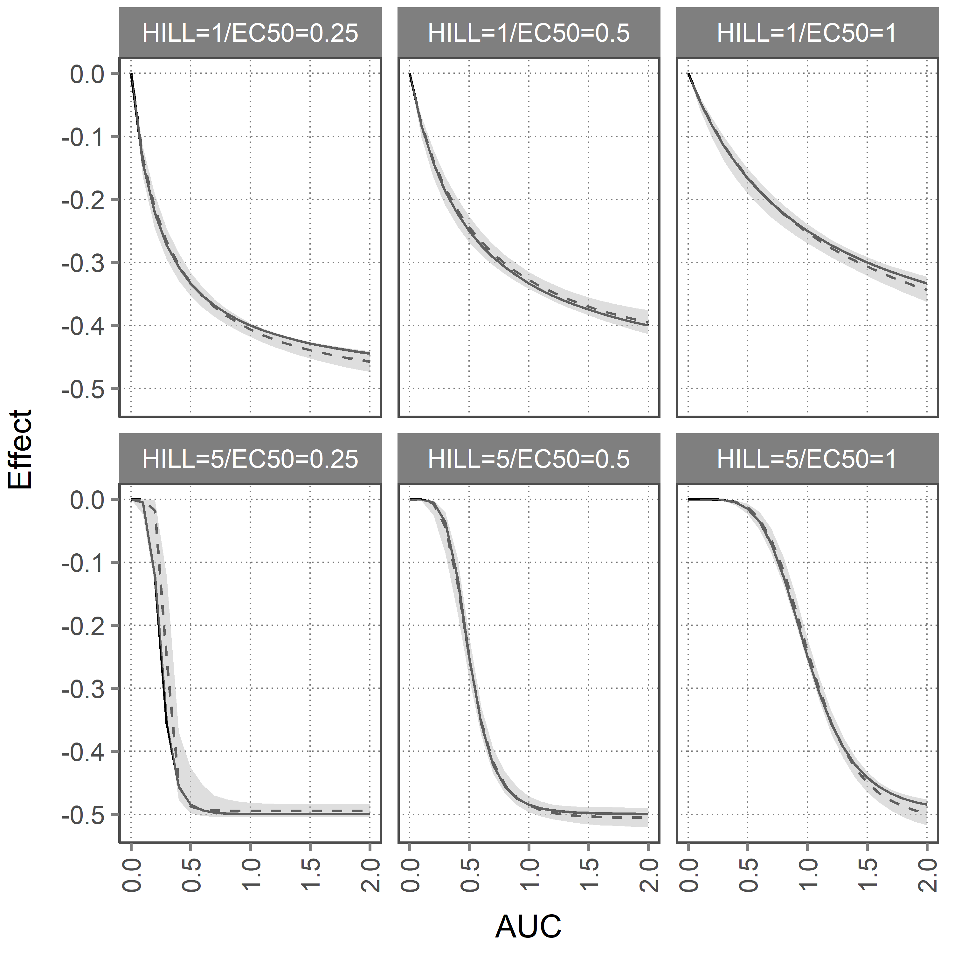
Figure S3. Comparison of the true E-R (solid line) and the estimated E-R (dashed line) and its 95% confidence interval (grey area) for the RTTE model using AUC(t) as the predictor of the hazard in Scenario A, where treatment discontinuation occurs completely random.

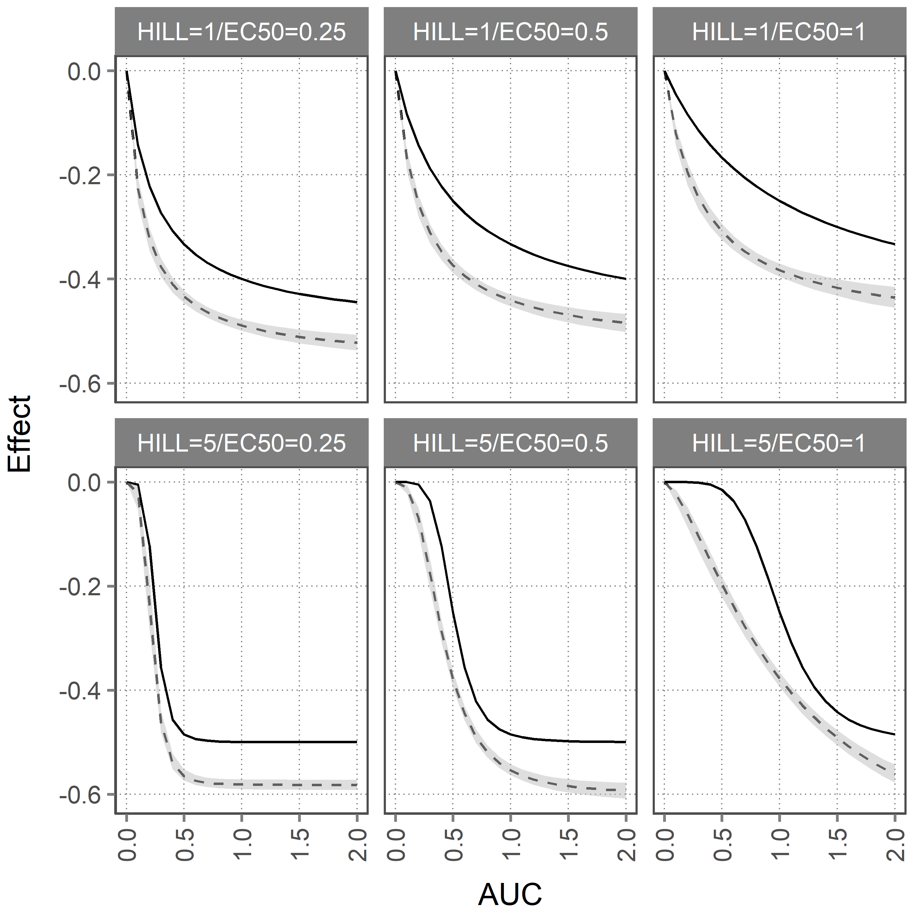
Figure S4. Comparison of the true E-R (solid line) and the estimated E-R (dashed line) and its 95% confidence interval (grey area) for the RTTE model using AUC(t) as the predictor of the hazard in Scenario C, where events (with 25% probability) can cause treatment discontinuation and these discontinuations sometimes (in CPED=25% of discontinuations) occur 1 day before the event.

Alternative versions of Figures 2-4 with additional RTTE models tested.
As additional sensitivity analysis, the simulated results presented in Figures 2-4 in the main manuscript were expanded by fitting three additional RTTE models
- AUC(t) no frailty. Similar to AUC(t), but removing the frailty term from the model (i.e. assuming no inter-individual variability in the base hazard).
- AUC_{avg} no frailty. Similar to AUC_{avg,} but removing the frailty term from the model.
- AUC(t) + BlindedStudyTreatment_{rank}. Similar to AUC(t), but includes BlindedStudyTreatment_{rank} as a covariate in the RTTE model.
The results below illustrate that the inclusion of BlindedStudyTreatment_{rank} only works with AUC_{avg}, not AUC(t). This can be intuitively understood from the fact that for a subject whose average dose is lower than the starting dose, a current high AUC(t) guarantees there will be a treatment discontinuation later in follow-up (which in Scenarios B and C means that there will be at least one more event). This can be seen by the fact that in Scenario B, when the true effect slope is 0 (i.e. no effect), the AUC(t)+ BlindedStudyTreatment_{rank} approach result in significant positive slope (higher exposure causing more events)
Figure S5. As Figure 2 in the main manuscript, but with additional RTTE models. Comparison of the true exposure-response (E-R) slope (horizontal dashed line) versus the estimated E-R slope and its 95% confidence interval (dot and error bars) for Scenario A, where treatment discontinuation occurs completely random. BST_{rank} = BlindedStudyTreatment_{rank}.

Figure S6. As Figure 3 in the main manuscript, but with additional RTTE models. Comparison of the true exposure-response (E-R) slope (horizontal dashed line) versus the estimated E-R slope and its 95% confidence interval (dot and error bars) for Scenario B, where events have a 25% probability of causing a treatment discontinuation after the event. BST_{rank} = BlindedStudyTreatment_{rank}.

Figure S7. As Figure 4 in the main manuscript, but with additional RTTE models. Comparison of the true exposure-response (E-R) slope (horizontal dashed line) versus the estimated E-R slope and its 95% confidence interval (dot and error bars) for Scenario C. In scenario C, like Scenario B, each event has a 25% chance to cause a treatment discontinuation. The difference with Scenario B is that in Scenario C, when an event causes a treatment discontinuation, there is a conditional probability (CPED) that the discontinuation occurs 1 day before the event instead of directly after the event. BST_{rank} = BlindedStudyTreatment_{rank}.

Additional sensitivity check of including down-titrations in addition to discontinuations.
The simulations presented in the body of the manuscript include treatment discontinuations. As a sensitivity analysis, we performed a simulation of Scenario B, where in patients receiving the highest dose level (DOSE_{study}(t) = 20 mg), events have a 25% chance of causing a down-titration to the lower dose level of 10 mg (instead of a direct discontinuation). Patients on the lower dose level of 10 mg (including patients that initially started on 20 mg), have a 25% chance of being discontinued at each event.

Figure S8. Sensitivity analysis of Scenario B that includes the possibility of down-titration in instead discontinuation after an event for patients on the higher dose level. Comparison of the true exposure-response (E-R) slope (horizontal dashed line) versus the estimated E-R slope and its 95% confidence interval (dot and error bars). BST_{rank} = BlindedStudyTreatment_{rank}.

Additional sensitivity check of impact of base hazard on Scenario B and C.
In this sensitivity check, the impact of increasing the base hazard rate of a typical individual from 0.15/year to 0.6/year was investigated.

Figure S9. Sensitivity check of increased base hazard (from 0.15/year to 0.6/year) in Scenario B. Comparison of the true exposure-response (E-R) slope (horizontal dashed line) versus the estimated E-R slope and its 95% confidence interval (dot and error bars) for Scenario B, where events have a 25% probability of causing a treatment discontinuation after the event. BST_{rank} = BlindedStudyTreatment_{rank}.

Figure S10. Sensitivity check of increased base hazard (from 0.15/year to 0.6/year) for Scenario C. Comparison of the true exposure-response (E-R) slope (horizontal dashed line) versus the estimated E-R slope and its 95% confidence interval (dot and error bars) for Scenario C. In scenario C, like Scenario B, each event has a 25% chance to cause a treatment discontinuation. The difference with Scenario B is that in Scenario C, when an event causes a treatment discontinuation, there is a conditional probability (CPED) that the discontinuation occurs 1 day before the event instead of directly after the event. BST_{rank} = BlindedStudyTreatment_{rank}.

