SUPPLEMENTARY MATERIALS
Table S1 Overview of studies included in the population PK analysis
Study code | Phase | Danicopan dosing regimen | Study population | Number of patients | PK sampling strategy | Total number of PK samples (range per patient)
ACH471-001 | 1 | Single dose: 200, 600, or 1200 mg (LFC) | Healthy (male) | 30 | One full profile | 492 (13–19)
ACH471-002 | 1 | Multiple dose (bid for 14 days in Cohorts 1–3, 7 days in Cohort 4): 75, 200, 500, or 800 mg (LFC) | Healthy (male) | 31 | Full profiles after first and last 2 doses (with sparse) | 1287 (31–46)
ACH471-006 | 1 | Single dose crossover (days 1, 5, 9): 800 mg (tablet and LFC crossover) | Healthy (male) | 26 | Full profiles after each dose | 864 (13–45)
ACH471-009 | 1 | Single dose: 200 mg (tablet) | Healthy and renal impairment (male/female) | 16 | One full profile | 234 (12–15)
ACH471-010 | 1 | Multiple dose (tid for 3 days): 150 mg (tablet) | Healthy (male) | 34 | One full profile | 340 (10–10)
ACH471-012 | 1 | Single dose: 200 mg (tablet) | Healthy and hepatic impairment (male) | 16 | One full profile | 236 (14–15)
ACH471-013 | 1 | Single dose (3 doses with washout): 400, 800, and 1200 mg (tablet) in each patient | Healthy (male/female) | 9 | Full profiles after each dose | 351 (39–39)
ACH471-014 | 1 | Multiple dose (tid for 4 days): 200 mg (tablet) | Healthy (male/female) | 71 | Sparse plus full profile on 4th day | 770 (1–11)
ACH471-017 | 1 | Multiple dose (tid for 4 days): 200 mg (tablet) | Healthy (male/female) | 49 | Sparse plus full profile on 4th day | 538 (10–11)
ACH471-016 | 1 | Food effect and elderly study | Healthy volunteer (male/female) | 25 | Full profiles | 662 (16–36)
ALXN2040- HV-101 | 1 | Single dose (3 doses with washout): 200 mg fasted, 200 mg fed, and 400 mg fasted (tablet) in each patient | Healthy, Japanese (male/female) | 9 | Full profiles after each dose | 380 (40–44)
NCT03181633 | 2 | Multiple dose (tid for up to 70 days): 75, 100, 125, 150, 175, or 200 mg (tablet); doses can change within a patient | PNH (male/female) | 10 | 3 full profiles after 2nd, 3rd, 4th doses (and some sparse) | 317 (27–34)
NCT03472885 | 2 | Multiple dose (tid for up to ~ 6 months): 100, 150, or 200 mg (tablet) | PNH (male/female) treated with eculizumab | 11 | Sparse | 167 (14–16)
NCT04469465 (ALPHA) | 3 | Single dose: 150 mg tid; patients could increase dose to 200 mg tid | PNH (male/female) treated with eculizumab or ravulizumab | 69 | Full profiles after each dose | 440
bid, two times daily; LFC, liquid-filled capsule; PK, pharmacokinetics; PNH, paroxysmal nocturnal hemoglobinuria; tid, three times daily.
Figure S1 pcVPC for the final population PK model by study
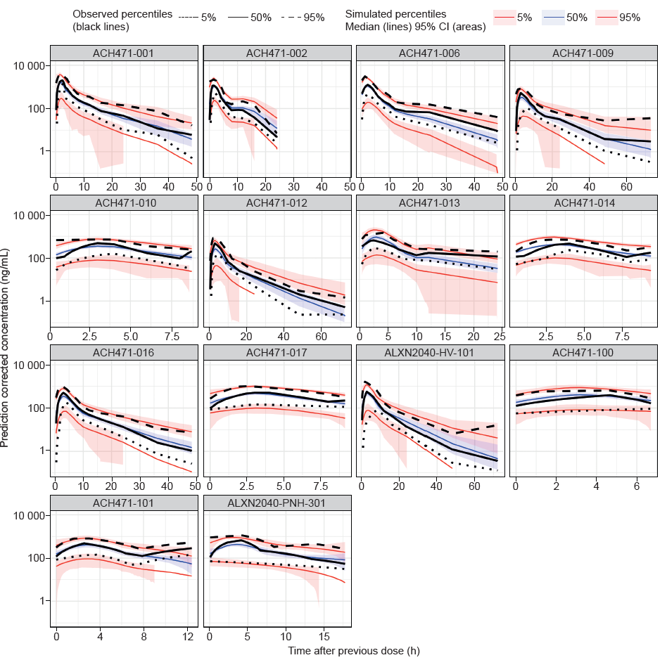
pcVPC, prediction-corrected visual predictive check; PK, pharmacokinetics.

Figure S2 Goodness-of-fit plots for the final population PK model for all studies
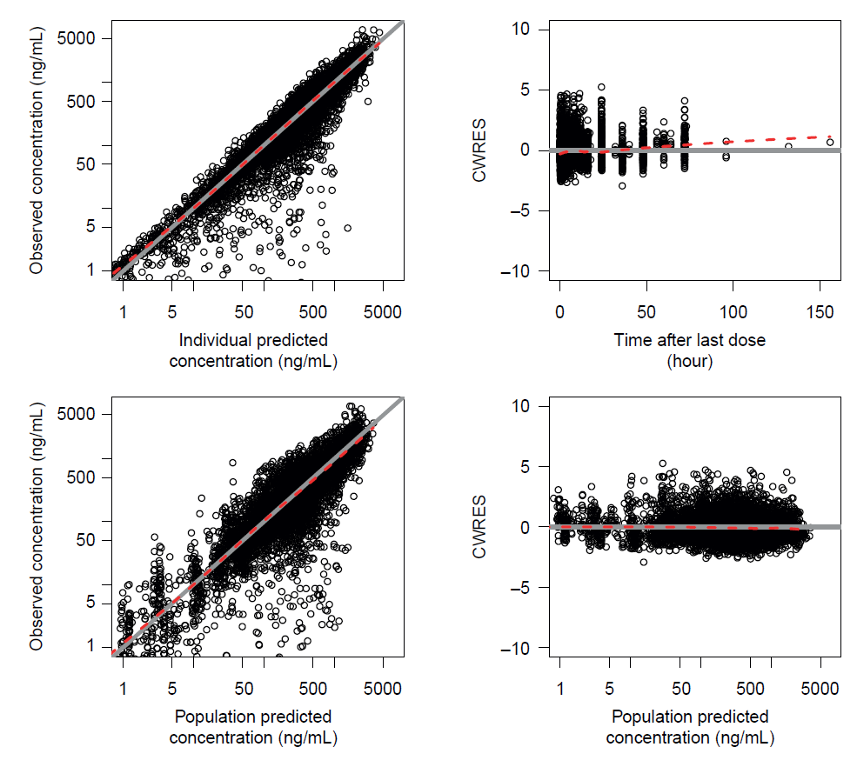
The solid grey line represents the line of unity; the red dashed line represents the locally estimated scatterplot smoothing line.
CWRES, conditional weighted residuals; PK, pharmacokinetics.
Figure S3 Plots of ETA in CL/F, Vc/F, Vp/F and K_{a} versus (A) weight, (B) sex and (C) eGFR in the final population PK Model
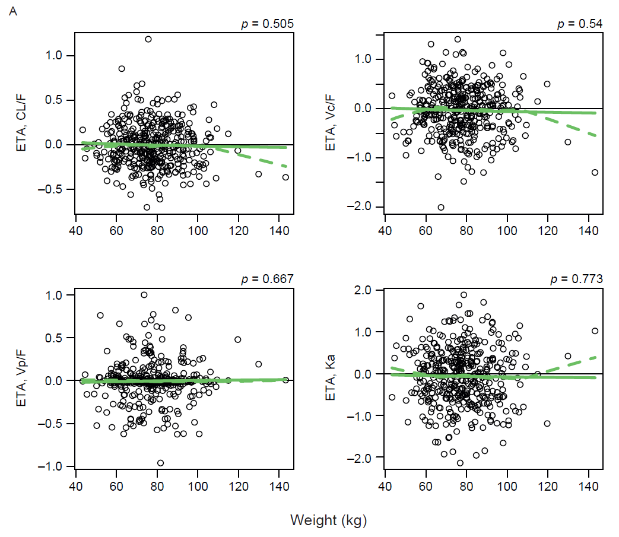
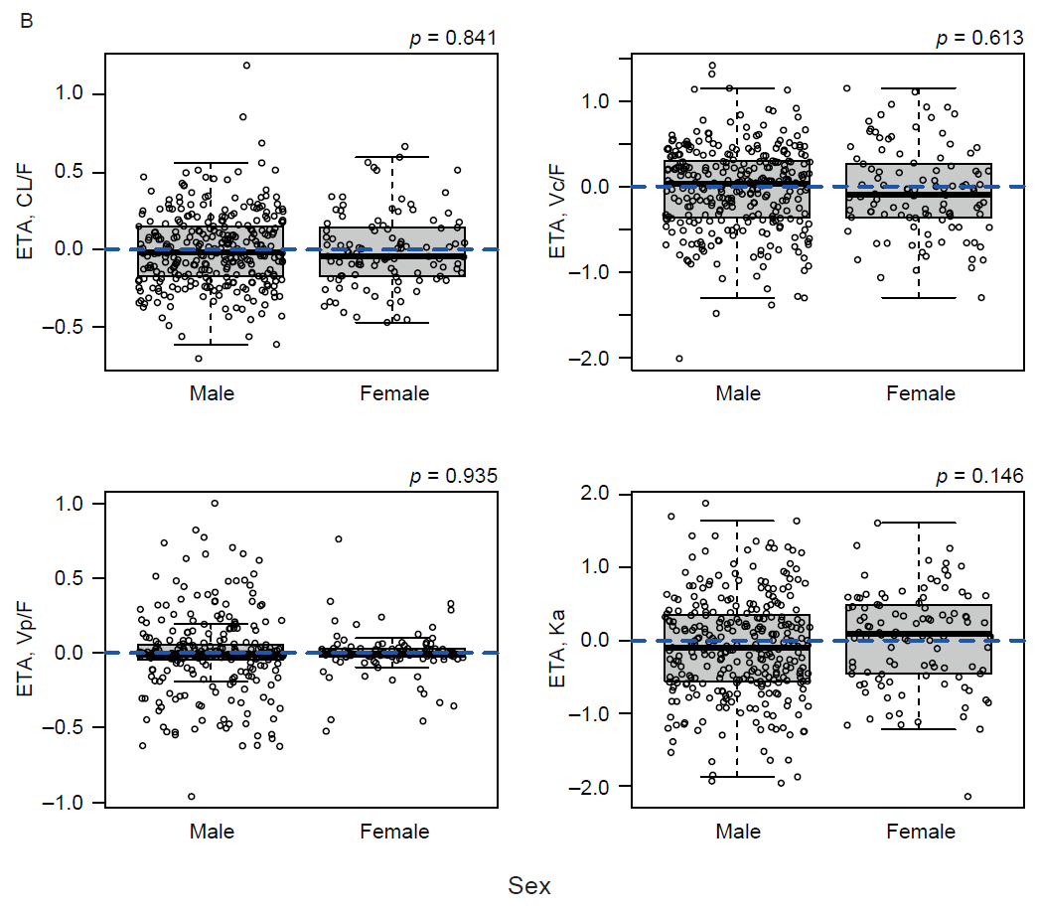
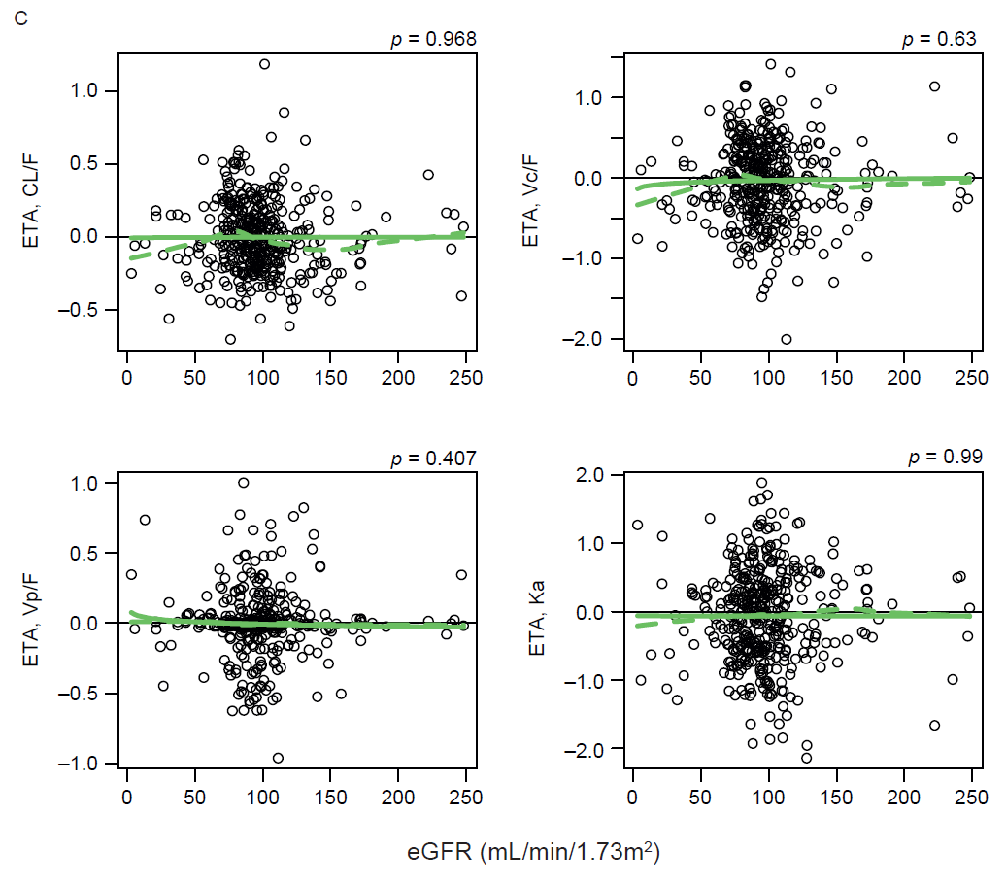
CL/F, apparent clearance; eGFR, estimated glomerular filtration rate; ETA, interindividual variability; Ka, first order absorption rate; PK, pharmacokinetics; Vc/F, apparent volume of the central compartment; Vp/F, apparent volume of the peripheral compartment.

Figure S4 pcVPC for APH in the final PK–PD model
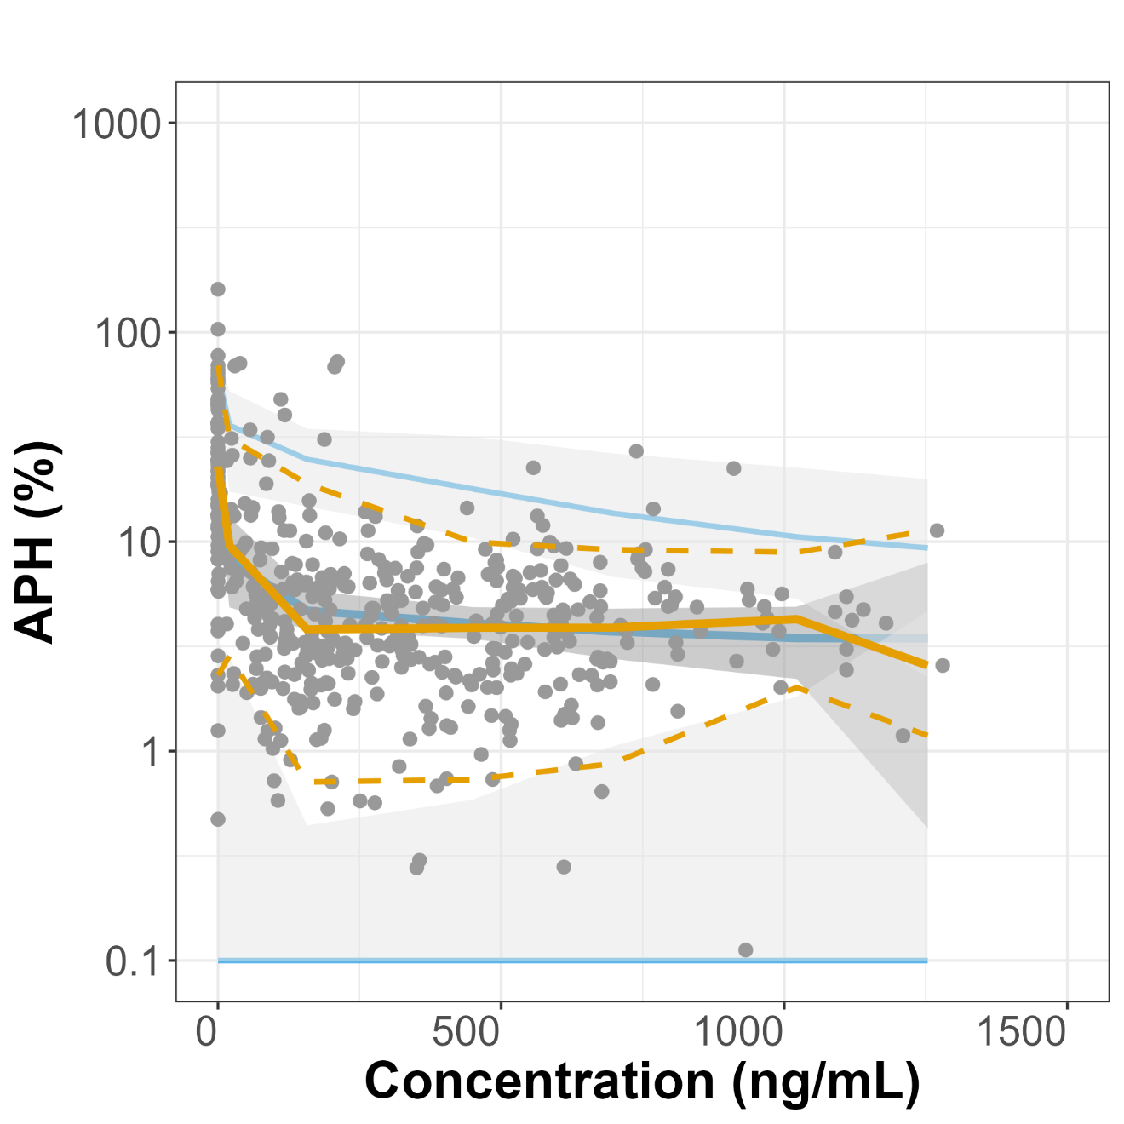
The grey dots represent individual prediction-corrected values. The yellow dashed lines represent the 5th, 50th (median) and 95th percentiles of the observed APH over a range of danicopan concentrations. The solid blue lines represent the 5th, 50th (median) and 95th percentiles of predictions from 1000 simulations. The gray shaded region indicates the 90% confidence interval of the 5th, 50th, and 95th percentiles of the simulations.
APH, alternative pathway activity by hemolysis assay; pcVPC, prediction-corrected visual predictive check; PK–PD, pharmacokinetic–pharmacodynamics.

NONMEM control script for the final population PK model
$SIZES PD=-100
$PROBLEM Danicopan PK
$INPUT CKEEP=DROP NROW STUDYID ID DATE=DROP TIME PERIOD=DROP
NTSFD=DROP NOMTIME=DROP PCDY=DROP TSFD TSPD DOSE AMT EVID
DV LOGDV=DROP BQL MDV CMT ADDL II SS DELFN DFRM FAST FOOD
AGE AGECAT=DROP SEXF WTKG RACE ETHN=DROP JAPAN
COUNTRY=DROP EASTASN BMI=DROP HGT=DROP PNH HI RI RFCATT
GFR=DROP GFRB CREAT=DROP CREATB CRCL=DROP CRCLB ALB=DROP
ALT=DROP AST=DROP ALP=DROP BILI=DROP ALBB ALTB ASTB ALPB
BILIB LDH=DROP BLDH HGB=DROP BHGB BHGBCAT=DROP FD=DROP FDB
C5 DROP DROP DROP DROP DROP DROP DROP DROP RATE
$DATA danicopan.ppk.dat4.csv IGNORE=@ IGNORE=(DELFN.EQ.9)
IGNORE=(DELFN.EQ.12) IGNORE=(DELFN.EQ.23)
IGNORE=(DELFN.EQ.50)
;Missing Concentration Value
;Pre-1st ^{d}ose BLQ Concentration
;Post-1st ^{d}ose BLQ Concentration
;Analyst-identified Outliers
$SUBROUTINE ADVAN4 TRANS4
$PK
;;; V2SEXF-DEFINITION START
V2SEXF=1
IF(SEXF.EQ.1) V2SEXF=(1+THETA(25))
;;; V2SEXF-DEFINITION END

;;; V2-RELATION START
V2COV=V2SEXF
;;; V2-RELATION END

;;; KAFOOD-DEFINITION START
KAFOOD=1
;IF(FOOD.EQ.0) KAFOOD=(1+THETA(23)) ;;Recoded below
IF(FOOD.EQ.2) KAFOOD=(1+THETA(24))
;;; KAFOOD-DEFINITION END

;;; KA-RELATION START
KACOV=KAFOOD
;;; KA-RELATION END

;;; CLSEXF-DEFINITION START
CLSEXF=1
IF(SEXF.EQ.1) CLSEXF=(1+THETA(22))
;;; CLSEXF-DEFINITION END

;;; CLRI-DEFINITION START
CLRI=1
IF(RI.EQ.2) CLRI=(1+THETA(21))
;;; CLRI-DEFINITION END

;;; CLALBB-DEFINITION START
CLALBB=1
IF(ALBB.GT.0) CLALBB=((ALBB/4.6)**THETA(20))
;;; CLALBB-DEFINITION END

;;; CLAGE-DEFINITION START
CLAGE=((AGE/33)**THETA(19))
;;; CLAGE-DEFINITION END

;;; CL-RELATION START
CLCOV=CLAGE*CLALBB*CLRI*CLSEXF
;;; CL-RELATION END

LFC = 0 ;LFC formulation, ref=TABLET
IF(DFRM.EQ.15) LFC=1

HIFAT = 0
IF (FOOD.EQ.2) HIFAT=1 ;; Food 0=Fast; 1=standard meal; 2 = high fat

TVCL = THETA(1)*(WTKG/75)**THETA(14)

TVCL = CLCOV*TVCL
TVV2 = THETA(2)*(WTKG/75)**THETA(13)

TVV2 = V2COV*TVV2
TVQ = THETA(3)*(WTKG/75)**THETA(14)
TVV3 = THETA(4)*(WTKG/75)**THETA(13)
TVKA = (THETA(5)*(1-LFC)+THETA(11)*LFC)+THETA(23)*FAST

TVKA = KACOV*TVKA
TVD1 = (THETA(6)*(1-LFC)+THETA(12)*LFC)*EXP(FAST*THETA(17))*EXP(HIFAT*THETA(18))

TTVF = (1*(1-LFC)+THETA(9)*LFC)*EXP(FAST*THETA(15))*EXP(HIFAT*THETA(16))
TVF1 = TTVF*(DOSE/200)**THETA(10)

CL = TVCL*EXP(ETA(1))
V2 = TVV2*EXP(ETA(2))
Q = TVQ
V3 = TVV3*EXP(ETA(3))
KA = TVKA*EXP(ETA(4))
D1 = TVD1*EXP(ETA(5))
F1 = TVF1

S2 = V2/1000 ;; Units: Dose=mg, Cp=ng/mL, V2=L

RUVCV = THETA(7)
RUVSD = THETA(8)

$ERROR (OBS ONLY)
IPRED=F
W = SQRT((F*F)*(RUVCV*RUVCV) + RUVSD*RUVSD)
Y = F+ERR(1)*W
IRES = DV-IPRED
IWRES = IRES/W

$THETA (0,81.4) ; 1 CL
(0,173) ; 2 V2
(0,34.4) ; 3 Q
(0,234) ; 4 Vp
(0,1.02) ; 5 KA
(0,3.14) ; 6 D1 Tablet
(0,0.445) ; 7 Proportional
(0,0.231) ; 8 Additive
(0,1.29) ; 9 BA of LFC formulation relative to tablet
-0.228 ; 10 F1 decrease with DOSE
(0,0.74) ; 11 KA LFC
(0,1.52) ; 12 D1 LFC
(0,0.863) ; 13 WT on V2,V3
(0,0.654) ; 14 WT on CL,Q
-0.143 ; 15 Fast on F1
0.106 ; 16 High fat mean on F1
0.115 ; 17 Fast on D1
0 FIX ; 18 High fat meal on D1
$THETA 0 FIX ; 19 Age on CL
$THETA 0 FIX ; 20 ALB on CL
$THETA -0.427 ; 21 RI on CL
$THETA -0.2 ; 22 SexF on CL
$THETA (0,7.08) ; 23 Fast on KA
0 FIX ; 24 High fat meal on Ka
$THETA 0 FIX ; 25 SexF on V2
$OMEGA BLOCK(2)
.0633
.0812 .435 ; 1, 2 CL Vc
$OMEGA .153 ; 3 Vp
$OMEGA .912 ; 4 KA
$OMEGA 0 FIX ; 5 D1
$SIGMA 1 FIX
$ESTIMATION METHOD=COND INTER POSTHOC MAXEVAL=9999 NOABORT PRINT=20
$COVARIANCE PRINT=E MATRIX=R

NONMEM control script for the final PK–PD model for APH
$PROBLEM Population human PKPD Model for Danicopan
;DV = APH, IDV = CONC
$INPUT C NROW STUDYID ID XDATE=DROP XTIME=DROP PERIOD NTSFD
NOMTIME PCDY TSFD TSPD DOSE AMT EVID=DROP CONC LOGDV=DROP
BQL=DROP XMDV=DROP CMT=DROP ADDL=DROP II=DROP SS=DROP
DELFN DFRM FAST FOOD AGE AGECAT SEXF WTKG RACE ETHN JAPAN
CTRY=DROP EASTAS BMI HGT=DROP PNH HI RI RFCATT GFR=DROP
GFRB=DROP CREAT=DROP CREATB=DROP CRCL=DROP CRCLB=DROP
ALB=DROP ALT=DROP AST=DROP ALP=DROP BILI=DROP ALBB=DROP
ALTB=DROP ASTB=DROP ALPB=DROP BILIB=DROP LDH=DROP
BLDH=DROP HGB=DROP BHGB BGHBCAT FD FDB C5 APW=DROP BAPW
APWNBS APH BAPH BAPHNBS TRANFHIS TRANFLAG RATE PCTPTNUM
STUDY=DROP USUBJID=DROP GTRT MDV FLAG DV=APHCOR LOGAPHC
WK12DOSE
$DATA danicopan.ppk.dat4.v3.csv IGNORE=C
IGNORE=(MDV.EQ.1,FLAG.EQ.1)
$PRED

FDBC=FDB
IF(FDB.EQ.0) FDBC=1

WTCAT=0
IF(WTKG.GE.69) WTCAT=1

COVIJ = (1 + THETA(6)*JAPAN)

COVBW = (WTKG/69)**THETA(7)
COVBD = (FDBC/2700)**THETA(8)
COVBE = (1 + THETA(9)*EASTAS)
COVBS = (1 + THETA(10)*SEXF)

BASE=(THETA(1)*COVBW*COVBD*COVBE*COVBS)+ETA(1)
IC50=THETA(2)*COVIJ*DEXP(ETA(2))
IMAX=THETA(3)*DEXP(ETA(3))

DRUGE = CONC/(IC50+CONC)
IPRED=BASE-(BASE-IMAX)*DRUGE

W=SQRT(THETA(4)**2+THETA(5)**2*IPRED*IPRED)
IRES=DV-IPRED
IWRES=IRES/W
Y=IPRED+W*EPS(1)

$THETA (0,30) ; BASE
(0,3) ; IC50)
(0,10) ; IMAX
0 FIX ; Add
(0,1) ; Prop
0 FIX
0.1
0 FIX
0.1
0 FIX
$OMEGA
10 ; etaBASE
4 ; etaIC50
0 FIX ; etaIMAX
$SIGMA 1 FIX
$ESTIMATION METHOD=1 INTERACTION MAXEVAL=9999 NOABORT PRINT=10

