SUPPLEMENTARY MATERIALS
Table S1. PK and immunogenicity sampling timepoints of studies included in the PopPK analysis.
Phase | Study Number | Part | Population | PK sampling timepoints | Immunogenicity sampling timepoints
1 | KPL-716-C001 | 1 | Moderate-severe AD | Pre-dose and 1, 4, 8, 12 hours post-dose on Day 0, Days 1 (24 hours post-dose), 2, 3, 4, 5, 6, 7, 10, 14, 17, 21, 24, 28, 31, 38, 45, 52, 60, 70, and 90 | Pre-dose on Day 0 and on Days 14, 28, 60, 90 and 120, or until resolution of anti-drug antibodies or 6 months, whichever came first
 |  | 3 | Healthy volunteers
 |  | 4 | Moderate-severe AD | Pre-dose on Day 0, Days 2, 4, 7, 11, 14, 18, 21, 25, 28, 35, 39, 42, 49, 56, 60, 63, 70, 77, 81, 91, 105, 119, 133 and 147 (PK sampling on Days 11, 18, 25, 39, 49, 63 and 81 was optional) | Pre-dose on Day 0 and on Days 14, 35, 91, 119 and 147, or until resolution of anti-drug antibodies or 6 months, whichever came first
2 | KPL-716-C201 Ph2a | - | Moderate-severe PN | For patients who received 16-week treatment: Pre-dose at Baseline (Day 1), Weeks 1, 2, 3, 4, 5, 6, 7, 8, 9, 10, 11, 12, 13, 14, 15, 16, 18, 20, and 24  For patients who received 8-week treatment, Pre-dose at Baseline, Weeks 1, 2, 3, 4, 5, 6, 7, 8, 10, 12, and 16 | For patients who received 16-week treatment: Pre-dose at Baseline, Weeks 2, 4, 8, 16 and 24  For patients who received 8-week treatment, Pre-dose at Baseline, Weeks 2, 4, 8 and 16
 | KPL-716-C201 Ph2b | - | PN patients with severe pruritus | Predose at Baseline, Weeks 2, 4, 8, 12, 16, 18, 20, 32, 48, 52 | Predose at Baseline, Weeks 2, 4, 8, 12, 16, 18, 20, 32, 48, 52
 | KPL-716-C202 | - | Five chronic pruritic diseases^{c} | Pre-dose at Baseline (Day 1), Weeks 1, 2, 3, 4, 5, 6, 7, 8, 10, 12, 14, 16 and 18 | Pre-dose at Baseline, Weeks 2, 4, 8, 12, 16 and 18

Table S2. Pre-specified covariates assessed in covariate analysis

Covariate | Code | Type | Parameters
Age at baseline (yr) | AGE | Continuous | CL, V_{c}
Weight at baseline (kg) | WT | Continuous | CLª, V_{c}ª, V_{p}
Sex | SEX | Categorical | CL, V_{c}
Race (Asian vs others) | RACE | Categorical | CL, V_{c}
ADA status^{b} | ATA | Categorical | CL
Patient population^{c} | DSSTAT | Categorical | CL, F1, Ka, R₀
ADA, anti-drug antibody; CL, clearance; F1, subcutaneous bioavailability (logit-transformed); K_{a}, first-order absorption rate constant; R₀, baseline target level; V_{c}, central volume of distribution; V_{p}, peripheral volume
ªConsidered as structural covariates, still evaluated in backward elimination
^{b}Positive ADA status was defined as having at least one positive post-baseline result
^{c}Healthy volunteers or patients with skin disorders (atopic dermatitis [AD], prurigo nodularis [PN], chronic pruritic diseases [Study KPL-716-C202])

Table S3. Summary of model runs.

Model | Reference model | OBJ | Delta OBJ | Condition number | Description
Base Model Development
run 1 | - | -606.5 | - | 1038 | Starting model: TMDD QSS structural model
run 2 | run 1 | -4506.1 | -3899.5 | 779.4 | Starting model + diagonal IIV on Vc, CL, Q, Vp, Ka, F1, R0)
run 2a (Base model) | run 2 | -5519.4 | -1013.3 | 211.7 | Starting model + diagonal IIV on Vc, CL, Q, Vp, Ka, F1, R0), outliers excluded
Covariate Model Development
run 3 | run 2a | -5652.9 | -133.5 | 210 | Base model + WT on CL/Vc
run 4 | run 3 | -5669.4 | -16.5 | 176.4 | Forward 1: Adding WT on Vp
run 5 | run 4 | -5679.7 | -10.2 |  | Forward 2: Adding AGE on Vc
run 6 (Covariate model) | run 5 | -5658.0 | 10.2 | 172.9 | Backward 1: Removing AGE on Vc  Final included: WT on CL/Vc/Vp
Model Refinement
run 7  (Final model) | run 6 | -5658.0 | 0 | 190.3 | Removing IIV on Q
run 8 | run 6 | -4643.6 | 1025.8 | 2087 | Re-including outliers

Table S4. Comparison of parameter estimates between run 2 and run 2a.
 | run 2 |  | run 2a (outliers removed, base model)
Parameter | Value (%RSEª) | Shrinkage (%) | Value (%RSE*) | Shrinkage (%)
Central volume of distribution, Vc (L) | 2.89 (6.1) |  | 2.91 (4.6)
Clearance, CL (L/h) | 0.00651 (3.5) |  | 0.0063 (3)
Inter-compartmental clearance, Q (L/h) | 0.0194 (17.7) |  | 0.0204 (16.2)
Peripheral volume of distribution, Vp (L) | 1.87 (8.8) |  | 1.73 (7.3)
Absorption rate constant, Ka (h⁻¹) | 0.011 (8.9) |  | 0.0123 (8.4)
Subcutaneous bioavailability, F (%) | 57.2 (3.3) |  | 55 (2.9)
Baseline receptor level, R₀ (nM) | 0.824 (22.9) |  | 2.17 (10)
Receptor degradation rate constant, K_{deg} (h⁻¹) | 0.233 (23) |  | 0.0812 (9.9)
Quasi steady-state rate constant, Kss (nM) | 0.0214 (24) |  | 0.0353 (11.8)
Complex elimination rate constant K_{int} (h⁻¹) | 0.000658 (6.9) |  | 0.000175 (31.5)
Between subject variability for Vc (CV%)^{b} | 24.4 (32.1) | 44.3 | 20.4 (33.7) | 46.3
Between subject variability for CL (CV%)^{b} | 27.8 (16.3) | 23 | 28.2 (14.7) | 20.2
Between subject variability for Q (CV%)^{b} | 93.5 (31.5) | 54.3 | 96.5 (30.5) | 52.5
Between subject variability for Vp (CV%)^{b} | 28.7 (40.1) | 53.5 | 18.8 (80.7) | 64.6
Between subject variability for R0 (CV%)^{b} | 38.5 (21.1) | 37.9 | 44.3 (16.8) | 31.3
Between subject variability for Ka (CV%)^{b} | 52.8 (25.4) | 49.6 | 52.1 (25.3) | 49.1
Between subject variability for F1 (CV%)^{b} | 55.6 (23.2) | 27.8 | 56.8 (18.7) | 22.6
Log-additive residual variability (CV%)^{c} | 23.6 (0.9) | 10.4 | 19.4 (1.1) | 11
ªRelative standard error (RSE)% calculated as $SE\left(θ\right)×100\%$
^{b}CV% calculated as $\sqrt{\exp\left(ω^{2}\right)-1}×100\%$
^{c}CV% calculated as $\sqrt{\exp\left(σ^{2}\right)-1}×100\%$

Table S5. Comparison of parameter estimates between run 7 and run 8.
 | run 7 (final model) |  | run 8 (outliers re-included)
Parameter | Value (%RSEª) | Shrinkage (%) | Value (%RSE*) | Shrinkage (%)
Central volume of distribution, Vc (L) | 3.04 (4.2) |  | 2.98 (4.7)
Weight on Vc | 0.762 (17.2) |  | 0.816 (16.1)
Clearance, CL (L/h) | 0.00649 (2.6) |  | 0.00652 (2.9)
Weight on CL | 0.943 (9.4) |  | 0.94 (9.7)
Inter-compartmental clearance, Q (L/h) | 0.0207 (16.7) |  | 0.0208 (14.6)
Peripheral volume of distribution, Vp (L) | 1.74 (5.9) |  | 1.83 (6.1)
Weight on Vp | 0.646 (27.4) |  | 0.591 (29.8)
Absorption rate constant, Ka (h⁻¹) | 0.0126 (7.5) |  | 0.0121 (9.3)
Subcutaneous bioavailability, F (%) | 56.6 (2.5) |  | 57.6 (2.6)
Baseline receptor level, R₀ (nM) | 1.84 (9.5) |  | 0.729 (28.5)
Receptor degradation rate constant, K_{deg} (h⁻¹) | 0.097 (9.4) |  | 0.271 (29.2)
Quasi steady-state rate constant, Kss (nM) | 0.0296 (10.6) |  | 0.0184 (29.8)
Complex elimination rate constant K_{int} (h⁻¹) | 0.000141 (33) |  | 0.000549 (6.5)
Between subject variability for Vc (CV%)^{b} | 18.1 (32.6) | 45.6 | 19.9 (27.9) | 44.9
Between subject variability for CL (CV%)^{b} | 24.9 (12.6) | 19.7 | 24.8 (13.2) | 21.2
Between subject variability for Q (CV%)^{b} | 91.6 (28.9) | 53.3 | 82.5 (31.4) | 57.2
Between subject variability for R0 (CV%)^{b} | 42.8 (15.7) | 29.6 | 38.6 (16.7) | 33.3
Between subject variability for Ka (CV%)^{b} | 51.1 (24.2) | 48.8 | 52.8 (25.8) | 50.5
Between subject variability for F1 (CV%)^{b} | 42.1 (19) | 27.6 | 37.1 (23.7) | 35.1
Log-additive residual variability (CV%)^{c} | 19.6 (1.1) | 10.2 | 24.1 (0.7) | 9.2
ªRelative standard error (RSE)% calculated as $SE\left(θ\right)×100\%$
^{b}CV% calculated as $\sqrt{\exp\left(ω^{2}\right)-1}×100\%$
^{c}CV% calculated as $\sqrt{\exp\left(σ^{2}\right)-1}×100\%$

Figure S1. Dose-normalized vixarelimab concentration-time profiles after IV single doses in healthy volunteers (KPL-716-C001 Part 3). Observations below the quantification limit were removed.
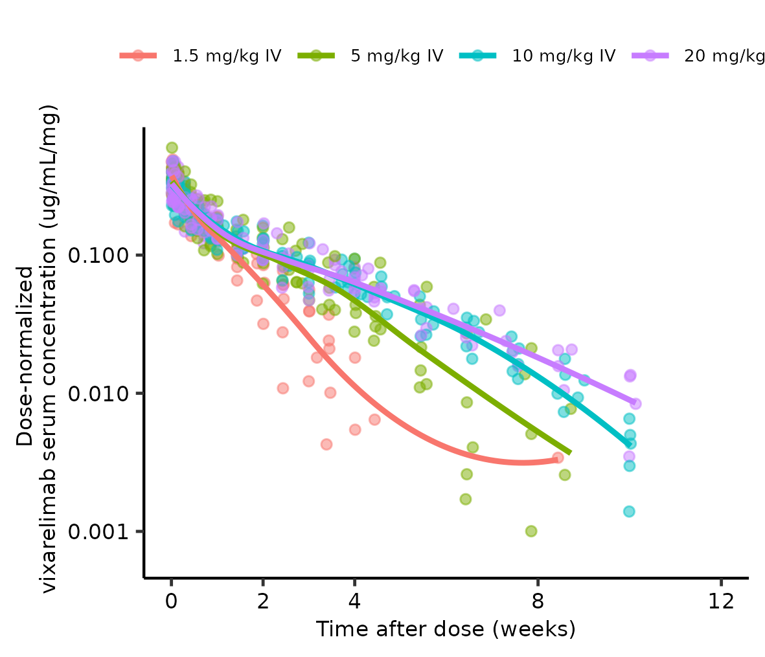

Figure S2. Comparison of observed PK profiles between healthy volunteers (KPL-716-C001 Part 3) and patients with atopic dermatitis (KPL-716-C001 Part 1) at 1.5 mg/kg given intravenously (IV) or subcutaneously (SC). Observations below the quantification limit (indicated by the dashed lines) were removed.
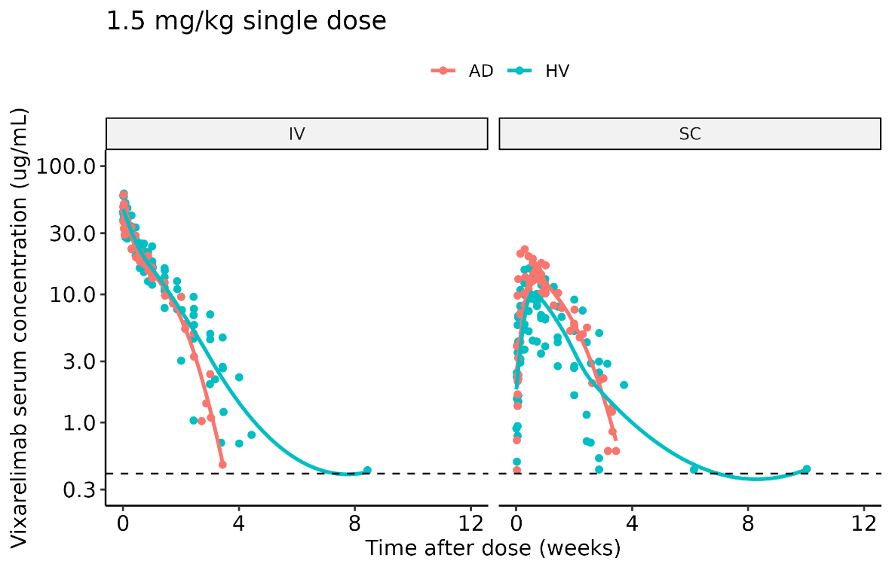

Figure S3. Diagnostic plots of the base model. The blue line represents the linear smooth.
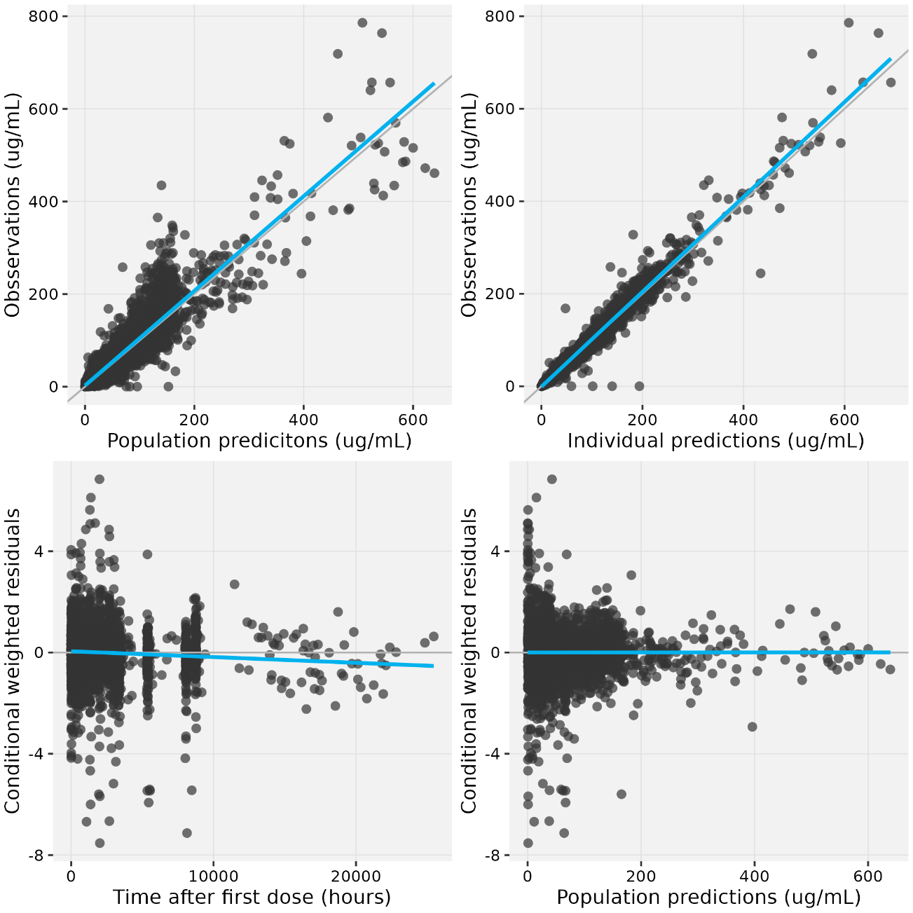

Figure S4. Visual predictive check for the final model stratified by dose using data from study KPL-716-C001 Parts 1 and 3. The gray circles represent observed concentrations. The solid gray line and the dashed gray lines represent the median and the 2.5th and 97.5th percentile of the observed concentrations, respectively. The gray area represents the 95% confidence interval for the model-predicted median, and the blue areas represent the 95% confidence intervals for the model-predicted 2.5th and 97.5th percentiles.
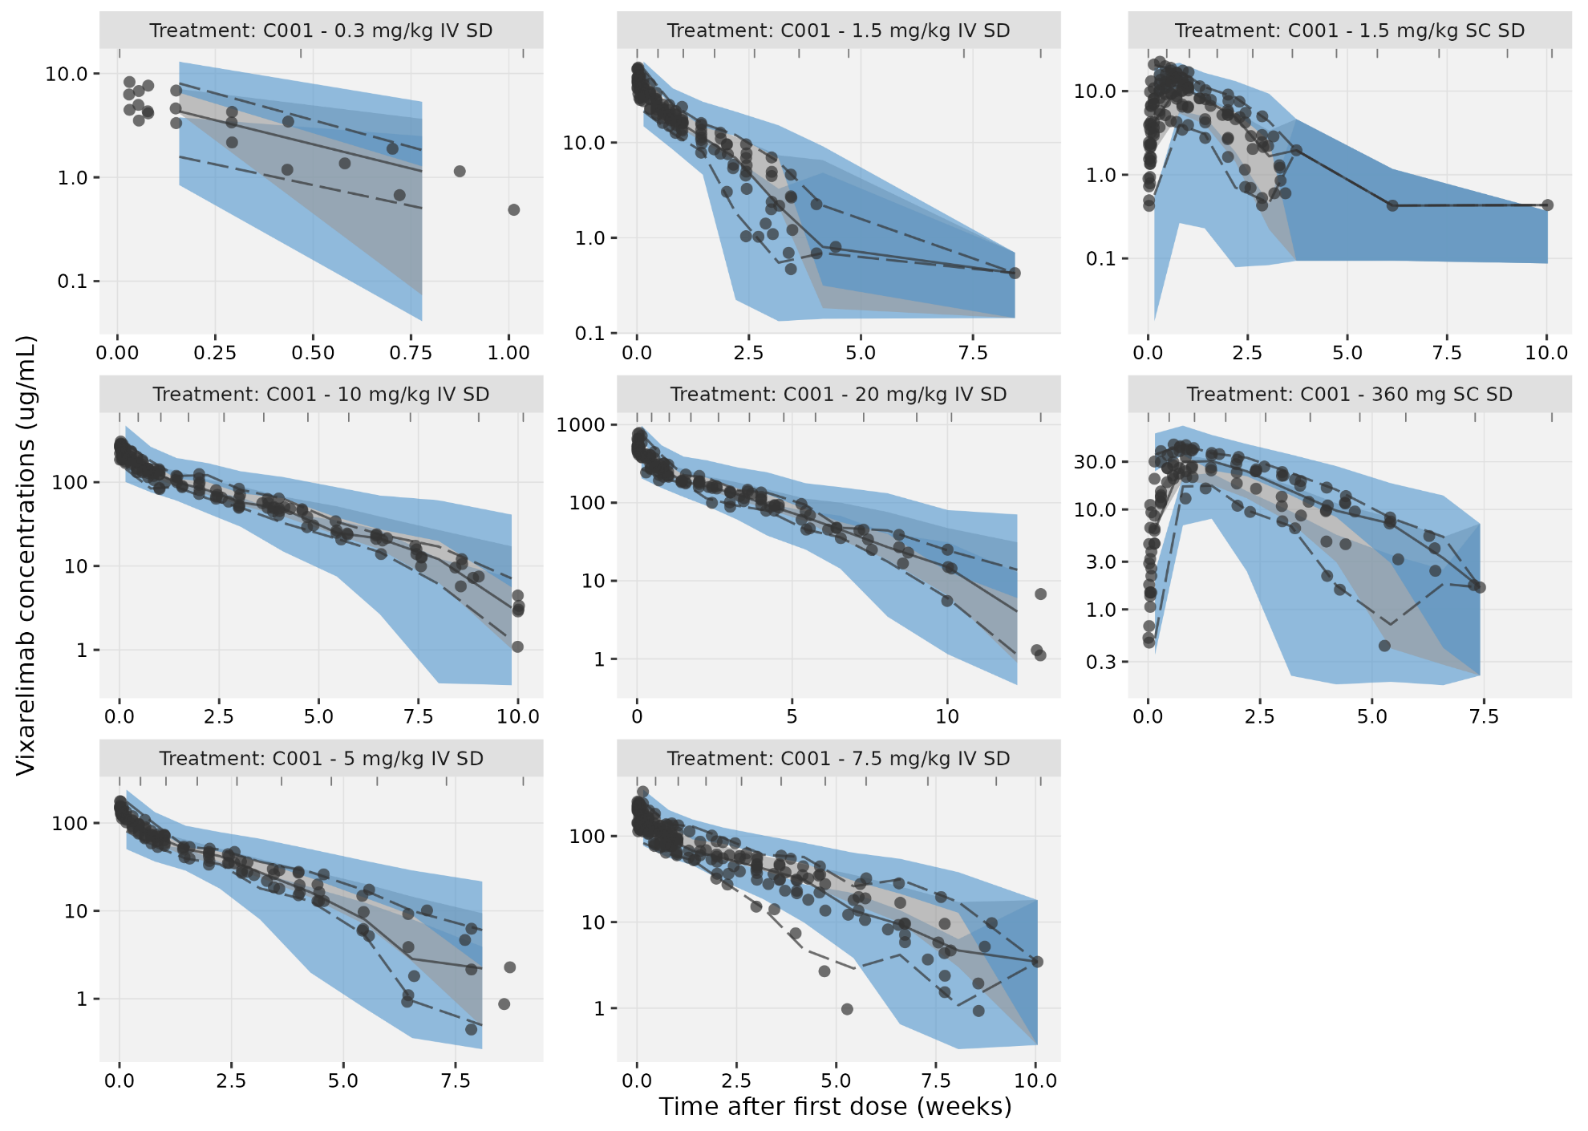

Figure S5. Visual predictive check for the final model stratified by dose using data from study KPL-716-C201 Ph2b. The gray circles represent observed concentrations. The solid gray line and the dashed gray lines represent the median and the 2.5th and 97.5th percentile of the observed concentrations, respectively. The gray area represents the 95% confidence interval for the model-predicted median, and the blue areas represent the 95% confidence intervals for the model-predicted 2.5th and 97.5th percentiles.

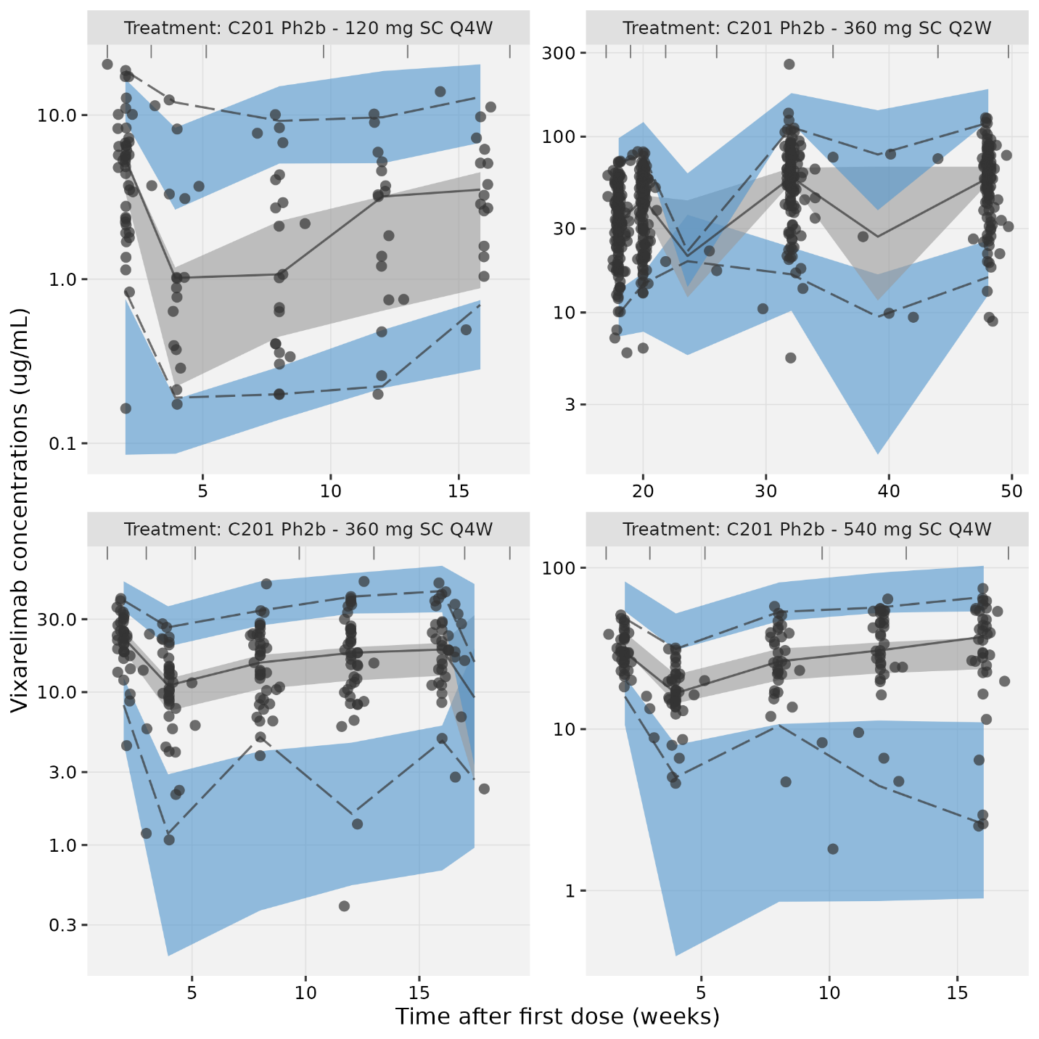
Figure S6. Predicted typical values of free receptor levels (%baseline) at the KPL-761-C201 Ph2b dose levels.

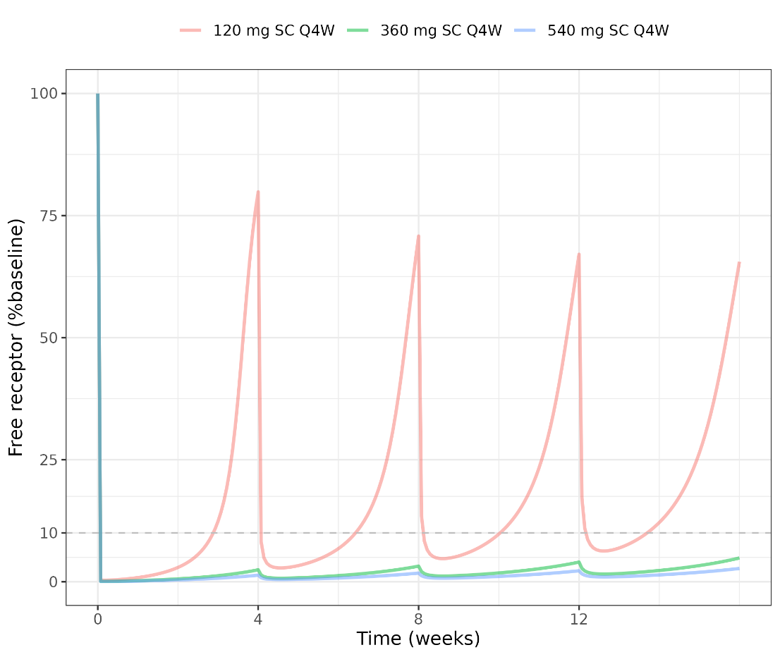

Model Code
$INPUT C COMMENT=DROP STUD PHAS=DROP PART PTNM=DROP ID TIME VISITC=DROP VISITN=DROP
NTIM TFDS AMTMG AMT ROUTEC=DROP ROUTE RATE DUR ODV DVUGML DVNM DV BLQ LLOQ LLOQNM EVID
MDV CMT DVID ATRT=DROP WT SEX
SEXC=DROP AGE RACE RACEC=DROP ATVO ATAV ATAO ATA ATATR DSSTAT DROP DROP RACEG SEQ DOSE
$DATA ../data/poppk_pooled_20250421_derived.csv IGNORE=C IGNORE=(BLQ.EQ.1)
IGNORE=(SEQ.EQ.1554)
IGNORE=(SEQ.EQ.2902)
IGNORE=(SEQ.EQ.2926)
IGNORE=(SEQ.EQ.3423)
IGNORE=(SEQ.EQ.3424)
IGNORE=(SEQ.EQ.3797)
IGNORE=(SEQ.EQ.3966)
IGNORE=(SEQ.EQ.4448)
IGNORE=(SEQ.EQ.4450)
IGNORE=(SEQ.EQ.5491)
IGNORE=(SEQ.EQ.5800)
$SUBROUTINE ADVAN13 TOL=9
$MODEL COMP=(DEPOTSC) COMP=(CENTRAL,DEFOBS) COMP=(RECEPTOR)
COMP=(PERI)
$PK
;;; VPWT-DEFINITION START
VPWT = ((WT/81.7)**THETA(13))
;;; VPWT-DEFINITION END

;;; VP-RELATION START
VPCOV=VPWT
;;; VP-RELATION END

;;; VCWT-DEFINITION START
VCWT = ((WT/81.7)**THETA(12))
;;; VCWT-DEFINITION END

;;; VC-RELATION START
VCCOV=VCWT
;;; VC-RELATION END

;;; CLWT-DEFINITION START
CLWT = ((WT/81.7)**THETA(11))
;;; CLWT-DEFINITION END

;;; CL-RELATION START
CLCOV=CLWT
;;; CL-RELATION END

TVVC = THETA(1)

TVVC = VCCOV*TVVC
TVCL = THETA(2)

TVCL = CLCOV*TVCL
TVQ = THETA(3)
TVVP = THETA(4)

TVVP = VPCOV*TVVP
TVBLR = THETA(5)
TVKDEG = THETA(6)
TVKSS = THETA(7)
TVKINT = THETA(8)
TVKA = THETA(9)
IF(ROUTE.EQ.1)KA = 0

VC = TVVC * EXP(ETA(1))
CL = TVCL * EXP(ETA(2))
Q = TVQ * EXP(ETA(3))
VP = TVVP * EXP(ETA(4))
BLR = TVBLR * EXP(ETA(5))
KDEG = TVKDEG * EXP(ETA(6))
KSS = TVKSS * EXP(ETA(7))
KINT = TVKINT * EXP(ETA(8))
KA = TVKA * EXP(ETA(9))

KSYN = KDEG * BLR
KEL = CL/VC
KPT = Q/VC
KTP = Q/VP
TVBIO = THETA(10)
TVPHI = LOG(TVBIO/(1-TVBIO))
PHI = TVPHI+ETA(10)
BIO = EXP(PHI)/(1+EXP(PHI))
F1 = BIO

S2 = VC

A_0(3) = BLR

$DES
CT = A(2)/VC
D = CT-A(3)-KSS
CF = 0.5*(D+SQRT(D**2+4*KSS*CT))

DADT(1) = -KA*A(1)
DADT(2) = KA*A(1) - (KEL+KPT)*CF*VC + KTP*A(4) - A(3)*KINT*CF*VC/(KSS+CF)
DADT(3) = KSYN - KDEG*A(3) - (KINT-KDEG)*A(3)*CF/(KSS+CF)
DADT(4) = KPT*CF*VC - KTP*A(4)

$ERROR CALLFL = 0

AA1 = A(1)
CTOT = A(2)/VC
RTOT = A(3)

DD = CTOT-RTOT-KSS
CFREE = 0.5*(DD+SQRT(DD**2+4*KSS*CTOT))

DEL=1E-12
IPRED = LOG(CFREE+DEL)
W = SQRT(SIGMA(1,1))
IRES=DV-IPRED
IWRES = IRES/W
Y = IPRED + EPS(1)

$THETA (1E-06,2.9) ; POPVC; L [1]
$THETA (1E-06,0.00649169) ; POPCL; L/h [2]
$THETA (1E-06,0.0206896) ; POPQ; L/h [3]
$THETA (1E-06,1.7424) ; POPVP; L [4]
$THETA (0.1,1.84202,10) ; POPBLR; nM [5]
$THETA (1E-06,0.097153,10) ; POPKDEG; 1/h [6]
$THETA (1E-06,0.0297392,0.1) ; POPKSS; nM [7]
$THETA (1E-06,0.000146168,0.1) ; POPKINT; 1/h [8]
$THETA (1E-06,0.0126071) ; POPKA; 1/h [9]
$THETA (1E-06,0.56628,0.999) ; BIO; NA [10]
$THETA (-100,0.942864,100000) ; CLWT1
$THETA (-100,0.761451,100000) ; VCWT1
$THETA (-100,0.646481,100000) ; VPWT1
$OMEGA 0.0321914 ; ETA_VC
0.0599205 ; ETA_CL
0.609013 ; ETA_Q
0 FIX ; ETA_VP
0.167648 ; ETA_BLR
0 FIX ; ETA_KDEG
0 FIX ; ETA_KSS
0 FIX ; ETA_KINT
0.232025 ; ETA_KA
0.162611 ; ETA_PHI
$SIGMA 0.0376765
$ESTIMATION MAXEVAL=9990 METHOD=1 INTERACTION NOABORT PRINT=1 NSIG=3
SIGL=9 NOTHETABOUNDTEST NOOMEGABOUNDTEST NOSIGMABOUNDTEST
NONINFETA=1 ETASTYPE=1 MSFO=msf7
$COVARIANCE MATRIX=S UNCONDITIONAL PRINT=E SIGL=12

$TABLE ID TIME AMT CMT MDV EVID CL VC KA BLR AGE WT SEX RACE RACEG SEQ ATA DOSE ROUTE DSSTAT ETAS(1:LAST) IPRED IWRES CWRES ONEHEADER NOPRINT FILE=mytab7
$TABLE ID STUD PART TIME TFDS NTIM ROUTE ODV DV MDV EVID IPRED CFREE CWRES ONEHEADER NOPRINT FILE=sdtab7
$TABLE ID CL VC KA Q VP KSYN KDEG BLR KINT ETAS(1:LAST) ONEHEADER NOPRINT FILE=patab7
$TABLE ID STUD SEX RACE ROUTE DSSTAT ATA RACEG ONEHEADER NOPRINT FILE=catab7
$TABLE ID AGE WT ONEHEADER NOPRINT FILE=cotab7

