Supplementary

List of Tables and Figures
Tables
Table S1. Summary of clinical trials included in the population pharmacokinetic analysis of serplulimab.

Figures
Figure S1. Diagnostic plots for the final population pharmacokinetic (PopPK) model of serplulimab.
Figure S2. Prediction-corrected visual predictive check (pcVPC) for the overall population.
Figure S3. Sensitivity analysis of the influence of significant covariates on first-dose exposure metrics (C_{avg1}, C_{max1}, and C_{min1}).
Figure S4. Comparison of steady-state exposure by baseline body-weight quartiles for flat-dose versus weight-based regimens.
Figure S5. Predicted probability of adverse events derived from exposure–response logistic regression models using C_{max1} as the exposure metric.

Table S1. Summary of clinical trials in the population pharmacokinetic analysis
Study number (Clinical Trial ID) | Study description | Dose regimen | N | PK sampling design | Cut-off date
HLX10-001 (NCT03468751) | A Phase 1 Study of HLX10 in patients with advanced solid tumors | 0.3, 1, 3, 10 mg/kg Q2W; 200 mg Q2W; 300 mg Q3W; 400 mg Q4W | 57 | Pre-dose, EOI, 2, 6, 24, 48, 96, 168 h post-dose in cycle 1 & 3; pre-2nd infusion in cycle 1–3; pre-dose of cycle 2 and 4–6 or up to 24 weeks; and at 28-day FU. | 2022-08-01
HLX10-004-NSCLC303 (NCT04033354) | A randomized, double-blind, phase III study comparing HLX10+chemo vs. chemo alone in NSCLC | 4.5 mg/kg Q3W | 439 | Pre-dose in cycles 1, 2, 4, 6, 8 and every 4 cycles thereafter (C12, C16, etc.); EOI at cycle 1 and 8; termination and safety follow-up. | 2023-01-31
HLX10-005-SCLC301 (NCT04063163) | Phase III study of HLX10 + chemo in previously untreated ES-SCLC | 4.5 mg/kg Q3W | 389 | Pre-dose: cycle 1, 2, 4, 6, 8 and every 4 cycles; post-dose: cycle 1 and 8 (within 2h); termination and safety follow-up. | 2022-06-13
HLX10-008-HCC201 (NCT03973112) | A Phase II study evaluating HLX10 in combination with HLX04 for advanced HCC | 3 mg/kg Q2W | 123 | Within 7 days before C1D1; within 3 days pre-dose of cycles 2, 4, 6, 8 and every 4 cycles thereafter; within 2h after HLX10 infusion on C1D1 and C8D1; EOT and FU. | 2023-04-26
HLX10-010-MSI201 (NCT03941574) | A Phase II study evaluating HLX10 monotherapy in MSI-H/dMMR solid tumors | 3 mg/kg Q2W | 108 | Pre-dose within 24h at cycles 1, 2, 4, 6, 8 and every 4 cycles; within 2h post-dose at cycle 1 and 8; EOT and FU. | 2021-07-10
HLX10-011-CC201 (NCT04150575) | A Phase II Study to Evaluate Efficacy and Safety of HLX10 Combined With Albumin-Bound Paclitaxel in Patients With Advanced Cervical Cancer Who Have Progressive Disease or Intolerable Toxicity After First-Line Standard Chemotherapy | 4.5 mg/kg, Q3W | 21 | Pre-dose: cycles 1, 2, 4, 6, and 8, and every 4 cycles thereafter within 24 h before HLX10 dosing.  Post-dose: cycles 1 and 8 within 0.5 h after HLX10 infusion (PK only).  Other: samples collected at EOT and during safety FU. | 2022-10-24
HLX10HLX04-001 (NCT03757936) | A Phase I Clinical Study to Evaluate the Safety, Tolerability and Pharmacokinetics of Anti-PD-1 Antibody (HLX10) in Combination With Avastin Biosimilar (HLX04) in Patients With Advanced Solid Tumors | 1 mg/kg Q2W,  3 mg/kg Q2W,  10 mg/kg Q2W | 26 | C1 & 4: pre-dose; EOI; 2, 8, 24, 48, 96, 168, 336 h.  C2/3/6: pre-dose; EOI.  Other: Day 28 after last dose/EOT. | 2022-10-11
HLX10HLX07-001 (NCT04297995) | A Phase II study, to Evaluate the Efficacy and Safety of HLX10 in Combination With HLX07 in Patients With Advanced Head and Neck Tumors | 3 mg/kg Q2W | 13 | C1D1 & C3D1: pre-dose; HLX10 EOI / before HLX07; HLX07 EOI; 2, 24, 72, 168 h. C1D15 & C3D15: pre-dose; HLX07 EOI. C2D1, C4D1, C6D1: pre-dose; HLX07 EOI.  Other: samples at EOT and FU visit 1 (if feasible). | 2022-09-16
HLX10-002-NSCLC301 (NCT03952403) | A Phase III; randomized, double-blind; HLX10+chemo±HLX04 vs chemo in 1L non-squamous NSCLC. | 4.5 mg/kg, Q3W | 491 | Pre-dose: C1 ≤ 7 days; C2/4/6/8 and q4 cycles ≤ 3 days before dosing.  Post-dose: C1 & C8 within 2 h after HLX10/HLX04 (or placebo) infusion.  Other: EOT and safety FU. | 2023-06-15
HLX10-007-EC301 (NCT03958890) | A Phase III, randomized, double-blind study of HLX10 + cisplatin/5-FU vs placebo + cisplatin/5-FU in first-line ESCC. | 3 mg/kg, Q2W | 389 | Pre-dose: ≤24 h before HLX10 in C1/2/4/6/8 and q4 cycles.  Post-dose: C1 & C8 within 0.5 h after HLX10 infusion.  Other: EOT and safety FU. | 2022-04-15
HLX10-015-mCRC301 (NCT04547166) | A Phase II/III; randomized, double-blind; HLX10 + HLX04 + XELOX vs placebo + bevacizumab + XELOX in 1L mCRC. | 300mg, Q3W | 64 | Part A (first 54): C1/4 ≤60 min; C2/5 ≤24 h; C6/8+q4 ≤24 h; C1/4 EOI + 2, 6, 24, 48, 96, 168, 336, 504 h; C8 ≤0.5 h after HLX10/HLX04.  Part B (others): Screening; C2/4/6/8+q4 ≤24 h; C1/8 ≤0.5 h after HLX10/HLX04; EOT+FU. | 2022-10-20
FU: follow-up; EOI: end of infusion; EOT: end of treatment; CxDy: cycle x day y (e.g., C1D1 = cycle 1 day 1); q4 ≤24 h: every 4 weeks ≤24 h before dose.

Figure S1. Diagnostic plots for the final PopPK model of serplulimab.
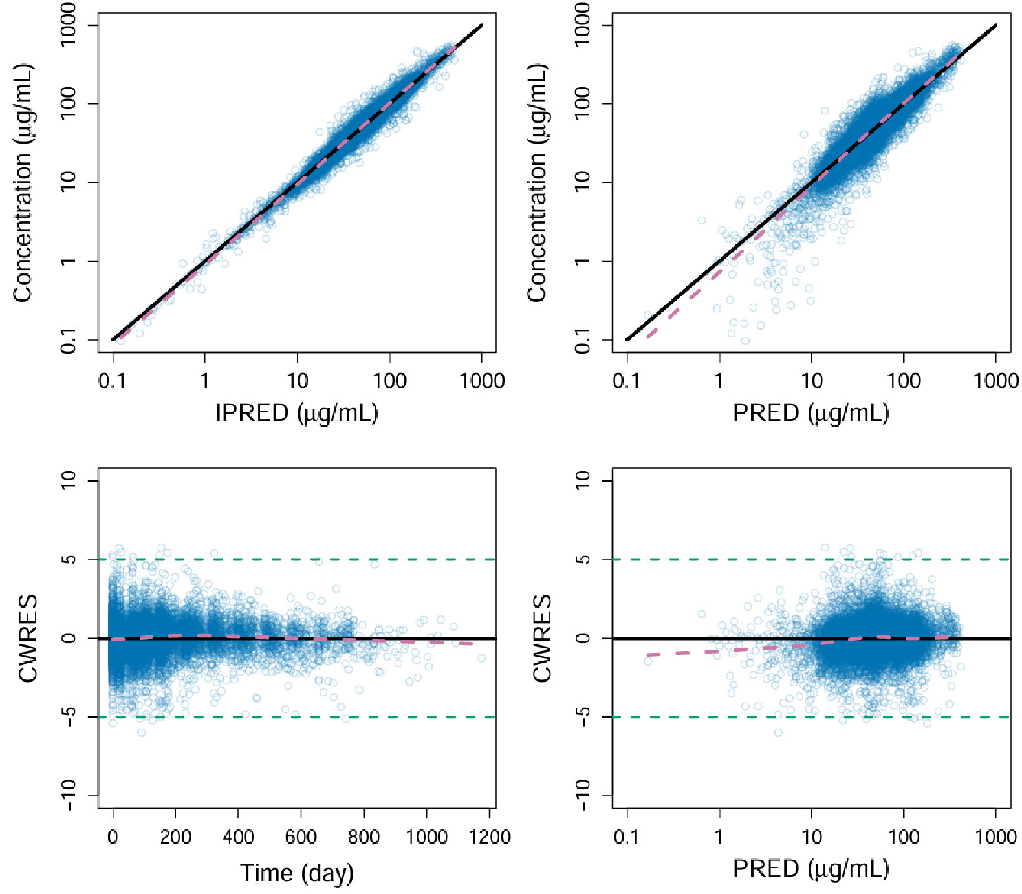
Observed concentrations versus population predictions and individual predictions are shown in the top panels. Conditional weighted residuals (CWRES) plotted against time and population predictions are shown in the bottom panels. The plots indicate good concordance between model predictions and observed data, with no apparent structural bias.

Figure S2. Prediction-corrected visual predictive check (pcVPC) for the overall population.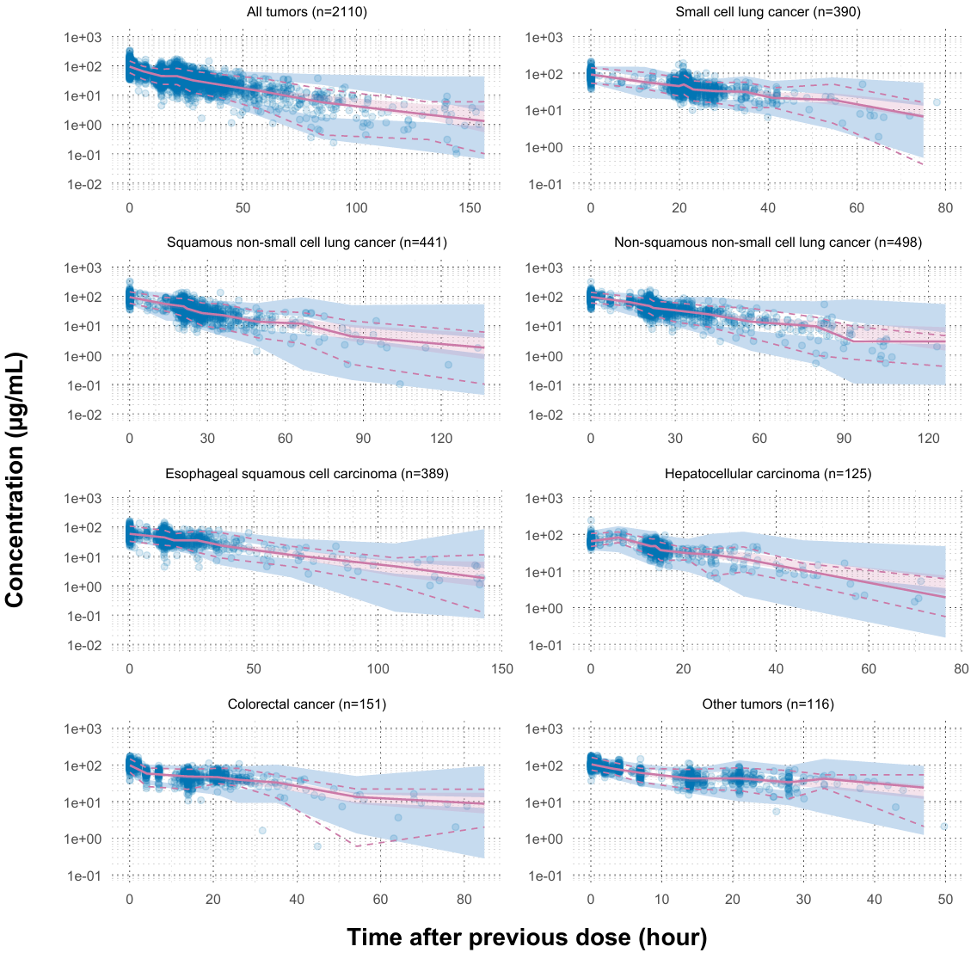
Observed 5th, 50th, and 95th percentiles of concentration–time data are overlaid with model-predicted median (solid line) and 95% prediction intervals (shaded areas). The agreement supports adequate predictive performance of the model across the pooled dataset.

Figure S3. Sensitivity analysis of the influence of significant covariates on first-dose exposure (Cavg1, Cmax1, and Cmin1).

The vertical black line represents the predicted exposure of a typical subject after the first dose. The pink shaded bars indicate the 5th–95th percentile range of population exposure. Each blue bar represents the effect of a covariate, with labels showing the 10th and 90th percentile exposure changes relative to the reference.

Figure S4. Comparison of steady-state exposure by baseline body-weight quartiles for flat-dose versus weight-based regimens.
Simulated steady-state average concentrations (C_{avg,ss}) were stratified by baseline body-weight quartiles (Q1–Q4). Comparisons are shown separately for the Q2W regimens (200 mg Q2W vs. 3 mg/kg Q2W) and the Q3W regimens (300 mg Q3W vs. 4.5 mg/kg Q3W). Within each dosing frequency, each subject was simulated under both dosing regimens; therefore, subjects contribute to both dosing groups within the same panel. One subject without baseline body-weight information was excluded, resulting in a total of 4,218 observations per dosing frequency (2,109 subjects × 2 regimens).

Figure S5
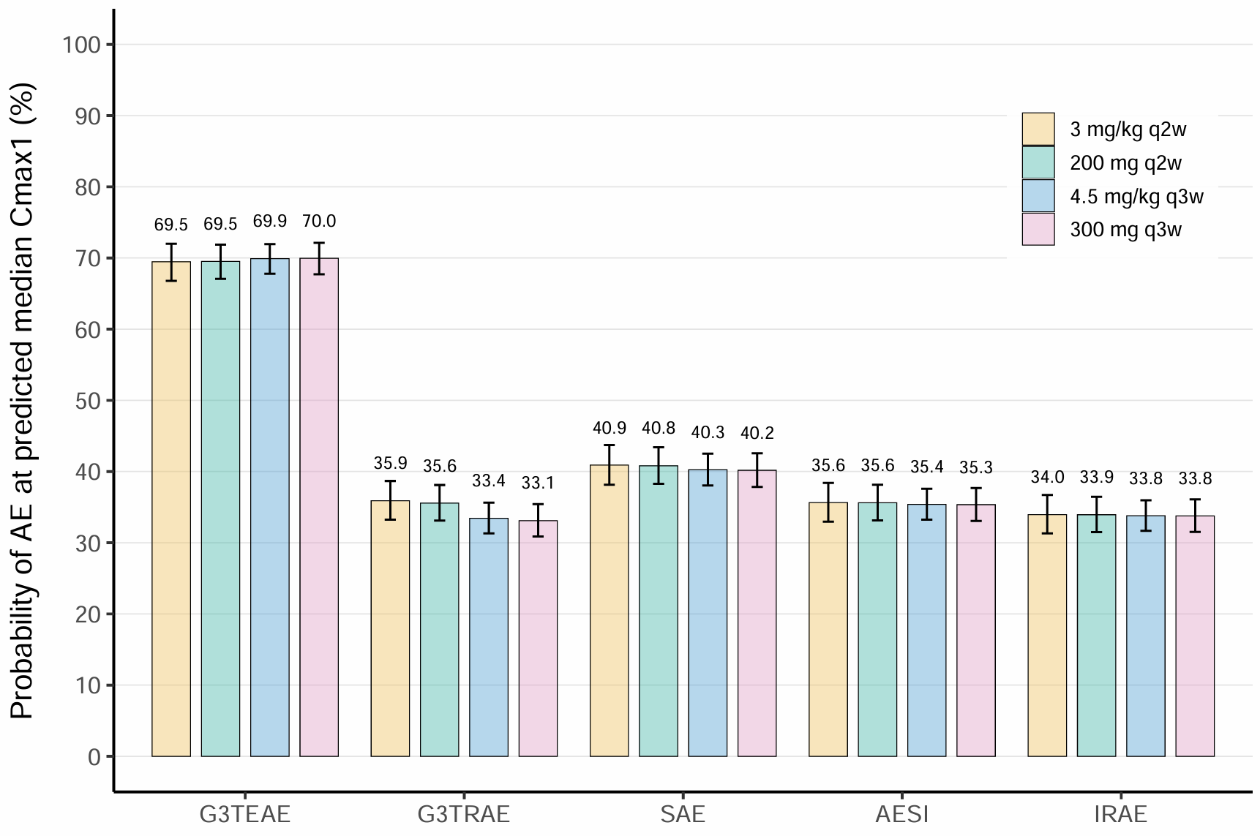
Predicted probability of G3TEAEs, G3TRAE, SAEs, AESIs, and irAEs derived from exposure–response logistic regression models using Cmax1 as the exposure metric. G3TEAE: grade ≥3 treatment-emergent AEs; G3TRAE: grade ≥3 treatment-related AEs; SAE: serious AEs; AESI: adverse events of special interest; IRAE: immune-related AEs.

