Supplementary information Figures

Figure S1 The representative portion of the dataset used in Part 1
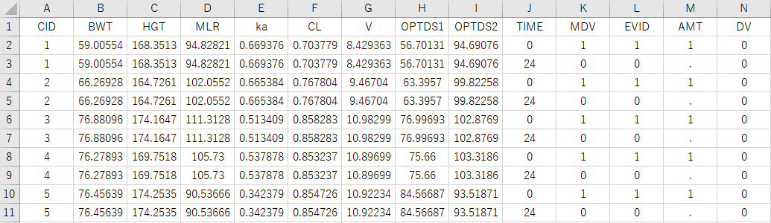

Figure S2 The representative portion of the dataset used in Part 2
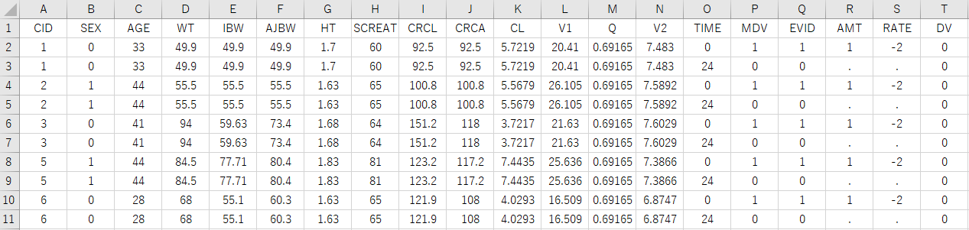

Figure S3 The representative portion of the dataset used in Part 3
A) 2-week-on, 1-week-off regimen B) Every-other-week regimen
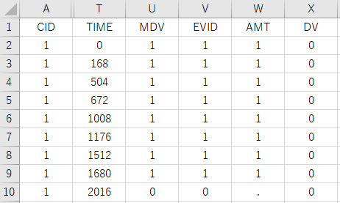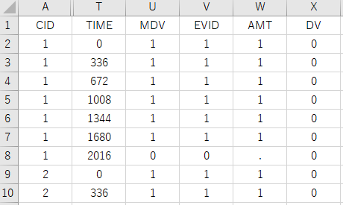

Figure S4 Box plots of percentage errors and the sum total of the penalty term value for each individual versus base-10 logarithms of penalty parameters (ρ) for Part 1

A) Scenario 1
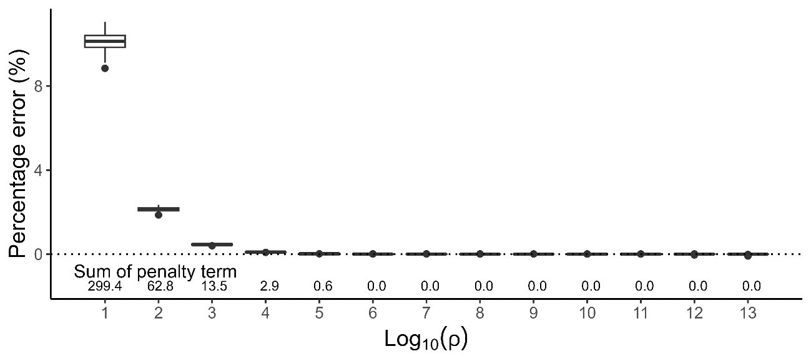

B) Scenario 2
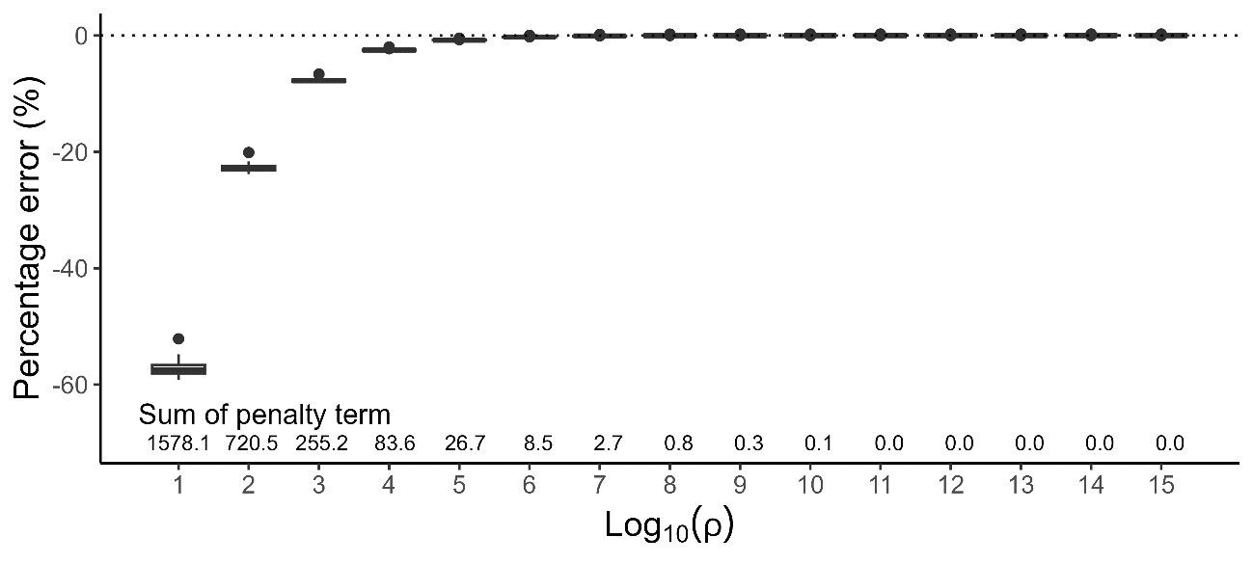

Figure S5 Scatter plots of estimated optimal doses versus theoretical optimal doses (top) and simulated concentrations when applying the estimated optimal doses for each individual (bottom) for Part 1. The solid line represents the identity line. The dotted line represents the targeted level of Cmax (A) and Ctrough at steady state (B)

A) Scenario 1 B) Scenario 2
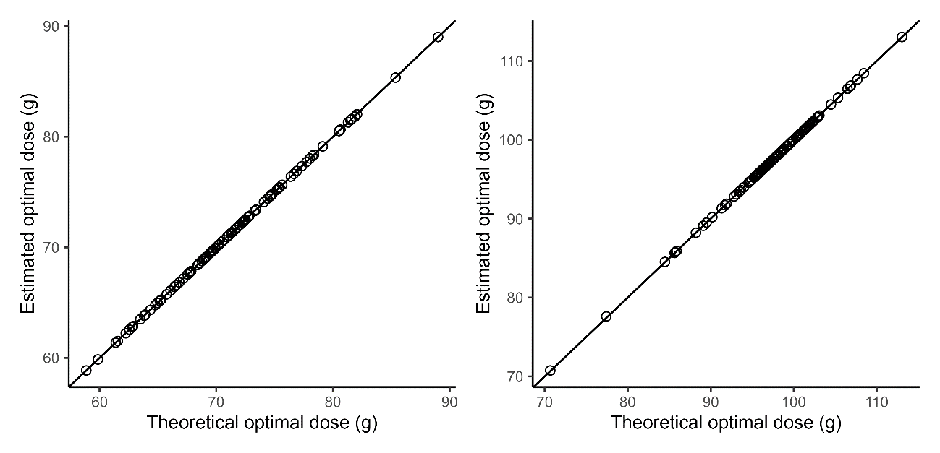
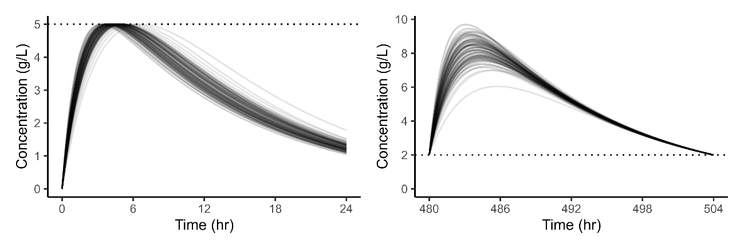

Figure S6 Box plots of percentage errors and the sum total of the penalty term value for each individual versus base-10 logarithms of penalty parameters (ρ) (top), scatter plot of estimated optimal doses versus theoretical optimal doses (bottom left), and simulated concentrations when applying the estimated optimal doses for each individual (bottom right) for Part 2.

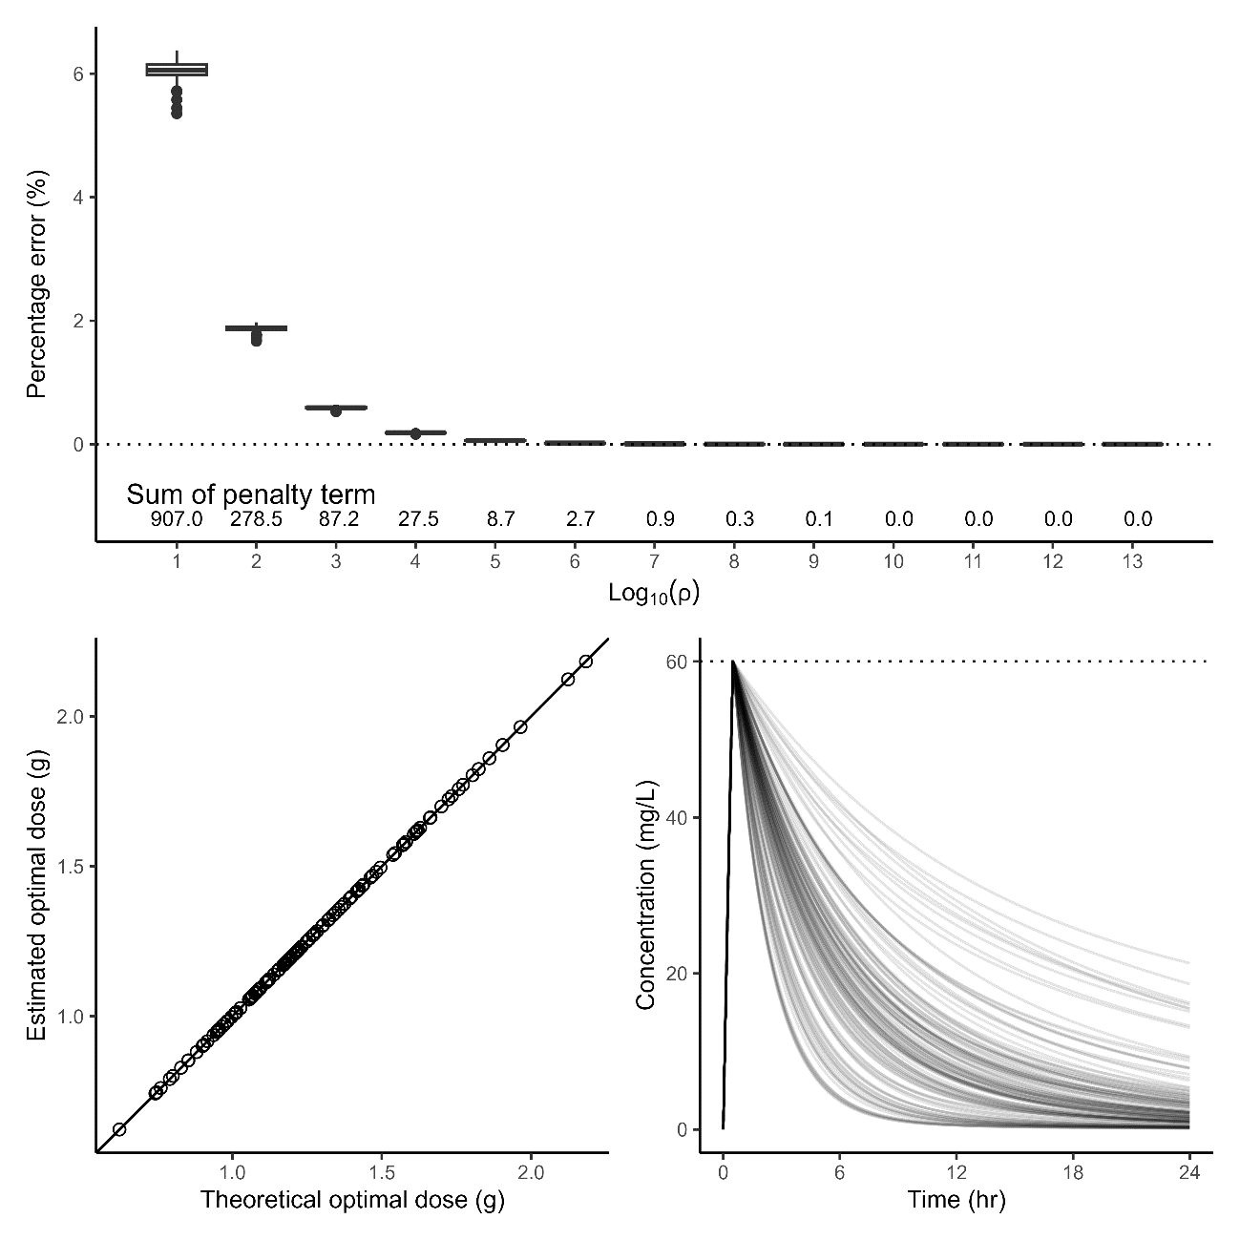

Figure S7 Simulated neutrophil profiles when applying the estimated optimal doses for each individual. The dotted line represents 500 /μL of the neutrophil count. (Part 3)

A) 2-week-on, 1-week-off regimen
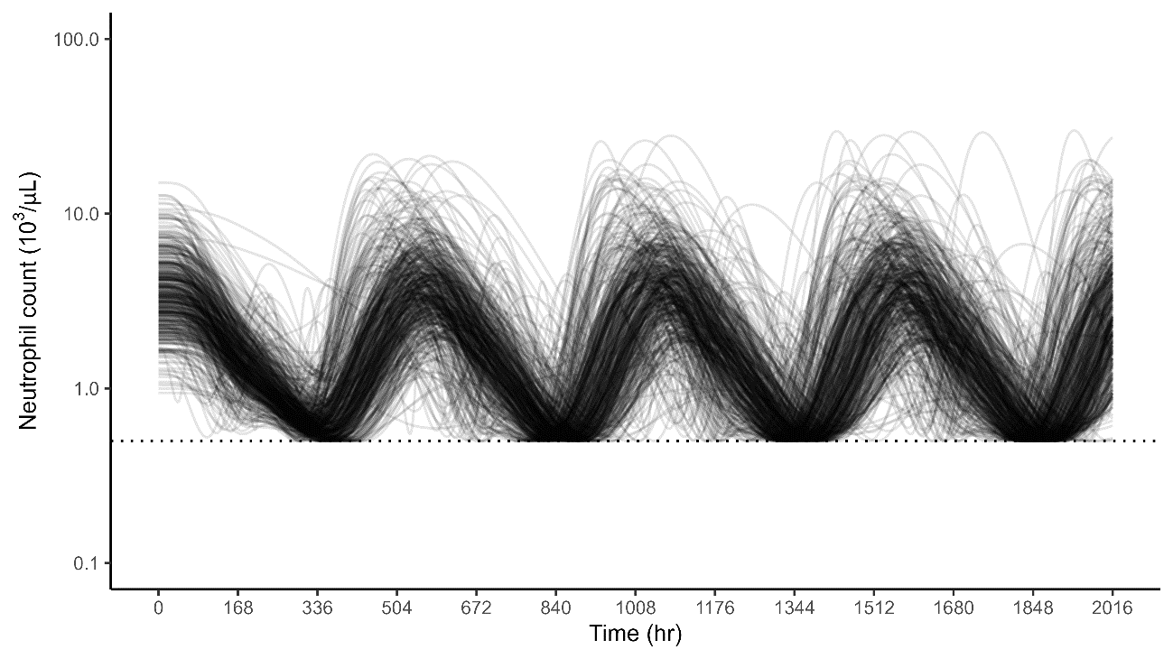

B) Every-other-week regimen
