Supplementary information S2
Parameter estimates (table) and the goodness-of-fit plots (figures) of the population PK model for amikacin (Part 2).

Parameter (units) | Estimate | RSE | Shrinkage
CL (L/hr) | 3.15 | 0.0740
V1 (L) | 19.3 | 0.0404
Q (L/hr) | 0.692 | 0.159
V2 (L) | 7.65 | 0.506
RUV prop | 0.170 | 0.0600
RUV add | 0.994 | 0.175
Omega-CL | 0.657 | 0.0861 | 0.112
Omega-V1 | 0.310 | 0.114 | 0.239
Omega-V2 | 0.807 | 0.754 | 0.770

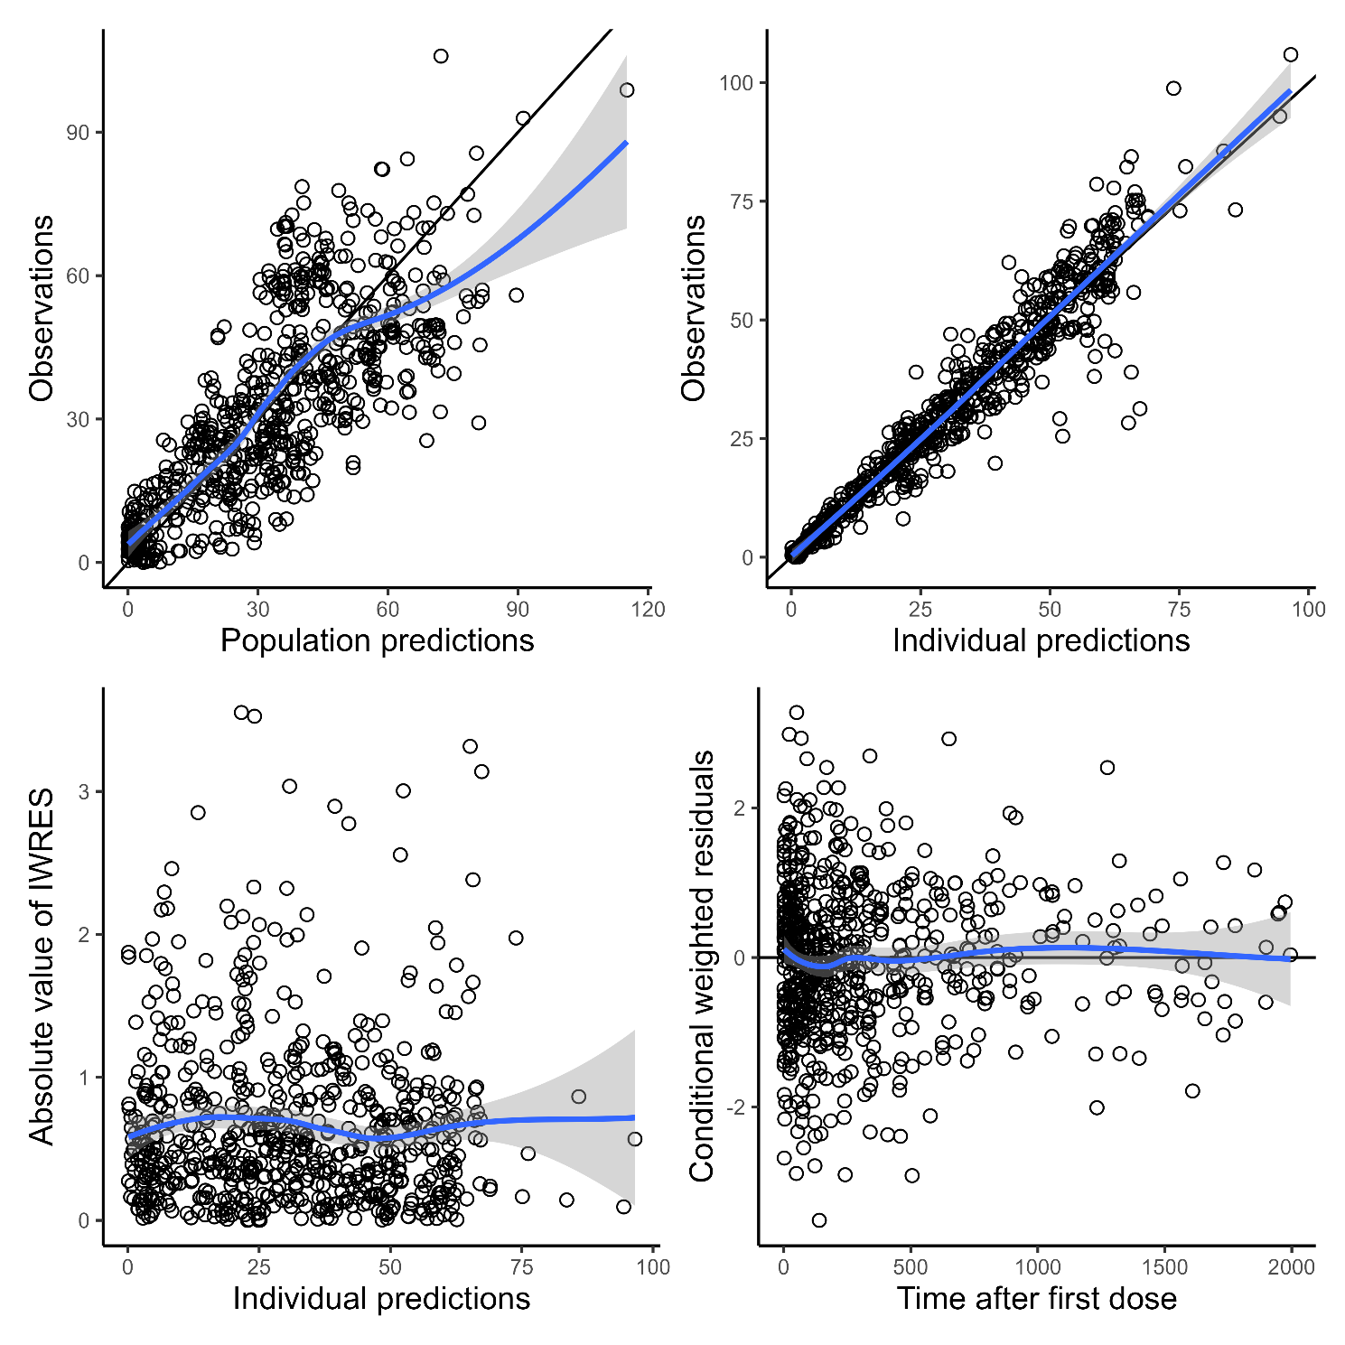
Abbreviations: RUV prop and add, SDs of proportional and additive error of combined intra-individual error model, respectively. Omega-CL, V1, and V2, SDs of inter-individual variability described by an exponential error model for CL, V1, and V2, respectively. IWRES, individual weighted residuals.

