Supplementary information S3
Parameter estimates (table) and the goodness-of-fit plots (figures) of the population PK/PD model for eribulin (Part 3).

Parameter (units) | Estimate | RSE | Shrinkage
Keo (/h) | 0.0203 | 0.110
Kprol (/h) | 0.0570 | 0.0596
Kout (/h) | 0.0257 | 0.0883
Gamma | 0.237 | 0.0364
Slope (L/μg) | 0.0443 | 0.0485
RUV prop | 0.360 | 0.0214
Omega-Keo | 0.856 | 0.145 | 0.422
Omega-Kprol | 0.374 | 0.127 | 0.278
Omega-Kout | 0.481 | 0.111 | 0.431
Omega-Gamma | 0.382 | 0.0558 | 0.223
Omega-Slope | 0.425 | 0.0646 | 0.253

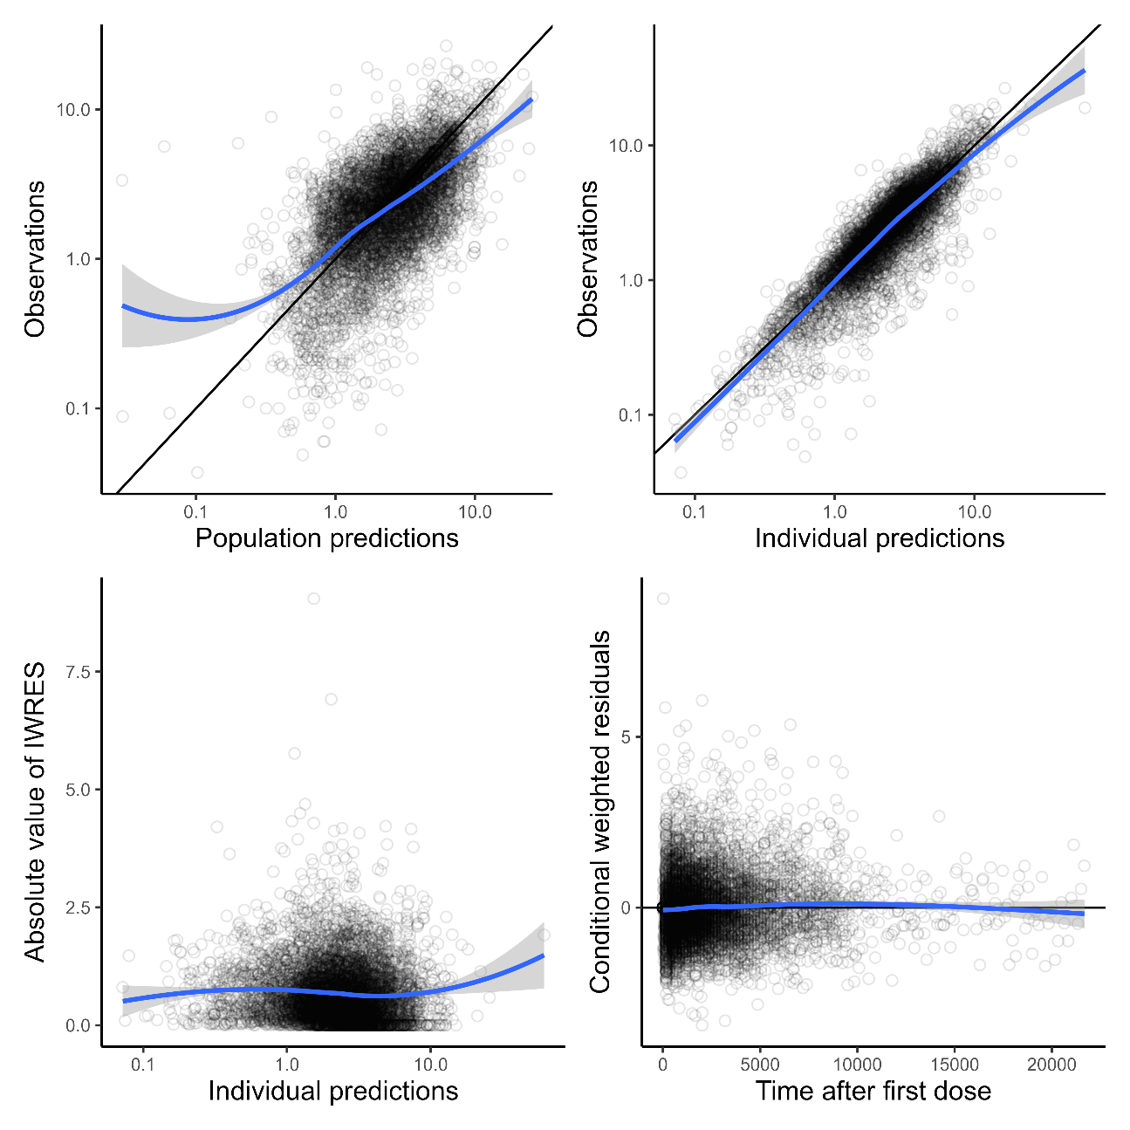
Abbreviations: Keo, equilibrium rate constant from the effect compartment. Kprol, neutrophil proliferation rate constant. Kout, neutrophil elimination rate constant. Gamma, feedback constant. Slope, linear coefficient of drug effect. RUV prop, SDs of proportional error of intra-individual error model. Omega-Keo, Kprol, Kout, Gamma, and Slope, SDs of inter-individual variability described by an exponential error model for Keo, Kprol, Kout, Gamma, and Slope, respectively. IWRES, individual weighted residuals.

