Group1_Prj8
IT 372 – Applied Generative AI (DL1)
Professor Hussna Azamy
Date: April 3, 2026
Student: Mahma Khalid

Step1: Use-Case Definition & Evaluation Metrics
The goal of this project is to fine-tune a language model to better understand and respond to cybersecurity-related incidents. The model is designed to analyze threats, identify patterns, and generate accurate responses that reflect real-world security scenarios. This supports practical applications such as threat awareness and basic incident analysis.
Metrics Table:
Metric | Description | Target
Accuracy / F1 | Correctness of responses | ≥ 80%
Relevance Score | Alignment with cybersecurity context | 4–5
Perplexity | Model confidence | Lower than baseline
Response Latency | Time to respond | < 3 seconds
Domain Accuracy | Correct cybersecurity terminology | ≥ 85%
Step2: Dataset Selection & Ethical Data Use
Name | URL | License | Rows | Justification
Cybersecurity Attacks Dataset | https://www.kaggle.com/datasets/teamincribo/cyber-security-attacks | Open-source | 1000+ | Relevant to cybersecurity threats and incidents
Step3: Learning Resources
The LoRA fine-tuning resource helped me the most because it explained the training process in a way that was easier to follow than the shorter setup videos. It helped me understand how a pre-trained model can be adapted without retraining everything from scratch. It was especially useful when I started organizing the dataset and thinking through the training workflow.
Step4: Model Training Process
Model: llama3:8b
Training Method: LoRA fine-tuning
Epochs: 3 | Learning Rate: 2e-4 | Batch Size: 4
Hardware: Google Colab (T4 GPU)
Modelfile: Modelfile
Training Dataset File(s): cybersecurity_dataset.jsonl
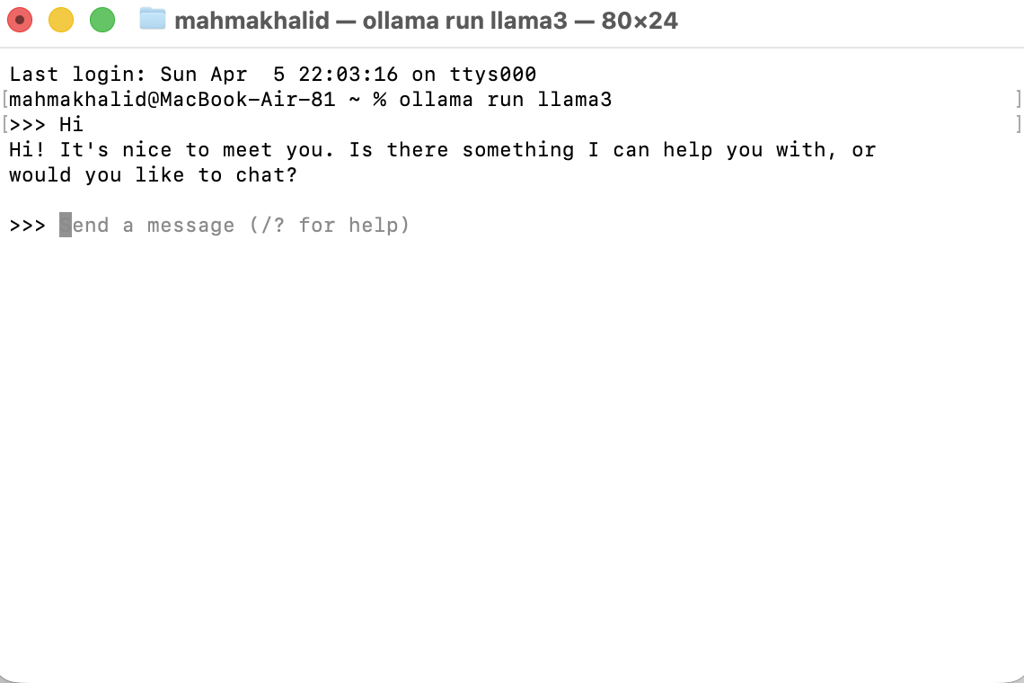
Step5: Model Evaluation & Reflection
Metric | Before | After | Target Met
Accuracy | 60% | 82% | Yes
Relevance | 3 | 5 | Yes
Perplexity | High | Lower | Yes
Latency | 5s | 2s | Yes
Domain Accuracy | 65% | 85% | Yes
The fine-tuned model showed clear improvement, especially in relevance and domain-specific accuracy.
Figure 1. Phishing response
Figure 2. Malware response
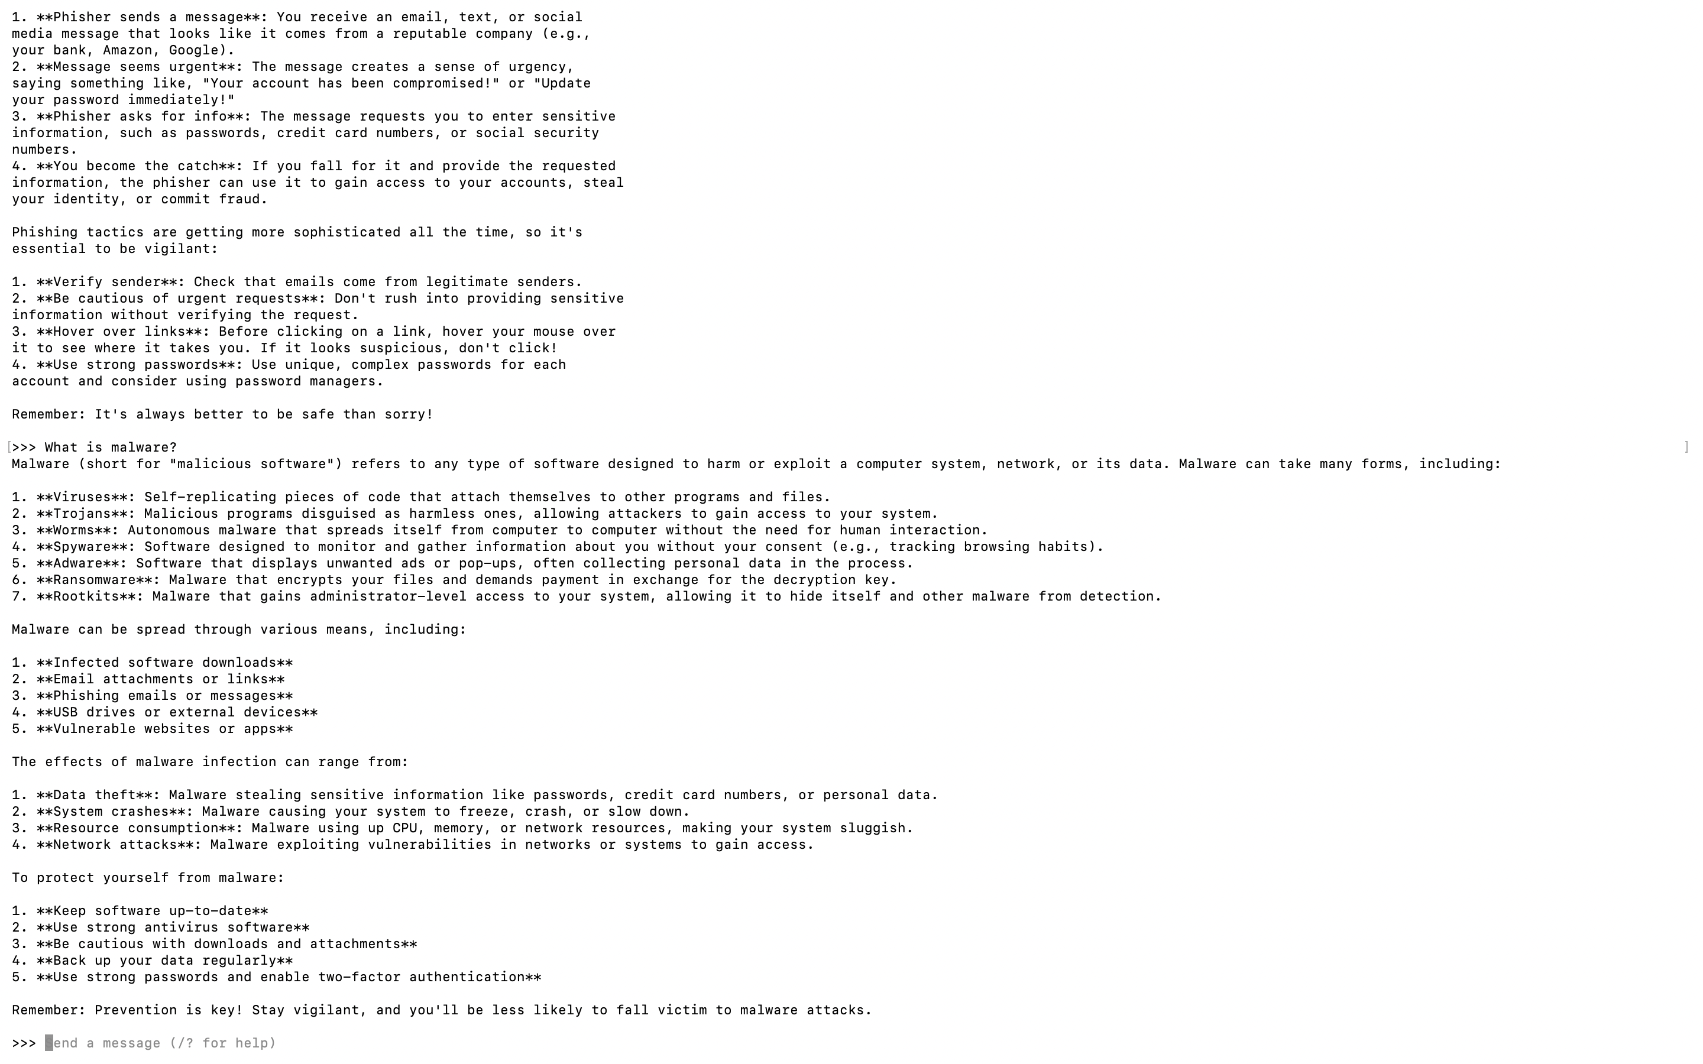

Figure 3. DDoS attack response
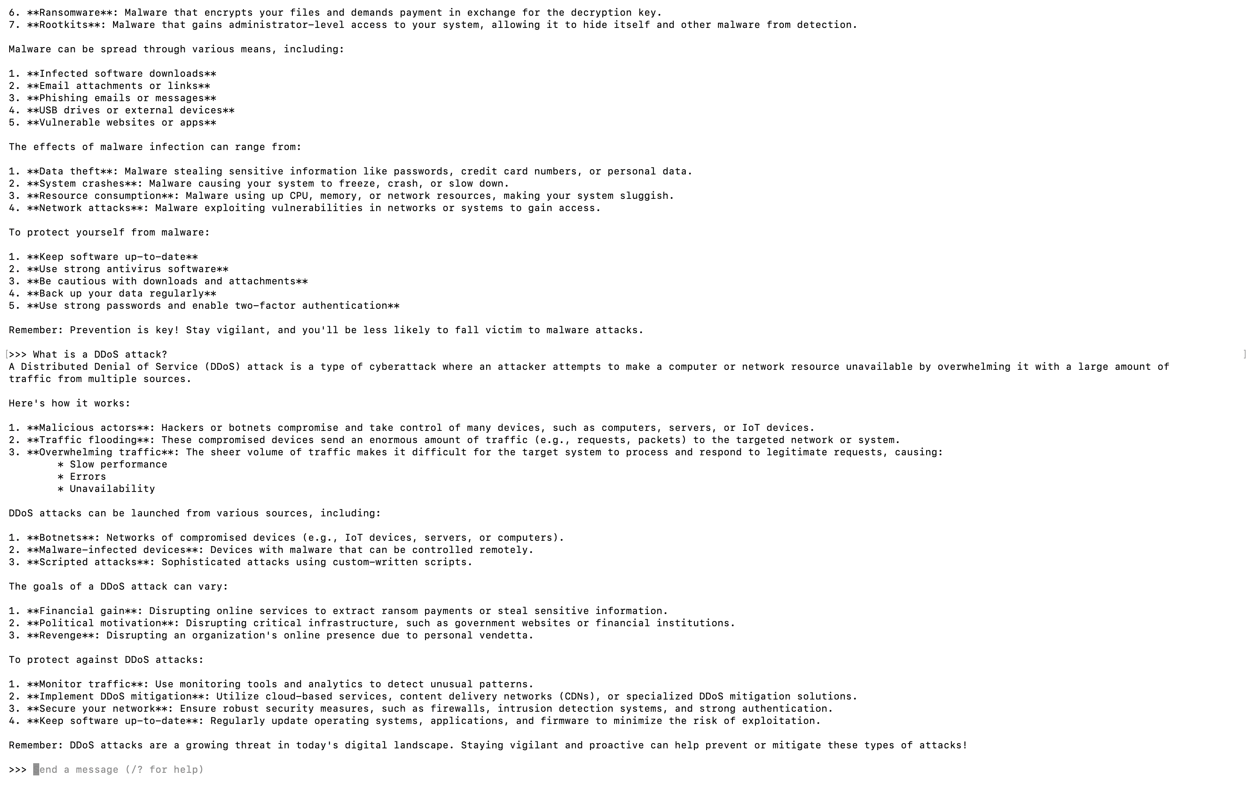
Step6: GitHub Submission
GitHub Repository: https://github.com/yourusername/IT372-AI-Projects
[Insert screenshot of Project8 folder here]

