Online Gaming Platform
  - Software Architecture Design & UML Class Model
Version 1.0 | Status: Proposed / pending review | Based exclusively on SRE specification, MoSCoW backlog, and acceptance criteria

1. Scope and source baseline
The logical model covers user accounts, game catalog and licensed integrations, gameplay and multiplayer, progress, subscriptions and payments, security, monitoring, incident response, deployment, backups, and capacity validation. The backlog contains 48 stories across 13 epics and 144 Given/When/Then criteria. The SRE baseline additionally lists FR-001–FR-015 and OBJ-01–OBJ-07. No cloud vendor, programming language, or framework is selected.

2. UML class diagram
Figure 1 provides a high-level class diagram. The accompanying StarUML (.mdj) and PlantUML (.puml) files contain the editable logical classes and relationships. Large diagrams are more readable when opened in an editor and zoomed.
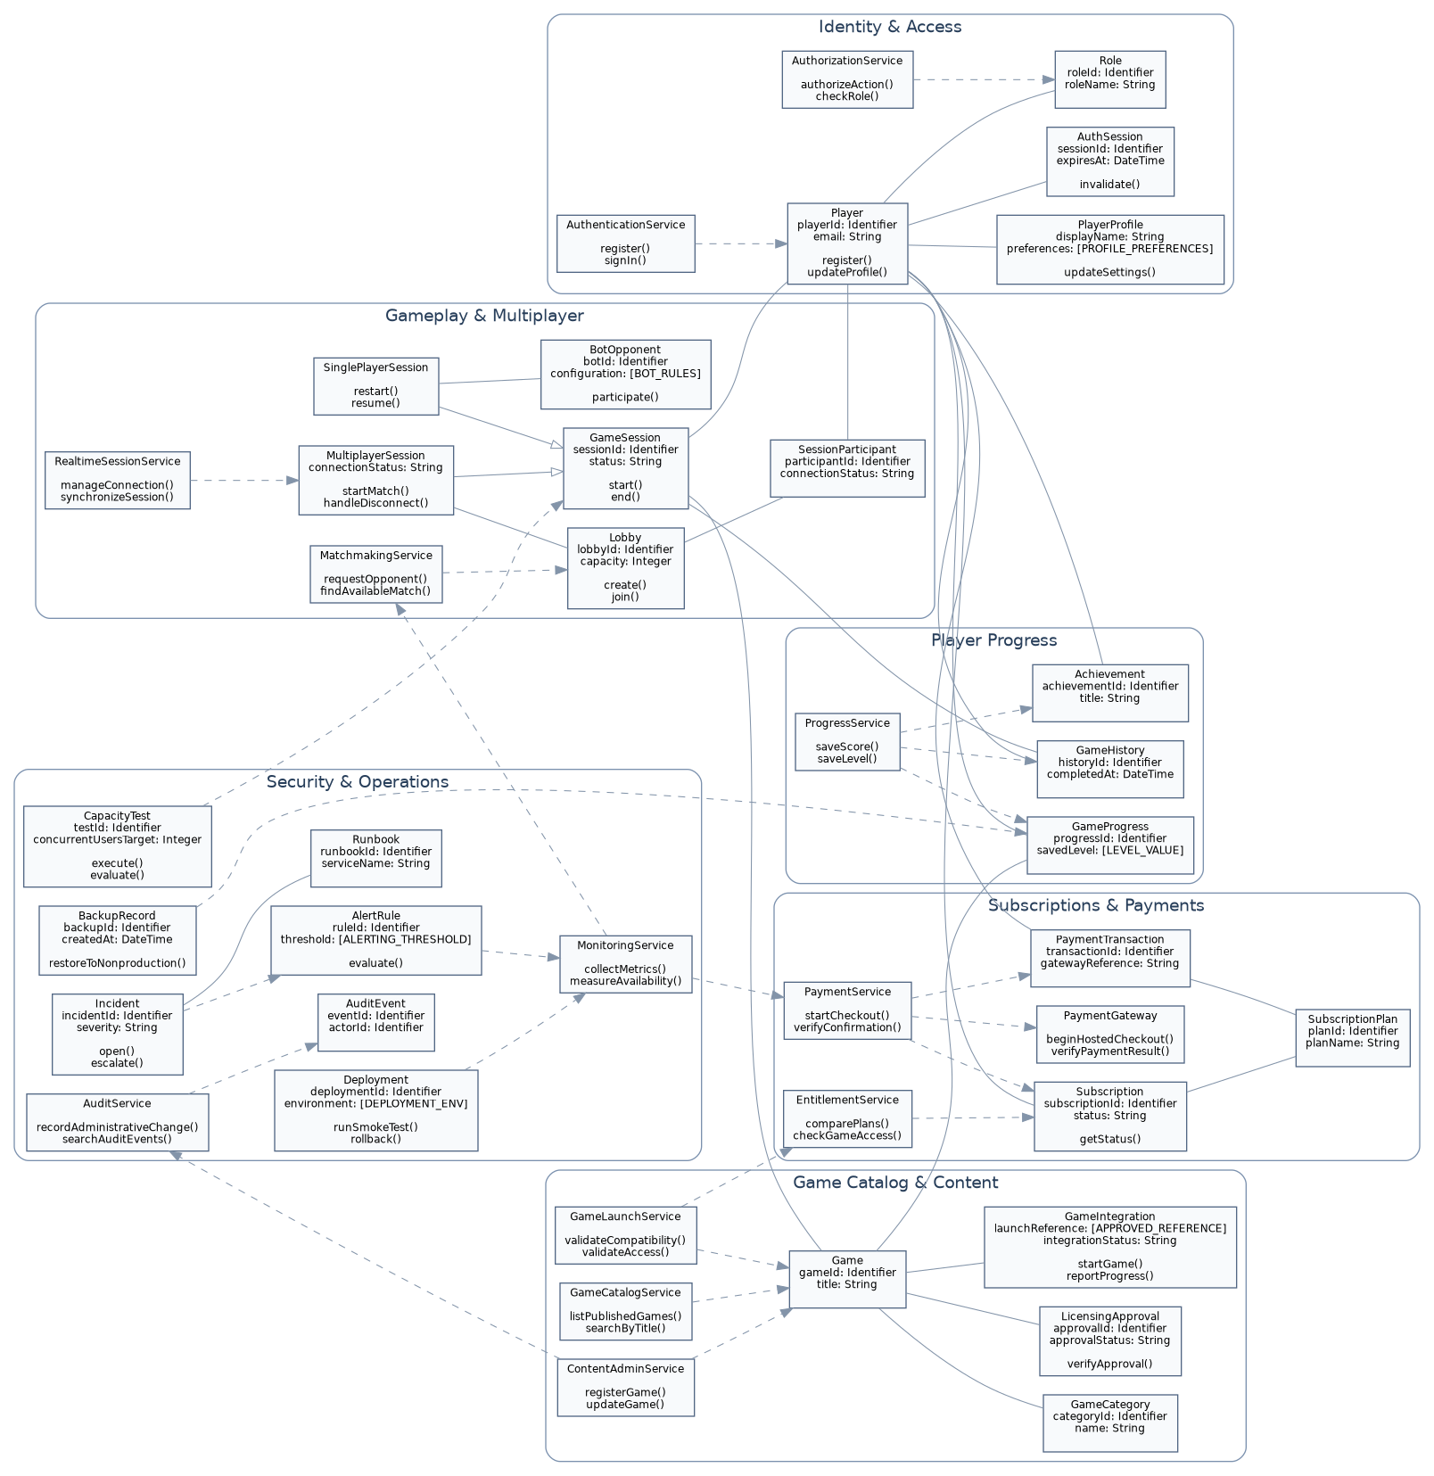
Figure 1. Platform logical class architecture (relationship arrows and class members are also supplied as editable source).

3. Diagram interpretation and relationship rationale

Identity and access
Player owns a PlayerProfile and has authenticated sessions and roles. AuthenticationService manages identity workflows, while AuthorizationService handles permissions and request controls.

Game catalog and content
Game and GameCategory describe discoverable content. LicensingApproval gates publication. GameCatalogService searches and filters; ContentAdminService manages listings; GameLaunchService validates access and compatibility.

Gameplay and multiplayer
GameSession is the common lifecycle abstraction, specialized as SinglePlayerSession and MultiplayerSession. Lobby and SessionParticipant represent grouped play; MatchmakingService locates opponents; RealtimeSessionService handles session connectivity; BotOpponent supports eligible solo games.

Player progress
ProgressService controls saving and retrieval of GameProgress, GameHistory and Achievement, related back to specific users, games and sessions.

Subscriptions and payments
SubscriptionPlan defines entitlements, Subscription records membership, and EntitlementService checks access. PaymentService verifies results through a provider-neutral PaymentGateway and records PaymentTransaction.

Security and operations
AuditService tracks administrative changes. MonitoringService and AlertRule define service signals and escalation triggers. Incident and Runbook guide recovery; Deployment, BackupRecord and CapacityTest represent release, recovery and scale validation.

UML semantics
Composition represents objects with tightly coupled lifecycles; inheritance separates session variants; associations represent domain links; dashed dependencies represent service usage. Method names indicate responsibilities, not implementation contracts.

4. Requirements traceability verification
Story and acceptance-criteria identifiers are grouped into contiguous ranges for review. Each interval is inclusive; this is a mapping to logical design elements, not a claim that unresolved acceptance boundaries have been approved.
Criteria | Design element(s) | Status
EP-01: stories EP01-01–EP01-04  AC-1.1–AC-4.3 | Player; PlayerProfile; AuthenticationService; AuthSession; AuthorizationService | Mapped
EP-02: stories EP02-01–EP02-04  AC-5.1–AC-8.3 | Game; GameCategory; GameCatalogService | Mapped
EP-03: stories EP03-01–EP03-04  AC-9.1–AC-12.3 | GameLaunchService; GameIntegration; LicensingApproval; ContentAdminService | Mapped
EP-04: stories EP04-01–EP04-03  AC-13.1–AC-15.3 | SinglePlayerSession; GameSession; BotOpponent | Mapped
EP-05: stories EP05-01–EP05-04  AC-16.1–AC-19.3 | MultiplayerSession; Lobby; SessionParticipant; RealtimeSessionService | Mapped
EP-06: stories EP06-01–EP06-03  AC-20.1–AC-22.3 | Lobby; MatchmakingService; SessionParticipant | Mapped
EP-07: stories EP07-01–EP07-04  AC-23.1–AC-26.3 | ProgressService; GameProgress; GameHistory; Achievement | Mapped
EP-08: stories EP08-01–EP08-04  AC-27.1–AC-30.3 | SubscriptionPlan; Subscription; EntitlementService | Mapped
EP-09: stories EP09-01–EP09-04  AC-31.1–AC-34.3 | PaymentService; PaymentGateway; PaymentTransaction; Subscription | Mapped
EP-10: stories EP10-01–EP10-03  AC-35.1–AC-37.3 | ContentAdminService; Game; LicensingApproval | Mapped
EP-11: stories EP11-01–EP11-03  AC-38.1–AC-40.3 | AuthorizationService; Role; AuditService; AuditEvent | Mapped
EP-12: stories EP12-01–EP12-04  AC-41.1–AC-44.3 | MonitoringService; AlertRule; Incident; Runbook | Mapped
EP-13: stories EP13-01–EP13-04  AC-45.1–AC-48.3 | Deployment; MonitoringService; CapacityTest; BackupRecord | Mapped
Operational SRE traceability
SRE criteria | Mapped design / remaining policy
FR-001–004 | Player, AuthenticationService, AuthorizationService, AuthSession
FR-005–008 | GameCatalogService, SinglePlayerSession, MultiplayerSession, BotOpponent
FR-009–010 | ProgressService, GameProgress, GameHistory
FR-011–015 | SubscriptionPlan, EntitlementService, PaymentService, PaymentTransaction
OBJ-01–05 | GameCatalogService, GameSession, Player, ProgressService, PaymentService
OBJ-06–07 | CapacityTest, MonitoringService, AlertRule
SLA / SLO / error budgets | MonitoringService, AlertRule; [SLO_POLICY] (partial)
Incident response / escalation | Incident, Runbook; [ESCALATION_POLICY] (partial)
Change management / deployment | Deployment; [CHANGE_POLICY] (partial)
Recovery / continuity | BackupRecord; [RECOVERY_POLICY] (partial)
Post-mortem / governance | Incident, AuditEvent; [POSTMORTEM_POLICY] (partial)

5. Known ambiguities and approval gates
- Email validity and password-length limits require boundary definitions [INCLUSIVE]/[EXCLUSIVE].
- Lobby capacity, reconnect eligibility, matchmaking timeouts, and bot behavior are not finalized.
- Payment provider, supported currencies, verification and dispute policies remain [APPROVED_PAYMENT_GATEWAY] and [PAYMENT_POLICY].
- Game rights, device compatibility, and progress ownership are subject to [LICENSING_RULES] and [GAME_INTEGRATION_CONTRACT].
- SLAs, SLOs, alert thresholds, error budgets, backup frequency, RTO/RPO and scaling headroom require approval.

6. Verification conclusion
All 48 backlog stories and 144 acceptance criteria map to at least one logical design element at the story-group level. The 15 SRE functional requirements and 7 objectives also map to the model. Operational policy coverage is partial until open values are approved. Individual criterion-level behavioral proof, including failure paths and exact thresholds, remains pending detailed design review.

Appendix A. PlantUML model source
The full editable PlantUML source is provided as a separate .puml file; the block below records the opening syntax and model inventory. The companion file is the authoritative textual UML representation.
Class inventory: Player, PlayerProfile, AuthenticationService, AuthSession, AuthorizationService, Role, Game, GameCategory, GameCatalogService, LicensingApproval, ContentAdminService, GameLaunchService, GameIntegration, GameSession, SinglePlayerSession, MultiplayerSession, Lobby, SessionParticipant, MatchmakingService, BotOpponent, RealtimeSessionService, ProgressService, GameProgress, GameHistory, Achievement, SubscriptionPlan, Subscription, EntitlementService, PaymentService, PaymentTransaction, PaymentGateway, AuditEvent, AuditService, MonitoringService, AlertRule, Incident, Runbook, Deployment, BackupRecord, CapacityTest.

Appendix B. Editable StarUML project
The companion .mdj file stores classes, attributes, operations and associations/dependencies as StarUML model elements. Visual layout/relationship-view compatibility may require arrangement in the installed StarUML release; inspect in StarUML before using it for audit sign-off.

