Md.Farha Fathima

Week-2 coding Assessment

1. Write a query to display account number, customer’s number, customer’s firstname, lastname, account opening date. Display the records sorted in ascending order based on account number.

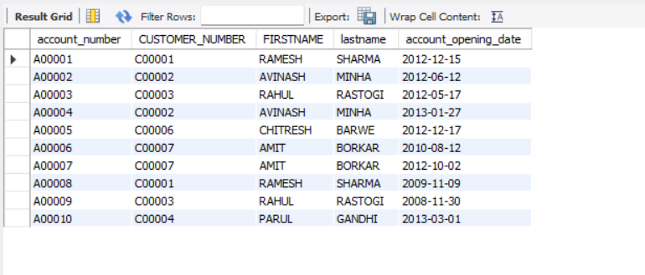

1. Write a query to display the number of customer’s from Delhi. Give the count an alias name of Cust_Count.

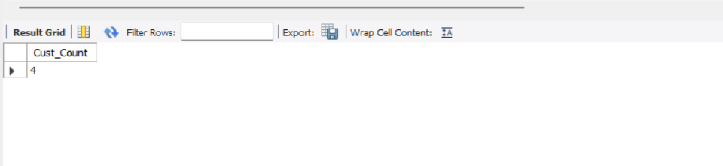

1. Write a query to display the customer number, customer firstname, account number for the customer’s whose accounts were created after 15th of any month. Display the records sorted in ascending order based on customer number and then by account number.

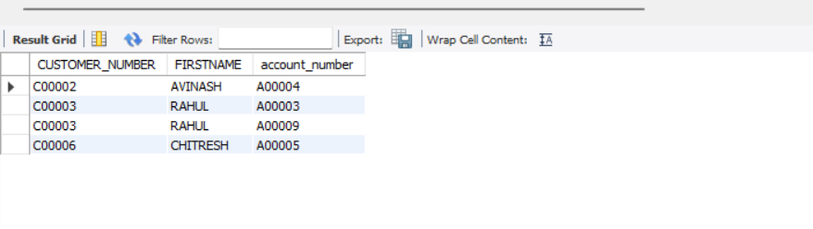

1. Write a query to display the number of customers who have registration but no account in the bank. Give the alias name as Count_Customer for number of customers.

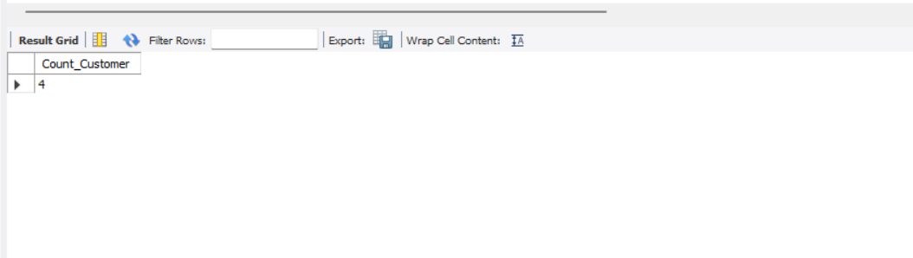

1. Write a query to display the total number of withdrawals and total number of deposits being done by customer whose customer number ends with 001. The query should display transaction type and the number of transactions. Give an alias name as Trans_Count for number of transactions. Display the records sorted in ascending order based on transaction type.

