Cairo University  
Faculty of Computers and Artificial Intelligent

**CS251**

**Software Engineering I**

Project Name

Software Design

Team Names

Month & Year

Contents

Instructions [To be removed] 3

Team 3

Document Purpose and Audience 3

System Models 3

I. Class diagrams 3

Important Algorithm 4

II. Sequence diagrams 5

Class - Sequence Usage Table 6

Ownership Report 6

Policy Regarding Plagiarism: 7

# Instructions [To be removed]

# Team

|  |  |  |  |
| --- | --- | --- | --- |
| **ID** | **Name** | **Email** | **Mobile** |
|  | 1st name is team leader |  |  |
|  |  |  |  |
|  |  |  |  |

# Document Purpose and Audience

# System Models

## I. Class diagrams

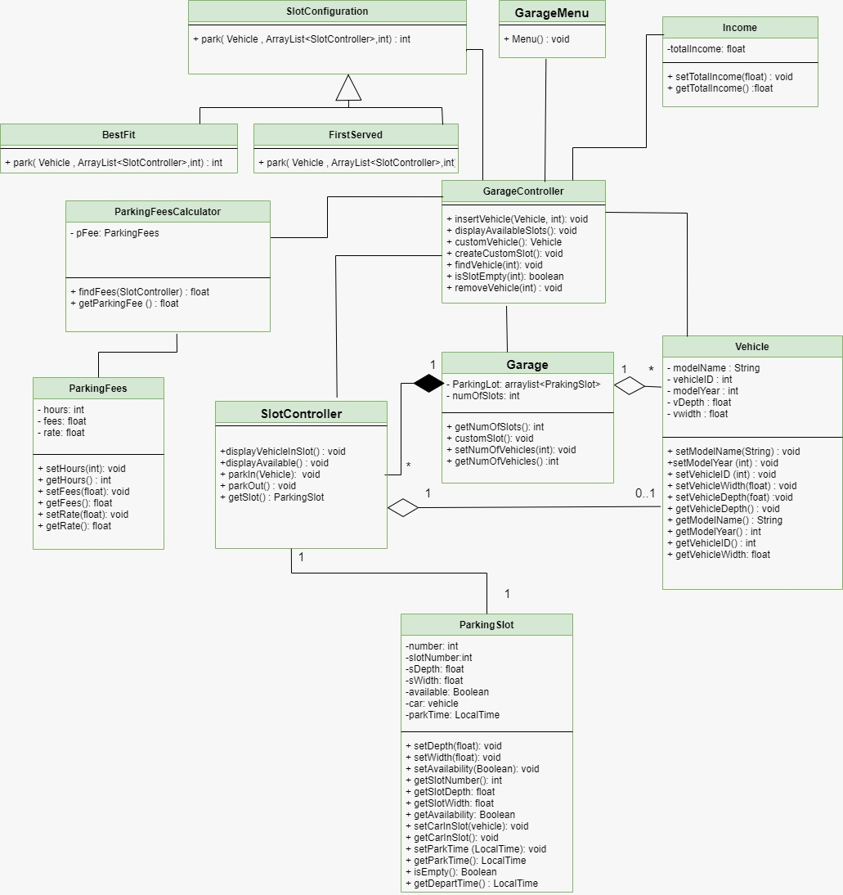

| **Class ID** | **Class Name** | **Description & Responsibility** |
| --- | --- | --- |
| 1 | Garage | Manage parking slots and number of vehicles |
| 2 | Parking slot | Hold all details about slot and time |
| 3 | Garage controller  **(controller)** | Manage vehicles (add,remove,find)  Show available slot  Create customer |
| 4 | Slot controller | Display all vehicle info , slot  Check the function park in or park out |
| 5 | Vehicle | Save all vehicle information |
| 6 | Parking fees calculator | Get parking fees |
| 7 | Parking fees | Get parking time and hour rate |
| 8 | GarageMenu  **(Boundary)** | User interface function |
| 9 | Income | Calculate total income |
| 10 | Slot configuration | To choose the type of park function |
| 11 | First served | Park with first serve way |
| 12 | Best fit | Park with best fit way |

## II. Sequence diagrams

**Sequence Id #1**

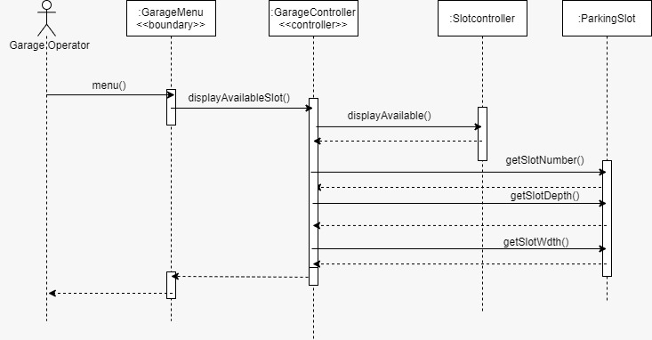

### 

**Sequence Id #2**

### 

**Sequence Id #3**

### 

**Sequence Id #4**

### 

**Sequence Id #5**

### 

**Sequence Id #6**

### 

**Sequence Id #7**

### 

**Sequence Id #8**

### 

### Class - Sequence Usage Table

| **Class Name** | **Sequence Diagrams** | **Overall used methods** |
| --- | --- | --- |
| Garage menu | 1,2,3,4,5,6,7,8 | Show menu |
| Garage controller | 1,2,3,4,5,6,7,8 | Check slots  Print income  Create customer slot  Add vehicle  Get garage info  Remove vehicle |
| Slot controller | 1,2,8 | Display available |
| Parking slot | 1,5,6,8 | Get slot info  Set slot info  Get availability |
| Garage | 3,5,6,8 | Get number of vehicles  Add slot  Set number of slots  Set number of vehicle |
| Income | 4,8 | Set total income  Get total income |
| First served | 6,7 | Choose funcionality |
| Best Fit | 6,7 | Choose funcionality |
| Parking fees calculator | 8 | Get parking fees |

# Ownership Report

|  |  |
| --- | --- |
| **Item** | **Owners** |
|  |  |
|  |  |