Cairo University  
Faculty of Computers and Artificial Intelligent

**CS251 - Software Engineering I**

Project Name

Software Requirements Specifications (SRS)

Team Names

Month & Year

Contents

Instructions [To be removed] 3

Team 3

Document Purpose and Audience 3

Introduction 3

Software Purpose 3

Software Scope 3

Definitions, acronyms, and abbreviations 3

Requirements 4

Functional Requirements 4

Non Functional Requirements 4

System Models 4

Use Case Model 4

Use Case Tables 5

Ownership Report 6

Policy Regarding Plagiarism: 6

# 

# Team

|  |  |  |  |
| --- | --- | --- | --- |
| **ID** | **Name** | **Email** | **Mobile** |
| 20200490 | Mahmoud Ahmed Abdo | Mahmoud123.ma878@gmail.com | 01096694106 |
| 20200469 | Mohamed magdy hassan | mohamedmagdyy01@hotmail.com | 01555872717 |
| 20200301 | Abdallah ahmed shouker | abdallahshouker0@gmail.com | 01158399097 |
| 20200687 | Ibrahim rashid Ibrahim | ibrahimrrashid@gmail.com | 01096562496 |

# Document Purpose and Audience

**The purpose of this documentation is to illustrate the requirements and specifications of the system that will manage the parking lot.**

**Potential audience could include project manager or software developers.**

# Introduction

**This document illustrates all specifications of the software in functionalities and constraints.**

## Software Purpose

**Facilitate the management of a parking lot using software engineering program to help carry out everyday tasks and validations more easily.**

## Software Scope

**The team should design a program that includes the following functionalities:**

1. **Park-In function for when a vehicle has a suitable slot to park that also saves the time of arrival.**
2. **Access to vehicle data.**
3. **Park-Out function for when a vehicle is leaving which saves the time of departure and the total parking fee.**
4. **Display available vacant parking slots.**
5. **Display how many vehicles are parked in certain time.**
6. **Calculate and display income.**

## Definitions, acronyms, and abbreviations

* **In a table, list all needed ones. Consider the audience**
* **Think as following: Document has abbreviation ATM..IFF audience doesn’t know it, let’s clarify it.**

# Requirements

## Functional Requirements

**System should be able to:**

* **Save vehicle specifications (model name, unique identification number, model year and dimensions).**
* **Save arrival and departure time (if a suitable parking slot is available).**
* **Choose a suitable slot based on first come first serve policy and minimum slot dimensions that can suffice vehicle.**
* **Calculate and display parking fees on vehicle departure.**
* **Find and display total income.**
* **Find and display number of parked vehicle at a time.**
* **Display in an orderly fashion available parking slots.**

## Non Functional Requirements

* **Registration.**
* **License.**
* **Accessibility.**
* **Performance.**
* **Scalability.**

|  |  |
| --- | --- |
|  | **Details** |
| **Performance** | * **Program shouldn’t take longer than 5 seconds to output (excluding input time)** |
| **Scalability** | * **Max number of vehicle slots shouldn’t be fixed** |
| **Registration** | * **Vehicle must have valid and unexpired registration** |
| **Accessibility** | * **Handicap parking slots should be reserved for disabled customers** |
| **License** | * **Customers must have valid and unexpired driver’s license** |

# 

# System Models

## Use Case Model

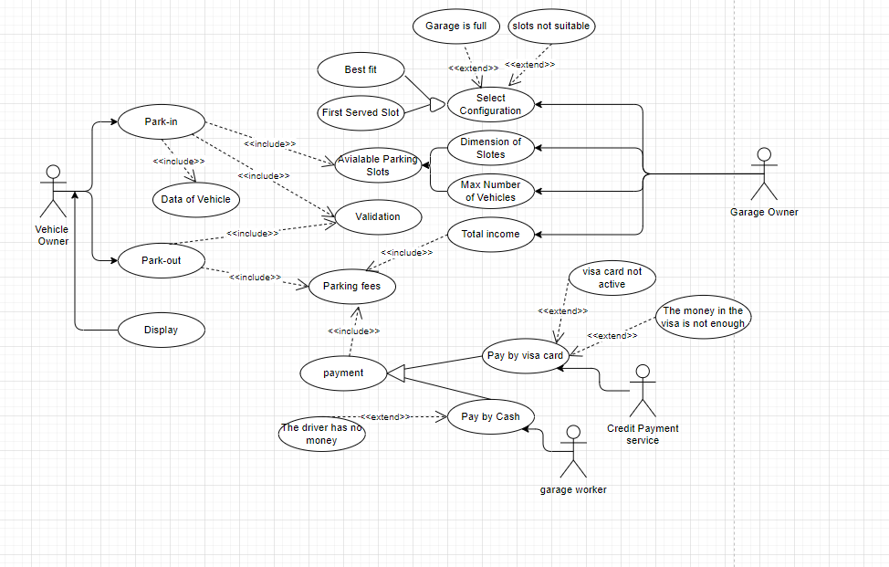

## 

## Use Case Tables

|  |  |  |
| --- | --- | --- |
| Use Case ID: | #01 | |
| Use Case Name: | Enter The Data of Vehicle. | |
| Actors: | Driver. | |
| Pre-conditions: | The driver add model name of vehicle, identification number, model year and dimensions (width, depth). | |
| Post-conditions: | The data of vehicle is saved and  Time start to calculate the time will take by vehicle. | |
| Flow of events: | **Driver Action** | **System Action** |
| 1-driver send request to start input the data of vehicle. |  |
|  | 2-the system respond by massage to enter the data. |
| 3-driver start to enter the data. |  |
|  | 4-the system check if all input is valid send massage “succeeded” |
| 5-display the massage. |  |
|  | 6-save data. |
| Exceptions: | **Driver Action** | **System Action** |
| 1- driver enter the date of vehicle in the future |  |
|  | 2-system send massage ”error enter valid model year” |
| 3-driver enter not unique identification number |  |
|  | 4-system send massage ”error enter valid identification number” |
| 5-driver enter illogical dimensions |  |
|  | 6-system send massage ”error enter valid dimensions” |
| Special Requirement: | 1-driver should be acknowledged No more than five seconds.  2-The system easy to use. | |

|  |  |  |
| --- | --- | --- |
| Use Case ID: | #02 | |
| Use Case Name: | Select Configuration | |
| Actors: | Garage Owner | |
| Pre-conditions: | Garage Owner choose between two configurations. | |
| Post-conditions: | Choosing the right slot for the garage owner | |
| Flow of events: | **Garage Owner Action** | **System Action** |
| 1-Garage owner send request to start select configuration. |  |
|  | 2-the system send two configuration to choose from him.(best fit or first served slot) |
| 3-garage owner select the best method for you. |  |
|  | 4-the system Execution method and send massage “successes”. |
| 5-diplay the massage |  |
| Exceptions: | **Garage Owner Action** | **System Action** |
| 1-send unsuitable configuration |  |
|  | 2-system send a warning message |
| Special | The system is explained option in an easy way | |

|  |  |  |
| --- | --- | --- |
| Use Case ID: | #03 | |
| Use Case Name: | Park-out with parking fees | |
| Actors: | Driver | |
| Pre-conditions: | The driver will go to pay the parking fees | |
| Post-conditions: | The driver get out of the garage. | |
| Flow of events: | **Driver** **Action** | **System Action** |
| 1-driver want to get out from garage. |  |
|  | 2-the system register time of park-out then calculate the parking fees |
|  | 3-display the time taken by parking and The cost of parking in the garage |
| 4-the driver will pay by visa card or cash. |  |
|  | 5-the system The money has been paid and send massage “successes”. |
| 6-the driver get out from the garage. |  |
| Exceptions: | **Driver Action** | **System Action** |
| 1-driver pay by cash but he hasn’t enough money. |  |
|  | 2-the system announces the failure and he can pay another way. |
| 3-The driver pay by visa card but amount over limit or visa card not active. |  |
|  | 4-the system announces the failure and send the warning massage “can’t get out without pay parking fees. |

|  |  |  |
| --- | --- | --- |
| Use Case ID: | #04 | |
| Use Case Name: | Total income | |
| Actors: | Garage owner | |
| Pre-conditions: | Garage owner request a total number of vehicle and total income | |
| Post-conditions: | The system calculate and display the total number of vehicle and total income | |
| Flow of events: | **Garage Owner Action** | **System Action** |
| 1-garage owner request a total income and number of vehicle. |  |
|  | 2-system request to enter any point of time. |
| 3-garage owner Input the time he need to calculate his needs from number of vehicle that used the parking garage in this time and total cost. |  |
|  | 4-system calculate the total income related to number of vehicle which the parking fees an hourly rate of 5 EGP. |
| 5-display the total income in this time and total number of vehicle parking in garage. |  |
| Exceptions: | **Garage Owner Action** | **System Action** |
| No exceptions |  |
| Special Requirement: | The total income does not have more than two fractions | |

# Ownership Report

|  |  |
| --- | --- |
| **Item** | **Owners** |
| Requirements | *Mohamed* |
| Use case | *Mahmoud* |