Cairo University Faculty of Computers and Artificial Intelligence



**Software design specification document**

**2022**

Contents

Instructions[To be removed] 2

Class diagram design 2

Class diagram Explanation 3

Sequence diagram design 3

Github repository link 4

# Class diagram design

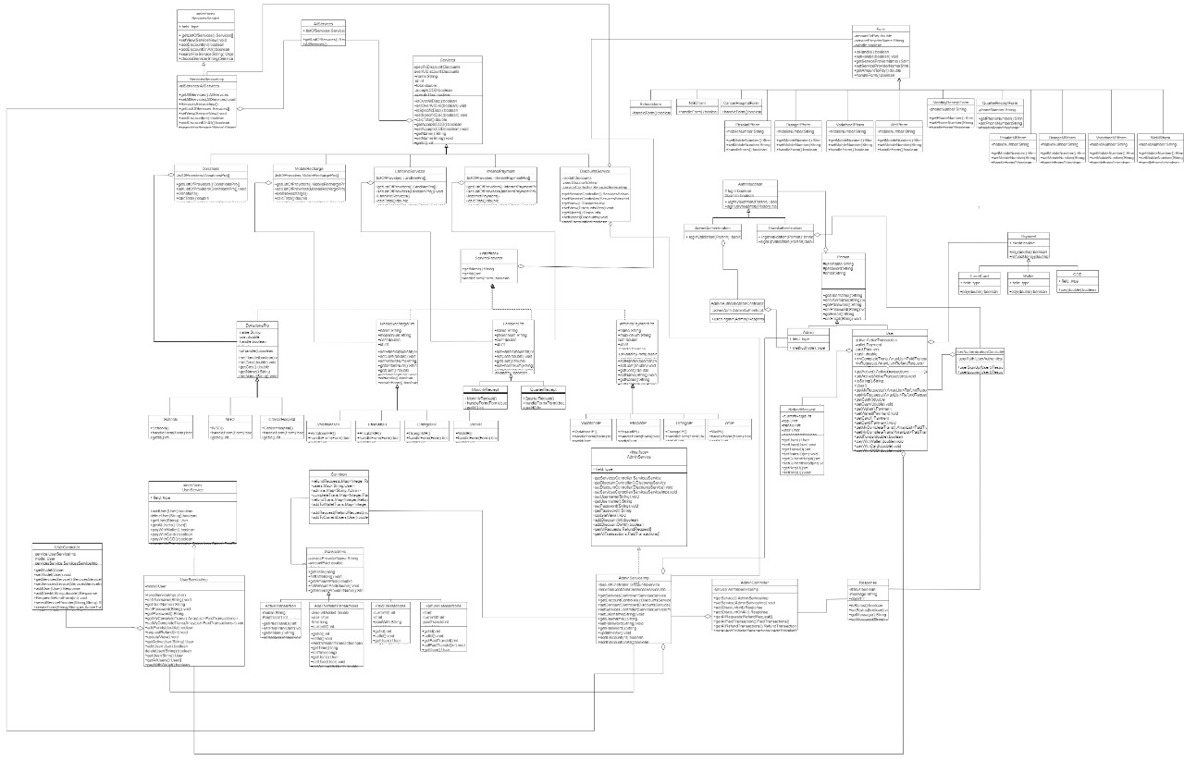

# 

# Class diagram Explanation

1) MVC Design Pattern

# Sequence diagram design

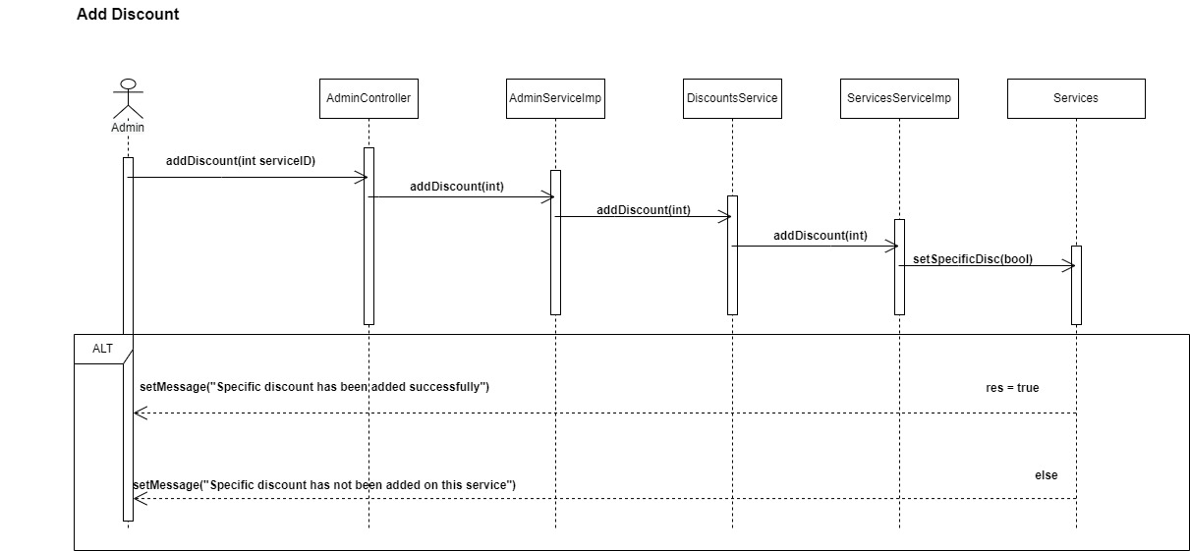

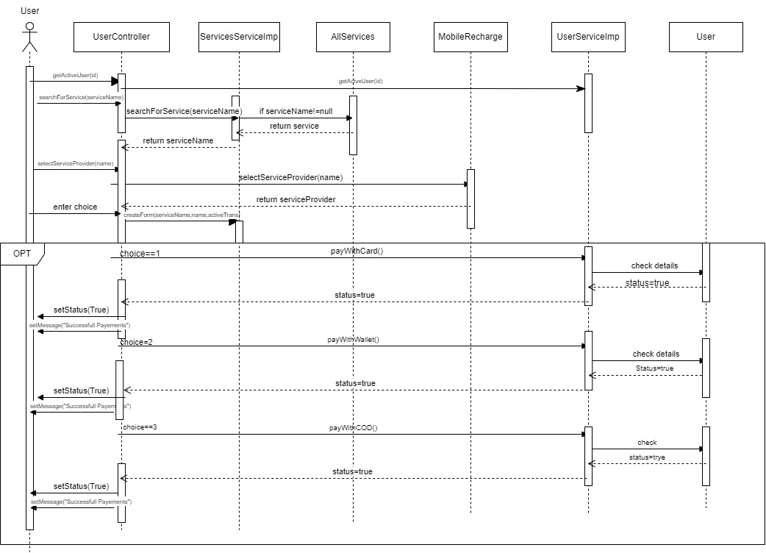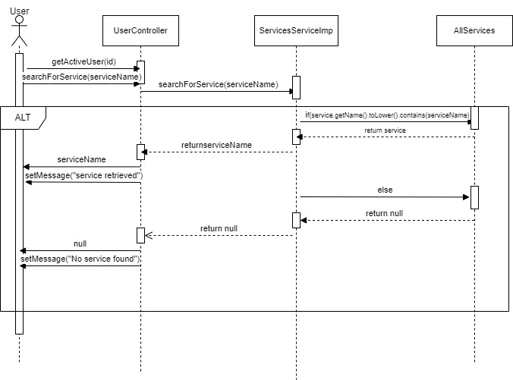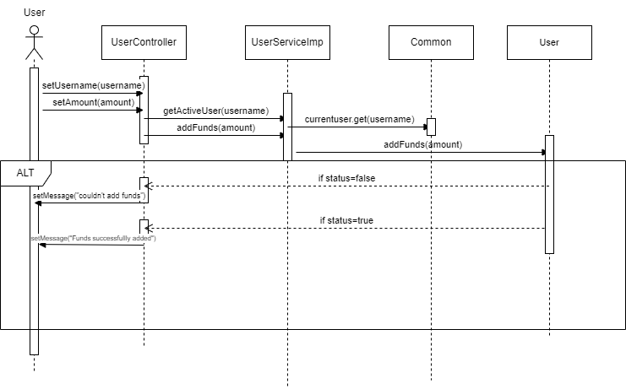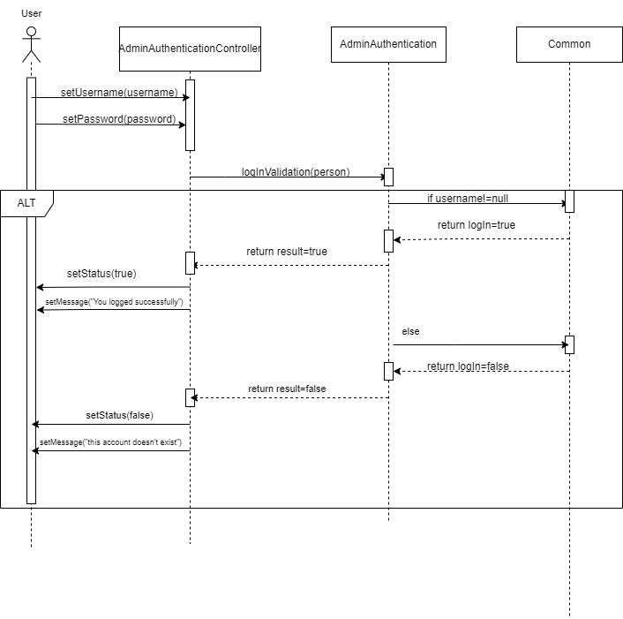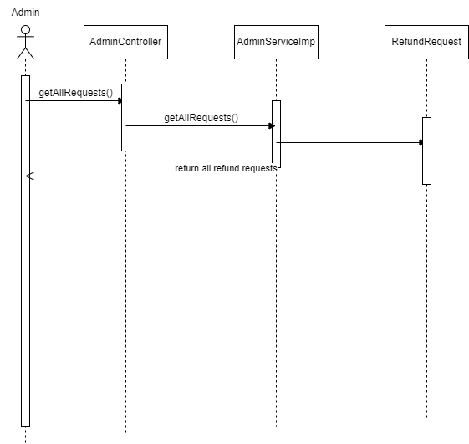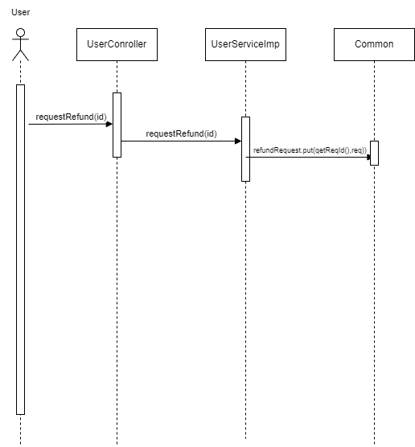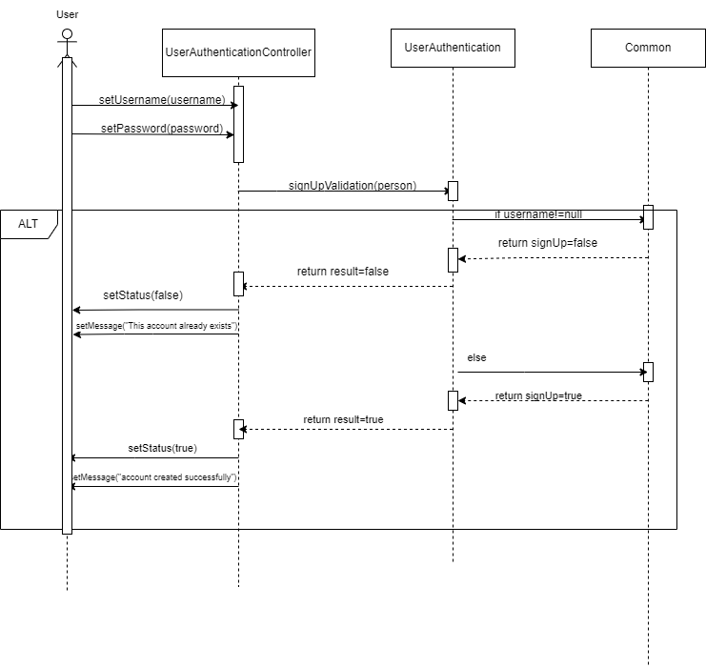

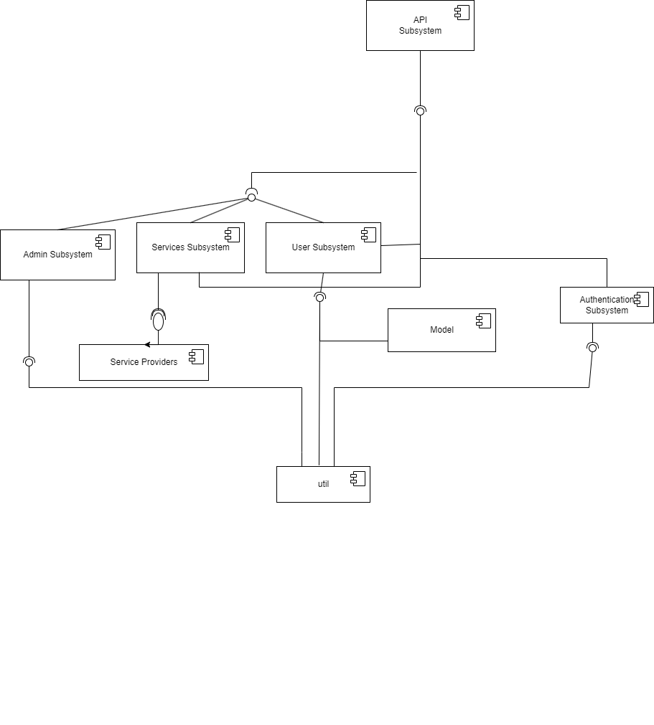

# Requirements Exposure as Web Service API

**Part 1: Exposed Postman Collection**

**Part 2:**

**Explain here the exact mapping between every single requirement and its corresponding web service API operation. A sample example is provided to better explain the concept.**

|  |  |  |  |
| --- | --- | --- | --- |
| Requirement |  | Exposed API | |
| The system should check if the username or the email is registered before. |  | 1- GET /user/check  A service to check if the user exists or not. This service returns all user info if exists  Input: email and password. | |
| The user should be able to sign-in to the system |  | POST/UserAuthenticationContoller/login A service to login a user into his account  Input: As-> Body  Its attributes (case sensitive): username(String), password(String)   * Example: * {“username”: ”malak”, “password”: “1234”}   **The response contains your id. Please save it as we will use it in the upcoming functions.** |  |
| The user should be able to sign up to the system |  | POST/UserAuthenticationContoller/signup A service to sign up a new user  Input: As-> Body  Its attributes (case sensitive): username(String), password(String), email(String)   * Example: * {“username”: ”malak”, “password”: “1234”, ”email”: “malak@”}   **The response contains your id. Please save it as we will use it in the upcoming functions.** | |
| The admin should be able to sign-in to the system |  | POST/AdminAuthenticationController/adminLogin A service to login an admin the system  Input: As-> Body  Its attributes (case sensitive): username(String), password(String)   * Example: * {“username”: ”malak”, “password”: “1234”} | |
| The user should be able to search for any service in the system |  | GET/UserController/{id}/searchForService/{name} A service to search for wanted service  Input: As-> PathVariable   * Enter the id you received after log in/sign up instead of-> {id} * Enter the service name you want to search for instead of-> {name} | |
| The user can pay for any service in the system |  | POST/UserController/{id}/selectServiceProvider/{serviceName}/{name}/enterForm/paymentMethods/{choice} A service in which the user can pay for the service needed  Input: As-> PathVariable AND body  PathVariable:   * Enter the id you received after log in/sign up instead of-> {id} * Enter the name of the service you want to search for instead of-> {serviceName} * Enter the name of the service provider you want instead of-> {name} * Enter a number (ranging from 1-3) representing your chosen payment method instead of-> {choice}   Where:  Credit card-> 1  Wallet-> 2  COD-> 3  Body:   * mobile: Must have 11 numbers AND the first three numbers are 011. * {“mobile”: ”01198956781”, “amountPaid”: 20.0, ”serviceProviderName”: “Vodafone”} * **The response contains the id of the transaction. Please save it as we will use it in the upcoming functions.** | |
| The user can ask for a refund for any complete transaction to any given service. |  | POST/UserController/{myID}/requestRefund/{id} A service to request a refund of a specific service  Input: As-> PathVariable   * Enter the id of the complete transaction you want a refund on instead of-> {id}   (that you received after paying for a service)   * Enter the id you received after log in/sign up instead of-> {myID} * **The response contains the id of the refund request. Please save it as we will use it in the upcoming functions.** | |
| The system maintain a wallet balance for each user |  | POST/UserController/{id}/addFundsToWallet A service to add money to wallet of the user through his credit card.  Input: As-> PathVariable AND Parameter  PathVariable:   * Enter the id you received after log in/sign up instead of-> {id}   Parameter:  KEY: amount , VALUE:(double) | |
| The admin should be able to add discounts to the system(specific) |  | POST/AdminController/addSepcificDiscount A service in which the admin can add a specific discount in any service inside the system  Input: As-> Parameter (KEY is case sensitive)  KEY: serviceID , VALUE: (int ranging from 1 to 4)  Where:  Mobile recharge-> 1  Internet payment-> 2  Landline services-> 3  Donations-> 4 | |
| The admin should be able to list all users paid transactions |  | GET/AdminController/getAllPaidTransactions A service in which the admin view all the paid transactions in the system.  No input | |
| The admin should be able to list all users refund transactions |  | GET/AdminController/getAllRefundTransactions A service in which the admin view all the refund transactions in the system.  No input | |
| The admin should be able to list all users add to wallet transactions |  | GET/AdminController/getAllAddToWalletTransactions A service in which the admin view all the add to wallet transactions in the system.  No input | |
| The admin should be able to list all refund requests. |  | GET /AdminController/getAllRequests A service in which the admin view all the refund requests in the system.  No input. | |
| The admin should be able to accept or reject any refund request |  | POST /AdminController/reviewRefundRequest/{id} A service in which the admin has the ability to accept or decline a refund request  Input: As-> Parameter (Key is case sensitive) AND PathVariable   * Enter the id of the complete transaction you want a refund on instead of-> {id}   (that you received after paying for a service)  KEY: accept , VALUE:(boolean) -> Boolean indicating whether to accept or refuse the request. | |
| The user should be able to check discounts for any service. |  | GET/UserController/{id}/checkDiscounts/{serviceName} A service in which the admin has the ability to accept or decline a refund request  Input: As-> Parameter (Key is case sensitive) AND PathVariable   * Enter the id you received after log in/sign up instead of-> {id} * Enter the name of the service you want to search for instead of-> {serviceName} | |