

**American International University- Bangladesh**

**CSC 3215: Web Technologies**

**CO1 and CO3 Evaluation**

**Project Report**

**Spring 2019-2020**

**Project Title: Online Pet Shop**

**Section: F**

|  |  |
| --- | --- |
| Student Name | Student Id |
| Feekra Baset Baishakhi | **18-39010-3** |
| Rahman, Fozlur | **18-39097-3** |
| Kabir, Md Mahmodul | 19-40642-1 |
| Md.Safaet | 18-38704-3 |

**Introduction:** *An online pet store. It allows users and clients to get pet necessities in one place. Nowadays there is hardly any person who doesn’t have a pet or love to nurture the animals. There is hardly any online shop where you can find multiple varieties of animal necessities. This webpage will provide food, toys, medical supplies, herbal medicines, vet doctor information, and local vet hospital locations.*

*Admin: They will have access to all the information and they will look into all the transitions of buyer and seller.*

*Seller: They will add different products to the website for potential customers. They will sell their product through the website*

*Buyer/Customer: They can buy products from the web application. They have to mention what kind of product they need so they can find if the product is available on the site and order the product. They can also ask for an online delivery option. Customers can pay through online payment methods.*

*Delivery: The product ordered by the customer will be delivered to the customer. The customer can choose the delivery service options.*

**Background Study**

*The idea of the website came from a Bangladeshi Online pet shop Katabon. It is a shop where you can easily find any pet related products and they also sell pets. Although at first it was completely a new generated idea but then we also took some of the ideas from the Katabon.*

*Link: https://katabononline.com*

**Requirement Analysis:**

1. **User Category:**

There are 4 types of users here. They are:

* Admin
* Seller
* User
* Deliveryman

1. **Feature List:**

Admin:

* Can update Information
* CRUD Seller
* CRUD Delivery Person
* Login and search for Seller/ Customer/ Delivery Person
* Can see Placed Orders (with Customer and Seller Information)
* Can see Canceled Orders
* Provide Vet doctor information/vet hospital locations

Seller:

* Added by Admin
* Can update information (Like: Shop name, Phone number, Address)
* Insert new pet information (Like: Picture of the Pet, Price, Size, Weight etc.) and Animal Necessities (Like: Food, Toys, Medicine etc.)
* View placed order (With Customer Details and Order Details)
* Can cancel placed orders
* Can insert new Pet/Animal Necessities (Like: Food, Toys, Medicine etc.) Information
* Can remove a Pet/ Animal Necessities (Like: Food, Toys, Medicine etc.) Information
* Can update Information of Pets (Like: Picture of the Pet, Price, Size, Weight etc.) / Animal Necessities (Like: Food, Toys, Medicine etc.)

Buyer/Customer:

* Register from outside
* Can update Information (Personal information only. Like: Name, DOB, Phone Number etc.)
* Login and search for Pets/ Animal Necessities products
* Can place multiple orders
* Can cancel orders
* Can add Item(s) to the cart
* Remove item(s) from the cart
* Can give rating to Pets/Products/Seller
* Can see Vet doctor information/vet hospital locations
* Can Return products (Condition: Has to be returned in 7 days)

Delivery Person:

* Added by Admin
* Login & search for Delivery info. & Customer’s info who has placed an order
* Can update Information (Personal information only. Like: Name, DOB, Phone Number, Profile Picture, Car number (if available) etc.)
* Provide customers with delivery schedule
* Can take payment
* Can take returned products

Common Features:

* Login
* Homepage (can view the trending Pets/Products in system)
* About us

**Design:**

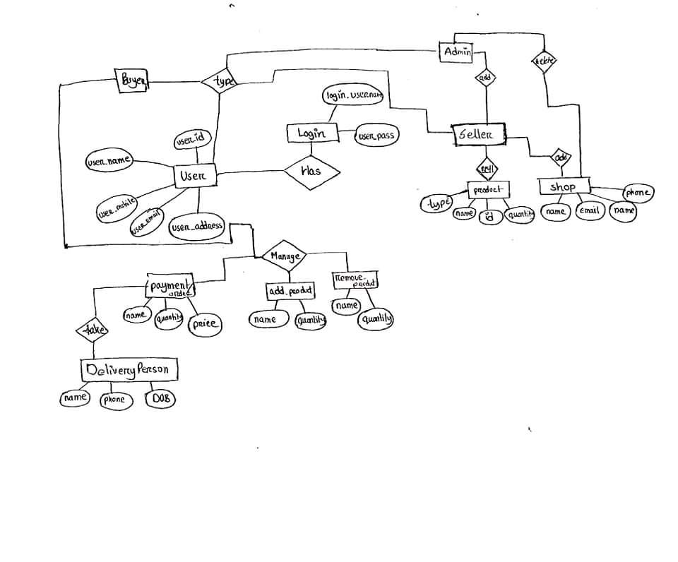

**Tools Used:**

To develop this project, we have used the following:

• XAMPP

• Google Chrome

• Microsoft Edge

• Notepad++

**System Images against the Specification:**

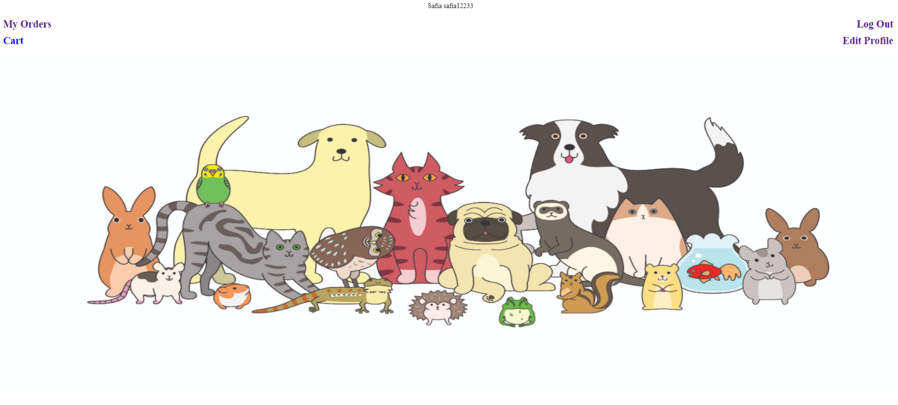

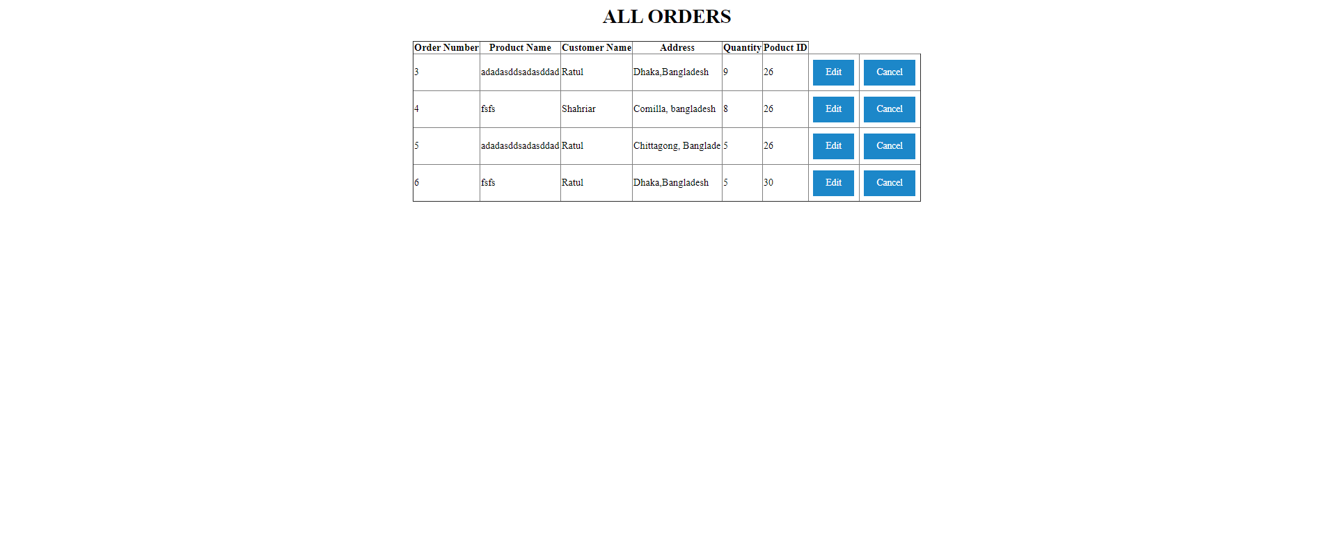

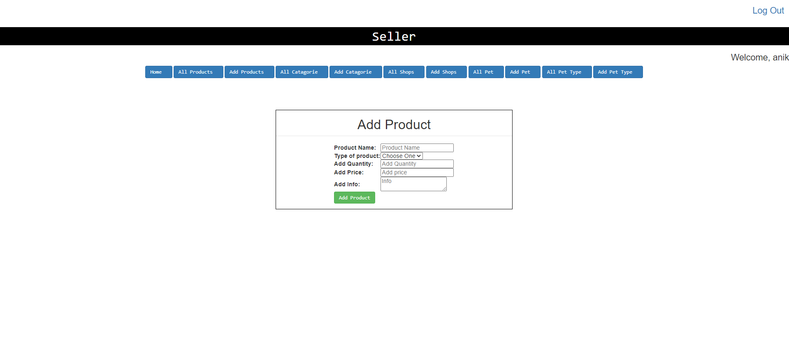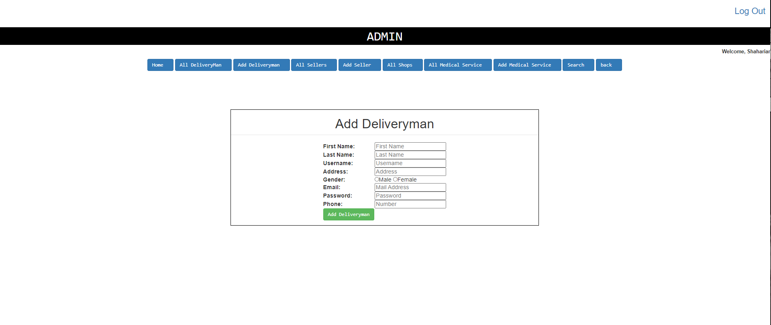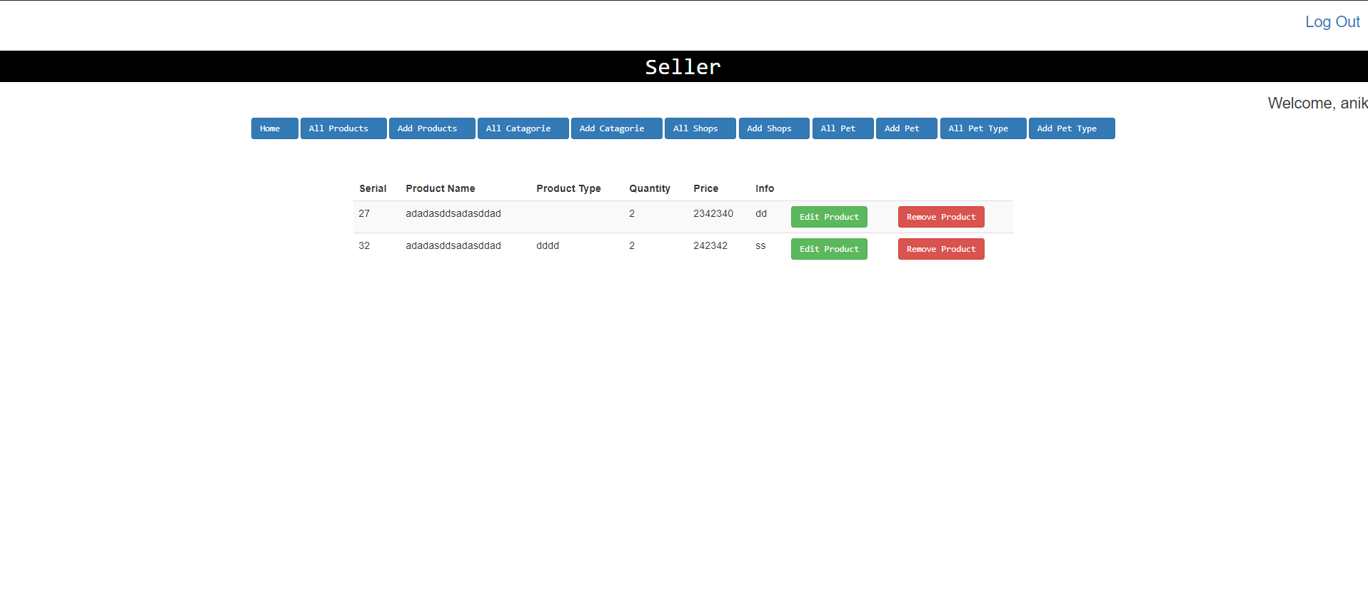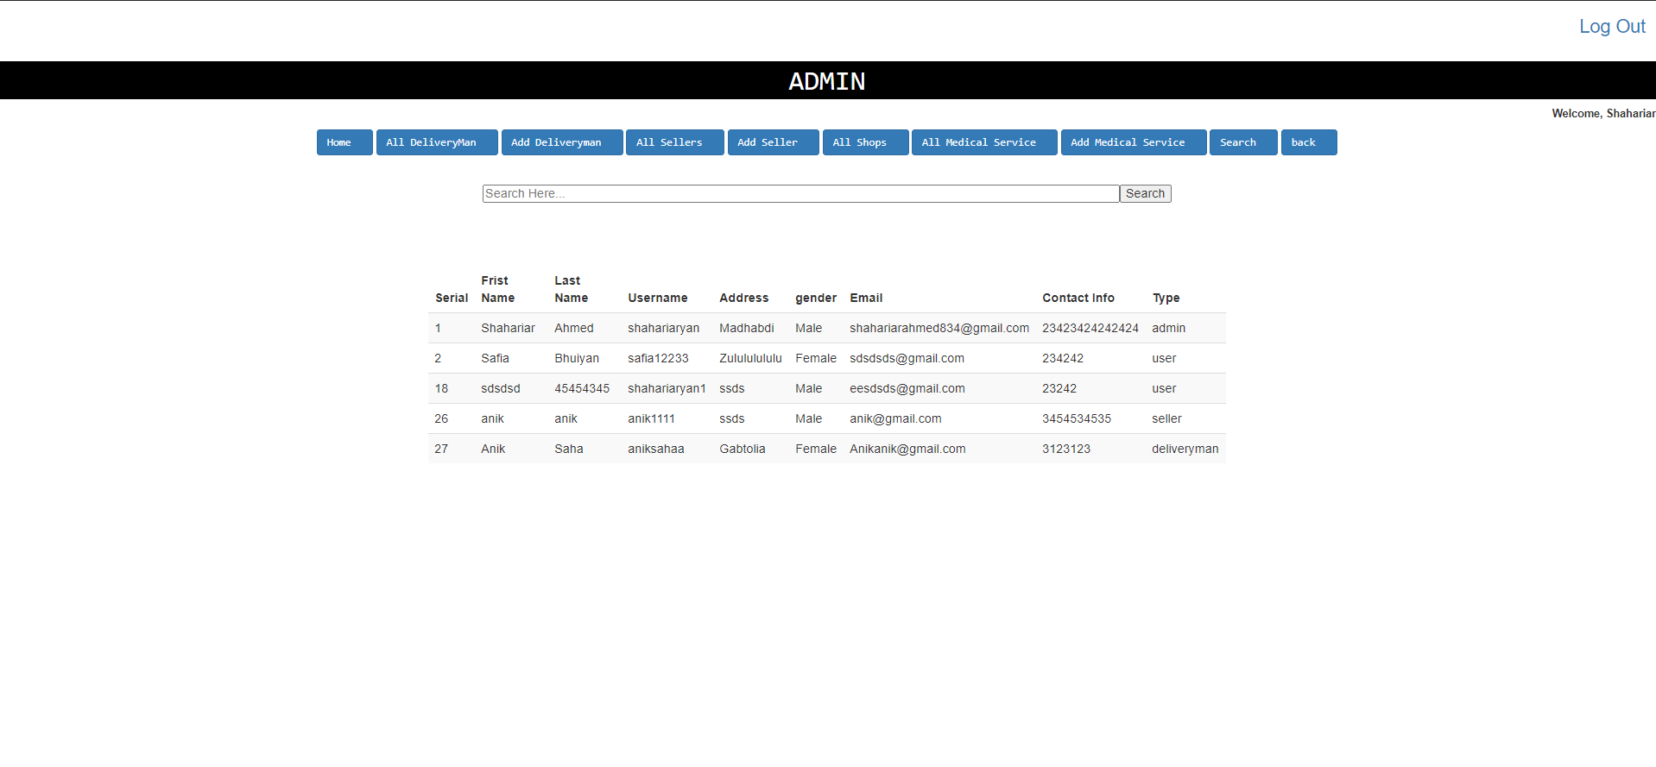

**Impact of this Project:**

Now a days it is possible to get your hands on anything with internet. These days it is possible to buy anything through online and if you have pet and it is really a big deal to get pet accessories and most importantly if you are new you don’t really get which food or accessories are good for your pet. So through a online pet shop you can get all information about which products or food you should get your pet just by browsing through the online shop. you don’t have to go to any shop or roam around in the market for your essentials. You can order online and your product will be delivered at your home.

**Limitations and Possible Future Improvements:**

This project has some limitations and more over it is not complete. In future this project obviously needs a lot of work and this project is not yet connected properly. So in future the goal would be to merge the project perfectly by connecting all the entities. Although some of the part of the project is connected perfectly with the database but most of the part of the project is not yet configured properly or connected with the database, So the only limitation of the project right now is project is not fully complete. Although we are planning on working on it and make it a complete project

***[Note: Make sure that your report is maximum 8 pages (including cover page). Print (Colored) the report and submit it with spiral bind.]***

|  |  |  |  |  |  |
| --- | --- | --- | --- | --- | --- |
| **CO1 and CO3 Evaluation: Project Report Evaluation** | | | | | |
| **Project Proposal**  **(5)** | **Background**  **Study**  **(5)** | **Requirement Analysis**  **(5)** | **Entity**  **Diagram**  **(5)** | **System Images**  **against the**  **Specification (5)** | **Total (25)** |
|  |  |  |  |  |  |
|  | | | | | |