Abstract
The project aims to enhance logo recognition and similarity search, which are critical tasks in areas such as brand authentication and fake detection. However, traditional models often struggle with accuracy and robustness due to limited datasets. This project addresses these challenges by leveraging a pre-generated synthetic dataset and a ResNet50 model optimized using a triplet loss function. The synthetic dataset enhances diversity and improves model generalization, while triplet loss ensures accurate feature learning by bringing similar logos closer together and separating dissimilar ones. The model is trained using a synthetic logo, extracting meaningful feature representations and optimizing similarity search through triplet loss. This approach reduces dependency on manually labelled datasets while improving retrieval performance. The system’s efficiency is validated using metrics such as accuracy, recall, and precision, demonstrating strong recognition performance, particularly with real-world data.

The use of synthetic data mitigates biases, ensuring the model’s robust performance on unseen logos. Unlike Traditional methods, this model demonstrates resilience to variations such as transformations, occlusions, and distortions. Results indicate that the combination of synthetic data and deep learning effectively addresses data scarcity in logo recognition. This project contributes to the development of reliable and scalable logo identification and similarity search systems. Future work may explore alternative loss functions and advanced augmentation strategies to further enhance recognition accuracy.

Table of Contents
Contents
Abstract i
Table of Contents ii
Introduction iii
Chapter 1: Literature Review 5
Chapter 2: Research Objectives 7
Chapter 3: Methodology 8
3.1 Pre-Processing 8
3.2 Training Stage 10
3.3 Retrieval Pipeline 12
Chapter 4: Results and Discussion 16
4.1 Discussion 18
Chapter 5: Conclusion 19
Bibliography i

Introduction
The logo recognition and similarity search that highly crucial in computer vision, digital marketing, and finding applications in brand authentication, fake detection, and intellectual property protection. With the increasing use of logos across industries, the maintenance of accuracy and efficient recognition systems is becoming more challenging. Due to their reliance on manually engineered features, the conventional recognition methods are often deficient in robustness to real-world variations like transformations, occlusions, and distortions.
Deep learning has significantly advanced logo recognition, as a result of convolutional neural networks (CNNs) to enhance the learning of hierarchical feature representations, directly from the raw images. ResNet50 has now gained crucial significance among the various deep learning architectures, due to its residual framework of learning, which typically allows the deep networks to train efficiently. However, the limited availability of labeled datasets is a significant barrier towards the process of training deep learning models training, for logo recognition. Provided that there is high diversity and continuous emergence of new logos, datasets in existence tend to fail often, in the aspect of capturing the real-world logos, leading to an insufficient level of model performance.
Tackling these issues requires the combination of synthetic data generation with a typically trained ResNet50 deep learning model using a triplet loss function. Synthetic data can tend to expand training datasets for the improvement of model generalization, mainly for unseen logo recognition. The triplet loss function supports the learning potential of the model for distinct logo features and enhancement of similarity search accuracy. This method is ultimately aimed towards the improvement of logo recognition systems' accuracy, reliability, and scalability.

Literature Review
The logo recognition and similarity searches have gained prior and crucial attention in the computer vision community as a result of their applications in brand detection, monitoring, and content-based image retrieval. The methods of traditional logo recognition rely on handcrafted feature extraction techniques, but recently, there have been advancements in deep learning, accompanied by vast improvements in terms of recognition accuracy and robustness. This section also reviews the latest research conducted on deep learning-based logo recognition, metric learning with triplet loss, synthetic data usage, and real-world applications of these technologies.
The early methods for logo recognition primarily had dependency on feature engineering techniques such as Histogram of Oriented Gradients (HOG) and Scale-Invariant Feature Transform (SIFT) (Dalal & Triggs, 2005). Regardless of being effective in controlled environments, these methods are deficient in robustness against real-world variations, including occlusion and rotation. Convolutional neural networks (CNNs) to marked improvement in image recognition tasks such as logo recognition. The CNN frameworks, such as AlexNet (Krizhevsky et al., 2012) and VGGNet (Simonyan & Zisserman, 2014), show a demonstration of superior performance by learning the feature representations from data. However, these frameworks tend to face barriers of deeper networks as a result of challenges such as vanishing gradients.

According to studies (He et al., 2015), these issues require residual learning by ResNet-50 to allow proper and significant training for deeper networks. Recently, studies have also shown that ResNet50 is highly effective, specifically in terms of image extraction features, which is due to its ability to extract essential spatial information across deeper layers. Furthermore, the demonstration shown by ResNet50 is outperforming networks on diverse logo datasets, making it a choice of preference for logo recognition. In recent years, advanced architectures such as hybrid CNN-Transformer models and Vision Transformers (ViTs) (Dosovitskiy et al., 2021) have been explored for image recognition. These models improve performance on certain tasks by effectively capturing both local features and long-range dependencies through self-attention mechanisms. However, typical models that are CNN-based, such as ResNet50, always remain the choice of preference for tasks that require high spatial resolution, computational efficiency, and robustness against real-world variations (He et al., 2015).

One of the biggest challenges facing deep learning models, including those for logo recognition, is the limited availability of large, diverse datasets. Models trained on static datasets often struggle to generalize to new variations, making it difficult to maintain accuracy in real-world applications. To address this, data augmentation techniques, including synthetic data generation, have emerged as powerful tools for expanding datasets and improving model performance (Shorten & Khoshgoftaar, 2019). Data augmentation techniques, such as rotation, scaling, and color adjustments, have traditionally been used to artificially expand datasets (Cubuk et al., 2019). In contrast, more advanced methods like Generative Adversarial Networks (GANs) (Goodfellow et al., 2014) enable the creation of entirely new synthetic images that closely resemble real-world examples. Studies have shown that GAN-generated synthetic datasets significantly enhance the performance of convolutional neural networks (CNNs), particularly in scenarios where training data is limited (Radford et al., 2015)
Logo similarity search relies on effective feature embeddings that accurately capture the visual similarity between logos while maintaining high retrieval efficiency. As demonstrated by (Schroff et al.,2015) in their FaceNet model, metric learning techniques, particularly triplet loss, are widely used for similarity learning tasks, such as face recognition and signature verification. The triplet loss function minimizes the distance between an anchor and a positive sample while maximizing the distance to a negative sample. This approach ensures that similar logos are closely clustered in the embedding space, while dissimilar logos are separated. Studies have shown that triplet loss significantly enhances retrieval accuracy by learning fine-grained representations, particularly for similarity-based tasks (Schroff et al., 2015). Gordo et al.,(2017) applied triplet loss to landmark retrieval, demonstrating a substantial improvement in ranking precision. Similarly, triplet loss has also proven effective in enhancing logo retrieval, providing robust differentiation between visually similar and distinct logos.

Research Objectives

- Improve Logo Recognition Accuracy: Development of a deep learning-based method by using ResNet50 for the enhancement of the accuracy of logo identification across diverse datasets.
- Enhance Similarity Search Performance: Utilization of a triplet loss function to improve the ability of the model to differentiate between similar and dissimilar logos effectively.
- Overcome Dataset Limitations: Generated synthetic data for proper resolution of the issue about limited real-world logo datasets to ensure better model generalization.
- Increase Model Robustness and Scalability: Evaluation of the impact of synthetic data and deep learning techniques on model robustness against variations such as transformations, occlusions, and distortions.
- Contribution to Real-World Applications: Improvement of the efficiency of logo recognition systems, mainly for applications in brand monitoring, content-based image retrieval, and fake detection.

Methodology

PrE-pROCESSING
The synthetic data used in this project was pre-generated and provided as part of the dataset. This dataset introduces a wide range of variations in logos, including changes in shape, color, orientation, and texture, simulating real-world conditions. By incorporating these variations, the synthetic dataset enhances the diversity of the training data, addressing the common challenge of limited real-world logo datasets.
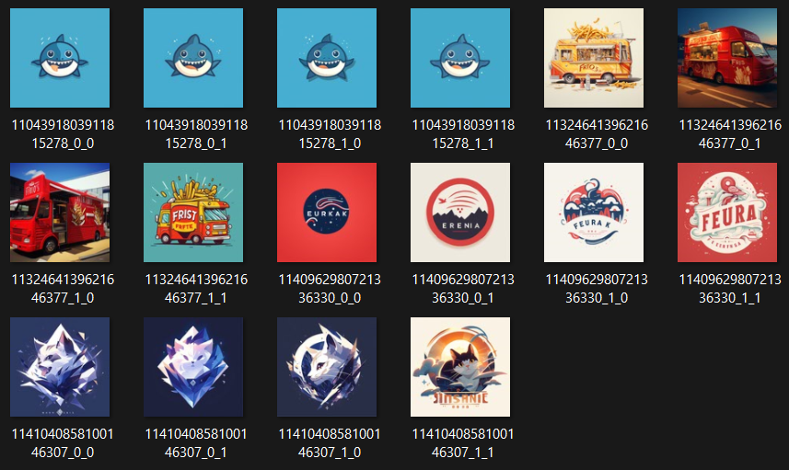
- Total logos generated: 1,777,584

Figure 1. Original Dataset
The next stage forms the backbone of the proposed logo recognition and similarity retrieval pipeline. The design focuses on transforming raw multi-modal inputs, including synthetic images and their associated textual prompts, into well-structured, low-dimensional representations suitable for deep metric learning and unsupervised clustering. At this stage, both visual semantics and textual concepts are modelled collaboratively, enabling scalable training and efficient retrieval.

Real-world logo datasets often have several challenges, including labeling costs, limited variety, and poor ability to work with new logos. To address these problems, this research creates a synthetic dataset with 1,777,584 logo images, each with a description explaining the logo’s theme, style, or concept. This setup uses both images and text to build a combined representation of each logo, following these steps:

Each image is processed using a ResNet50 model that was initially pre-trained on ImageNet. The final fully connected classification layer is removed, and the output from the last convolutional block is flattened to produce a 2048-dimensional feature vector representing the visual characteristics of the logo. At the same time, the corresponding text prompt for each logo is embedded using the MiniLM model (all-MiniLM-L6-v2), a transformer-based language model. This process generates a 384-dimensional semantic vector that captures the textual features relevant to the logo design.

The visual and text embeddings are combined to create a single 2432-dimensional feature vector for each logo. Although this combined representation is highly informative, its large dimensionality can cause issues with clustering due to computational overhead and complexity. To overcome this, UMAP (Uniform Manifold Approximation and Projection) is applied to reduce the dimensionality of the feature vector from 2432 to 600. UMAP is configured to use cosine similarity as the distance metric and a minimum distance of zero, ensuring that fine-grained local structure in the embedding space is preserved.

After dimensionality reduction, the dataset is clustered using HDBSCAN (Hierarchical Density-Based Spatial Clustering of Applications with Noise), an unsupervised clustering algorithm that does not require a predefined number of clusters. HDBSCAN identifies dense regions in the embedding space as clusters and labels low-density points as outliers (label = -1). To ensure that all logos are assigned to a category, a second clustering pass is performed, specifically for the outlier samples, using a new HDBSCAN model. The cluster IDs from this secondary pass are adjusted to prevent overlap with those from the primary clustering phase.

The second step clustering process produces a total of 209,310 logo image categories, each containing at least two images. These categories serve as weak labels, guiding construction triplets in the subsequent metric learning stage. This pseudo-labeling approach allows the model to learn similarity relationships without relying on manually annotated classes, making it scalable to millions of logos with minimal supervision.

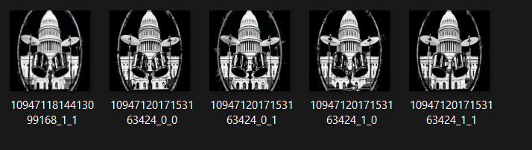
Figure2: Dataset After Clustering Using HDBSCAN

After completing the clustering process, the dataset is divided into training and test subsets using a stratified strategy that preserves category integrity. For each visual category generated by HDBSCAN, all associated samples are considered. If a category contains fewer than two images, it is excluded from training to prevent triplet loss decay during training. For the remaining categories, the samples are randomly shuffled, with approximately 80% assigned to the training set and up to 20% reserved for testing. This allocation is only applied if at least two samples remain in the training set, ensuring the formation of valid anchor-positive pairs. This process guarantees that every triplet sampled during training reflects meaningful class relationships.

The outcome of the pre-processing stage is a clean and well-organized dataset consisting of approximately 1,458,113 training samples and 319,471 test samples. Each sample is labeled with a category from unsupervised clustering. This structured dataset provides a strong foundation for learning high-quality metric representations during training and supports robust performance evaluation on previously unseen logos.

Training Stage
This stage represents, the critical phase in which the proposed model,
$$f\left(x\right)=\frac{W_{2}.R_{e}LU\left(W_{1}. x+ b_{1}\right)+ b_{2}}{{||W}_{2}.R_{e}LU (W_{1} . x + b_{2 }{||}_{2}}$$

Where $W_{2} ∈ R^{512 X 2048} , W_{2} ∈ R^{256 x 512} ,$ and the final output to be a unit-normalized vector in $R^{256}$ . This projection helps to ensure that the model outputs reside on a typical hyper-sphere, to allow the Euclidean (L2) distance to represent a meaningful similar metric
The model tends to be optimized using the standard Triple Margin Loss, which helps to encourage the anchor-positive distance to be smaller than the anchor-negative distance by a fixed marging $∞$ . The definition of an objective function for a single triplet ${(x}_{a},x_{p}, x_{n})$is as follows:
$${L(x}_{a, }x_{p} , x_{n})=\max{(0, } |\left|f\left(x_{a}\right) -f{(x}_{p}\right){||}_{2}^{2}-||fx_{a} {-f(x}_{n}){||}_{2}^{2} + ∝ )$$
During this work, the margin parameter $∝$ is set to 1.0, which was enough for the enforcement of meaningful separation between unalike samples, without the training stability, being compromised. 0.

Training data is generated using triplets that are dynamically constructed from the clustered dataset. For each anchor logo, a positive sample is selected from the same cluster (category) but must differ from the anchor to avoid biased cases. A negative sample is then chosen from a different cluster, ensuring both semantic and visual dissimilarity. This dynamic sampling strategy, applied at each mini-batch, increases training diversity and prevents redundancy. The sampled categories are derived from the unsupervised HDBSCAN clustering performed in the pre-processing stage, ensuring that the model learns from naturally discovered groups of visually similar logos.

The training process is performed over 50 epochs using the Adam optimizer, starting with an initial learning rate of 1 × 10⁻⁴, which is gradually reduced using a step scheduler to improve convergence. Each training batch consists of 1,024 triplets, totaling 3,072 logo images per iteration (including anchor, positive, and negative samples). Training is conducted using mixed precision, which reduces memory usage and accelerates computation. Loss values are monitored across epochs to track the model's learning progress.
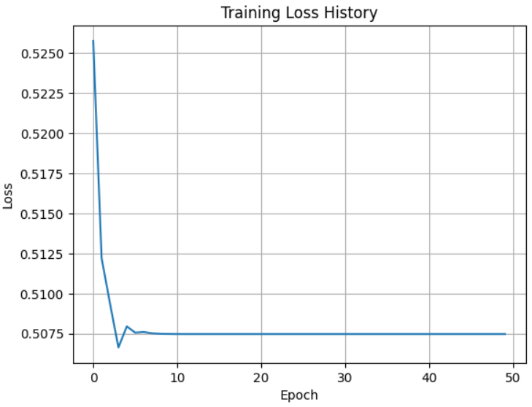

Figure 3. Model Training

The training process demonstrates rapid convergence, as indicated by a sharp decrease in loss within the first few epochs. This behavior reflects the model’s efficient learning of the metric space through triplet loss, supported by the high-quality synthetic dataset and the robust feature extraction capabilities of the ResNet50 backbone. The loss value stabilizes around 0.5075, suggesting consistent performance without signs of overfitting.
The final trained model is capable of generating discriminative 256-dimensional embeddings for any logo image input. These embeddings are subsequently used in the retrieval and evaluation stages. The model must generalize well to logos outside the training distribution because it learns similarity relationships in a weakly supervised manner.
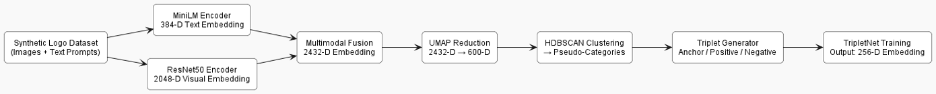
Figure 4. Training Architecture

Retrieval Pipeline
The retrieval pipeline represents the operational phase of the proposed logo recognition system, where the trained model is utilized for the performance of similarity-based logo search in real-time. This stage primarily capitalizes on the embedding space learned through metric learning for the identification of logos that are similar semantically and visually to a given query. It helps in the transformation of learned representations from a theoretical construct into a functional retrieval mechanism capable of handling datasets of logos on a large scale.

At the core of the retrieval pipeline, embedded the 256-dimensional output of the Triplet Net Model. Once the completion of the training is completed, this model is employed for the extraction of embedding for all logo images in both the training and test sets. Each embedding is a unit-normalized vector that encodes rich information about the structure, shape, style, and color of the logo, as well as the latent semantic idea inferred from the associated prompt. These embedding are computed in batch mode and stored efficiently using the datasets of the library called the Hugging Face; enabling rapid accessibility.

To enable similarity search that is scalable, a FAISS (Facebook AI Similarity Search) index is built over the training set embedding. FAISS is a critically optimized library for the nearest neighbour efficient search in high-dimensional spaces, specifically suited for large datasets. In this project, a flat L2 index is used for the performance of search but is useful for significant GPU acceleration and vectored operations due to the relatively moderate dimensionality of the embedding. This choice gives more prioritization to retrieval accuracy over approximate speed-ups that could result in degraded performance.

When a query logo is provided by a user, the system tends to process through the trained Triplet Net for the generation of its 256-dimensional embedding. These embeddings are used for the performance of a Top-K similarity search against the indexed training embedding, by using the L2 distance as the similarity metric. The FAISS engine returns the indices and similarity scores of the K nearest neighbours. Hence, these scores are a reflection of the proximity of the query to each retrieved logo in the learned metric space.

The logo retrieval system demonstrates strong performance in identifying visually similar images to a given query. As shown in the figure, the query image (top-left) is compared against a set of candidate images, with each retrieved image assigned a similarity score. The model effectively retrieves images that closely resemble the query, both in style and color scheme, indicating the effectiveness of the metric learning approach, triplet loss in capturing fine-grained visual features.
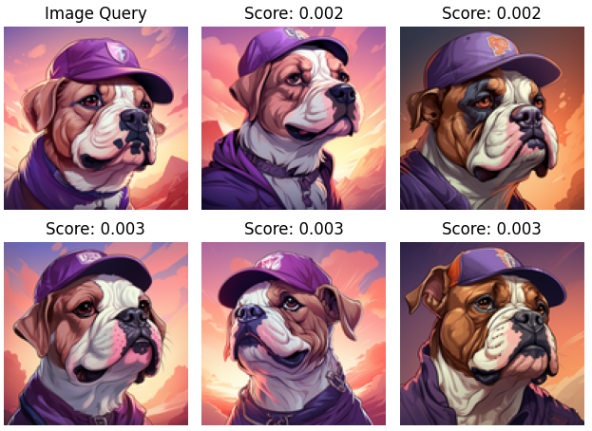
Figure5. Logo Similarity Retrieval System
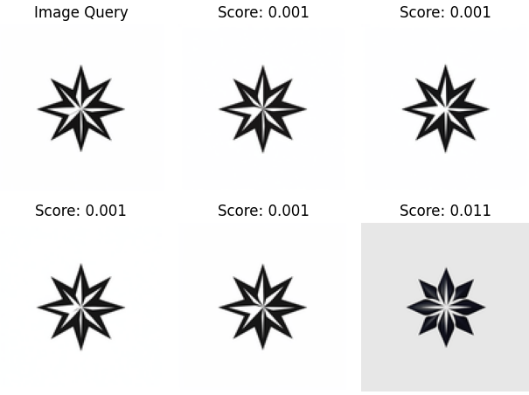
Figure6. Logo Similarity Retrieval System

Summarily, the pipeline retrieval process relies on the learning of a similarity space through an efficient and accurate nearest neighbour search mechanism. This leverages the gap in between model training and real-world usage, thereby offering a powerful tool for logo similarity search at scale, which tends to be interactive and automated.

Figure7. Logo Similarity Retrieval Architecture

Results and Discussion
This section critically presents the empirical evaluation of the proposed TripletNet-based logo recognition and similarity retrieval system. The model was assessed using the Recall@K metric at three different retrieval depths: K =1, K = 5, K = 10. Evaluation was performed on a held-out test set of 319,471 logos, which were not seen during the time of training. This embedding for the test and training sets was put to extraction via the trained TripleNet, and a FAISS L2 index was utilized for the similarity search performance against the training embedding.

The usage of two different ground truth signals was used in retrieval relevance evaluation, as follows:

- Clustering-based category: These are labels generated using HDBSCAN, reflecting an unsupervised semantic grouping.
- RestNet50-class-based labels: This helps in top-K class predictions encoding, from the ImageNet-pretrained ResNet50 used as the visual framework.

Quantitative Result
The Table below is the summary of the recall performance at different values of K
K | Recal@K(Category) | Recall@K(ResNet50 Class)
1 | 0.2504 | 0.7820
5 | 0.5315 | 0.9640
10 | 0.5874 | 0.9856

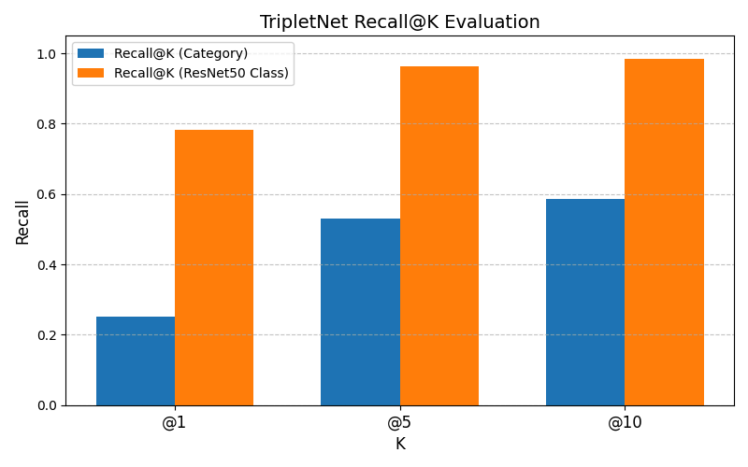
Figure 7. TripleNet Recall@K Evaluation for both Category and ResNet50 Class.

This result is an indication that the model achieves strong performance in retrieval, especially when evaluation is done based on the ResNet50 class labels. For instance, at K= 10, the model correctly retrieves at least one image sharing the same top-1 predicted class in 98.56% of the cases. This shows a high level of consistency in the learned embedding space with respect to low-level visual attributes, including color, texture, distribution, and shape, which are preserved by the pre-trained ResNet50 backbone.

In contrast, the model's retrieval performance is lower when using HDBSCAN-generated categories. At K = 10, the recall is around 58.74%. This is because these clusters are more abstract, lacking the clear structure of predefined classes like those in ResNet50, which are directly linked to ImageNet’s organized categories. HDBSCAN categories are created automatically, based on a mix of visual features (such as colors, shapes, and styles) and conceptual information from text prompts. This combination makes them more flexible but also harder to define clearly. As a result, finding similar logos within these loosely defined clusters is more challenging. However, even with this complexity, the model still shows a reasonable understanding of logo similarity, capturing both visual and semantic aspects.

Discussion
These findings highlight the effectiveness of the TripletNet architecture in creating a meaningful embedding space for logo recognition. The model demonstrates strong performance in ResNet50-class-based recall, indicating that it effectively distinguishes logos based on their visual characteristics. However, the moderate performance on category-based recall suggests that achieving conceptual and stylistic clustering without explicit supervision is challenging, particularly across 209,310 clusters of highly diverse synthetic logos:

- Semantic diversity of synthetic prompts: Since the prompts used for the generation of logos, tends to vary widely in abstraction and specificity, there can be inconsistency on their contribution, towards clustering quality.
- Weaks from clustering: The categories used for the training are generated automatically and may include some noisy or overlapping clusters, which tend to affect both the triplet sampling and evaluation.
- Fixed backbone features: The visual encoder (ResNet50) was kept frozen during the training, purposely for the reduction of computational overhead. Although it’s effective in the preservation of general features, there tends to be a limitation in the model's ability to adapt to the specific distribution of synthetic logos.

Nevertheless, the system tends to show demonstration of excellent scalability and high retrieval precision in tasks that are visually grounded. In real-world applications such as duplicate detection or visual band search, the level of performance observed at K = 5 and K = 10 is relatively more than sufficient for the provision of useful candidate logos, for review or any further automated filtering.

Conclusion
This research will present a deep learning pipeline that is highly scalable and effective for logo recognition and similarity retrieval, by leveraging the synthetic data generation, multimodal embedding, unsupervised clustering, and triplet-based metric learning. Addressing the crucial challenges of the limited labelled datasets, real-world visual variability, and brand diversity, the proposed approach tends to reflect a demonstration in terms of how synthetic logos (such as those paired with prompt-guided embedding) can be used for constructing high-quality retrieval system, without having reliance on manual annotation.

The methodology integrates a frozen ResNet50 visual backbone with MiniLM prompt embedding for the creation of a joint 2432-dimensional representation of each logo. Reduction in dimensionality was done via the UMAP and unsupervised clustering using HBDSCAN, yielding over 200,000 pseudo-categories, which were then used for the construction of semantically meaningful triplet samples for training. The triplet Net Model was trained using the triplet margin loss, purposely for the successful learning of embedded logos into a 256-dimensional space where semantically or visually related logos tend to reside closely. Evaluation using the Recall@K on a test set of over 300,000 samples shows a demonstration of the model’s potential to retrieve similar logos with high precision. The system tends to achieve over 96% recall at K = 5 and 98% at K = 10, when evaluation is done using the ResNet50-based visual class agreement. Although the performance under HBDSCAN-based category recall was more moderate 58.9% at K = 10, it nonetheless reflected the model’s potential to generalize over abstract, unsupervised semantic groupings.

Overall, the proposed pipeline tends to offer a flexible, label-free framework for training robust similarity models across large-scale logo datasets. It proves the effectiveness in both precision-critical and open-domain settings and serves as a strong foundation for real-world applications, like brand monitoring, visual search platforms, and duplicate detection. In the future, extensions may be required incorporate hard-negative mining, adaptive sampling strategies or transformer-based vision backbones, to further enhances the retrieval robustness and semantic sensitivity in ecosystems that is highly diverse and evolving.

Bibliography
Alexey Dosovitskiy, Beyer, L., Kolesnikov, A., Weissenborn, D., Zhai, X., Unterthiner, T., Dehghani, M., Matthias Minderer, Georg Heigold, Gelly, S., Jakob Uszkoreit and Houlsby, N. (2021). An Image is Worth 16x16 Words: Transformers for Image Recognition at Scale. International Conference on Learning Representations, 3(4).
Cubuk, E.D., Zoph, B., Mané, D., Vasudevan, V. and Le, Q.V. (2019). AutoAugment: Learning Augmentation Strategies From Data. [online] IEEE Xplore. doi:https://doi.org/10.1109/CVPR.2019.00020.
Dalal, N. and Triggs, B. (2005). Histograms of Oriented Gradients for Human Detection. 2005 IEEE Computer Society Conference on Computer Vision and Pattern Recognition (CVPR’05), 1(2), pp.886–893. doi:https://doi.org/10.1109/cvpr.2005.177.
Goodfellow, I., Pouget-Abadie, J., Mirza, M., Xu, B., Warde-Farley, D., Ozair, S., Courville, A. and Bengio, Y. (2014). Generative Adversarial Nets. [online] Available at: https://arxiv.org/pdf/1406.2661.
Gordo, A., Almazán, J., Revaud, J. and Larlus, D. (2017). End-to-End Learning of Deep Visual Representations for Image Retrieval. International Journal of Computer Vision, 124(2), pp.237–254. doi:https://doi.org/10.1007/s11263-017-1016-8.
He, K., Zhang, X., Ren, S. and Sun, J. (2015). Deep Residual Learning for Image Recognition. [online] Available at: https://www.cv-foundation.org/openaccess/content_cvpr_2016/papers/He_Deep_Residual_Learning_CVPR_2016_paper.pdf.
Krizhevsky, A., Sutskever, I. and Hinton, G.E. (2012). ImageNet Classification with Deep Convolutional Neural Networks. Communications of the ACM, 60(6), pp.84–90.
Lowe, D.G. (2004). Distinctive Image Features from Scale-Invariant Keypoints. International Journal of Computer Vision, 60(2), pp.91–110. doi:https://doi.org/10.1023/b:visi.0000029664.99615.94.
Radford, A., Metz, L. and Chintala, S. (2015). Unsupervised Representation Learning with Deep Convolutional Generative Adversarial Networks. [online] arXiv.org. Available at: https://arxiv.org/abs/1511.06434.
Schroff, F. and Philbin, J. (2015). FaceNet: A Unified Embedding for Face Recognition and Clustering. [online] Available at: https://www.cv-foundation.org/openaccess/content_cvpr_2015/papers/Schroff_FaceNet_A_Unified_2015_CVPR_paper.pdf.
Shorten, C. and Khoshgoftaar, T.M. (2019). A survey on Image Data Augmentation for Deep Learning. Journal of Big Data, [online] 6(1). doi:https://doi.org/10.1186/s40537-019-0197-0.
Simonyan, K. and Zisserman, A. (2014). Very Deep Convolutional Networks for Large-Scale Image Recognition. Computer Vision and Pattern Recognition, 5(5).

