REAL-TIME ENERGY CONSUMPTION MONITORING USING ARTIFICIAL INTELLIGENCE BASED NON-INTRUSIVE LOAD MANAGEMENT SYSTEM


Group Members:
MUHAMMAD MOIN DILDAR (211201)
MUHAMMAD MAHMOOD GHAURI (211265)
MUHAMMAD SALMAN (211291)

BE MECHATRONICS (Session 2021-2025)
Project Supervisor
Engr. Umer Farooq
Lecturer

DEPARTMENT OF MECHATRONICS & BIOMEDICAL ENGINEERING
FACULTY OF ENGINEERING
AIR UNIVERSITY, ISLAMABAD

REAL-TIME ENERGY CONSUMPTION MONITORING USING ARTIFICIAL INTELLIGENCE BASED NON-INTRUSIVE LOAD MANAGEMENT SYSTEM

FINAL YEAR PROJECT REPORT
(SESSION 2021-2025)

DEPARTMENT OF MECHATRONICS & BIOMEDICAL ENGINEERING
REAL-TIME ENERGY CONSUMPTION MONITORING USING ARTIFICIAL INTELLIGENCE BASED NON-INTRUSIVE LOAD MANAGEMENT SYSTEM

Submitted By:
MUHAMMAD MOIN DILDAR (211201)
MUHAMMAD MAHMOOD GHAURI (211265)
MUHAMMAD SALMAN (211291)

Project Supervisor

Engr. Umer Farooq
Lecturer

Chair Department

Dr. Noman Naseer

Acknowledgments
The successful completion of this project would not have been possible without the invaluable support and contributions of several individuals and entities.
We would like to express our sincere gratitude to Engr. Umer Farooq, our project supervisor, Dr. Hafiz Zia Ur Rehman, our project co-supervisor and all other faculty members for their continuous guidance, encouragement, and insightful feedback throughout the development process. Their expertise and support were instrumental in shaping this project.
We are also thankful to our team members, for their assistance and their contributions were crucial in this project. Furthermore, we would like to acknowledge DEPARTMENT OF MECHATRONICS & BIOMEDICAL ENGINEERING, for providing the resources and necessary support to carry out this project. This support played a vital role in ensuring the project's success.

Abstract
Nonintrusive load monitoring (NILM) systems serve to uncover the energy usage patterns of individual devices within an electrical system, yet expanding their market reach poses a significant hurdle. A novel approach to NILM, utilizing edge processing, is introduced, wherein energy consumption data undergo processing directly on the device installed within the monitored facility. Specifically, a neural network implemented on a Raspberry pi 4B (8GB RAM) is employed for this purpose. The NILM system is slated for installation on four everyday using appliances in real-world scenarios. This report outlines a promising configuration aimed at facilitating the widespread adoption of NILM frameworks by reducing their implementation costs and complexity, while also addressing privacy concerns associated with cloud-based data processing. The outcomes of real-world testing in this endeavor are expected to provide compelling evidence of the potential of the proposed NILM framework across various applications, including smart homes, building automation, and industrial energy management.

Nomenclature
Symbol Abbreviation
A | Unit of Current
AI | Artificial Intelligence
ANN | Artificial Neural Network
CNN | Convolutional Neural Network
DL | Deep Learning
FHMM | Factorial Hidden Markov Model
flin | Linear Frequency
HMMs | Hidden Markov Models
Hz | Unit of Frequency
ILM | Intrusive Load Monitoring
Imax | Maximum Current
Inom | Normal Current
NILM | Non-Intrusive Load Monitoring
NN | Neural Network
RMS | Root Mean Square
V | Unit of Voltage
Vnom | Normal Voltage
Vmax | Maximum Voltage

Table of Contents

1 Introduction 1
1.1 Background and Motivation 2
1.1.1 Sustainable Development Goals 2
1.2 Literature Review 2
1.3 Problem Statement 5
1.4 Objectives of the Project 5
1.5 Cost Analysis 6
1.6 Timeline of the Project 6
1.7 Work Division 6
1.8 Organization of Report 7
2 Description 8
2.1 Description of the Project 8
2.2 Methodology 8
2.3 Product Specifications 10
2.3.1 Schematic Diagram 10
2.4 Preliminary Design and Calculations 11
3 Modeling and Simulation 12
3.1 Algorithms 12
3.1.1 Flowcharts 13
4 Experimental Setup 15
4.1 Hardware Description 16
4.2 Components 17
5 Results and Discussion 19
5.1 Results 19
5.2 Discussion 23
5.3 Project Outcomes 23
5.3.1 Project Impact 24
6 Conclusions and Future Recommendations 25
6.1 Conclusions 25
6.2 Future Recommendations 25
Bibliography 26
Appendices 28
Appendix A 28
Appendix B 28
Appendix C 28
Appendix D 28

List of Figures
Figure 1.1: Timeline of the Project 6
Figure 2.1: Code Flow in the form of Flow Chart 8
Figure 2.2: Block Diagram of NILM System (Final System) 9
Figure 2.3: Block Diagram of ILM System (During Dataset Collection) 9
Figure 2.4: Schematic Diagram of ILM System (During Dataset Collection) 10
Figure 2.5: Schematic Diagram of NILM System (Final System) 11
Figure 3.1: Flow of Code in SEQ2Point (AI Model) 14
Figure 4.1: Hardware of ILM System Installed at Home (During Dataset Collection) 15
Figure 4.2: Hardware of NILM System Installed at Home (Final System) 15
Figure 4.3: Test Bench for testing of NILM System (Final System) 16
Figure 4.4: Features of each device collected during Dataset Collection (ILM System) 16
Figure 5.1: Trained Model Output Prediction of Iron Active Power 21
Figure 5.2: Trained Model Output Prediction of Vacuum Cleaner Active Power 21
Figure 5.3: Trained Model Output Prediction of Fridge Active Power 21
Figure 5.4: Trained Model Output Prediction of Oven Active Power 22
Figure 5.5: AI Model Output Scores 22
Figure 5.6: Hardware of Final Electric Meter implementing NILM System 22

List of Tables
Table 1.1: Cost Estimation 6
Table 4.1: List of Hardware Components 17
Table 5.1: Results of Combinations Detected by NILM System (Final System) 20

Introduction
Energy management is a critical aspect of modern society, with increasing demands for efficient utilization of resources and sustainable practices. In response to this need, this project focuses on developing an AI-based energy monitoring embedded system. This system integrates advanced technologies such as Non-Intrusive Load Monitoring (NILM), Neural Networks (NN), and hardware components like the Raspberry Pi 4B. Today, it's really important for businesses and homes to keep an eye on how much energy they use. This project is all about helping with that. This project tends to create a smart system that can track energy use in real- time. In a world where everything costs money and resources are precious, it's really useful to know where the energy is consumed. This project isn't just about looking at numbers; it's about helping user to make better choices about how they use energy. With this system, user can see exactly where energy is being used, find ways to use less, and save money on energy bills. When humans use energy more carefully, pollution can be reduced and make the world a cleaner, healthier place for everyone.

Background and Motivation

Sustainable Development Goals
Today’s world is using more energy than ever, and it's hurting the environment. That's why we need smarter ways to track how much energy we're using.
The old way of monitoring energy was Intrusive Load Monitoring (ILM) which needs each monitoring device to be installed on every appliance, which could be challenging sometimes to be implemented practically. This project tackles that problem with an approach called Non-Intrusive Load Monitoring (NILM). In which a system can analyze overall energy usage and figure out how much each appliance is using by analyzing the input AC voltage signal, all without installing each monitoring device on each appliance.
NILM uses artificial intelligence (AI) to become a super-powered detective for energy usage. It can analyze energy usage in real-time, helping user understand where user can save money and be kinder to the environment. This project dives into the world of AI- powered NILM, exploring its potential to revolutionize how we manage energy

Literature Review
Since Hart [1] introduced the primary NILM framework during the 1980s, there have been huge progressions in the field. All through the accompanying twenty years, research basically centered around finding novel marks prepared to do precisely recognizing gadgets and creating classifiers to decipher these marks. This approach frequently involves recognizing occasions prior to classifying them. When an occasion is distinguished, the related machine's elements (and accordingly its mark) are separated. This technique can be broken down into three key stages: occasion recognition, include extraction, and burden ID. These procedures are normally sorted inside an occasion-based structure, where an "occasion" alludes to any adjustment of the electrical boundaries of the total sign.
Dong et al. [2] proposed a framework focused on distinguishing power signal occasions and their connected boundaries, including dynamic power range, receptive power range, consonant substance range, presence of spikes, number of stages, and occasion search time. The recognized occasions are then connected with machine functional cycles utilizing a bunching calculation. In [3], a comparative methodology is taken, connecting identified power signal occasions to machines by limiting contrasts across different boundaries, for example, successful voltage, compelling current, dynamic power, receptive power, obvious power, power factor, complete symphonious bending, and voltage-current direction. Over the long haul, endeavors have been pointed toward recognizing highlights extractable from occasions that empower exact machine separation while preferably staying predictable across various working circumstances. Thus, Teshome et al [4] disintegrated the total current into two symmetrical parts and characterized V-I directions comparative with every part.
Gupta et al. [5], further investigated this road by ceaselessly observing the electromagnetic obstruction impacts created by machines during their initiation or deactivation. Their framework processes the voltage estimated at a family attachment progressively to get its Fourier change. Post-handling uncovers a striking expansion in symphonic substance following machine exchanging occasions. Recognizable proof of the machine liable for the noticed symphonic substance is accomplished through a k-closest neighbor classifier. Essentially, in [6], the effect of turning procedure on the retained current sign was surveyed to create galvanically detached estimation frameworks. Be that as it may, these strategies share a few limits: Right off the bat, the adequacy of occasion location calculations is tested by the trouble in adjusting bogus up-sides and misleading negatives. Commotion in total power flags frequently clouds the distinguishing proof of minor burdens. While recently proposed occasion-based frameworks show remarkable execution because of precisely quantifiable post-occasion highlights, for example, those referenced prior, they display unfortunate speculation abilities, particularly when sent in concealed families or when prepared on information from different homes [7]. Furthermore, a considerable lot of these frameworks face computational difficulties that raise essentially with the quantity of burdens to be dis-collected, delivering them unrealistic for true applications [4].
Lastly, while many of these systems can detect appliance activities, they often lack the ability to provide quantitative insights into energy consumption. Non-intrusive acquisition of information regarding the status of various appliances holds significance in numerous applications where NILM systems find utility, including smart home automation and ambient assisted living. NILM systems serve to delineate the energy consumption patterns of individual appliances, potentially facilitating the development of recommendation systems.
Around 2010, a prominent shift arose in the domain of NILM frameworks research: the ascent of frameworks that sidestep the underlying occasion discovery stage. These frameworks work on a ceaseless stream of total sign examples (basically time-series information), handling them without hanging tight for explicit occasions. Named non- occasion-based frameworks, they take out the requirement for elements or marks, depending rather on the total power signal itself. Kolter et al. [8] were among the trailblazers in this field, presenting frameworks in light of discriminative meager coding for energy disaggregation. This technique includes preparing discriminative models for various machine classes, with individual energy utilization determined as a mix of essential capabilities increased by initiations.
Secret Markov models (Gee) have turned into a staple in non-occasion based NILM frameworks. Kim et al. [9] were early defenders, presenting a factorial Well (FHMM) where every machine's way of behaving is displayed freely. Following a preparation stage, the FHMM can gather machine states from the total utilization signal, empowering individual utilization division. In [10], Well are coordinated into a Bayesian structure, amalgamating different machine models into an exhaustive machine model. Bonfigli et al.
[11] proposed a bivariate FHMM utilizing both active and reactive power consumption data. Additionally, Paradiso et al. [12] exhibited that consolidating advantageous data like house inhabitance and machine use times can upgrade disaggregation results.
In 2015, Kelly and Knottenbelt [13] in presented the utilization of profound learning (DL) in non-occasion based NILM frameworks. While fake brain organizations (ANNs) had been used beforehand in NILM research, they were ordinarily utilized as classifiers in occasion-based frameworks' heap recognizable proof stages. [13] for the initial time, the total power signal was handled through an ANN utilizing moving-window handling, regarding the issue as a visually impaired source partition task. The creators exhibited that such designs beat combinatorial streamlining [8] and FHMM models [9], [10]. DL algorithms offer the benefit of computerizing highlight extraction, learning undertakings, for example, individual apparatus utilization, on-off state advances, and functional lengths straightforwardly from the information utilizing ANNs.
[14] Sense tracks your home's energy, it starts to perceive most apparatuses and different gadgets that utilization in excess of 60 watts. Normally the Sense screen identifies 12 gadgets in the
principal month after it's introduced and 25-30 gadgets following a year. Each house is unique, notwithstanding, so the quantity of recognized gadgets might be sequential. Sense is intended for fast establishment and consistent improvement. The screen utilizes sensors that read the electrical flow north of 1 million times each second, while AI utilizes that information to figure out what gadgets are here and there.
[15] In this study, a Nonintrusive Load Monitoring (NILM) system leveraging edge processing is introduced, meaning to observe the energy utilization ways of behaving of individual gadgets inside an electrical arrangement. The proposed framework conducts energy utilization information handling straightforwardly on the gadget introduced inside the observed office. In particular, it embraces a succession to-point approach utilizing a convolutional brain network executed on an Arm CortexM7 microcontroller. Moreover, the paper presents discoveries from a broad year testing stage. The NILM framework was conveyed in two genuine homes in focal Italy to survey it’s down to earth sending and likely utility in true settings. This exploration offers a promising arrangement ready to work with the far-reaching reception of NILM frameworks, tending to worries in regards to execution expenses, intricacy, and protection related with cloud- based information handling. The results of true testing highlight the proposed NILM framework's possible across different spaces, including brilliant homes, building computerization, and modern energy the board.

Problem Statement
The current landscape of energy consumption monitoring lacks efficient real-time capabilities, often relying on intrusive hardware installations but that could be challenging to practically implement. To address this, there is a critical need for a non- intrusive load management system (NILM) powered by artificial intelligence (AI) that can accurately monitor energy consumption in real-time, including individual appliance energy usage.

Objectives of the Project
- Identifying the Energy consumption of individual device from the selected group of daily use household appliances.
- Real Time Data collection (stored on server) and by analyzation to predict the possible power consumption by a specific appliance.
- Implementing AI algorithm in Microcontroller.

Cost Analysis
Table 1.1: Cost Estimation
Item | No. of Items | Price
Raspberry pi 4B | 1 | 25,500
ESP 32 | 3 | 3,400
Sensors | 6 | 15,300
SD Card Module | 2 | 300
RTC DS3231 | 2 | 1,300
Wires & Sockets |  | 7,700
Display, SD Cards & Other miscellaneous items |  | 7,500
Total |  | 61,000

Timeline of the Project
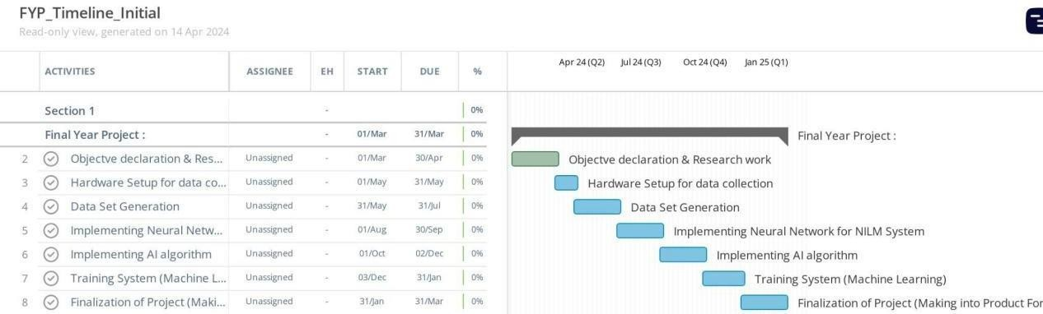
Figure 1.1: Timeline of the Project

Work Division
- Research work, theoretical background and AI algorithm training & Implementation is performed by MUHAMMAD SALMAN.
- Deployment of trained AI algorithm, Hardware design and Programming of system for data set collection is performed by MUHAMMAD MAHMOOD GHAURI.
- PCB Designing is performed by MUHAMMAD MOIN DILDAR.

Organization of Report
In Chapter 1, an introduction is presented and discusses the background motivation to perform this project. Also mentioned the previous work done on technologies used in this project. Chapter 1 discusses why today’s world needs it and what objectives are to be achieved. Also, what cost and timeline required to do this project.
Chapter 2 discusses the final product specifications and approach used to achieve the above- mentioned objectives. Also chapter 2 describe the methodology adopted to achieve the objectives of Project and Schematics of the Systems.
Chapter 3 explain the AI algorithm seq2point model used and flowchart explain the code flow of the model
Chapter 4 discusses the Experimental Setup designed, made, tested and deployed to implement ILM system (during dataset collection), NILM system (final electric meter) and test bench to test NILM system.
Chapter 5 explains the output of the system like how AI model is predicting Active Power of each device in a real-world scenario.
Chapter 6 recommend the future improvements to be made to make the system more efficient.

Description
Chapter 1, the background, motivations, and already research related to AI-powered energy management systems had been studied, In Chapter 2, further searched on the project. Here, a detailed description of the system itself, outlining the methodology behind its development, product specifications, and a preliminary schematic diagram. And also delve into the design considerations and initial calculations that will guide the project's implementation.

Description of the Project
This project aims to monitor energy consumption using smart technology called Non- Intrusive Load Monitoring (NILM) Using Artificial Intelligence (AI). The main goal of this device is to help businesses and households to keep track of their energy usage in a simple and efficient way. The project consists of several components, including the design of the monitoring system, the integration of NILM and AI technologies using Raspberry Pi 4B (4GB RAM), ESP 32, sensors (Smart Samaan single phase energy metering module) and Display. The device works by analyzing overall energy consumption data to identify patterns associated with specific appliances or behaviors, without the need for intrusive methods like installing sensors on individual devices. It helps businesses and homes to save money by finding ways to reduce their energy usage and to protect the environment by promoting energy-saving practices that reduce pollution and save resources and it makes energy monitoring easier for everyone, so more people can manage their energy usage better.

Methodology
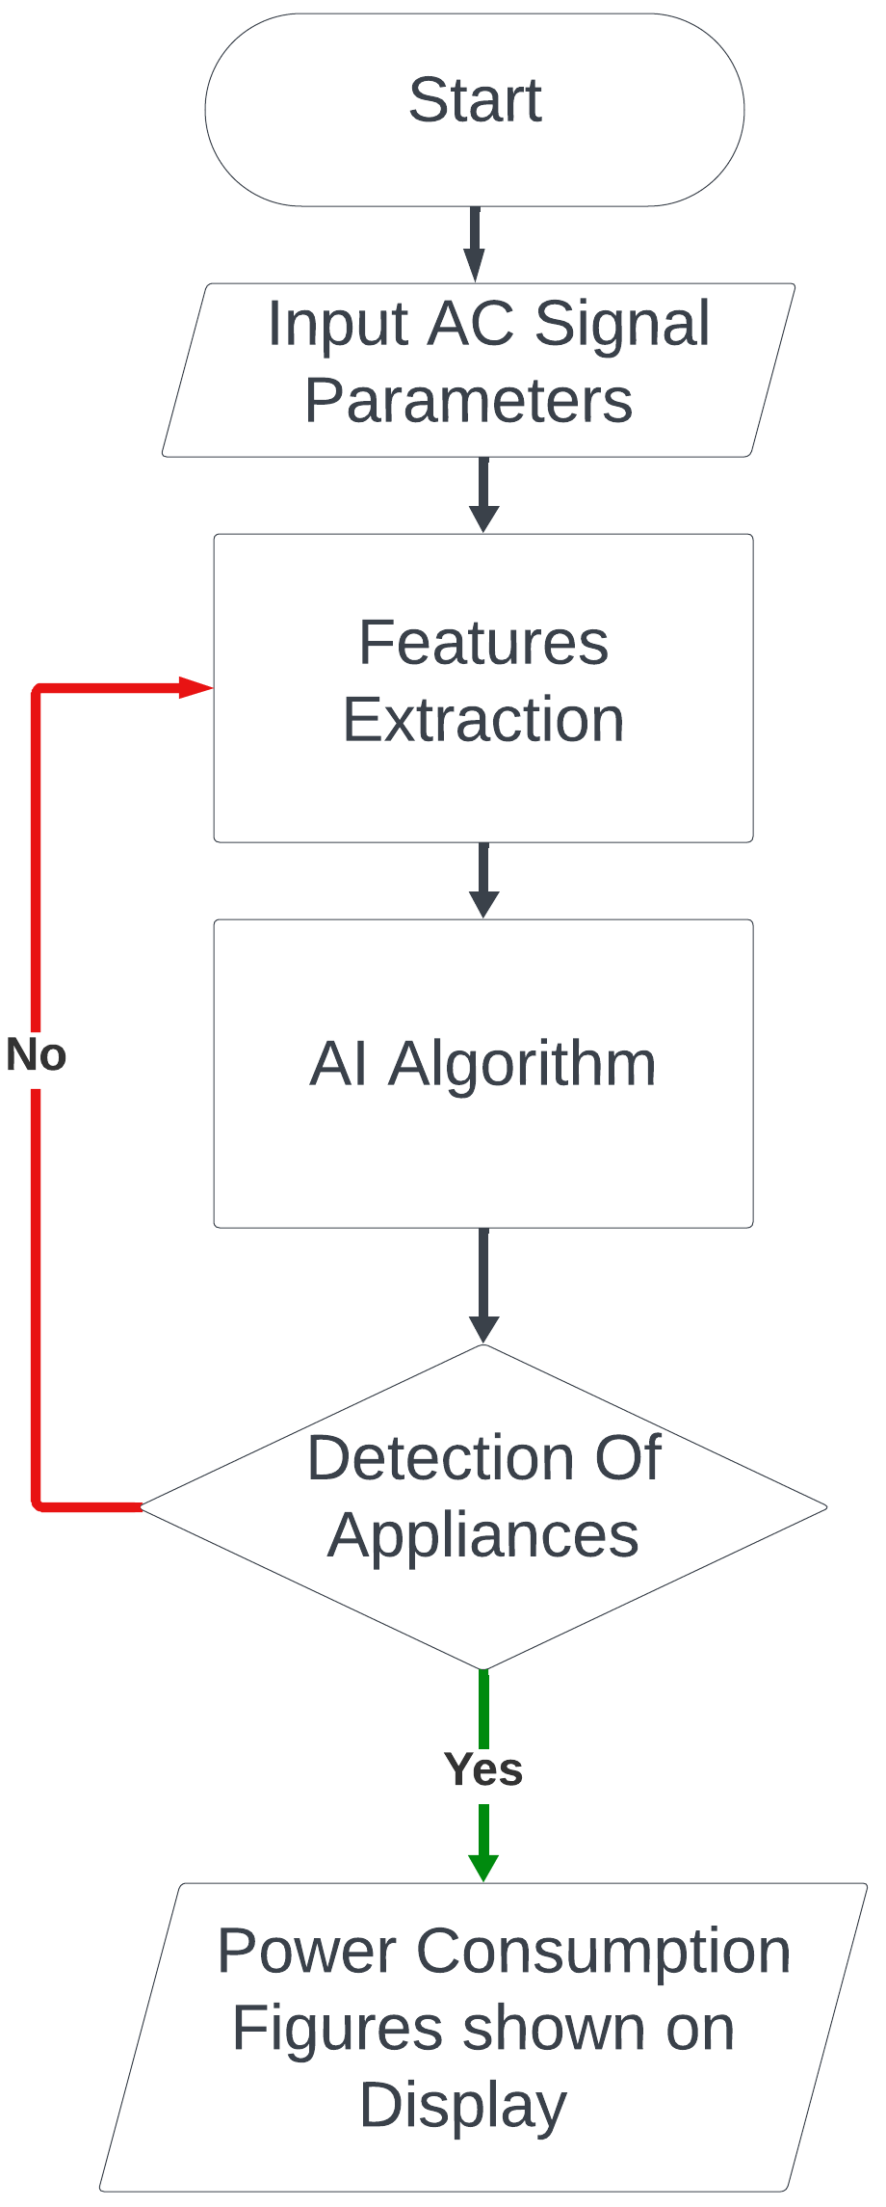
Figure 2.1: Code Flow in the form of Flow Chart

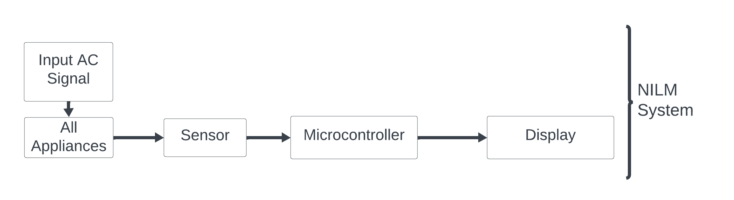
Figure 2.2: Block Diagram of NILM System (Final System)
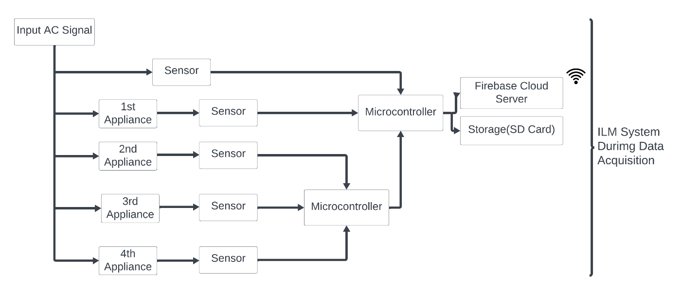
Figure 2.3: Block Diagram of ILM System (During Dataset Collection)
In Figure 2.1, flow of code is represented in the form of flowchart. The system will extract feature and AI algorithm by using these features detects which appliance is consuming energy and the results will be shown on display. Also results will be transmitted to wireless monitoring station.
In Figure 2.3, the system is shown in block diagram form during data set generation where the system will act as an intrusive load monitoring system in which signal from each appliance will be stored in a storage device and overall signal of combined load of input will be analyzed and stored.
In Figure 2.2, the final product is shown on block diagram level in which system will be Non- Intrusive Load Monitoring system. The system will only analyze input signals and through Energy Disaggregation technique, energy consuming device and energy consumption by each device will be detected.

Product Specifications
Here, the list of features and operational specifications of our project is mentioned.
- Real-Time Monitoring: The device provides up-to-date information on energy consumption, permitting users to path usage patterns as they occur.
- Non-Intrusive Operation: Using Non-Intrusive Load Monitoring (NILM) technology, the system analyzes overall power consumption without the need for intrusive hardware installation.
- AI Integration: By including Artificial Intelligence, the device can identify individual appliance usage patterns and provide insights for monitor and display.
- User-Friendly Interface: The device features a simple interface that permits users to easily access and illuminate energy usage data.
- Environmental Sustainability: It helps protect the environment by promoting energy- saving practices that reduce pollution and save resources and it makes energy monitoring easier for everyone, so more people can manage their energy use better

Schematic Diagram
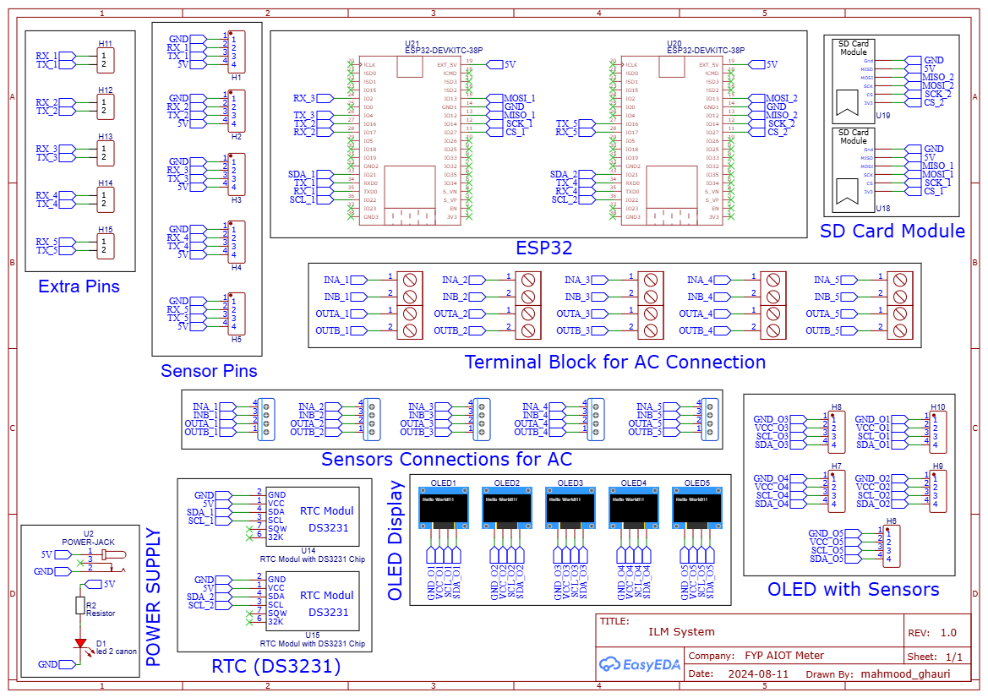
Figure 2.4: Schematic Diagram of ILM System (During Dataset Collection)
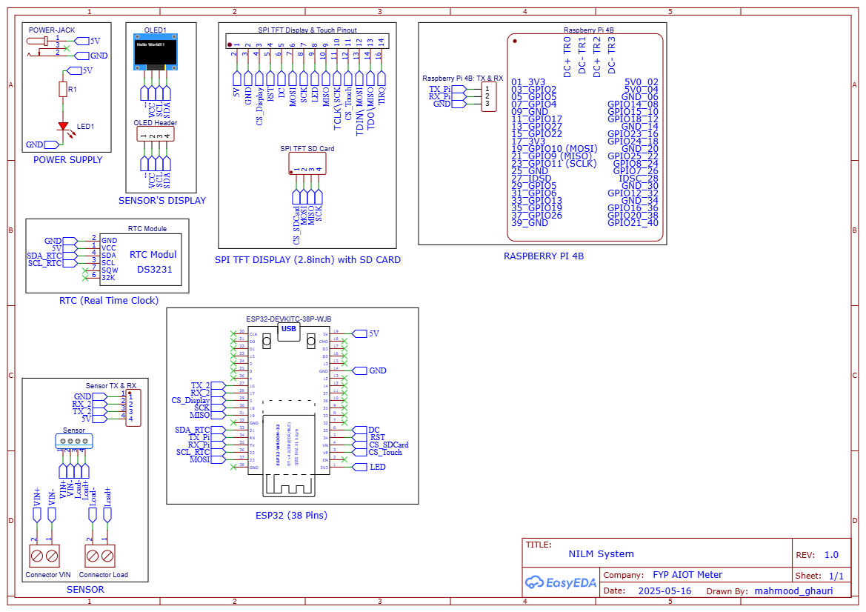
Figure 2.5: Schematic Diagram of NILM System (Final System)

Preliminary Design and Calculations
- Vmax = 840 Vpeak
- Imax = 43 A
- Single Phase Energy Monitoring

Modeling and Simulation

Algorithms
Algorithm for Sequence-to-Point NILM
This algorithm describes the steps to implement the Sequence-to-Point CNN model for NILM, from data preprocessing to real-time deployment.
- Input Aggregate Power Data
Obtain aggregate power measurements from a smart meter or an energy monitoring system.
- Preprocess the Data
  - Normalization: Adjust the power data to achieve a mean of 0 and a standard deviation of 1.
  - Sliding Window Method: Split the data into fixed-size overlapping segments (for example, 599 samples per segment).
  - Designate the power reading of the appliance at the center of each segment as the target value for training.
- Configure the Sequence-to-Point CNN Model
  - Specify a CNN architecture that includes convolutional layers for feature extraction and fully connected layers for output regression.
  - Input: A sequence of aggregate power samples (e.g., 599 samples).
  - Output: A single value indicating the power consumption of the appliance at the midpoint.
- Train the Model
Utilize the prepared dataset to train the CNN model:
    - Loss Function: Aim to minimize the Mean Squared Error (MSE) between predicted and actual outcomes
    - Optimizer: Implement the Adam optimizer to achieve quicker convergence
    - Conduct training in batches and perform multiple epochs of iteration.
- Validate and Test the Model
Evaluate the trained model on validation and test datasets using:
- Mean Absolute Error (MAE): Average error in predictions.
- Signal Aggregate Error (SAE): Measure of total energy prediction accuracy.
- Quantize the Model for Deployment
Convert the model weights from 32-bit floating-point to 8-bit integers to reduce size and computational requirements.
- Deploy the Model on an Embedded Device
Deploy the quantized model on a Raspberry Pi 4B.
- Real-Time Processing
- Feed real-time aggregate power readings to the model.
- Use the sequence-to-point structure to predict appliance-level power consumption for the current window.
- Output Appliance-Level Power
Generate real-time predictions of power usage for individual appliances, enabling energy monitoring and analysis.

Flowcharts
The following flowchart shows the steps for using a sequence-to-point CNN model for Non- Intrusive Load Monitoring (NILM). It starts with collecting total power usage data, which is processed by normalizing and splitting it into smaller windows. A CNN model is trained to predict the power usage of individual appliances from this data. After training, the model is simplified (quantized) to run on a small device like a raspberry pi 4b. Once deployed, it processes live power data and provides real- time predictions of how much power each appliance is using.
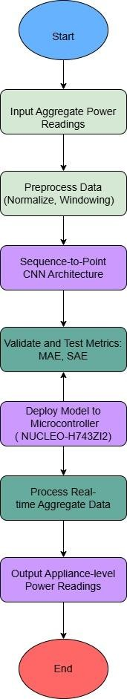
Figure 3.1: Flow of Code in SEQ2Point (AI Model)

Experimental Setup
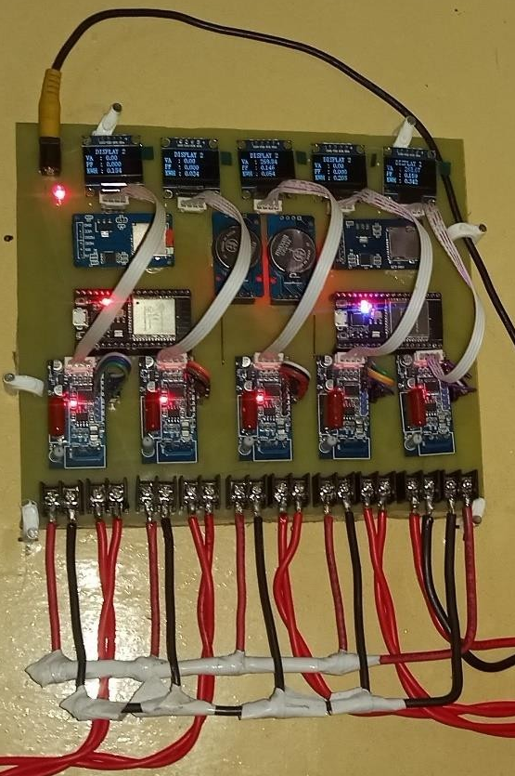
Figure 4.1: Hardware of ILM System Installed at Home (During Dataset Collection)
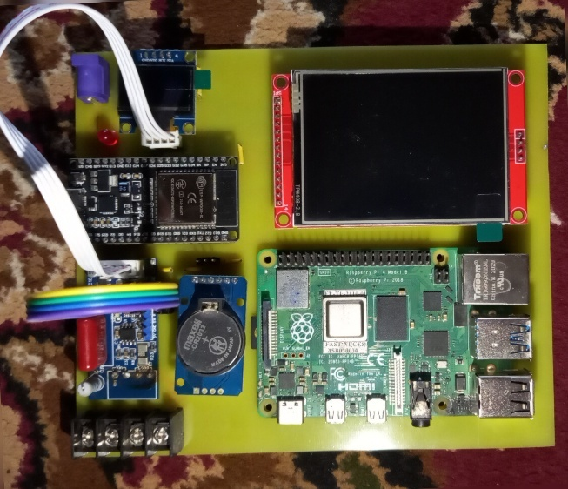
Figure 4.2: Hardware of NILM System Installed at Home (Final System)
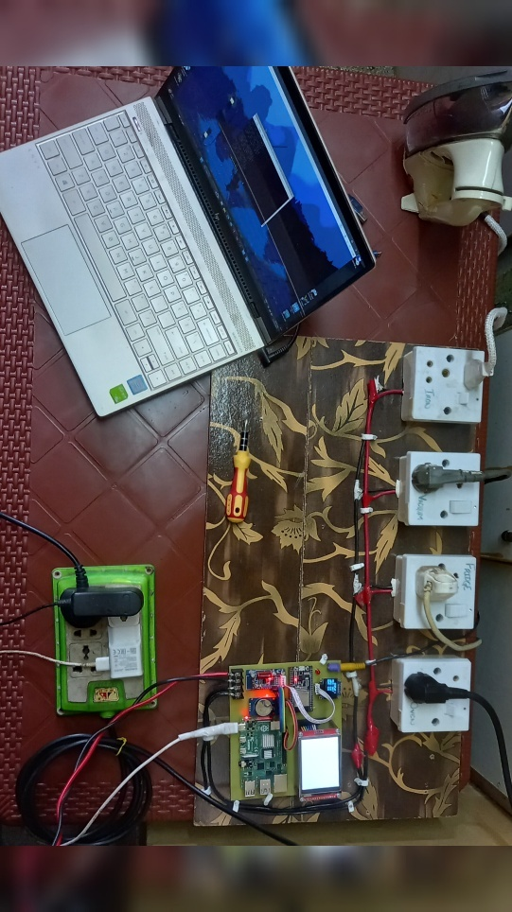
Figure 4.3: Test Bench for testing of NILM System (Final System)

Hardware Description
In Final Product NILM system is implemented in which sensor is reading the features of input AC supply. ESP32 is reading features of input AC supply and transmitting features to Raspberry Pi 4B via serial port. Raspberry Pi runs AI model and give real-time sensor to AI model as an input. Output results (Predicted Active Power of individual device and ON/OFF state of each device) are shown on display mounted on system.
For data set collection ILM system is implemented in which each sensor is reading the features of each appliance. Also, one sensor is reading features of input AC supply. These sensors are serially transmitting features to ESP32s and then ESP32s are storing these features in SD card & cloud-based Firebase database. Real time clock module to get UNIX-timestamp for dataset. Features which we will be extracting during Dataset collection are shown in following Figure 4.4:
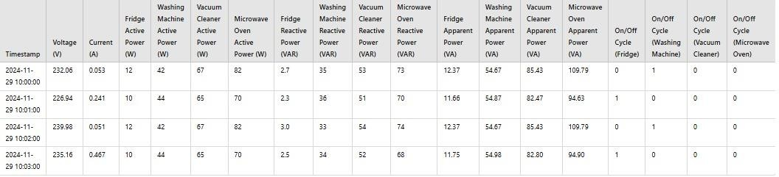
Figure 4.4: Features of each device collected during Dataset Collection (ILM System)

Components
Table 4.1: List of Hardware Components
Single Phase Energy Metering Module by Smart Samaan | 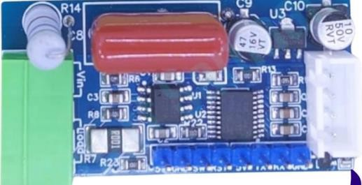
ESP32 | 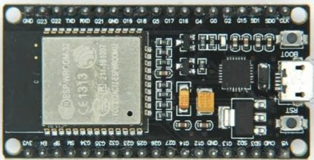
RTC DS3231 | 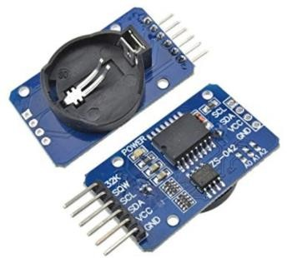
SD Card Module | 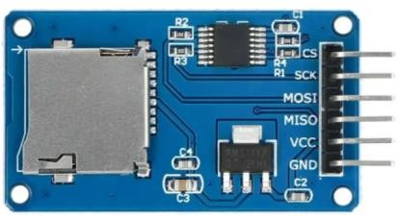
OLED Display | 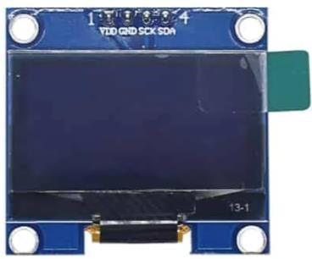
5V, 2A DC Supply Charger | 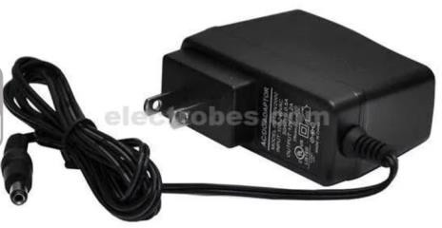
Wires (3/29, 7/29) | 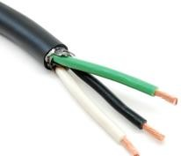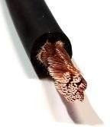
Raspberry Pi 4B (8GB RAM) | 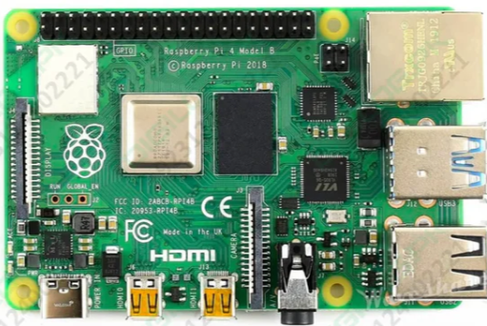
TFT Display | 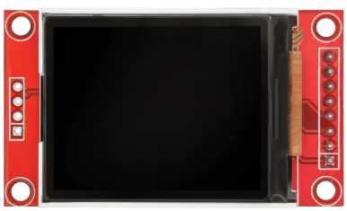

Results and Discussion
The Seq2Point show effectively forecasted four domestic appliances dynamic control consumption Iron, Vacuum, Fridge, and Oven and their ON/OFF states classification. The relapse errand shown a moo cruel supreme mistake (MAE), reflecting exact control estimation, and the classification assignment displayed a tall F1 score, reflecting reliable location of gadget operation cycles. The convolutional structure of the demonstrate backed significant highlight extraction from time-series input information, upgrading generally forecast precision. Comparisons of visual genuine and anticipated control values guaranteed the solidness of the Seq2Point show. Trading the prepared show to TensorFlow Lite made it conceivable to convey effectively on Raspberry Pi 4, which is perfect for real-time vitality observing.

Results
In this Project, we built and prepared a Seq2Point demonstrate to foresee mutually the dynamic control utilization and operational state (ON/OFF) of four domestic machines: Press, Vacuum, Ice chest, and Stove. The show might learn from the input highlights and make rectify estimations for both relapse and classification tasks.
At test time, the show delivered an amazingly moo Cruel Supreme Blunder (MAE) of 0.00518 for anticipating control, reflecting tall exactness in approximating vitality utilization. The Normalized Disaggregation Mistake (NDE) was 0.2323, once more affirming to the model's capacity to closely track genuine control signals. Within the classification assignment, the demonstrate achieved an amazing F1 Score of 0.9962, reflecting sublime precision in recognizing apparatus ON/OFF status.
We too tried the execution of the show utilizing visual comparisons of genuine and evaluated control values, which confirmed tight assertion between real and evaluated information. The comes about hence appear that the show generalizes to inconspicuous information and can be trusted in commonsense use.
In expansion, the show was effectively ported to the TensorFlow Lite organize and executed on a Raspberry Pi 4 board. This illustrates the model's status for inserted, real-time vitality observing frameworks utilized in savvy homes.

Table 5.1: Results of Combinations Detected by NILM System (Final System)
Combination No. | Devices Combination | Status
1 | Fridge | Detected
2 | Iron | Detected
3 | Vacuum | Detected
4 | Oven | Detected
5 | Fridge + Iron | Detected
6 | Fridge + Vacuum | Detected
7 | Fridge + Oven | Not Detected
8 | Iron + Vacuum | Detected
9 | Iron + Oven | Detected
10 | Vacuum + Oven | Not Detected
11 | Fridge + Iron + Vacuum | Detected
12 | Fridge + Iron + Oven | Detected
13 | Fridge + Vacuum + Oven | Not Detected
14 | Iron + Vacuum + Oven | Not Detected
15 | Fridge + Iron + Vacuum + Oven | Not Detected

Overall, the extend shows promising signs of improving vitality proficiency and keen gadget administration through correct disaggregation of control utilization in a multi-device setup.
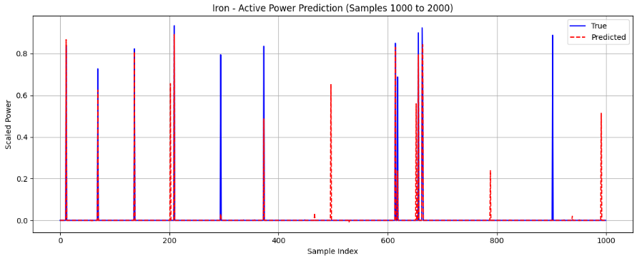
Figure 5.1: Trained Model Output Prediction of Iron Active Power
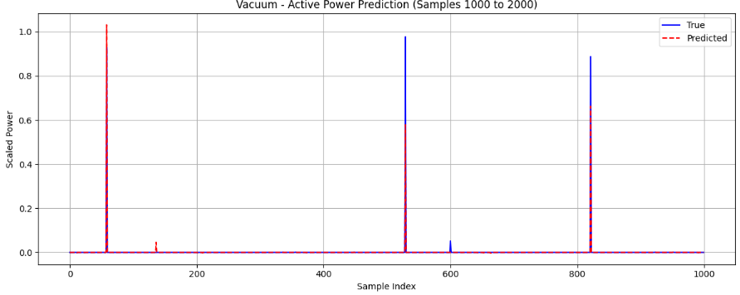
Figure 5.2: Trained Model Output Prediction of Vacuum Cleaner Active Power
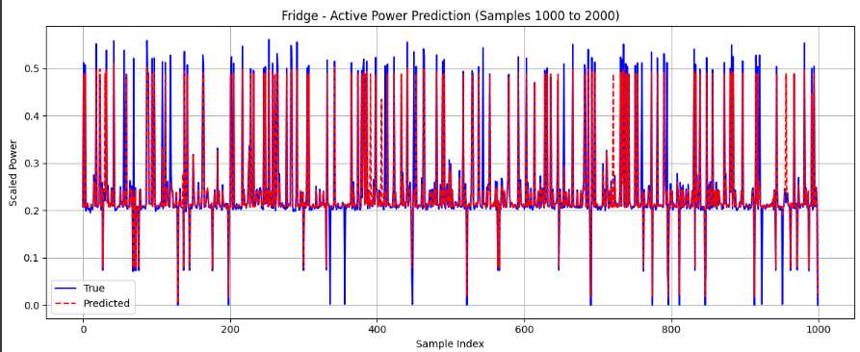
Figure 5.3: Trained Model Output Prediction of Fridge Active Power
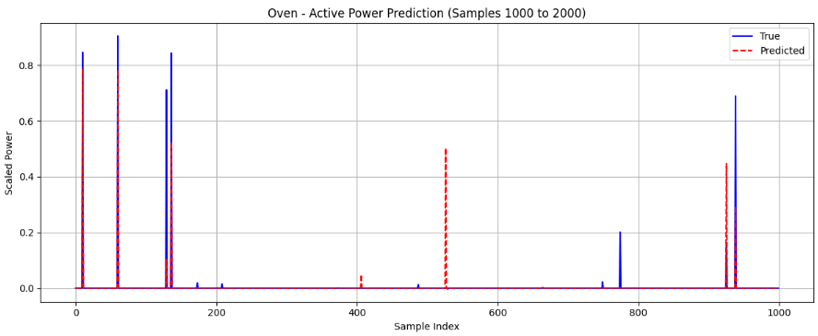
Figure 5.4: Trained Model Output Prediction of Oven Active Power
The Seq2Point model delivered strong overall results. For the Power regression task, it achieved an MAE of 0.34 and an NDE of 0.1512, indicating highly accurate predictions. For the Cycle classification, the model reached an impressive F1 score of 0.957, showing good prediction performance.
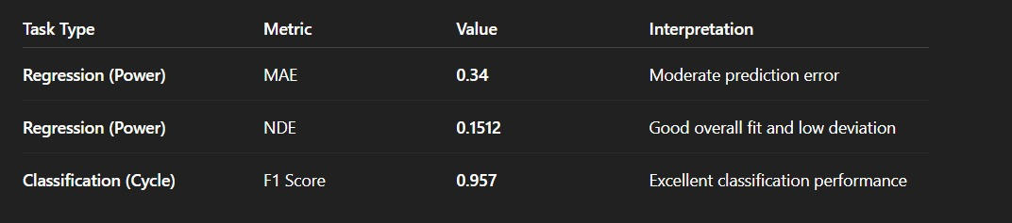
Figure 5.5: AI Model Output Scores
Figure 5.6: Hardware of Final Electric Meter implementing NILM System

Discussion
The extend was completed independently in different parts with the point of accomplishing generally adjust vitality disaggregation. The dataset was to begin with accumulated from family apparatuses with both control utilization values and operational cycle statuses. The crude information was at that point preprocessed, normalized, and organized for demonstrate preparing with most extreme care.
Subsequently, windowed arrangements of input information were built utilizing a sliding window approach to account for transient connections within the control signals. These arrangements contained normalized timestamps and add up to dynamic control as the inputs to the model.
A Seq2Point multitask profound learning show was created and prepared to perform two errands at once: relapse for determining dynamic control utilization of four gadgets, and classification to recognize their ON/OFF states. Strategies counting dropout layers and callbacks such as early halting and learning rate lessening were utilized to optimize preparing and avoid overfitting.
The demonstrate was tried on another free test set and gave amazing execution measurements a Cruel Supreme Blunder (MAE) of 0.00518 and Normalized Disaggregation Blunder (NDE) of 0.2323 for control forecast, and a fabulous F1 Score of 0.9962 for gadget state classification.
Visual comparison of real versus evaluated control utilization advance outlined the model's tall exactness. In conclusion, the demonstrate was optimized to TensorFlow Lite and effectively actualized on a Raspberry Pi 4, highlighting its real-world utilization on implanted hardware.
Overall, the project included information collection, preprocessing, multitask learning, exhaustive assessment, and real-world arrangement â effectively giving a effective and effective arrangement for appliance-level vitality checking.

Project Outcomes
- Successfully collected and prepared a comprehensive dataset containing power consumption and operational cycle data for multiple household appliances.
- Developed a multitask Seq2Point deep learning model that performs both regression (predicting active power) and classification (detecting ON/OFF states) tasks simultaneously.
- Achieved high performance metrics with a Mean Absolute Error (MAE) of 0.00518 for power prediction and an F1 Score of 0.9962 for classification accuracy.
- Implemented effective training techniques including dropout layers and callbacks to prevent overfitting and optimize learning.
- Validated the model’s predictions with visual plots comparing true and predicted values, confirming strong alignment.
- Converted the trained model to TensorFlow Lite format and deployed it on a Raspberry Pi 4, demonstrating practical real-time application capability.
- Provided a scalable and cost-effective solution for detailed energy monitoring in residential settings.

Project Impact
This project represents a major step forward in home energy monitoring by allowing for accurate, device-level power usage analysis. The multitask Seq2Point model's capability of predicting power consumption and device status jointly provides an efficient and effective solution that surpasses conventional single-task approaches.
By running the model on a low-cost Raspberry Pi 4, the project closes the loop between high-level AI methods and low-cost practical hardware implementation. This renders intelligent energy management more accessible to a wider audience, promoting energy-saving habits.
The precise monitoring capability can help reduce wasteful power consumption, lower electricity bills, and promote environmental sustainability through minimizing carbon footprints.
In addition, the scalability of this method makes it easy to add more appliances to it and combine it with smart home systems for smarter, more sustainable homes.

Conclusions and Future Recommendations

Conclusions
In this Final Year Project, we successfully developed and implemented a Non-Intrusive Load Monitoring (NILM) system using an AI-based algorithm to identify and monitor the power consumption of four common household appliances. By focusing on a limited number of appliances, we were able to effectively train and test our algorithm, demonstrating the feasibility and practicality of NILM in a simplified yet realistic home environment.
The system was able to analyze aggregated energy data and accurately disaggregate the power usage of individual devices, providing valuable insights into energy consumption patterns. This not only validates the potential of NILM technology for energy monitoring and conservation but also lays a foundation for future expansion toward a more comprehensive smart home energy management system.
While our project focused on only four appliances due to scope and resource constraints, the framework developed is scalable and adaptable. With further refinement and training on larger datasets, the AI algorithm can be extended to accommodate a wider range of devices, enhancing its application in real-world settings. Overall, this project highlights the role of artificial intelligence in advancing energy efficiency and promotes the adoption of smart energy solutions in residential sectors.

Future Recommendations
Future work should include a broader range of household appliances with varying power consumption patterns. This will enhance the system’s scalability and improve its applicability to real-world home environments.
Collecting a larger and more diverse dataset, including data from different households, will help improve the accuracy and generalization of the AI model. Incorporating transfer learning or ensemble methods could also enhance performance.
Deploy the NILM system on a real-time embedded platform such as an STM32 microcontroller with optimized AI inference. This will allow the system to operate autonomously and efficiently in a live household setting.

Bibliography
[1] | G. Hart, "Prototype Nonintrusive Appliance Load Monitor," Electric Power Research Institute, Virginia, USA, 1985.
[2] | M. Dong, P. C. Meira, W. Xu and C. Y. Chung, “Non-intrusive signature extraction for major residential loads,” IEEE Transactions on Smart Grid, vol. 4, no. 3, p. 1421–1430, 2013.
[3] | G. Bucci, F. Ciancetta, E. Fiorucci and S. Mari, "Load identification system for residential applications based on the NILM technique," in 2020 IEEE International Instrumentation and Measurement Technology Conference (I2MTC), Dubrovnik, Croatia, 2020.
[4] | D. F. teshome, T. D. Huang and K. L. Lian, “Distinctive load feature extraction based on Fryze’s time-domain power theory,” IEEE Power and Energy Technology Systems Journal, vol. 3, no. 2, pp. 60-70, 2016.
[5] | S. Gupta, M. S. Reynolds and S. N. Patel, "ElectriSense: Single-point sensing using EMI for electrical event detection and classification in the home," in 12th ACM International Conference on Ubiquitous Computing (UbiComp), New York, USA, 2010.
[6] | G. Bucci, F. Ciancetta, E. Fiourucci, S. Mari and A. Fioravanti, “Measurements for non-intrusive load monitoring through machine learning approaches,” Acta IMEKO, vol. 10, no. 1, pp. 90-96, 2021.
[7] | S. Dash and N. C. Sahoo, “Electric energy disaggregation via non-intrusive load monitoring: A state-of-the-art systematic review,” Electric Power Systems Research, vol. 213, p. 108674, 2022.
[8] | J. Z. Kolter, S. Batra and A. Y. Ng, “Energy disaggregation via discriminative sparse coding,” in 23rd International Conference on Neural Information Processing Systems (NIPS), Vancouver, Canada, 2010.
[9] | H. D. Kim, M. Marwah, M. Arlitt, G. Lyon and J. Han, “Unsupervised disaggregation of low frequency power measurements,” in 2011 SIAM International Conference on Data Mining, New York, USA, 2011.
[10] | O. Parson, S. Ghosh, M. Weal and A. Rogers, “Non-intrusive load monitoring using prior models of general appliance types,” in National Conference on Artificial Intelligence (AAAI), Toronto, Canada, 2012.
[11] | R. Bonfigli, E. Principi, M. Fagiani, M. Severini, S. Squartini and F. Piazza, “Non-intrusive load monitoring by using active and reactive power,” Applied Energy, vol. 208, pp. 1590-1607, 2017.
[12] | F. Paradiso, F. Paganelli, D. Giuli and S. Capobianco, “Context-based energy disaggregation in smart homes,” Future Internet, vol. 8, no. 1, pp. 1-14, 2016.
[13] | J. Kelly and W. Knottenbelt, “Deep neural networks applied to energy disaggregation,” in 2nd ACM International Conference on Embedded Systems for Energy-Efficient Built Environments (BuildSys ’15), New York, USA, 2015.
[14] | Sense, “Sense Energy Monitor,” January 2022. [Online]. Available: https://sense.com/.
[15] | S. Mari, G. Bucci, F. Ciancetta, E. Fiorucci and A. Fioravanti, “An embedded deep learning NILM system,” IEEE Transactions on Instrumentation and Measurement, vol. 72, pp. 1-13, 2023.

Appendices

Appendix A
Source Code of the ILM System during Dataset Collection: ESP32 Slave

Appendix B
Source Code of the ILM System during Dataset Collection: ESP32 Master

Appendix C
Source Code (ESP32) of Final Electric Meter implementing NILM System: ESP32 NILM

Appendix D
Source Files (Raspberry Pi) of Final Electric Meter implementing NILM System: Raspberry Pi 4B NILM

Appendix E
All Source Files of this Project: Source Files

