**An agile methodology** is an iterative approach to software development. Each iteration of agile methodology takes a short time interval of 1 to 4 weeks. The agile development process is aligned to deliver the changing business requirement. It distributes the software with faster and fewer changes.

The single-phase software development takes 6 to 18 months. In single-phase development, all the requirement gathering and risks management factors are predicted initially.

The agile software development process frequently takes the feedback of workable product. The workable product is delivered within 1 to 4 weeks of iteration.

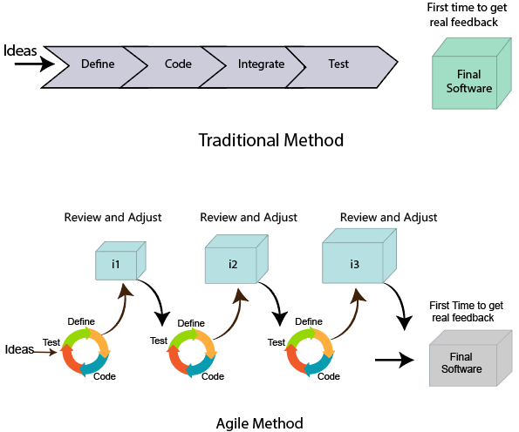

**Agile Manifesto--**

**Values -**

1. Individuals and interactions over Processes and tools.
2. Working software over comprehensive documentation.
3. Customers are collaboration over contact negotiation.
4. Responding to change over following a plan.

**Principles:**

1. **Customer Satisfaction:** Manifesto provides high priority to satisfy the costumer's requirements. This is done through early and continuous delivery of valuable software.
2. **Welcome Change:** Making changes during software development is common and inevitable. Every changing requirement should be welcome, even in the late development phase. Agile process works to increase the customers' competitive advantage.
3. **Deliver the Working Software:** Deliver the working software frequently, ranging from a few weeks to a few months with considering the shortest time period.
4. **Collaboration:** Business people (Scrum Master and Project Owner) and developers must work together during the entire life of a project development phase.
5. **Motivation:** Projects should be build around motivated team members. Provide such environment that supports individual team members and trust them. It makes them feel responsible for getting the job done thoroughly.
6. **Face-to-face Conversation:** Face-to-face conversation between Scrum Master and development team and between the Scrum Master and customers for the most efficient and effective method of conveying information to and within a development team.
7. **Measure the Progress as per the Working Software:** The working software is the key and primary measure of the progress.
8. **Maintain Constant Pace:** The aim of agile development is sustainable development. All the businesses and users should be able to maintain a constant pace with the project.
9. **Monitoring:** Pay regular attention to technical excellence and good design to maximize agility.
10. **Simplicity:** Keep things simple and use simple terms to measure the work that is not completed.
11. **Self-organized Teams:** The Agile team should be self-organized. They should not be depending heavily on other teams because the best architectures, requirements, and designs emerge from self-organized teams.
12. **Review the Work Regularly:** The work should be reviewed at regular intervals, so that the team can reflect on how to become more productive and adjust its behavior accordingly.

**Agile Project Management**

Agile project management is an interactive approach to manage software development. The agile project management focuses on continuous releases and covers customer feedback with every iteration.

Traditionally the agile project management is classified into two frameworks: **scrum and kanban.** The [scrum framework](https://www.javatpoint.com/agile-scrum) focused fixed-length project iterations, whereas [kanban framework](https://www.javatpoint.com/agile-kanban) focused on continuous releases. After competition of project first iteration (or steps) project management activity immediately moves on to the next.

The agile project management calls for teams to regularly evaluate cost and time as they move through their work. They use velocity, burnup and burndown charts to measure their work, rather than Gantt charts and project milestones to track progress.

The agile team practices to continuous development and continuous integration using technology that automates steps to speed up the release and use of products.

The presence and participation of the project manager are not required in agile project management. Although the presence of the project manager is essential for success under the traditional (waterfall model) project delivery. The role of the project manager is to distribute task among team members. However, the project manager is not obsolete in agile project management, and many organizations use them in a large, more complex project. The organization mostly places them in the project coordinator role.

Agile Project Management demands that team members know how to work in this new agile methodology. The team member must be able to coordinate with each other, as well as with users.

**Scrum** is a framework that helps agile teams to work together. Using it, the team members can deliver and sustain the complex product. It encourages the team to learn through practice, self-organize while working on the problem. Scum is a work done through the framework and continuously shipping values to customers.

It is the most frequent software that is used by the development team. Its principle and lessons can be applied to all kinds of teamwork. Its policy and experiences is a reason of popularity of Scrum framework. The Scrum describes a set of tools, meetings, and roles that help the teams structure. It also manages the work done by the team.

**Kanban** is a popular framework which is used to implement agile software development. It takes real time communication of capacity and complete transparency of work. The work items are represented in a kanban board visually, allowing team members to see the state of every piece of work at any time.

**Kanban vs Scrum board**

The following are the differences between Kanban and Scrum board:

|  |  |
| --- | --- |
| **Kanban** | **Scrum** |
| Kanban is an ongoing process. | Scrum sprints have a start and stop dates |
| Kanban has no formal roles. | Role is clearly defined of each team in the scrum (product owner, development team, and scrum master). Both teams are self-organized. |
| A kanban board is used throughout the lifecycle of a project | Scrum board is cleared and recycled after each sprint. |
| This board is more flexible with regards to tasks and timing. Its task can be reprioritized, reassigned, or updated as needed. | This board has the number of tasks and a strict deadline to complete them. |