The **Agile methodology** is a practice that promotes continuous iteration of development and testing throughout entire SDLC. So, development and testing activities are concurrent.

**Agile** is a term used to describe software development approaches that employ continual planning, learning, improvement, team collaboration, evolutionary development, and early delivery. It encourages flexible responses to change.

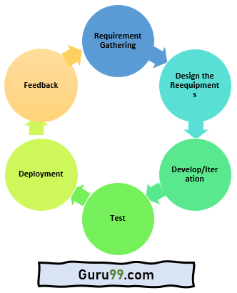

The agile software development emphasizes on **four core values.**

* Individual and team interactions over processes and tools
* Working software over comprehensive documentation
* Customer collaboration over contract negotiation
* Responding to change over following a plan

**Agile method in software testing:**

* Agile methodologies propose incremental and iterative approach to software design.
* **Agile process** in software testing is broken into individual models that designers work on.
* The customer has early and frequent opportunities to look at the product and make decision and changes to the project.
* Error can be fixed in the middle of the project.
* Development process is iterative, and the project is executed in short (2-4) weeks iterations. Planning is very less.
* Every iteration has its own testing phase. It allows implementing regression testing every time new functions or logic are released.
* At the end of every sprint, user acceptance is performed.
* It requires close communication with developers and together analyze requirements and planning.

**Agile model Manifesto:**

* Individuals and interactions are given priority over processes and tools.
* Adaptive, empowered, self-organizing team.
* Focuses on working software rather than comprehensive documentation.
* Agile Model in software engineering aims to deliver complete customer satisfaction by rapidly delivering valuable software.
* Welcome changes in requirements, even late in the development phase.
* Daily co-operation between businesspeople and developers.
* Priority is customer collaboration over contract negotiation.
* It enables you to satisfy customers through early and frequent delivery.
* A strong emphasis is placed on face-to-face communication.
* Developing working software is the primary indicator of progress.
* Promote sustainable development pace.
* A continuous focus is placed on technical excellence and sound design.
* An improvement review is conducted regularly by the team.

**Types of Agile:**

1. Scrum
2. DSDM (Dynamic Software Development method)
3. Crystal
4. Kanban
5. Feature Driven Development
6. Lean Software Development
7. Extreme Programming

**Scrum:** This agile method focuses primarily on managing tasks in team-based development conditions. In the [Scrum Agile model](https://www.guru99.com/agile-scrum-extreme-testing.html#scrum), the team should strictly follow a work plan for each Sprint. Agile and Scrum consist of three roles:

* [**Scrum Master**](https://www.guru99.com/scrum-master-training.html)is responsible for setting up the team, sprint meeting and removes obstacles to progress.
* **The Product Owner** creates product backlog, prioritizes the backlog and is responsible for the delivery of the functionality at each iteration.
* **Scrum Team manages** its own work and organizes the work to complete the sprint or cycle.

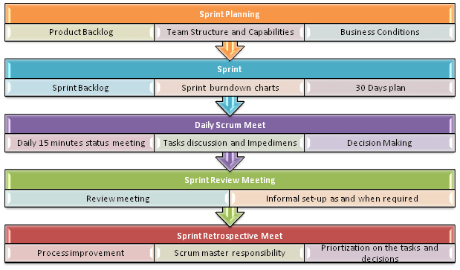

**Process Flow:**

* Each iteration of a scrum is known as Sprint
* Product backlog is a list where all details are entered to get the end-product
* During each Sprint, top user stories of Product backlog are selected and turned into Sprint backlog
* Team works on the defined sprint backlog
* Team checks for the daily work
* At the end of the sprint, team delivers product functionality

**Crystal:** Using Crystal methodology is one of the most straightforward and most flexible approaches to developing software, recognizing that each project has unique characteristics. Therefore, policies and practices need to be tailored to suit them.

Crystal Methodology is based on three concepts:

1. **Chartering:** Various activities involved in this phase are creating a development team, performing a preliminary feasibility analysis, developing an initial plan and fine-tuning the development methodology
2. **Cyclic delivery:** The main development phase consists of two or more delivery cycles, during which the
   1. Team updates and refines the release plan
   2. Implements a subset of the requirements through one or more program test integrate iterations
   3. Integrated product is delivered to real users
   4. Review of the project plan and adopted development methodology
3. **Wrap Up:** The activities performed in this phase are deployment into the user environment, post- deployment reviews and reflections are performed.

Crystal methodologies are categorized as below:

* **CLEAR:** User for small and low critical efforts.
* **ORANGE:** User for moderately larger and critical projects.
* **ORANGE WEB:** Typically, electronic business

**DSDM** is a [Rapid Application Development](https://www.guru99.com/what-is-rad-rapid-software-development-model-advantages-disadvantages.html) (RAD) approach to software development and provides an agile project delivery framework. The important aspect of DSDM is that the users are required to be involved actively, and the teams are given the power to make decisions. Frequent delivery of product becomes the active focus with DSDM. The techniques used in DSDM are

1. Time Boxing
2. MoSCoW Rules
3. Prototyping

The DSDM project consists of 7 phases

1. Pre-project
2. Feasibility Study
3. Business Study
4. Functional Model Iteration
5. Design and build Iteration
6. Implementation
7. Post-project

**Feature Driven Development** is focused around “designing & building” features. Unlike other Agile methods in software engineering, FDD describes very specific and short phases of work that has to be accomplished separately per feature. It includes domain walkthrough, design inspection, promote to build, code inspection and design. FDD develops product keeping following things in the target

1. Domain object Modeling
2. Development by feature
3. Component/ Class Ownership
4. Feature Teams
5. Inspections
6. Configuration Management
7. Regular Builds
8. Visibility of progress and results

**Lean software development** method is based on the principle “Just in time production”. It aims at increasing speed of software development and decreasing cost. Lean development can be summarized in seven steps.

1. Eliminating Waste
2. Amplifying learning
3. Defer commitment (deciding as late as possible)
4. Early delivery
5. Empowering the team
6. Building Integrity
7. Optimize the whole

**Extreme Programming technique** is very helpful when there is constantly changing demands or requirements from the customers or when they are not sure about the functionality of the system. It advocates frequent “releases” of the product in short development cycles, which inherently improves the productivity of the system and also introduces a checkpoint where any customer requirements can be easily implemented. The XP develops software keeping customer in the target. Business requirements are gathered in terms of stories. All those stories are stored in a place called the parking lot.

In this type of methodology, releases are based on the shorter cycles called Iterations with span of 14 days time period. Each iteration includes phases like coding, unit testing and system testing where at each phase some minor or major functionality will be built in the application.

**Kanban** is a very popular framework for development in the agile software development methodology. It provides a transparent way of visualizing the tasks and work capacity of a team. It mainly uses physical and digital boards to allow the team members to visualize the current state of the project they are working on.

**Agile vs Scrum:**

* Agile is a continuous iteration of development and testing in the software development process whereas Scrum is an Agile process to focus on delivering the business value in the shortest time.
* Agile methodology delivers the software on a regular basis for feedback while Scrum delivers the software after each sprint.
* In the Agile process, leadership plays a vital role; on the other hand, Scrum fosters a self-organizing, cross-functional team.
* Agile involves collaborations and face-to-face interactions between the members of various cross-functional teams whereas Scrum collaboration is achieved in daily stand up meetings.
* In Agile process design and execution should be kept simple whereas in Scrum process design and execution can be innovative and experimental.

**Agile vs Kanban:**

* Agile is a beneficial method for projects where the final goal is not set while Kanban is beneficial for Reducing waste and removing activities that never add value to the team.
* Agile process focuses on constant communication whereas Kanban process have shorter sprint lengths forced to break up items to fit within sprint boundaries.
* Agile process allows Iterative Development whereas Kanban process does not allow Iterative Development.
* Agile does not provide support for visually checking the work in progress while Kanban does allow visually checking the work in progress.
* The goal of Agile approach is continuous Integration, development and testing whereas the goal of Kanban approach is to improve the team’s process.
* Agile process depends on Story Boards while Kanban process depends on Kanban Boards.