**Agile Testing** is a testing practice that follows the rules and principles of agile software development.

Here are the essential Principles of Agile Testing:

* In this Agile testing model, working software is the primary measure of progress.
* The best result can be achieved by the self-organizing teams.
* Delivering valuable software early and continuously is our highest priority.
* Software developers must act to gather daily throughout the project.
* Enhancing agility through continuous technical improvement and good design.
* Agile Testing ensures that the final product meets the business’s expectations by providing continual feedback.
* In the Agile Test process, we need to execute the testing process during the implementation, which reduces the development time.
* Testing process in Agile should work on the consistent development pace
* Provide regular reflections on how to become more effective.
* The best architectures, requirements, and designs emerge from self-organizing teams.
* Each time the team meets, it reviews and adjusts its behavior in order to become more effective.
* Face-to-face conversation with the development team is the most effective and efficient method of conveying information within the team.

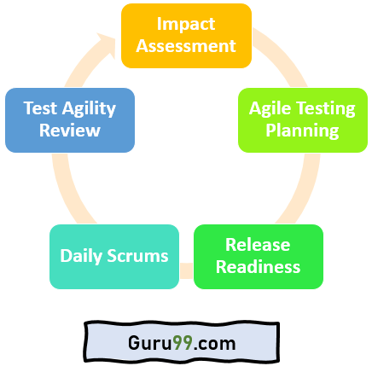

**Phase1: Impact Assessment:** In this initial phase, we gather inputs from stakeholders and users. This phase is also called the feedback phase, as it assists the test engineers in setting the objectives for the next life cycle.

**Phase 2: Agile Testing Planning:** It is the second phase of the Agile testing life cycle, where all stakeholders come together to plan the schedule of the testing process and deliverables.

**Phase 3: Release Readiness:** At this stage, we review the features that have been developed/ Implemented are ready to go live or not. In this stage, it is also decided which one needs to go back to the previous development phase.

**Phase 4: Daily Scrums:** This stage includes every standup morning meeting to catch up on the status of testing and set the goal for the entire day.

**Phase 5: Test Agility Review:** The last phase of the Agile life cycle is the Agility Review Meeting. It involves weekly meetings with stakeholders to regularly evaluate and assess progress against goals.

**Agile test plan** includes types of testing done in that iteration like test data requirements, infrastructure, [test environments](https://www.guru99.com/test-environment-software-testing.html), and test results. Unlike the waterfall model, in an agile model, a test plan is written and updated for every release. Typical test plans in agile includes

* Testing Scope
* New functionalities which are being tested
* Level or Types of testing based on the features complexity
* Load and Performance Testing
* Infrastructure Consideration
* Mitigation or Risks Plan
* Resourcing
* Deliverables and Milestones

**Agile Testing Strategies**

Agile testing life cycle spans through four stages

[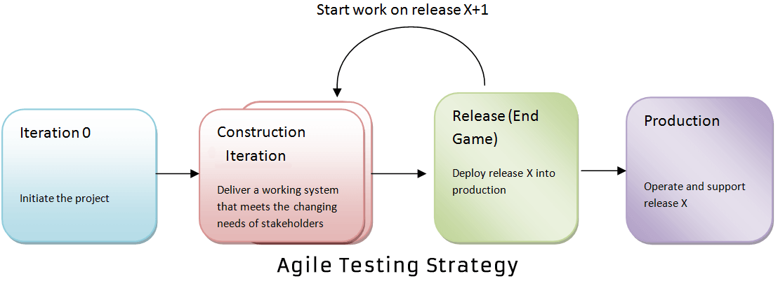](https://www.guru99.com/images/11-2014/agile_testing_1.png)

**Iteration 0**

During the first stage or iteration 0, you perform initial setup tasks. It includes identifying people for testing, installing testing tools, scheduling resources (usability testing lab), etc. The following steps are set to achieve in Iteration 0

* Establishing a business case for the project
* Establish the boundary conditions and the project scope
* Outline the key requirements and use cases that will drive the design trade-offs
* Outline one or more candidate architectures
* Identifying the risk
* Cost estimation and prepare a preliminary project

**Construction Iterations**

The second phase of agile testing methodology is Construction Iterations, the majority of the testing occurs during this phase. This phase is observed as a set of iterations to build an increment of the solution. In order to do that, within each iteration, **the team implements** a hybrid of practices from XP, Scrum, Agile modeling, and agile data and so on.

In construction iteration, the agile team follows the prioritized requirement practice: With each iteration, they take the most essential requirements remaining from the work item stack and implement them.

Construction iteration is classified into two, confirmatory testing and investigative testing. **Confirmatory testing concentrates** on verifying that the system fulfills the intent of the stakeholders as described to the team to date, and is performed by the team. While the investigative testing detects the problem that confirmatory team has skipped or ignored. In Investigative testing, tester determines the potential problems in the form of defect stories. Investigative testing deals with common issues like integration testing, load/stress testing, and security testing.

Again for, confirmatory testing there are two aspects **developer testing** and **agile acceptance testing. Both of them** are automated to enable continuous regression testing throughout the lifecycle. Confirmatory testing is the agile equivalent of testing to the specification.

Agile acceptance testing is a combination of traditional functional testing and traditional acceptance testing as the development team, and stakeholders are doing it together. While developer testing is a mix of traditional unit testing and traditional service integration testing. Developer testing verifies both the application code and the database schema.

**Release End Game Or Transition Phase**

The goal of “Release, End Game” is to deploy your system successfully into production. The activities include in this phase are training of end users, support people and operational people. Also, it includes marketing of the product release, back-up & restoration, finalization of system and user documentation.

The final agile methodology testing stage includes full system testing and acceptance testing. In accordance to finish your final testing stage without any obstacles, you should have to test the product more rigorously while it is in construction iterations. During the end game, testers will be working on its defect stories.

**Production**

After the release stage, the product will move to the production stage.

**The Agile Testing Quadrants**

[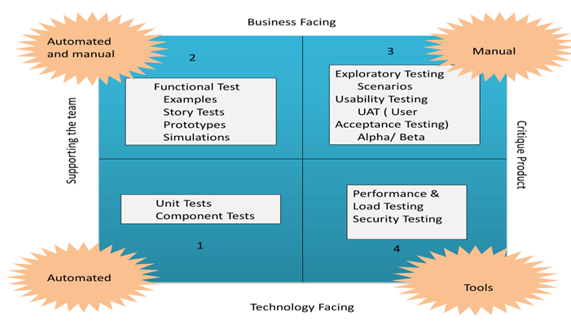](https://www.guru99.com/images/11-2014/agile_testing_2.png)

The agile testing quadrants separate the whole process in four Quadrants and help to understand how agile testing is performed.

**Agile Quadrant I**

The internal code quality is the main focus in this quadrant, and it consists of test cases which are technology driven and are implemented to support the team, it includes

* Unit Tests
* Component Tests

**Agile Quadrant II**

It contains test cases that are business driven and are implemented to support the team. This Quadrant focuses on the requirements. The kind of test performed in this phase is

* Testing of examples of possible scenarios and workflows
* Testing of User experience such as prototypes
* Pair testing

**Agile Quadrant III**

This quadrant provides feedback to quadrants one and two. The test cases can be used as the basis to perform automation testing. In this quadrant, many rounds of iteration reviews are carried out which builds confidence in the product. The kind of testing done in this quadrant is

* Usability Testing
* Exploratory Testing
* Pair testing with customers
* Collaborative testing
* User acceptance testing

**Agile Quadrant IV**

This quadrant concentrates on the non-functional requirements such as performance, security, stability, etc. With the help of this quadrant, the application is made to deliver the non-functional qualities and expected value.

* Non-functional tests such as stress and performance testing
* Security testing with respect to **authentication** and hacking
* Infrastructure testing
* Data migration testing
* Scalability testing
* Load testing

**QA challenges with agile software development**

* Chances of error are more in agile, as documentation is given less priority, eventually puts more pressure on QA team
* New features are introduced quickly, which reduces the available time for test teams to identify whether the latest features are according to the requirement and does it truly address the business suits
* Testers are often required to play a semi-developer roled
* Test execution cycles are highly compressed
* Very less time to prepare test plan
* For regression testing, they will have minimal timing
* Change in their role from being a gate-keeper of quality to being a partner in Quality
* Requirement changes and updates are inherent in an agile method, becoming the biggest challenge for QA

**Risk of Automation in Agile Process**

* Automated UI provides a high level of confidence, but they are slow to execute, fragile to maintain and expensive to build. Automation may not significantly improve test productivity unless the testers know how to test
* Unreliable tests are a major concern in automated testing. Fixing failing tests and resolving issues related to brittle tests should be a top priority in order to avoid false positives
* If the automated test are initiated manually rather than through CI (Continuous Integration) then there is a risk that they are not regularly running and therefore may cause failing of tests
* Automated tests are not a replacement for an exploratory manual testing. To obtain the expected quality of the product, a mixture of testing types and levels is required
* Many commercially available automation tools provide simple features like automating the capture and replay of manual test cases. Such tool encourages testing through the UI and leads to an inherently brittle and difficult to maintain tests. Also, storing test cases outside the version control system creates unnecessary complexity
* In order to save time, much times the automation test plan is poorly planned or unplanned which results in the test fail
* A test set up and tear down procedures are usually missed out during test automation, while Performing manual testing, a test set up and tear down procedures sounds seamless
* Productivity metrics such as a number of test cases created or executed per day can be terribly misleading, and could lead to making a large investment in running useless tests
* Members of the agile automation team must be effective consultants: approachable, cooperative, and resourceful, or this system will quickly fail
* Automation may propose and deliver testing solutions that require too much ongoing maintenance relative to the value provided
* Automated testing may lack the expertise to conceive and deliver effective solutions
* Automated testing may be so successful that they run out of important problems to solve, and thus turn to unimportant problems.

**Agile Automation Testing** in software development is an approach of using test automation in agile methodologies. The purpose of agile automation testing is to make the software development process more effective and efficient while maintaining the quality and time as well as resource consumption. Thus, the implementation of such a process requires a lot of coordination and collaboration between teams. **Automation testing by the very nature of the technology is not exploratory** in nature since the main role of Automation Testing is saving time and reducing costs. Automation Testing is not meant to come up with new and innovative defects. Automation Testing aims at mostly confirmation of the already existing.

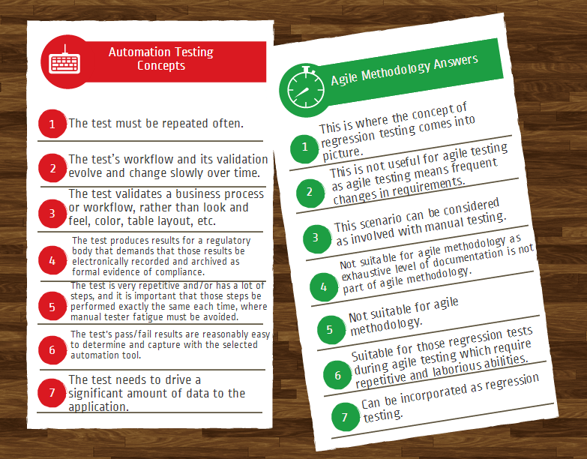

**Defect triage** is a process where each bug is prioritized based on its severity, frequency, risk, etc. Triage term is used in the Software testing / QA to define the severity and priority of new defects. The goal of Bug Triage is to evaluate, prioritize and assign the resolution of defects. The team needs to validate severities of the defect, make changes as per need, finalize resolution of the defects, and assign resources. Mainly used in agile project management.

[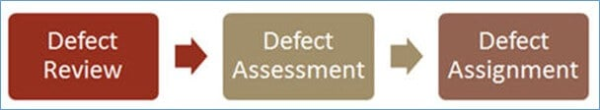](https://www.guru99.com/images/1/111517_1128_WhyBugDefec1.jpg)

The frequency of Defect triage meeting is not fixed. It depends on project situation.Here, are some important factors that decide the frequency of Defect Triage Meetings:

These Important factors are:

* As per the project schedule
* Number of defects in the system
* Impact on schedules of team members’ availability
* Overall project health

Usually, Defect Triage Meetings are held two or three times in a week.