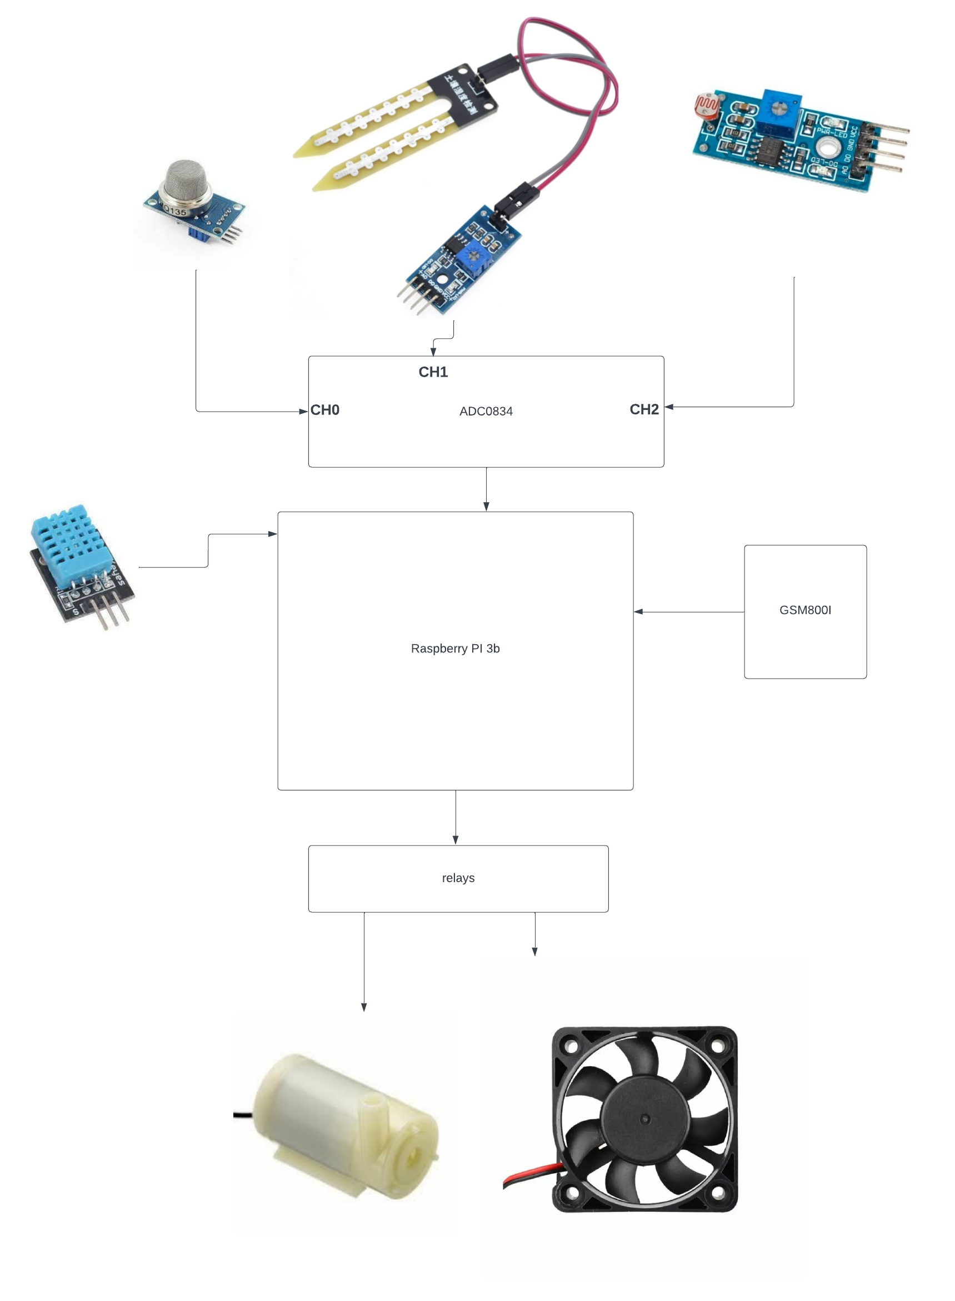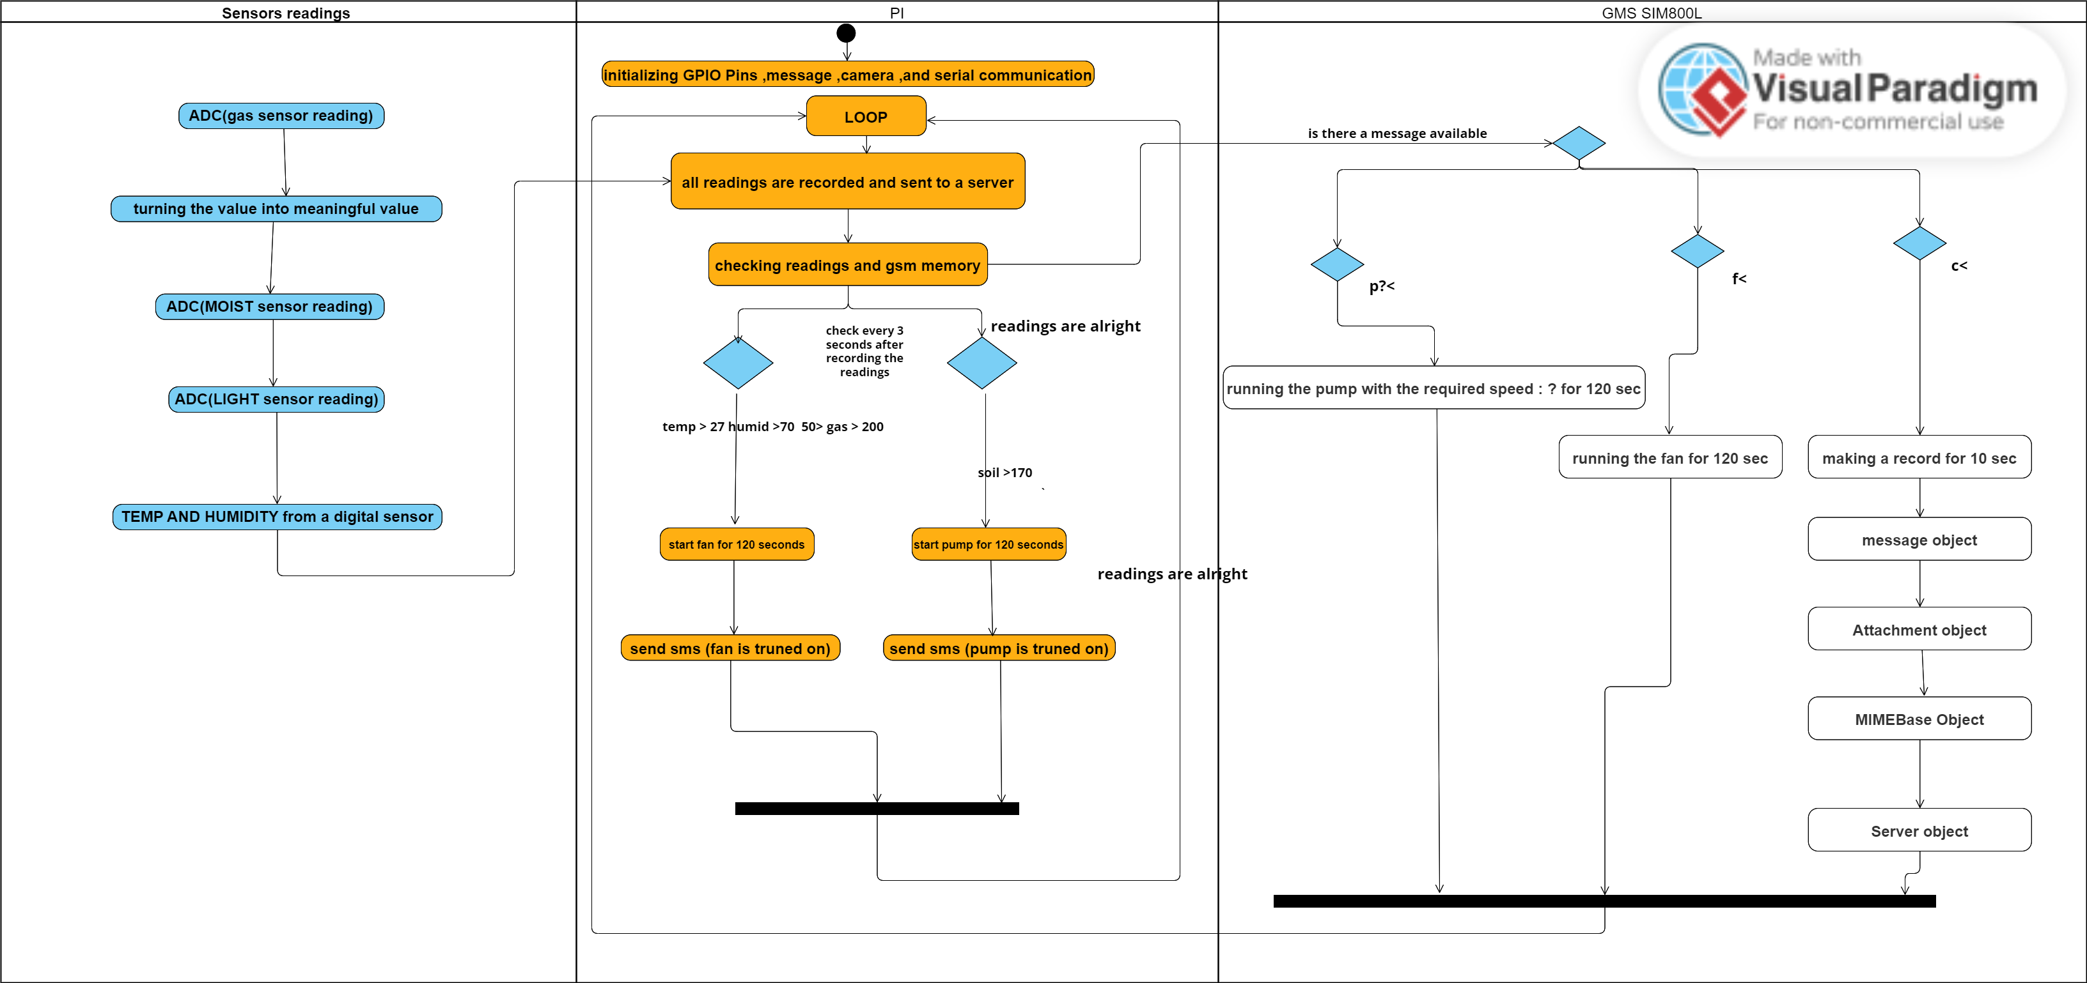

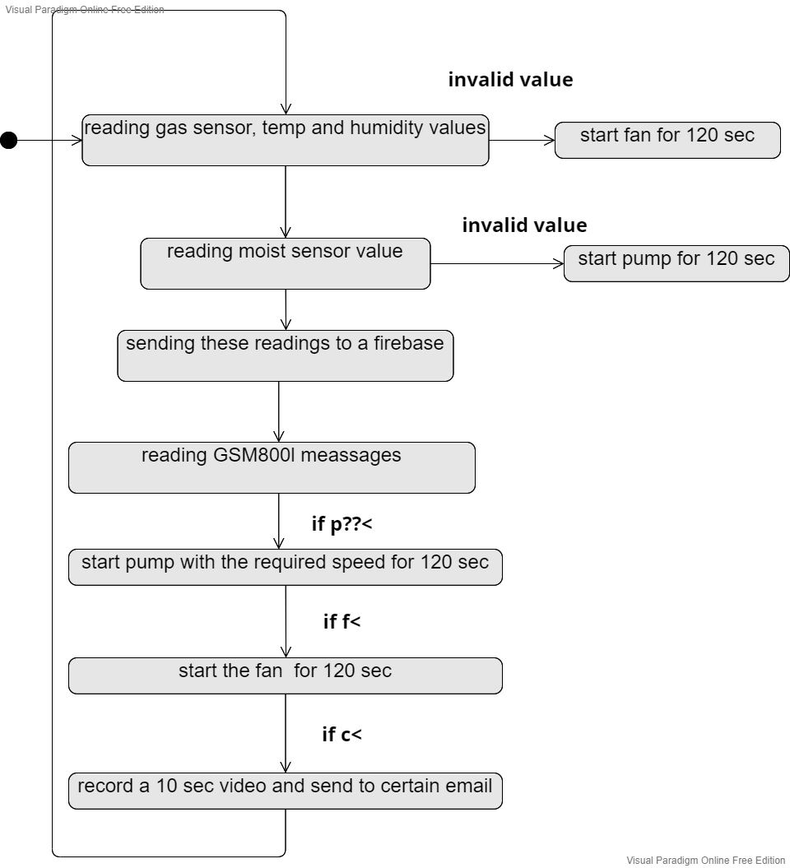

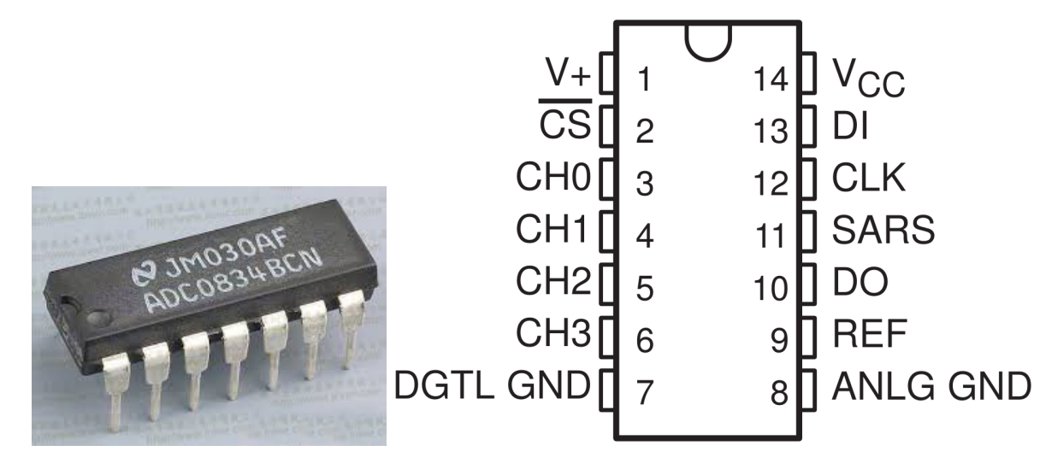

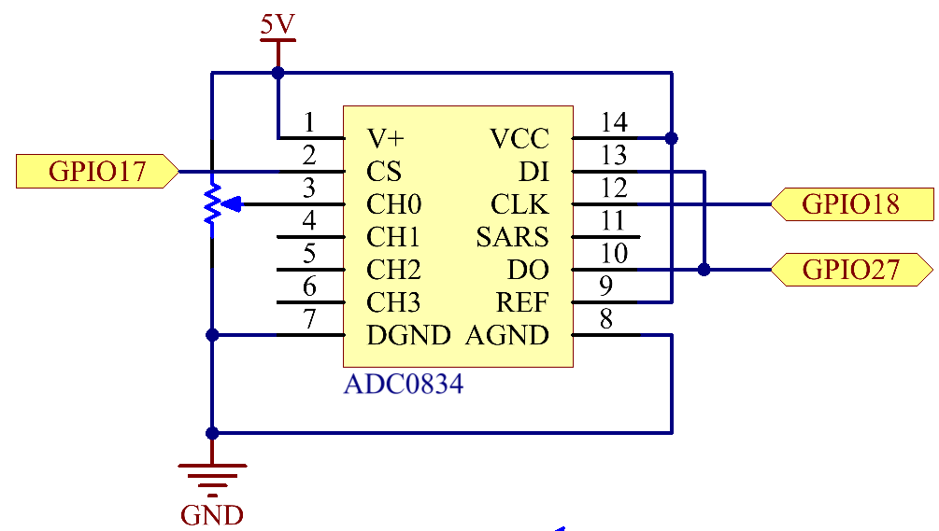

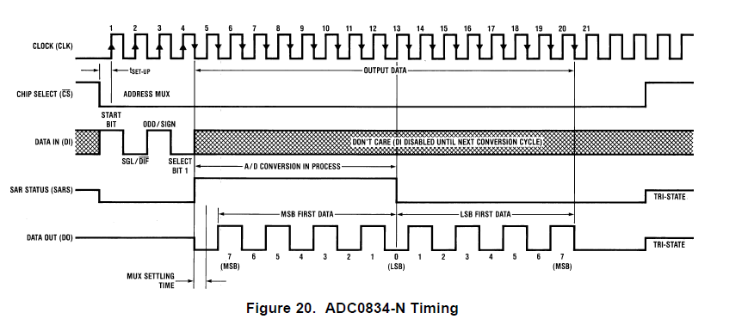

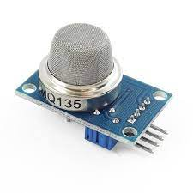

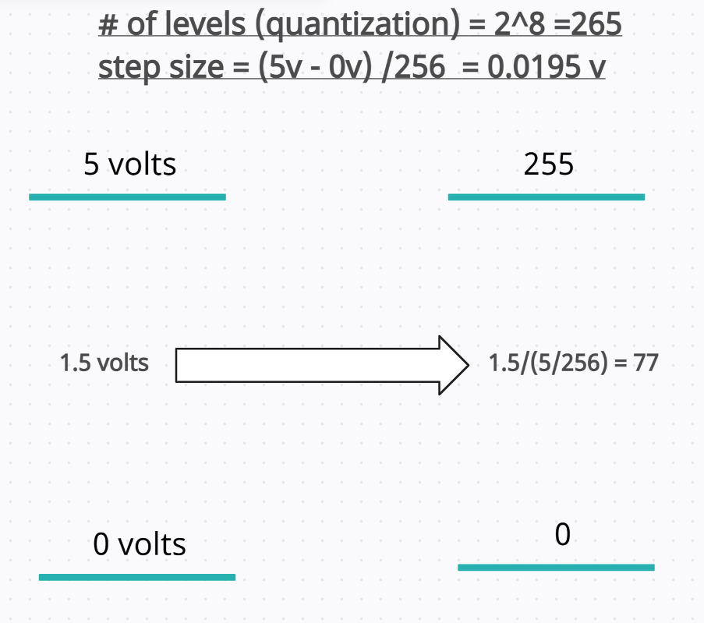

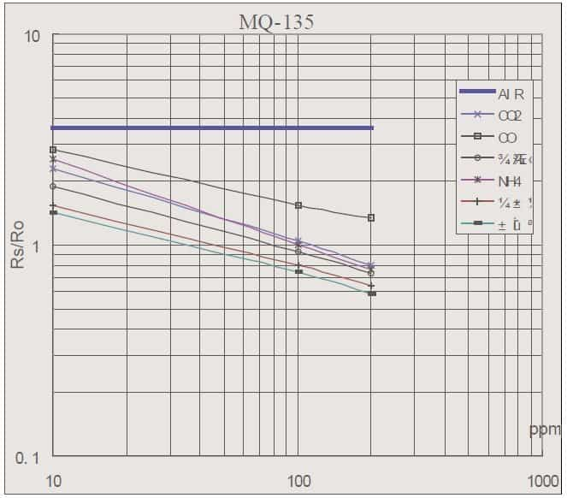

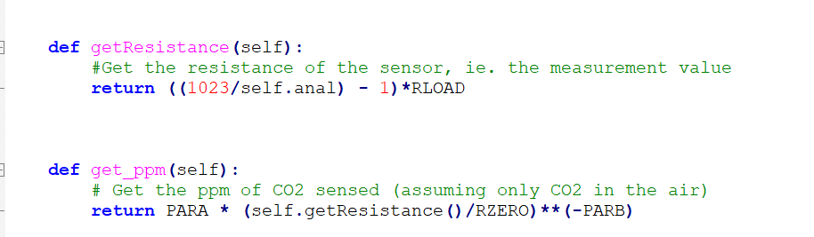

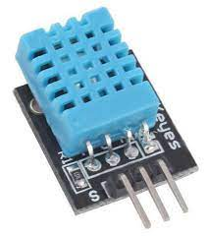

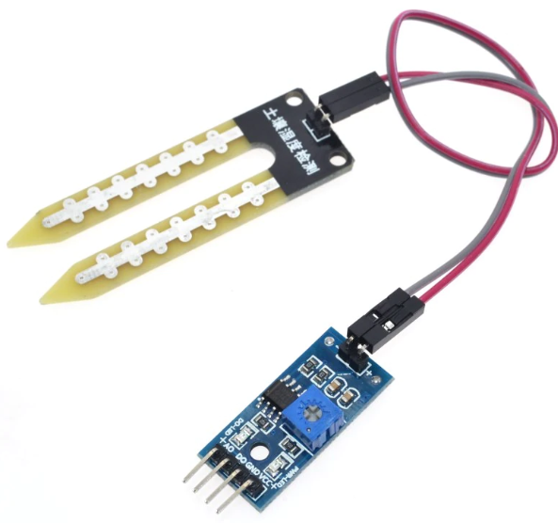

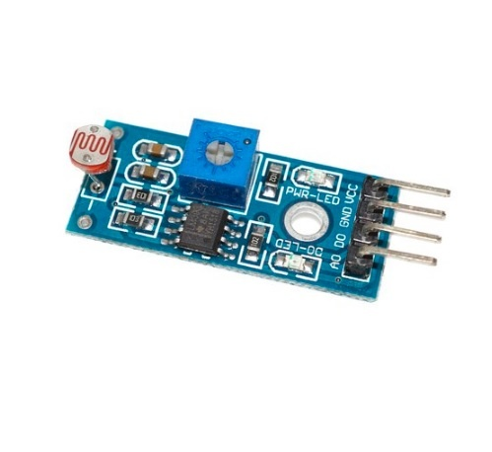

**gas = mq135(ADC0834.getResult(0))**

**gas_mesurement = gas.get_ppm()**

**humid, temp = Adafruit_DHT.read_retry (temp_sensor, dht11_pin)**

**moist = ADC0834.getResult(1)**

**Brightness = ADC0834.getResult(2)**

**Actions considering the output**

**1.fan: when the gas sensor readings is above 200ppm or below 50ppm or the temp was > 27 degree Celsius or the humid was larger than 70 2 actions are taken:**

**a. fan works for 120 sec**

**b. a message is sent to the default number with text:**

**the fan is turned on due to: temp:{0}\n humid:{1}\n gas:{2}\n flag is {3}**

**2. pump: when the moist level is > 200 2 actions are taken:**

**a. pump works for 120 sec**

**b. the pump is turned on due to moist:{0}\n flag is {1}**

**GSM800l Module**

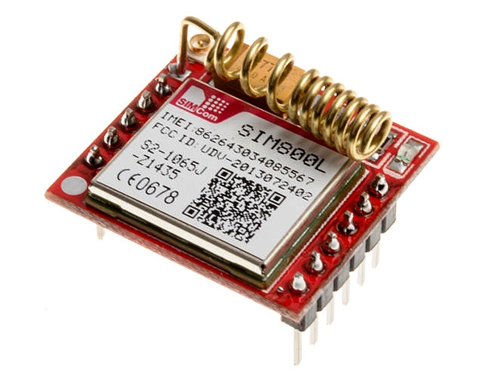

**The GSM module is connected with the Raspberry pi through UART protocol and connected with a level shifter to convert 5v from GSM to 3.3 volts from the Raspberry Pi**

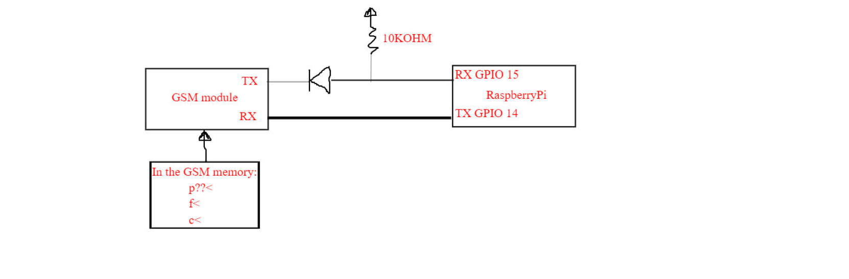**sim800l=SIM800L('/dev/ttyS0')**

The sim800i object starts communication between Pi and GSM,

Once communication started we can send any commands from Pi to GSM from the below list of commands

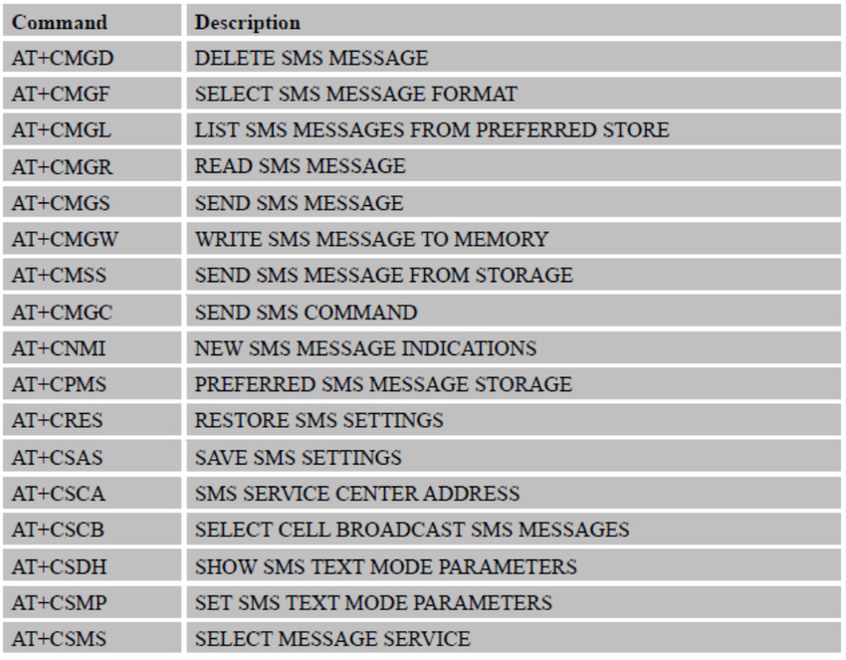

The GSM can receive only the messages:

1. p??<
2. f<
3. c<

else it will ignore and delete it

