Task -1

freq={} *# defining freq (dictionary)*file=open(**'textfile.txt'**,**'r'**) *# open textfile.txt*string=file.readline() *# use readline to get next line of the file***for** i **in** string.split(**" "**): *# split the words* words=freq.keys() *# return list of all available keys in keys* **if** i **in** words: *# use if condition* freq[i]+=1 *# if same word is available in words add 1* **else**: *# else condition* freq[i]=1 *# the freq of word remain 1*print(freq) *# print freq{}*

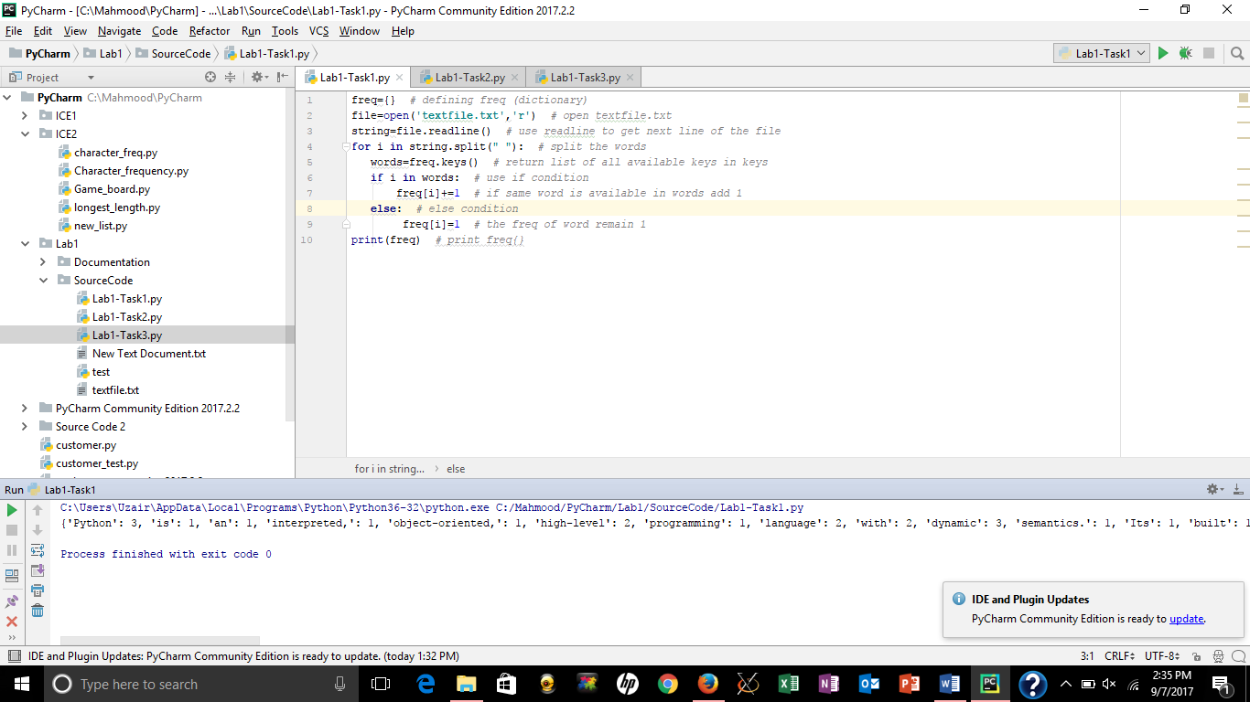

Task-2

string = str(input(**'Enter a string:'**)) *# Ask user to enter string.*string=string.replace(**' '**,**''**) *# Replace ' ' with ,***if** set(string) >= set(**'abcdefghijklmnopqurstuvwxyz'**): *# Use if condition to check if the string contains all letters of alphabets.* print(**'String contains all letters of alphabet.'**) *# If true, print string contains all letters of alphabet.***else**: *# use else condition if false* print(**'String does not contains all letters of alphabet.'**) *# Print string does not contain all letters of alphabets.*

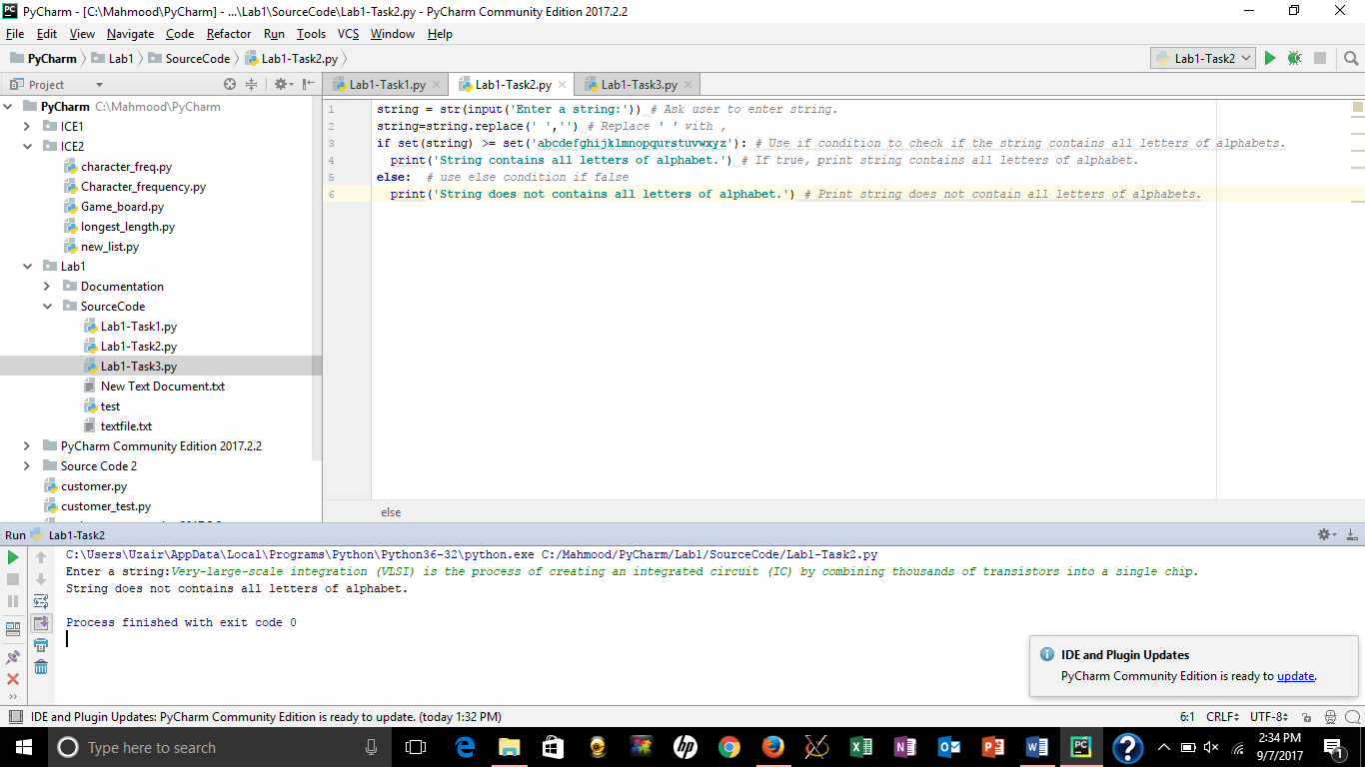

Task -3

list=[] *# define list***for** i **in** range(700,1700): *# iterate between 700 to 1700* **if** (i%5==0) **and** (i%2==0): *# if number is divisible by 5 and multiple of 2* list.append(str(i)) *# append the number in the string*print(**','**.join(list)) *# join numbers in the list seperated with coma and print*

