**Lab #2**

**Task #1**

*#Ask user to enter sentence, split the sentence with whitespace*string = input(**"Enter a sentence: "**).split(**' '**)  
*#assign the sentence as set*string_set = set(string)  
*#sort the string and join whitespace between words.*print(**' '**.join(sorted(string_set)))

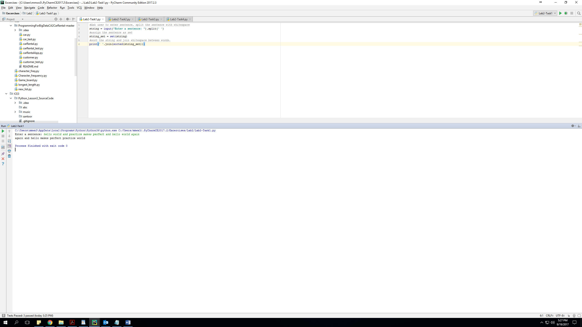

**Task #2**

*#ask user to enter any number*n=int(input(**"give any number: "**))  
*#define dictionary*a=dict()  
*#use for loop***for** i **in** range(1,n+1):  
 a[i]=i*i  
*#print a*print(a)

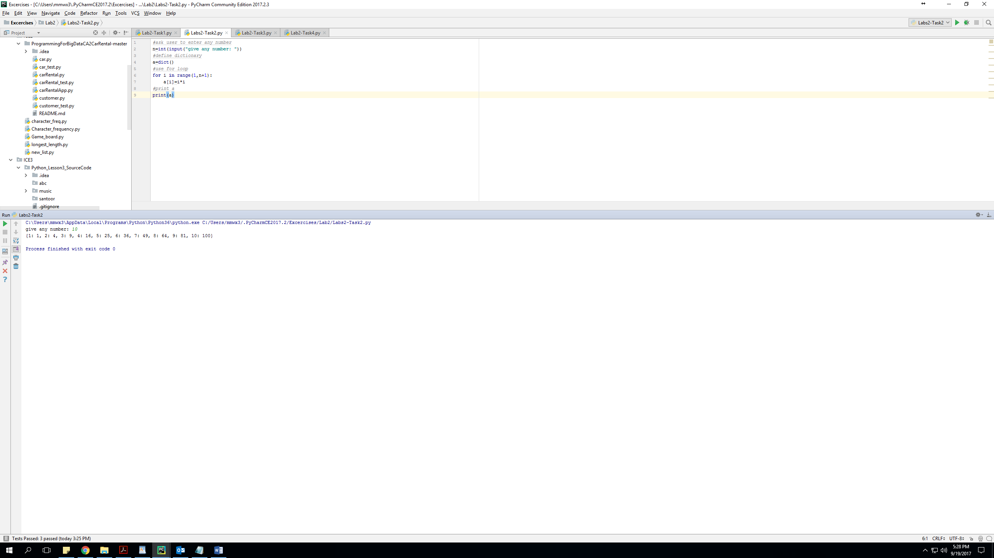

**Task #3**

*'''Student Enrollment system'''***class** Person(object):  
 *'''Student Enrollment System'''* **def** __init__(self, name, age, gender):  
 self.name = name  
 self.age = age  
 self.gender = gender  
  
**class** Aid():  
 **def** __init__(self,scholarship):  
 self.scholarship=scholarship  
  
**class** Student(Person, Aid):  
 **def** __init__(self, name, age, gender, scholarship, rollno):  
 Person.__init__(self, name, age, gender)  
 Hobby.__init__(self, scholarship)  
  
 self.rollno = rollno  
  
**class** Department(Student):  
 **def** __init__(self, name, age, gender, scholarship, rollno, school, emailID, major):  
 Student.__init__(self, name, age, gender, scholarship, rollno)  
 self.school = school  
 self.major = major  
 self.emailID = emailID  
  
**class** Semester(Department):  
 **def** __init__(self, name, age, gender, scholarship, rollno, school, emailID, major,semester):  
 Department.__init__(self, name, age, gender, scholarship, rollno, school, emailID, major)  
 self.grade = semester  
  
**class** GPA(Semester):  
 **def** __init__(self, name, age, gender, scholarship, rollno, school, emailID, major, semester, GPA):  
 Grade.__init__(self, name, age, gender, scholarship, rollno, school, emailID, major, semester)  
 self.GPA = GPA  
  
print(**"\nWelcome to XXX Student Enrollment Sytem\n"**)  
y=input(**"Did you paid previous semester complete fees? "**)  
**if** y **in** [**'y'**, **'Y'**, **'yes'**, **'Yes'**, **'YES'**]:  
 name = input(**"Enter name: "**)  
 age=input(**"Enter your age? "**)  
 gender=input(**"Mention your gender "**)  
 scholarship=input(**"Do you have any scholarship? "**)  
 rollno=input(**"Please enter roll number: "**)  
 school=input(**"Enter your School name: "**)  
 major=input(**"What is your major?"**)  
 emailID=input(**"Enter your email address: "**)  
 semester=input(**"Your are in which semester? "**)  
 GPA=input(**"Enter your cummulative GPA "**)  
 print(**"\nYou will shortly receive an email, regarding your enrollment decision!!! "**)  
**else**:  
 print(**"In order to get enroll in next semester pay your previous semester complete fees."**)

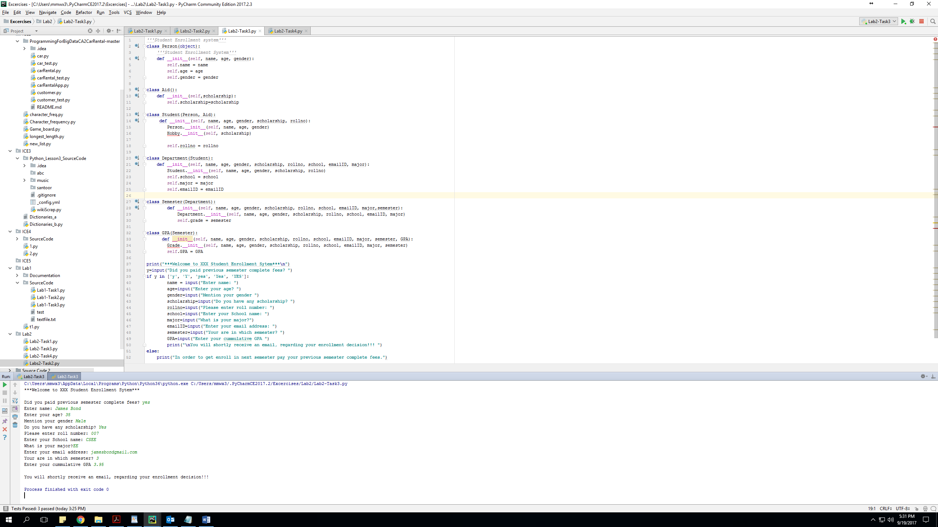

**Task #4**

*#import NumPy***import** numpy **as** np  
*# create random vector of size 15*x = np.random.random(15)  
*#print original vector*print(**"\nOriginal vector:\n"**)  
print(x)  
*#find max value in original vector*max1 = np.amax(x)  
*#print max value of original vector*print(**"\nMaximum value in original vector is:"**,max1)  
*#repalce max value by 100*x[x.argmax()] = 100  
*#print vector*print(**"\nMaximum value replaced by 100:\n"**)  
print(x)

