1.Competition Rules:
Brake System Plausibility Device:
Functionality:
it must open the shutdown circuit when hard braking happens if less than 5kW is delivered to the motors and if the throttle position is more than 25% over idle position.
T11.6.1:
A standalone non-programmable circuit, the BSPD, must open the shutdown circuit, see EV6.1 and CV4.1, when hard braking occurs, whilst • [EV ONLY] ≥5 kW power is delivered to the motors, • [CV ONLY] The throttle position is more than 25% over idle position
Importance:
It cuts the power to try and avoid any accidents like accelerating into a wall or starting a fire from the power train due to lack of cooling or the brakes due to friction.
Insulation Monitoring Device:
Functionality:
Measures the insulation resistance between the TS system and vehicle chassis or ground and opens the shutdown circuit if the isolation drops to 500 ohms/volt.
EV6.3.3
The response value of the IMD must be set to ≥500 Ω/V, related to the maximum TS voltage.
EV6.3.1
Every vehicle must have an IMD installed in the TS system.
Importance:
Prevents electrical shock by cutting the connection if it detects that the insulation barrier isn’t working properly.

Accumulator Isolation Relays:
Functionality:
When open they make sure no high voltage is present outside the accumulator container and they provide galvanic isolation between the battery side and other vehicle electronics.

EV5.6.2
The AIRs must open both poles of the TS accumulator. If the AIRs are open, no TS voltage may be present outside of the TSAC and the vehicle side of the AIRs must be galvanically isolated from the accumulator side, see EV1.2.1.
EV1.2.1 Galvanic Isolation – two electric circuits are defined as galvanically isolated, if all of the following conditions are true: • The resistance between both circuits is ≥500 Ω/V, related to the maximum TS voltage of the vehicle, at a test voltage of maximum TS voltage or 250 V, whichever is higher.
Importance:
Makes the outer frame safe to touch without shock and keeps the low voltage electronics safe.

Brake Over-Travel Switch:
Functionality:
If a brake fails or breaks it opens the shutdown circuit and shuts down the vehicle.

T6.2.1 This switch must be installed so that in the event of a failure in at least one of the brake circuits the brake pedal over-travel will result in the shutdown circuit being opened. This must function for all possible brake pedal and brake balance settings without damaging any part of the vehicle.
Importance:
Avoids crashes or problems due to brake failure by noticing it and powering off the vehicle.

Inertia switch:
Functionality:
Cuts off the electrical power upon crashing and is manually reset.
T11.5.1 An inertia switch must be part of the shutdown circuit, see EV6.1 and CV4.1, such that an impact will result in the shutdown circuit being opened. The inertia switch must latch until manually reset
Importance:
Prevents electrical hazards and fires after crashing.

Tractive system active light:
Functionality:
Indicates Ts status, flashes red when Ts has energy and to 15 min. after switching it off and lights green when safe.
EV4.10.2 The TSAL itself must have a red light, flashing continuously with a frequency between 2Hz and 5Hz and a duty cycle of 50%, active whenever the LVS is active and for at least 15 minutes after it is switched off
Importance:
Warns anyone approaching whether there is high voltage, preventing electrocution.

PCB & Circuits:
2.Crosstalk in PCB and How to reduce it:
Crosstalk is the unwanted transfer of energy from an element which is called the aggressor to another which is called the victim. It happens due to capacitive and inductive coupling due to changing signals of voltage and current over time.
We can reduce it by increasing the distance between the elements, routing horizontally on one layer and vertically on the other, decrease the distance to GND reference layer and route differential pairs.

3.Build the circuit in your simulator:
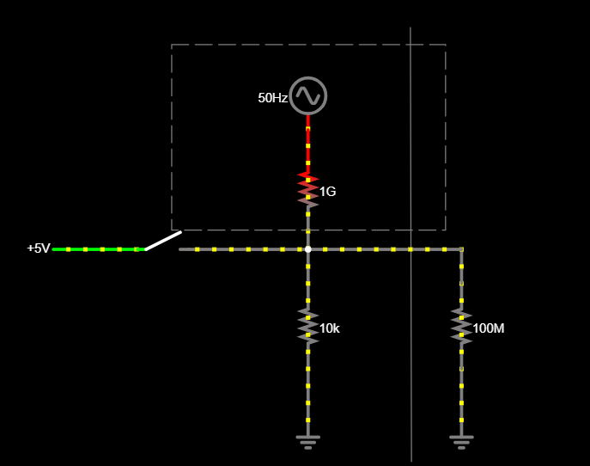
3.a) circuit’s primary function
It is a pull-down resistor to eliminate the noise. It replaces the noise with 0v when the switch is open

b) they represent the noise. The Ac source represents the stray electrical fields from electric towers or the main board While the big value resistor acts as the air which has great impedance.

c)
1) We let noise in by messing up the voltage divider ratio causing the pin to float.
2) A floating pin (floating input)
3)We should select the value small enough to overcome the noise but big enough to limit current and Power consumption to our preference.
d) the arrow is pointing to what is connected to a pin and treated as input. R2 is acting as the internal impedance of the input pin and senses the voltage. We could call it the input impedance.
e) We should then connect R1 to +5V to make it a pull-up resistor and the circuit would be an active low as when the switch is closed it is zero.
f) My hands would bring the noise in the air to the wire and cause floating.
4.Decoupling capacitors are usually small in size (0.01uF to 1uF) and is put next to an IC power pin, while bulk capacitors are bigger (from 10uF to 1000uF and above ) and are put next to power pins or entry of the board.
We use decoupling capacitors to short high frequency noise to the ground and give small burst charges, Bulk capacitors on the other hand are used to store energy and slow voltage drops.

5.They are two adjacent traces that carry equal and opposite voltage signals with strong resistance to noise.
We have to route them as equal length traces while leaving an equal spacing between them and use 45 angle bends to retain the same length.

6.polygon pours are when we take unrouted areas of the same net(GND,+3V3,etc.) and group them in a polygon and pour it with copper. They are preferred because they have low resistance which minimizes voltage drops and makes them able to handle high current capacity as they need to handle the total current, they also dissipate heat better than normal routes as they have more surface area and they lower noise as they have low impedance.

