Schematic
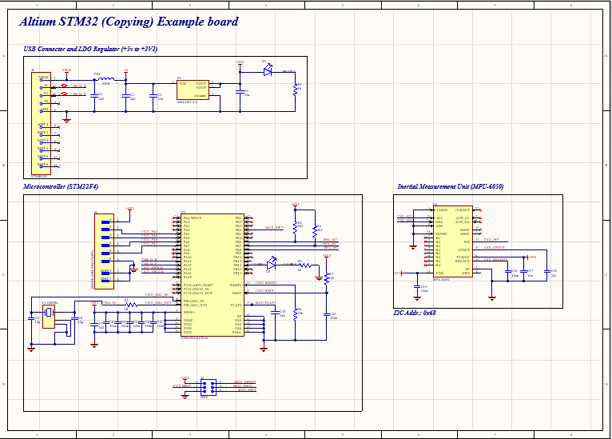
https://github.com/user-attachments/assets/8ed18997-27c4-4494-b7ed-b9a66c9b6840
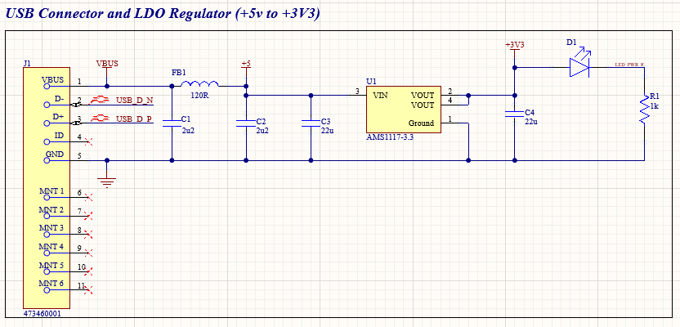
https://github.com/user-attachments/assets/002672e2-6ccd-435e-9d88-035a33832523
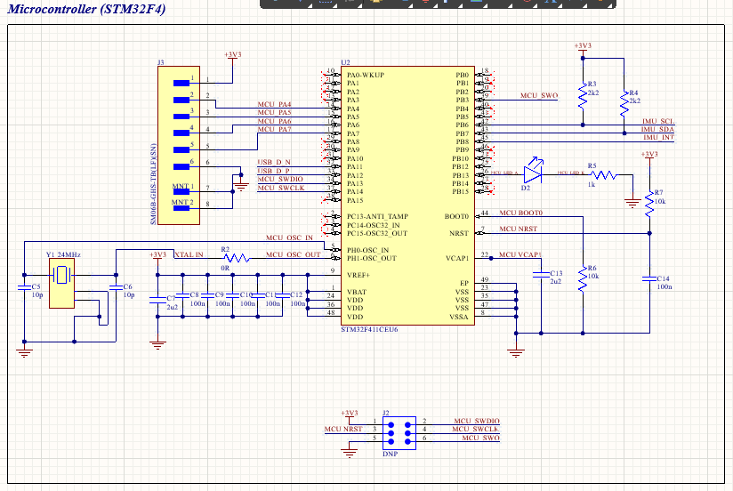https://github.com/user-attachments/assets/1125b18d-d75f-454e-ad1e-775edfbfa2c6
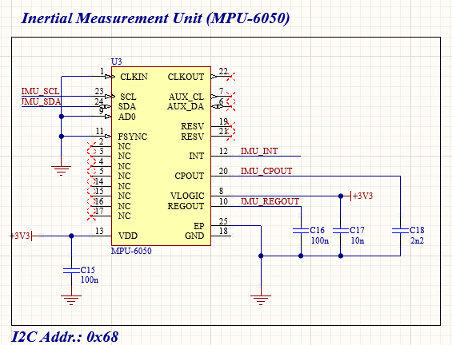
https://github.com/user-attachments/assets/fcb3047f-2e8f-456e-a8fe-e83ade0f2909

PCB Design: 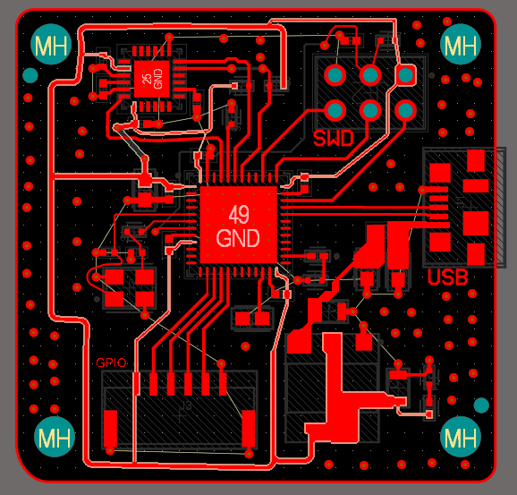
https://github.com/user-attachments/assets/3e9a39b3-c4f4-462d-a9d2-43100e092897
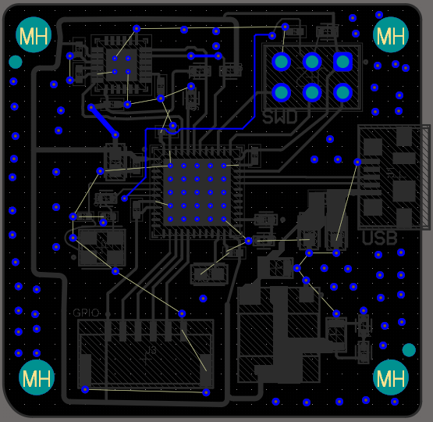
https://github.com/user-attachments/assets/9be91dec-90c4-476a-a814-e8b857eacfb2
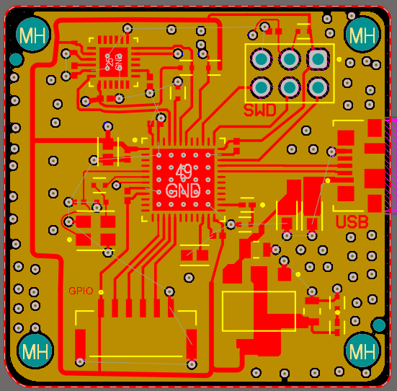
https://github.com/user-attachments/assets/41077157-dc51-4055-ab6d-97b1b01c0ec7

