Soft Desk API Documentation

Introduction
Soft Desk is a project management and issue tracking API designed to manage users, projects, tickets (issues), and comments. The API allows authenticated users to create, manage, and track projects, assign tasks, add comments, and much more, making it ideal for team collaboration and issue resolution.

Base URL
- The base URL for accessing the API is: http://<your-domain>/api/

Authentication
- The Soft Desk API uses JWT (JSON Web Token) for authentication.
- You must include an Authorization header with the Bearer token to access any endpoint.
- To obtain a JWT token, use the /api/token/ endpoint by providing your username and password.

Endpoints Overview

User Endpoints
- GET /user/
  - Retrieve a list of all users (restricted to authenticated users).
- GET /user/{id}/
  - Retrieve detailed information for a specific user by ID.
- PUT /user/{id}/
  - Update user details (restricted to the authenticated user or an admin).
- DELETE /user/{id}/
  - Delete a user (restricted to the authenticated user or an admin).

Project Endpoints
- GET /project/
  - Retrieve a list of all projects.
- POST /project/
  - Create a new project. The authenticated user becomes the creator of the project.
- GET /project/{id}/
  - Retrieve details of a specific project.
- PUT /project/{id}/
  - Update project details (restricted to the creator or an admin).
- DELETE /project/{id}/
  - Delete a project (restricted to the creator or an admin).

Ticket Endpoints
- GET /project/{project_id}/ticket/
  - Retrieve all tickets for a specific project.
- POST /project/{project_id}/ticket/
  - Create a new ticket under a specific project.
- GET /project/{project_id}/ticket/{ticket_id}/
  - Retrieve details of a specific ticket.
- PUT /project/{project_id}/ticket/{ticket_id}/
  - Update ticket information (restricted to contributors of the project or an admin).
- DELETE /project/{project_id}/ticket/{ticket_id}/
  - Delete a ticket (restricted to the ticket creator or an admin).

Comment Endpoints
- GET /project/{project_id}/ticket/{ticket_id}/comment/
  - Retrieve all comments related to a specific ticket.
- POST /project/{project_id}/ticket/{ticket_id}/comment/
  - Create a comment on a specific ticket.
- GET /project/{project_id}/ticket/{ticket_id}/comment/{comment_id}/
  - Retrieve details of a specific comment.
- PUT /project/{project_id}/ticket/{ticket_id}/comment/{comment_id}/
  - Update comment details (restricted to the comment creator or an admin).
- DELETE /project/{project_id}/ticket/{ticket_id}/comment/{comment_id}/
  - Delete a comment (restricted to the comment creator or an admin).

Permissions:

- IsAuthenticated: All endpoints require authentication.
- IsProjectContributor: Only users registered to a project or admins can manage tickets and comments.
- IsCreator: Only the project creator or admins can modify or delete projects.

Example Requests

1. Obtain JWT Token
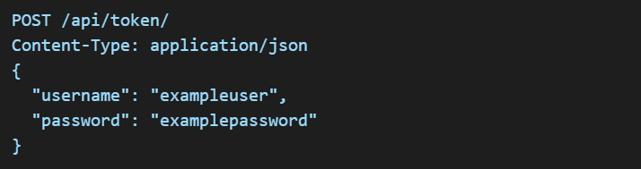
Response:
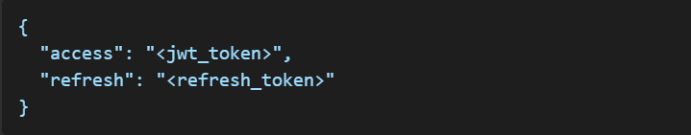

2. Create a New Project
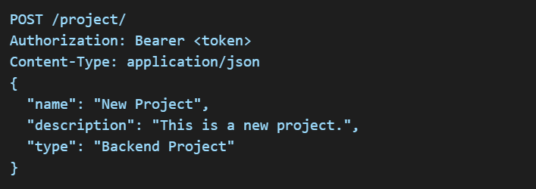
Response:
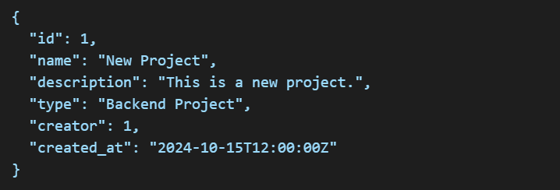

3. Create a Ticket
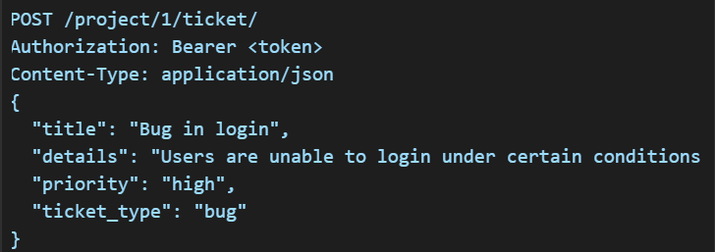

Response:
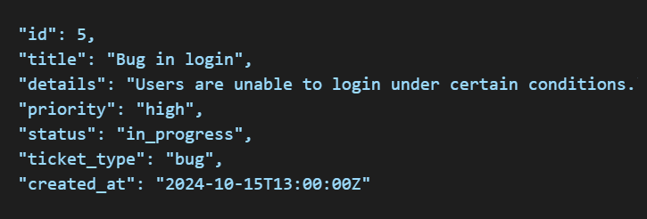

4. Create a Comment

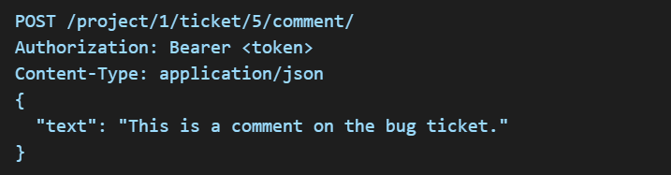

Response:
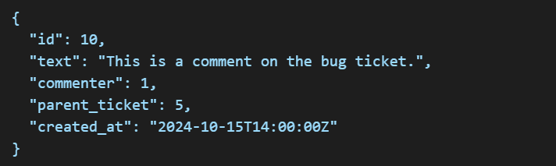

Error Handling
- 400 Bad Request: Invalid input.
- 401 Unauthorized: No valid authentication credentials provided.
- 403 Forbidden: You do not have permission to perform this action.
- 404 Not Found: The requested resource was not found.

Best Practices
- Authentication: Always provide a valid JWT token in the header.
- Permissions: Ensure you have proper permissions before attempting to update or delete resources.
- Data Validation: Always check the response for validation errors to prevent sending invalid data.

Conclusion
The Soft Desk API is a powerful tool for managing collaborative projects and tracking issues. It provides flexible user permissions, nested resource management, and efficient tracking of tickets and comments to streamline project workflows.
Feel free to reach out if you have any questions or need further assistance in

