Procrastinate.

Another idea

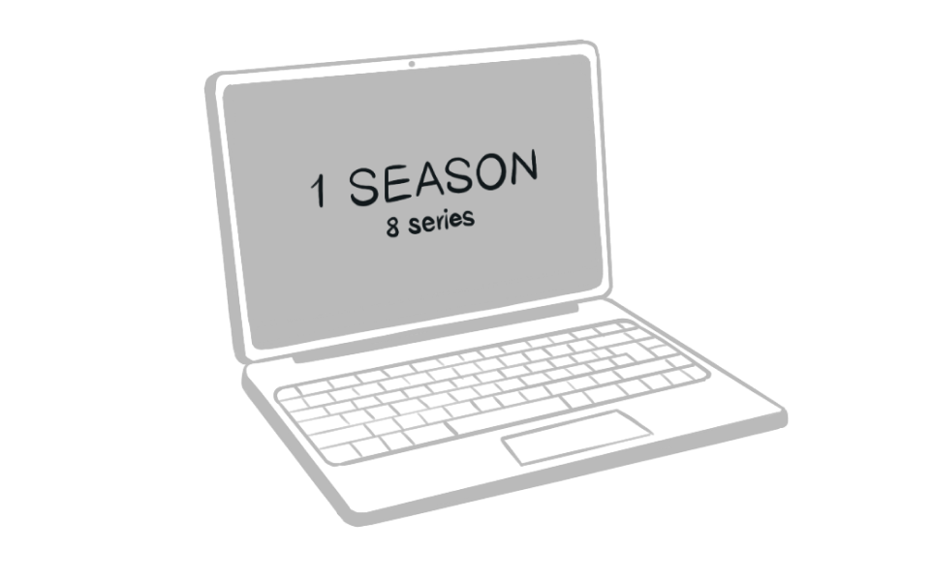Take a break from coding and do something else. 

© 2022 by Mahmoud Adas