

Egypt University of Informatics

Computer and Information Systems

Data Analysis Course

Examining the Impact of Leisure Activities on Academic Performance: A Study of EUI Students by: Mahmoud Ashraf, 22-101201

**Title: Examining the Impact of Leisure Activities on Academic Performance.**

**Population of interest**: The study targets EUI students from different faculties

**Data collecting method**: Online survey sent to college students in EUI

**Sampling method:**

In this study we used a form of convenience sampling where we designed the survey and sent it to available and accessible students through whatsapp. While convenience sampling isn’t the most unbiased sampling method and usually doesn’t result in representative samples, it is the easiest to conduct in this case.

**Bias identification:**

A potential source of bias identified in this study is the tendency for students with above-average academic performance to be more willing to participate. To mitigate this bias, efforts were made to directly target students with diverse academic backgrounds and levels of achievement.

**Survey Questions:**

* What is your age?
* How many hours per week on average do you spend on hobbies and leisure activities?
* How many hours per week on average do you spend studying (excluding class time)?
* What hobbies or leisure activities do you mostly engage in?
* What is your current Cumulative GPA?

**Number of responses: 29**

**Survey link:** [**Survey**](https://docs.google.com/forms/d/e/1FAIpQLSfeOBv2FUeQwxrK01ihlsP6IxkBL5UelMWjsht26VdBK94i6A/viewform?usp=sf_link)

**Level 1 Analysis:**

Number of hours spent on hobbies and leisure activities has an average (mean) of 13.9 hours and standard deviation of 10.8

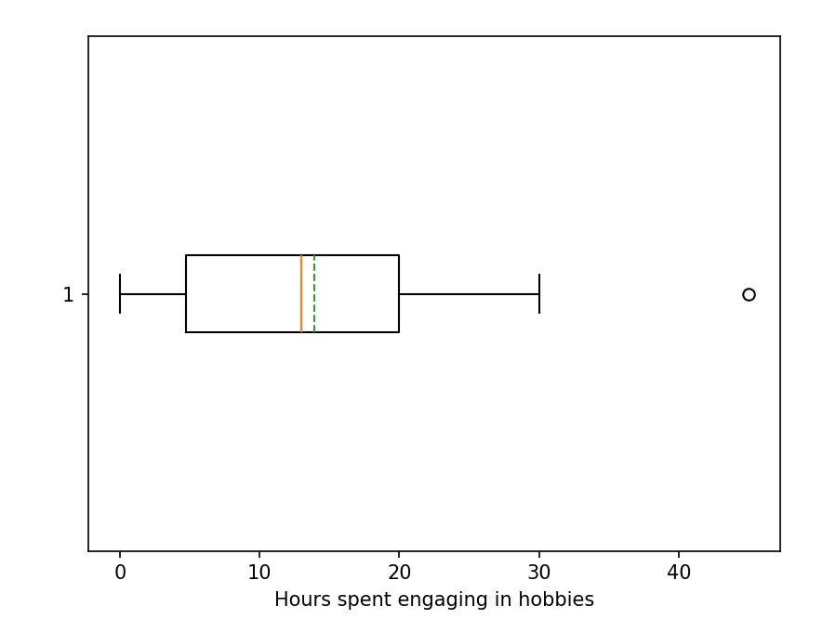

Number of hours spent on studying (excluding class time) has an average (mean) of 16 hours and standard deviation of 10

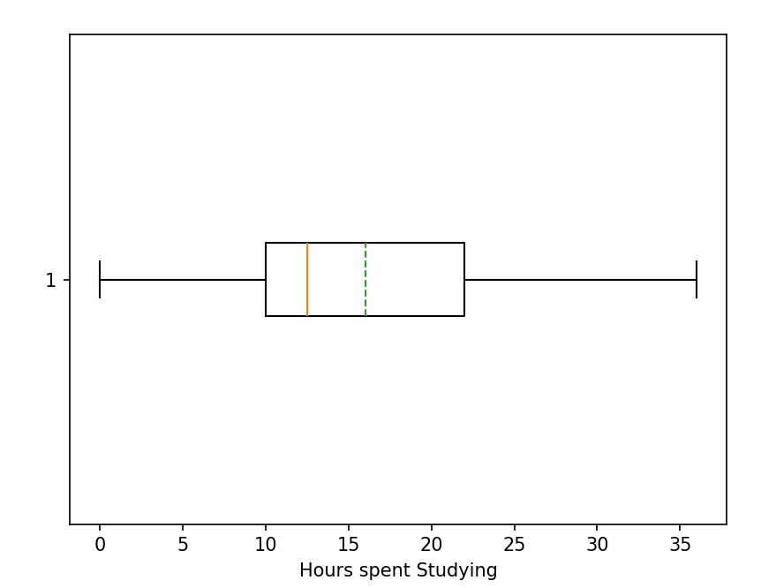

Cases of this study had an average C-GPA of 3.3 with a standard deviation of 0.7 with the maximum being 3.95 and the minimum being 1.56

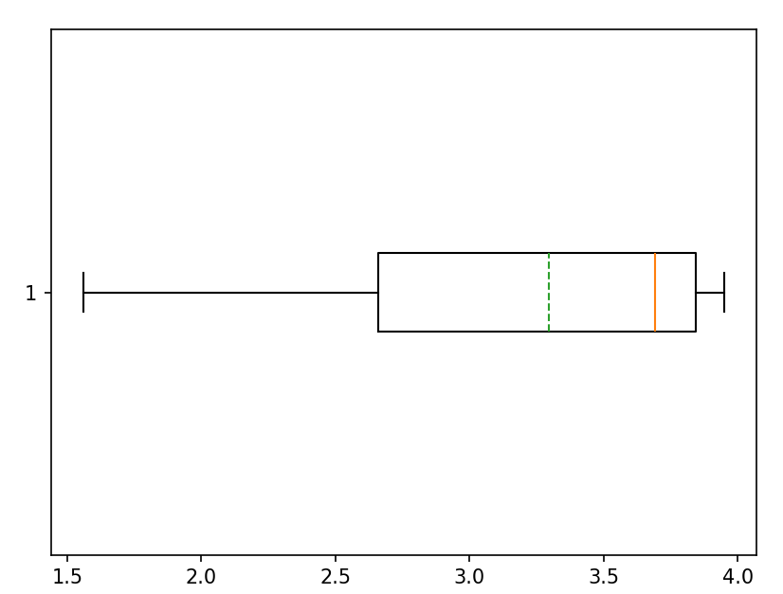

**Level 2 Analysis: Is there any correlation between these variables?**

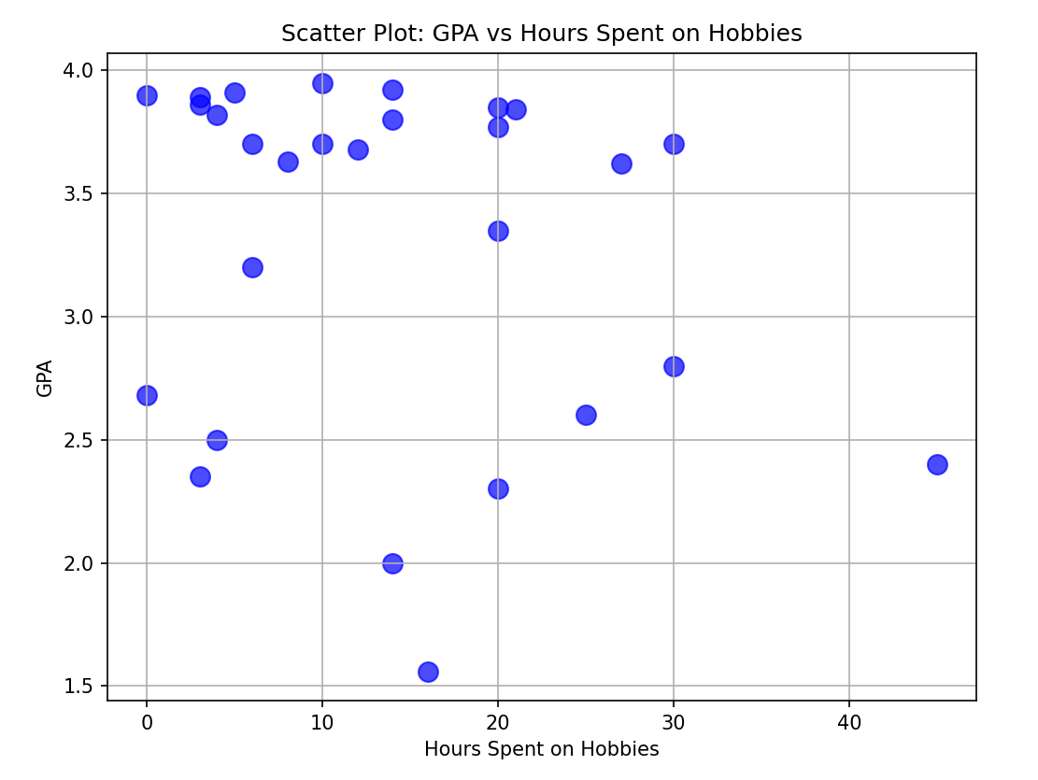

According to this figure there doesn’t seem to be a relation between hours spent on hobbies and GPA in this data set. However, this can’t be used to draw conclusions about the population since the sample isn’t representative as mentioned before.

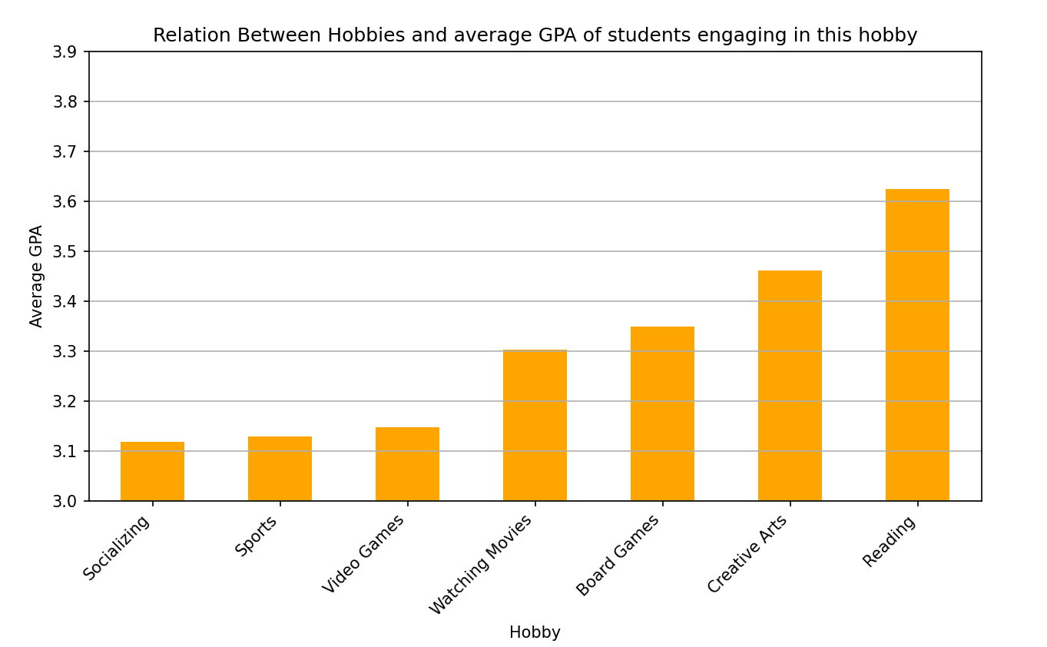

There does seem, however, to be a correlation between activities students spend leisure time on and their academic performance. From the bar chart we can notice that students who have the hobbies of reading and/or creative arts tend to get higher GPA on average.

**Conclusion:**

Upon analyzing the collected data, we can conclude that for the study’s subjects there is no relation between the amounts of time they spend on their hobbies and their academic performance. We also noticed that there is a relation between the activities students engage in and their academic performance.

However, this isn’t sufficient to draw conclusions about the whole population due to:

1. The sample size being too small
2. The sample being biased as mentioned before
3. Some randomness in the data due to potential misunderstanding of the questions and/or students failing to estimate number of hours per week.