INDUSTRIAL INSTRUMENTATION ENGINEERING MASTER COURSE

CHAPTER 2 · MODULE 01
Physical Quantities, Units, Geometry, and Engineering Conversions
Mass • Weight • Density • Metric Prefixes • Area • Volume • Dimensional Analysis

MODULE PURPOSE
Establish the physics and measurement foundation required for instrumentation engineering by developing clear understanding of mass, force, acceleration, density, geometry, metric prefixes, dimensional analysis, and reliable unit conversion.

1. Why Physics Matters in Instrumentation
Industrial instrumentation is applied physics. Every transmitter, switch, sensor, control valve, actuator, flowmeter, thermowell, weighing system, and analyzer responds to matter, energy, motion, pressure, temperature, or electromagnetic effects. Engineers who understand the physical quantity being measured can select, install, calibrate, and troubleshoot instruments more effectively.
ENGINEERING VIEW
Physics studies matter and energy. Instrumentation measures and controls matter and energy. The quality of measurement depends on understanding the physical behavior behind the signal.

[PROFESSIONAL ENGINEERING ILLUSTRATION PLACEHOLDER]

Industrial instrumentation map connecting pressure, flow, level, temperature, force, motion, density, and energy to representative sensors and control elements.

2. Mass, Weight, Force, and Acceleration

2.1 Mass
Mass is an object's resistance to acceleration. It is an intrinsic property and does not change simply because the object moves to a different gravitational environment. A 20 kg metal block has the same mass on Earth, on the Moon, or in orbit.
[PROFESSIONAL ENGINEERING ILLUSTRATION PLACEHOLDER]

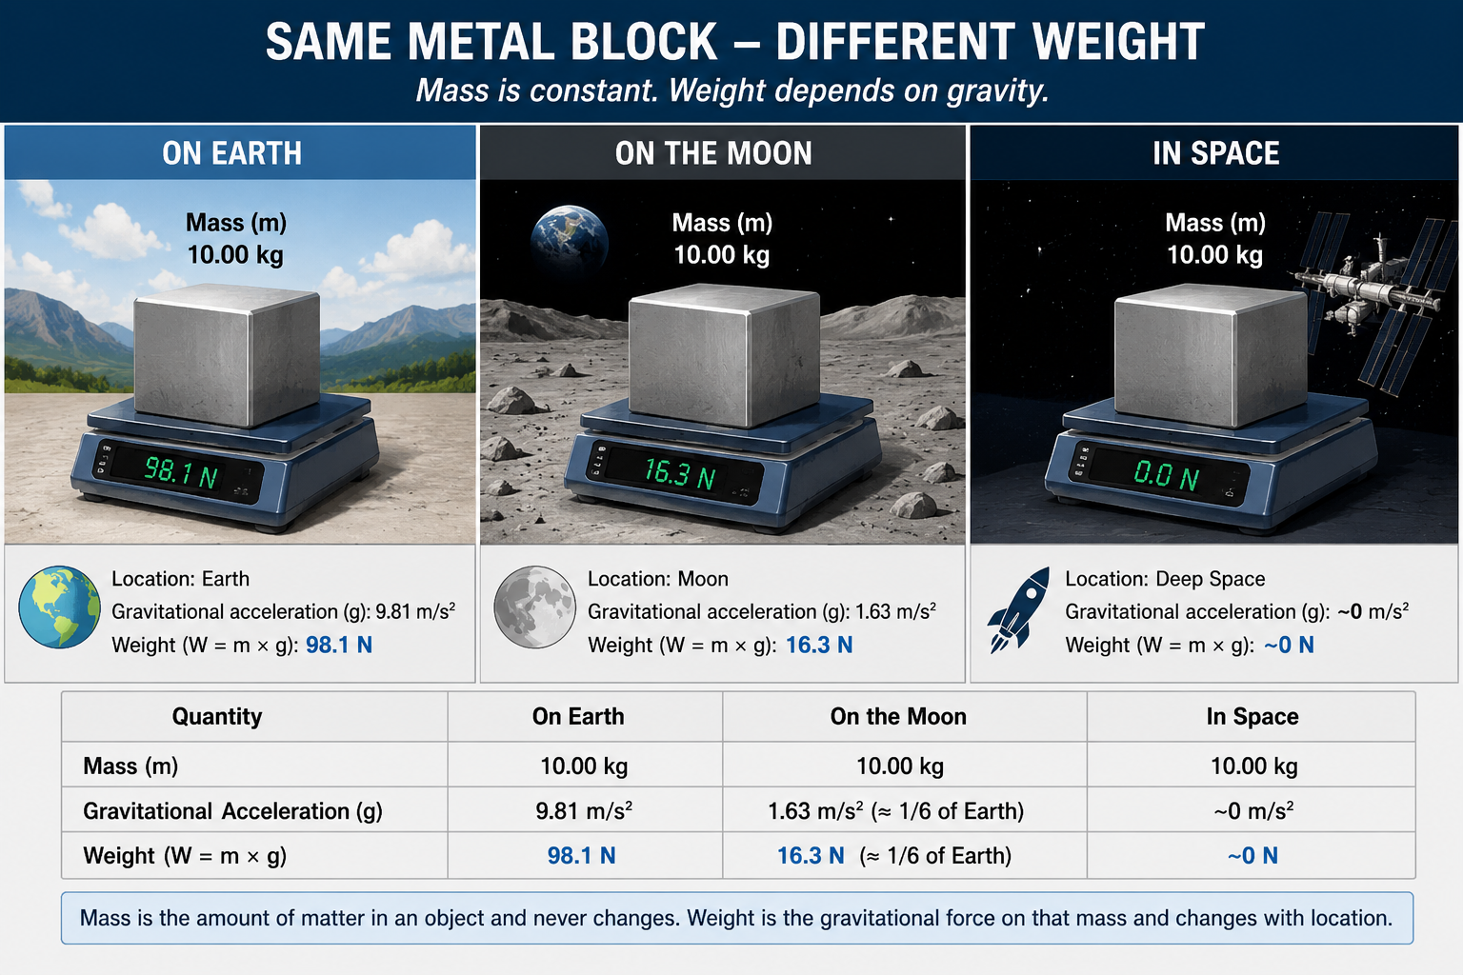
Same metal block shown on Earth, the Moon, and in space: constant mass but different weight.

2.2 Weight
Weight is the gravitational force acting on a mass. Unlike mass, weight depends on the local gravitational field. On Earth near sea level, gravitational acceleration is approximately 9.81 m/s².
F = m a
W = m g
W = weight force, m = mass, g = gravitational acceleration.
Quantity | Meaning | SI unit | Common symbol
Mass | Resistance to acceleration | kilogram | m
Force | Push or pull capable of changing motion | newton | F
Acceleration | Rate of change of velocity | m/s² | a
Weight | Gravitational force on mass | newton | W or Fg

COMMON MISTAKE
Kilogram is a unit of mass, not force. A force should be expressed in newtons in SI calculations.

2.3 Worked Example: Weight of a Calibration Mass
A 25 kg calibration mass is used to test a load-cell system.
W = m g = 25 × 9.81 = 245.25 N
The load cell responds to approximately 245 N of downward force, not merely the number 25. The mechanical installation and calibration equation must distinguish mass from force.

2.4 Force as a Rate of Velocity Change
Acceleration is the rate at which velocity changes. Newton's second law may therefore be written using differential notation:
F = m dv/dt
Because velocity is itself the rate of position change, force may also be related to the second derivative of position:
F = m d²x/dt²
INSTRUMENTATION CONNECTION
Accelerometers, vibration sensors, motion controllers, and dynamic weighing systems all rely on the relationship among displacement, velocity, acceleration, mass, and force.

3. Density

3.1 Mass Density
Mass density is the amount of mass contained in a unit volume. It is a property of the material and varies with temperature, pressure, phase, and composition.
ρ = m / V

3.2 Weight Density
Weight density is the weight force contained in a unit volume. Mass density and weight density are related through gravitational acceleration.
γ = ρ g
Density type | Definition | Typical SI unit | Typical use
Mass density | Mass per unit volume | kg/m³ | Flow, level, mass balance, buoyancy
Weight density | Weight per unit volume | N/m³ | Hydrostatic force and pressure

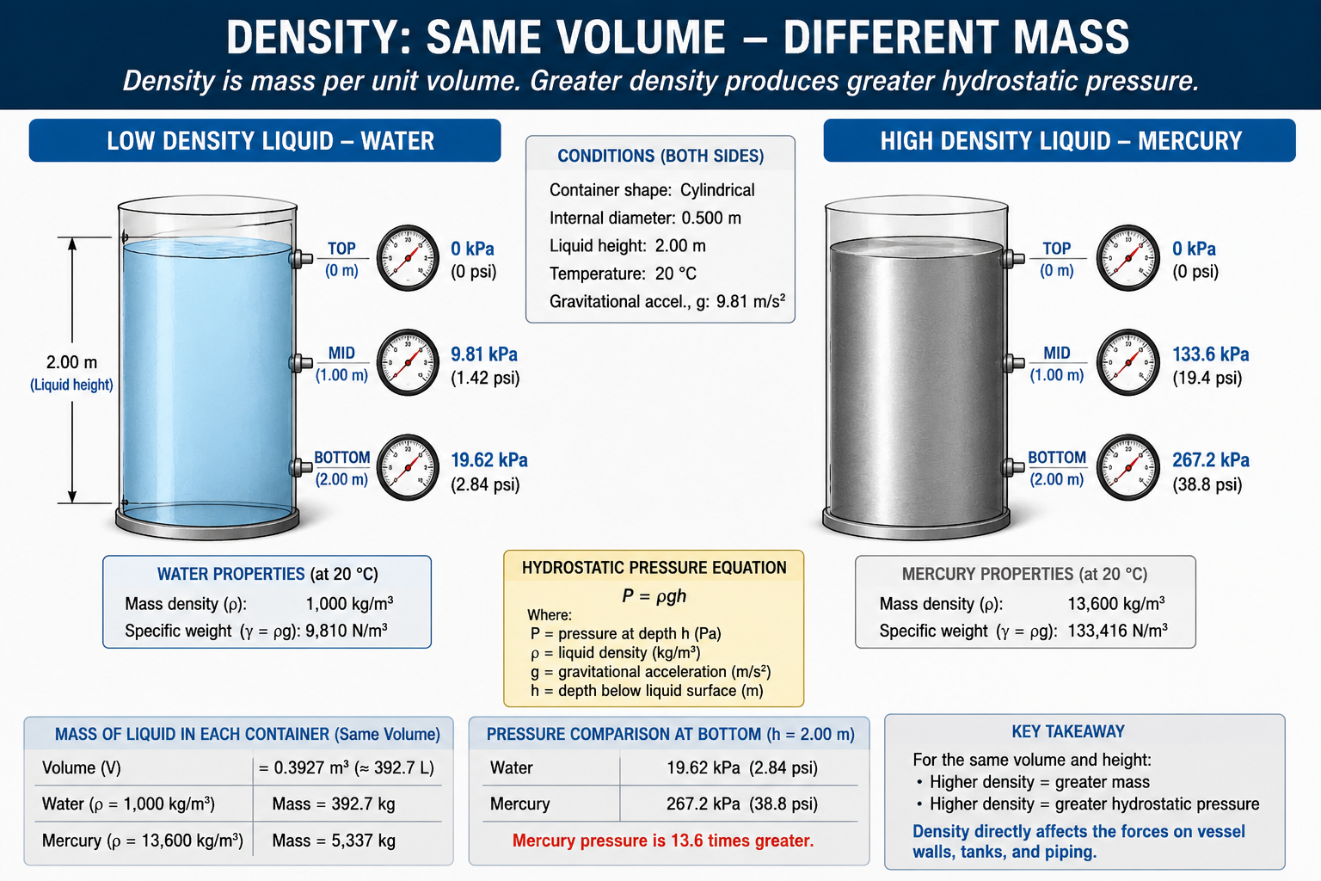
Equal-volume containers holding different liquids, illustrating low and high mass density and resulting hydrostatic effects.

3.3 Industrial Importance of Density
- Hydrostatic level measurement depends on liquid density.
- Differential-pressure flow measurement may require density compensation.
- Coriolis meters directly measure mass flow and often report density.
- Tank inventory calculations require volume and density.
- Gas density changes strongly with pressure and absolute temperature.
- Slurry and concentration measurements may infer composition from density.
FIELD PRACTICE
A level transmitter calibrated for water will not read correctly on a denser or lighter process liquid unless the specific gravity is accounted for.

4. Metric Prefixes
Metric prefixes scale units by powers of ten. They simplify very large and very small engineering quantities and allow rapid mental comparison.
Prefix | Symbol | Multiplier | Instrumentation example
tera | T | 10¹² | terahertz radiation frequency
giga | G | 10⁹ | gigahertz communication
mega | M | 10⁶ | megohm insulation resistance
kilo | k | 10³ | kilopascal pressure
none | — | 10⁰ | volt, ampere, meter
milli | m | 10⁻³ | milliampere signal
micro | µ | 10⁻⁶ | microvolt thermocouple signal
nano | n | 10⁻⁹ | nanofarad capacitance
pico | p | 10⁻¹² | picofarad sensor capacitance

CASE-SENSITIVE SYMBOLS
Uppercase M means mega (10⁶), while lowercase m means milli (10⁻³). Confusing them creates a billion-to-one error.

[PROFESSIONAL ENGINEERING ILLUSTRATION PLACEHOLDER]
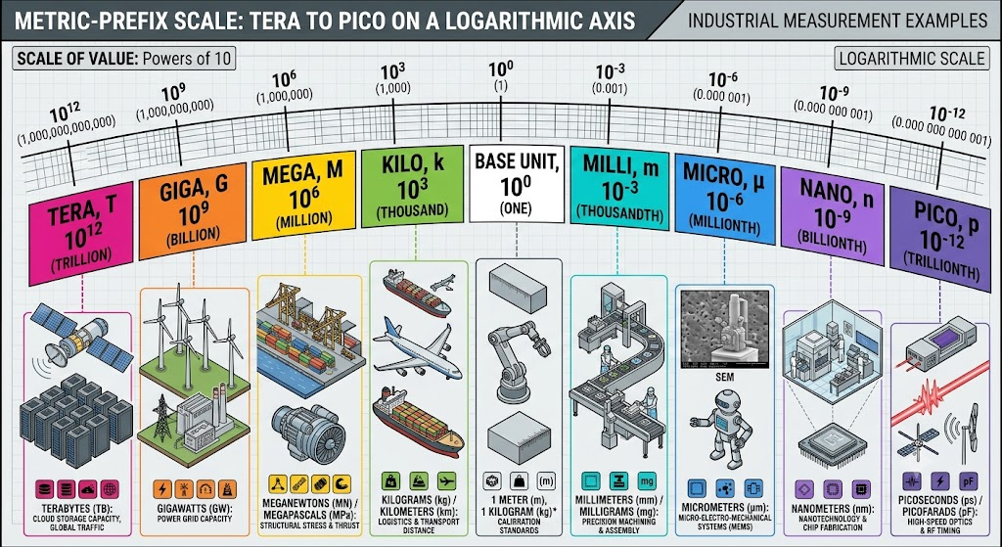
Metric-prefix scale from tera to pico with industrial measurement examples positioned on a logarithmic axis.

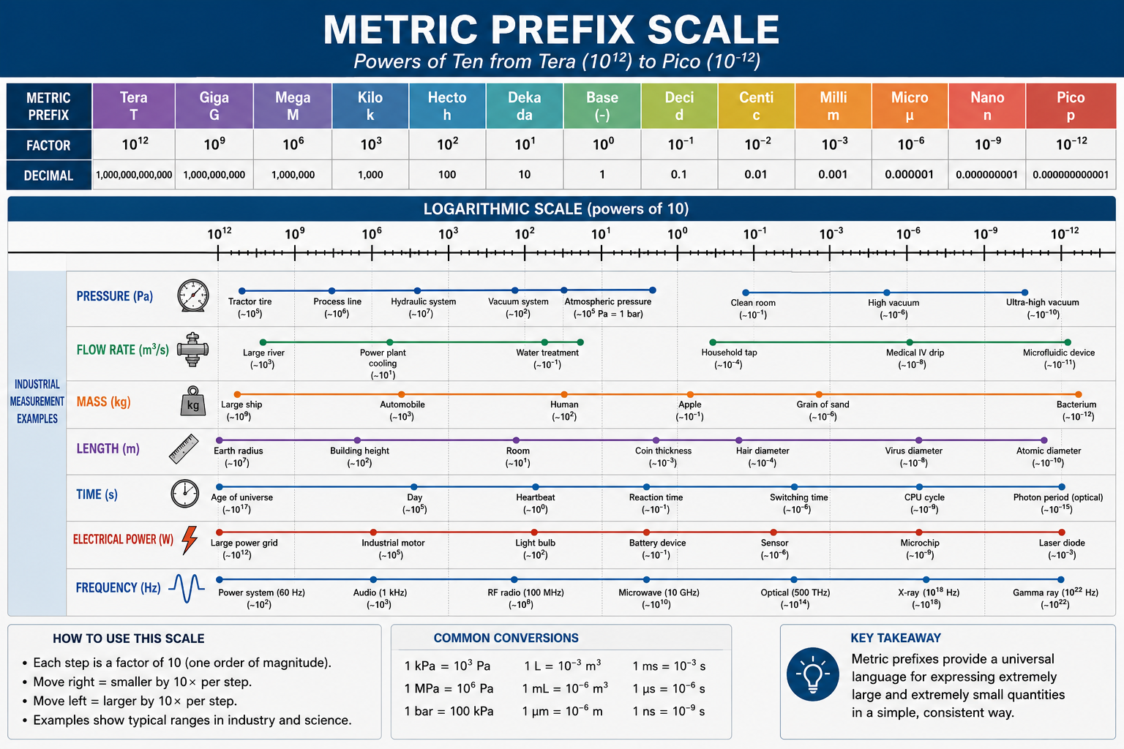

4.1 Worked Prefix Conversions
Original value | Converted value | Reasoning
4.5 mA | 0.0045 A | milli = 10⁻³
250 kPa | 250,000 Pa | kilo = 10³
35 µV | 0.000035 V | micro = 10⁻⁶
2.2 MΩ | 2,200,000 Ω | mega = 10⁶

5. Area and Volume
Area describes a two-dimensional surface. Volume describes a three-dimensional space. Instrumentation calculations use area for diaphragms, pistons, orifice openings, vessel surfaces, and heat-transfer surfaces. Volume is used for vessels, tanks, impulse lines, gas spaces, and inventory.
DIMENSIONAL WARNING
A linear conversion factor must be squared for area and cubed for volume. Because 1 ft = 12 in, then 1 ft² = 144 in² and 1 ft³ = 1728 in³.

5.1 Common Plane Shapes
Shape | Key formula | Instrumentation use
Rectangle | A = x y | Panel openings, rectangular ducts, weirs
Triangle | A = ½ b h | V-notches, structural sections
Trapezoid | A = ½(b + B)h | Open-channel cross-sections
Circle | A = πr²; C = 2πr | Pipes, diaphragms, orifices, tanks

[PROFESSIONAL ENGINEERING ILLUSTRATION PLACEHOLDER]
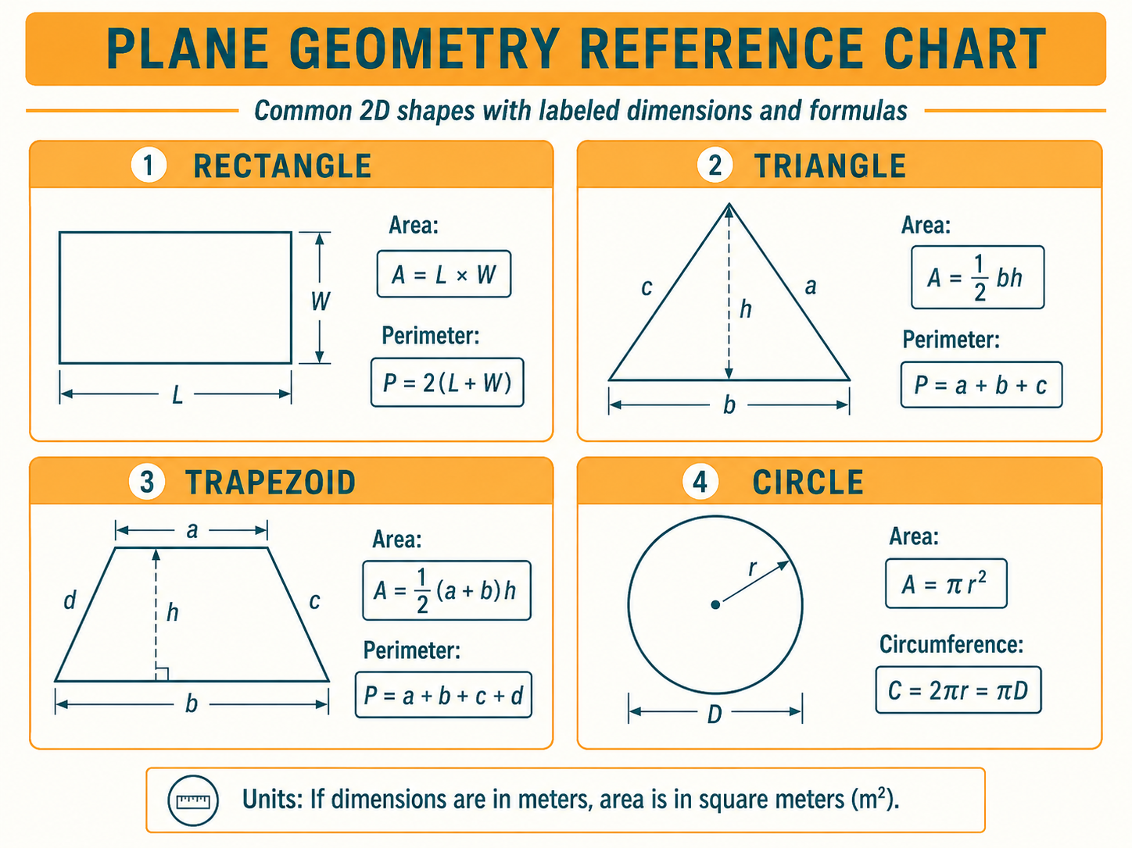
Professional geometry chart showing rectangle, triangle, trapezoid, and circle with labeled dimensions and formulas.

5.2 Common Solids
Solid | Volume | Typical industrial example
Rectangular solid | V = x y z | Control cabinet, rectangular tank
Cylinder | V = πr²h | Storage tank, pipe section, calibration column
Sphere | V = 4/3 πr³ | Spherical pressure vessel
Cone | V = 1/3 πr²h | Hopper and conical tank bottom
Pyramid or tetrahedral form | V = 1/3 × base area × height | Hopper geometry

[PROFESSIONAL ENGINEERING ILLUSTRATION PLACEHOLDER]
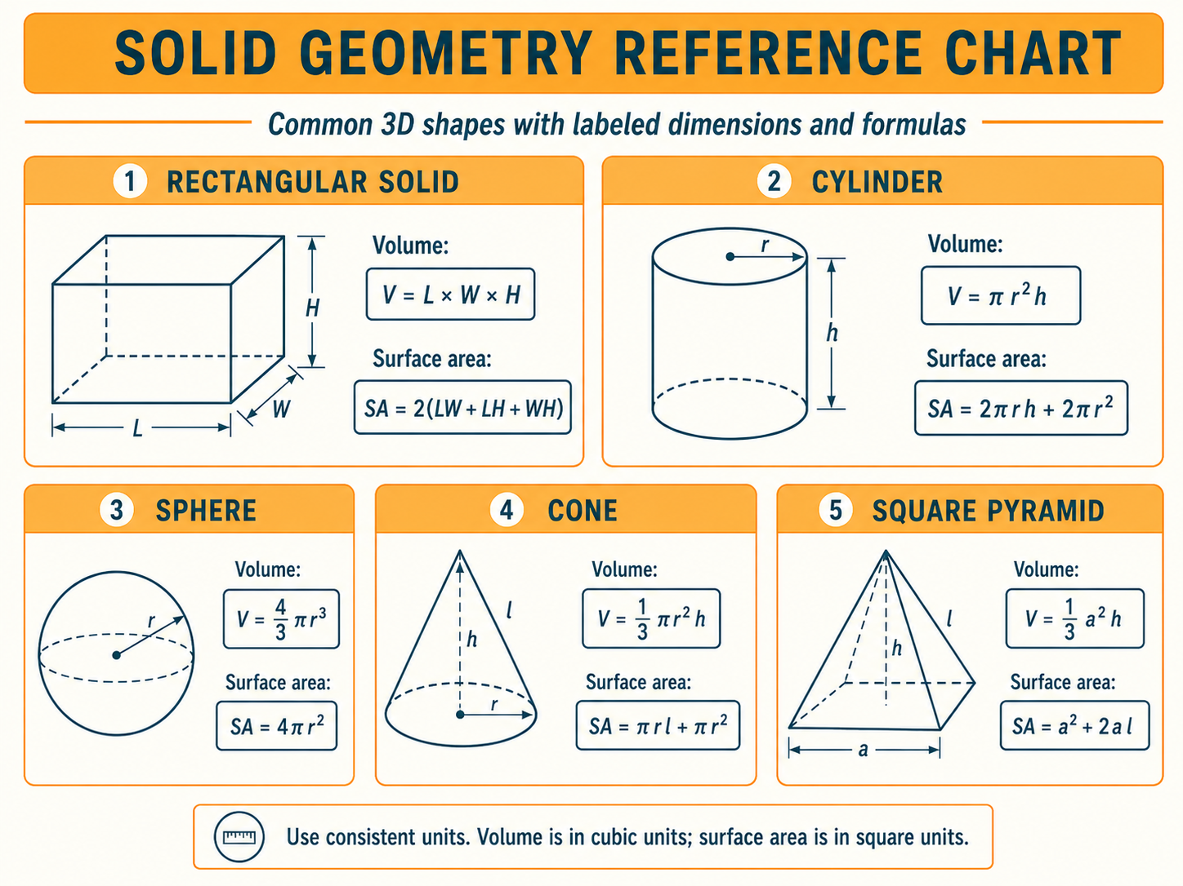
Professional geometry chart showing rectangular solid, cylinder, sphere, cone, and pyramid with labeled dimensions and formulas.

5.3 Worked Example: Cylindrical Tank Volume
A vertical cylindrical tank has an internal diameter of 3.0 m and straight-side height of 8.0 m.
r = D/2 = 1.5 m
V = πr²h = π × 1.5² × 8 = 56.55 m³
This is the geometric capacity of the cylindrical section. Real usable capacity may be reduced by roof shape, bottom geometry, nozzles, internals, operating limits, and freeboard.

5.4 Worked Example: Diaphragm Force
A circular diaphragm has an effective diameter of 80 mm and is exposed to 200 kPa.
A = π(0.04)² = 0.00503 m²
F = P A = 200,000 × 0.00503 ≈ 1005 N
ENGINEERING CONNECTION
Pressure becomes force only after acting over an effective area. This principle governs diaphragms, bellows, pistons, load cells, and hydraulic actuators.

6. Unit Conversion by Unity Fractions
A unity fraction is a ratio of physically equal quantities, so its numerical value is one. Multiplying by such fractions changes units without changing the physical quantity.
METHOD
Write the original quantity as a fraction, multiply by conversion ratios arranged to cancel unwanted units, then verify that only the desired units remain.

6.1 Basic Example: Quarts to Gallons
(35 qt) × (1 gal / 4 qt) = 8.75 gal
The unit qt cancels, leaving gallons.

6.2 Multiple-Step Example: Flow Conversion
Convert 205 ft³/min to yd³/day.
(205 ft³/min) × (1 yd / 3 ft)³ × (60 min / 1 h) × (24 h / 1 day)
= 10,933.3 yd³/day
[PROFESSIONAL ENGINEERING ILLUSTRATION PLACEHOLDER]
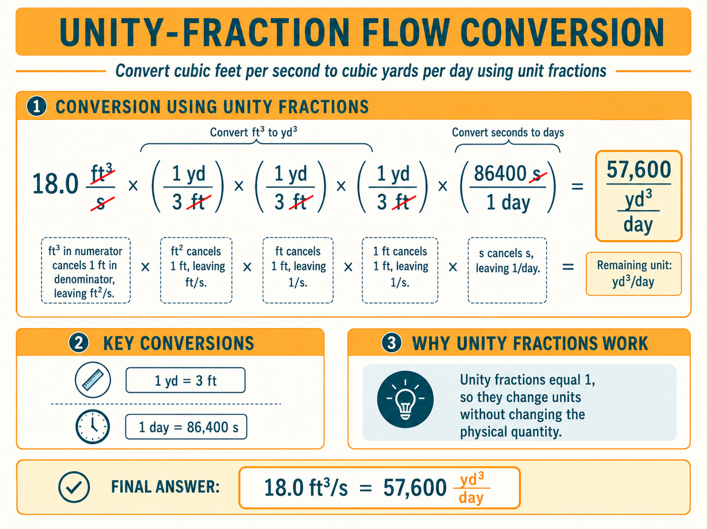
Unity-fraction flow conversion with every canceled unit visually crossed out and the remaining yd³/day highlighted.

6.3 Why Powers Matter
Using 1 ft/12 in once will cancel only one power of inches. For cubic units, the entire conversion ratio must be cubed.
(1 ft / 12 in)³ = 1 ft³ / 1728 in³
COMMON ERROR
Never convert cubic inches to cubic feet by dividing by 12. The correct divisor is 12³ = 1728.

6.4 Conversions That Are Not Direct Proportions
Unity fractions work only for directly proportional units. Offset, inverse, or logarithmic scales require explicit formulas.
Conversion type | Why unity fractions fail | Correct approach
Celsius ↔ Fahrenheit | Scales have both ratio and offset | Use conversion formula
Gauge ↔ absolute pressure | Zero points differ by atmospheric pressure | Add or subtract atmospheric pressure
Wire gauge ↔ diameter | Nonlinear inverse numbering system | Use standard table or formula
Power ratio ↔ decibels | Logarithmic relationship | Use logarithmic equation

7. Temperature Conversion Formulas
Conversion | Formula
Celsius to Fahrenheit | °F = (°C × 9/5) + 32
Fahrenheit to Celsius | °C = (°F − 32) × 5/9
Fahrenheit to Rankine | °R = °F + 459.67
Celsius to Kelvin | K = °C + 273.15

7.1 Worked Example
Convert 80 °C to °F and K.
°F = (80 × 9/5) + 32 = 176 °F
K = 80 + 273.15 = 353.15 K
ABSOLUTE TEMPERATURE
Kelvin and Rankine are absolute scales. Many gas, radiation, and thermodynamic equations require absolute temperature.

8. Common Engineering Conversion Factors
Quantity | Useful equality
Length | 1 in = 2.54 cm; 1 ft = 12 in
Volume | 1 gal = 3.7854 L; 1 mL = 1 cm³
Velocity | 1 mi/h = 0.44704 m/s
Mass | 1 lbm = 0.4535924 kg
Force | 1 lbf = 4.448222 N
Pressure | 1 psi = 6.894757 kPa
Pressure | 1 bar = 100 kPa = 14.504 psi
Energy | 1 Btu = 1055.06 J
Power | 1 hp = 745.7 W

[PROFESSIONAL ENGINEERING ILLUSTRATION PLACEHOLDER]

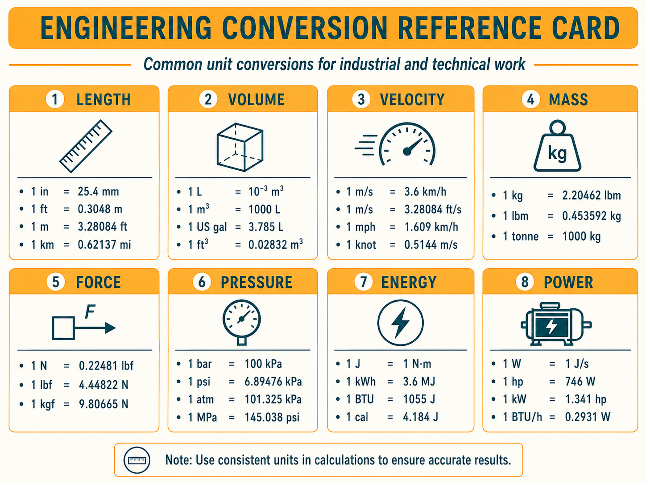
Engineering conversion reference card for length, volume, velocity, mass, force, pressure, energy, and power.

9. Dimensional Analysis
Dimensional analysis replaces variables with units to verify whether an equation is physically consistent. It is one of the most effective ways to detect setup errors before calculating.

9.1 Electrical Power Example
P = I V
[W] = [A][V]
[J/s] = [C/s][J/C] = [J/s]
Coulombs cancel, leaving joules per second, which is the definition of watts.

9.2 Mechanical Force Example
F = m a
[N] = [kg][m/s²]

9.3 Pressure Example
P = F/A
[Pa] = [N/m²]
CHECKING RULE
If the units do not reduce to the expected unit, the equation, conversion factors, or variable definitions are incorrect.

10. The SI System
The International System of Units defines seven base quantities. Most engineering units are derived from these.
Physical quantity | SI base unit | Symbol
Length | meter | m
Mass | kilogram | kg
Time | second | s
Electric current | ampere | A
Thermodynamic temperature | kelvin | K
Amount of substance | mole | mol
Luminous intensity | candela | cd

10.1 Important Derived Units
Derived quantity | Unit | Base-unit form
Force | newton (N) | kg·m/s²
Pressure | pascal (Pa) | N/m² = kg/(m·s²)
Energy | joule (J) | N·m = kg·m²/s²
Power | watt (W) | J/s = kg·m²/s³
Electric charge | coulomb (C) | A·s

11. Instrumentation Applications
Application | Physics and unit issue
Hydrostatic level transmitter | Pressure depends on density, gravity, and height
Orifice flowmeter | Area, density, pressure differential, and unit consistency
Load cell | Mass must be converted to force where required
Control valve actuator | Pressure multiplied by diaphragm or piston area gives force
Tank strapping table | Vessel geometry converts measured level to volume
Thermocouple and RTD | Temperature scale and absolute-vs-relative differences
Gas flow compensation | Absolute pressure and absolute temperature required
Vibration measurement | Displacement, velocity, and acceleration units must not be mixed

12. Installation, Calibration, and Documentation Practice
- Record every engineering unit explicitly on drawings, datasheets, and PLC tags.
- Never assume psi means gauge or absolute; state psig, psia, or psid.
- Confirm whether density is mass density, weight density, or specific gravity.
- Use dimensional analysis during transmitter range calculations.
- Preserve sufficient significant figures through intermediate calculations.
- Round only at the final reported result.
- Verify unit systems when vendor data use mixed SI and customary units.
- Include temperature and pressure reference conditions for gas quantities.

13. Common Field Mistakes
- Using kilograms as though they were newtons.
- Confusing mass density with weight density.
- Writing M instead of m or m instead of M in metric prefixes.
- Applying a linear conversion factor to area or volume without squaring or cubing it.
- Converting gauge pressure to absolute by multiplication instead of adding atmospheric pressure.
- Using Celsius in an equation that requires Kelvin.
- Mixing diameter and radius in circle equations.
- Dropping units during calculations and discovering the error only after commissioning.
- Ignoring liquid density changes when calibrating hydrostatic level instruments.

14. Engineering Deep Dive

14.1 Effective Area
The geometric area of a diaphragm or bellows is not always equal to its effective area. Flexure shape, clamping, convolution geometry, and pressure distribution can alter the force-producing area. Manufacturer data should be used for precision actuator and instrument calculations.

14.2 Reference Conditions
Gas volume is meaningful only when pressure and temperature conditions are known. Normal cubic meters and standard cubic feet represent volume corrected to specified reference conditions. Different organizations may use different standards, so the reference pressure and temperature must be stated.

14.3 Significant Figures and Accuracy
A calculation cannot be more accurate than its least accurate input. Reporting many decimal places does not create measurement accuracy. Engineering reports should preserve useful precision without implying false certainty.

15. Key Takeaways
- Mass is intrinsic; weight is gravitational force.
- Force, mass, and acceleration are related by F = ma.
- Mass density and weight density are different but related by gravity.
- Metric prefixes are powers of ten and are case-sensitive.
- Area conversions require squared factors; volume conversions require cubed factors.
- Unity fractions provide a reliable unit-conversion method for proportional quantities.
- Offset and logarithmic scales require explicit formulas.
- Dimensional analysis verifies whether an equation is physically consistent.
- SI uses seven base units from which engineering units are derived.
- Correct units are essential to safe calibration, design, and troubleshooting.

16. Module Summary
This module established the measurement language used throughout industrial instrumentation. It distinguished mass, weight, force, acceleration, and density; introduced metric prefixes and common geometry; developed the unity-fraction conversion method; and demonstrated dimensional analysis and SI units. These skills form the foundation for pressure, flow, level, temperature, motion, and energy calculations in later modules.

17. Review Questions
1. Mass is best defined as:
A. Gravitational force
B. Resistance to acceleration
C. Volume per unit weight
D. Energy per unit time
Answer: B. Mass measures inertia or resistance to acceleration.
2. Weight is calculated by:
A. W=m/g
B. W=mg
C. W=V/m
D. W=ρ/V
Answer: B. Weight is gravitational force.
3. The SI unit of force is:
A. kilogram
B. pascal
C. newton
D. joule
Answer: C. A newton equals kg·m/s².
4. Mass density is:
A. Weight per area
B. Mass per volume
C. Force per distance
D. Energy per time
Answer: B. ρ=m/V.
5. Weight density is related to mass density by:
A. γ=ρ/g
B. γ=ρg
C. γ=ρV
D. γ=g/ρ
Answer: B. Weight density equals mass density times gravity.
6. The prefix milli means:
A. 10³
B. 10⁻³
C. 10⁶
D. 10⁻⁶
Answer: B. Milli is one-thousandth.
7. The prefix M means:
A. milli
B. micro
C. mega
D. meter
Answer: C. Uppercase M is mega.
8. The area of a circle is:
A. 2πr
B. πr²
C. 4/3πr³
D. πrh
Answer: B. Circle area uses radius squared.
9. The volume of a cylinder is:
A. πr²h
B. 2πr
C. 1/3πr²h
D. xyz/2
Answer: A. Cylinder volume is base area times height.
10. To convert square feet to square inches, the factor 12 must be:
A. Used once
B. Squared
C. Cubed
D. Added
Answer: B. Area uses the square of the linear conversion.
11. Unity fractions work directly for:
A. Proportional unit conversions
B. Celsius to Fahrenheit only
C. Gauge to absolute pressure only
D. Decibels only
Answer: A. They rely on multiplicative proportionality.
12. Which conversion requires an offset formula?
A. Inches to centimeters
B. Gallons to liters
C. Celsius to Fahrenheit
D. Pounds-force to newtons
Answer: C. The scales differ in both size and zero point.
13. Kelvin is obtained from Celsius by:
A. Multiplying by 273.15
B. Adding 273.15
C. Subtracting 32
D. Dividing by 1.8
Answer: B. K=°C+273.15.
14. One pascal is:
A. One newton-meter
B. One newton per square meter
C. One kilogram per second
D. One joule per coulomb
Answer: B. Pressure is force divided by area.
15. The main purpose of dimensional analysis is to:
A. Increase decimal places
B. Check physical consistency of equations
C. Replace calibration
D. Remove units
Answer: B. Correct units must cancel and combine to the expected result.

