# " بسم الله الرحمن الرحيم "

# 

**Face Recognition Assignment**

Name: Anas Karakra

ID:1200467  
Name: Mahmoud Duhaidi

ID:1200340

Department of computer science,Birzeit University

COMP432, COMPUTER SECURITY

**Dr.Mohammad Alkhanafseh**

Sec: 1

9/5/2024

Contents

System Design Description 3

methodology and Algorithms: 3

1.1 methodology: 3

1.2 Algorithm: 3

*1.2.1 Face Encoding:* 3

1.2.2 Matching: 3

12.3 Threshold Selection: 4

System Architecture: 4

2.1 Training Phase: 4

2.2 Testing Phase: 5

2.3 Evaluation: 6

Evaluation Results: 7

3.1 ROC Curve: 7

3.2 Equal Error Rate (EER): 7

Discussion: 8

4.1 Factors Affecting System Performance: 8

4.1.1 Quality of Training Data: 8

4.1.2 Face Detection and Encoding Accuracy 8

# 

# System Design Description

# methodology and Algorithms:

## 1.1 methodology:

The system utilizes facial recognition as the biometric methodology·

## 1.2 Algorithm:

### 1.2.1 Face Encoding:

The system uses the face_recognition library to extract facial encodings from training images folder (find_encodings function)· These encodings capture unique features of each face, forming a compact representation suitable for comparison·

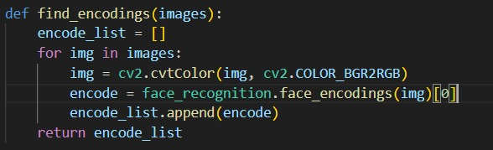

### 1.2.2 Matching:

For each test image from the folder, the system detects faces, encodes them, and compares these encodings with the known encodings from the training set· It uses the face_recognition·compare_faces function with a predefined tolerance to determine potential matches·

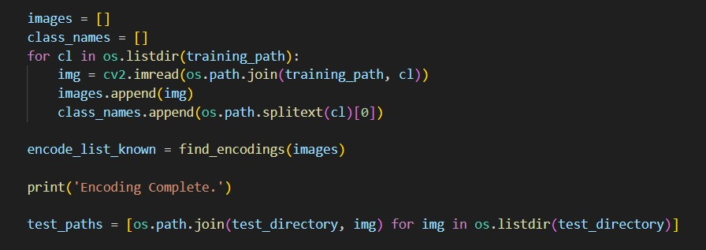

### 12.3 Threshold Selection:

The system tests different thresholds to evaluate performance· A threshold defines the maximum acceptable difference between face encodings to consider a match·



# System Architecture:

## 2.1 Training Phase:

The system reads training images, extracts facial encodings, and stores these along with corresponding class names·

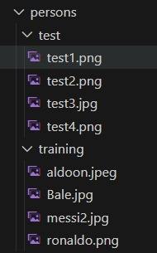

## 

## 2.2 Testing Phase:

Test images are processed similarly: faces are detected, encoded, and compared against the known encodings·

For each threshold, False Match Rate (FMR) and False Non-Match Rate (FNMR) are calculated·

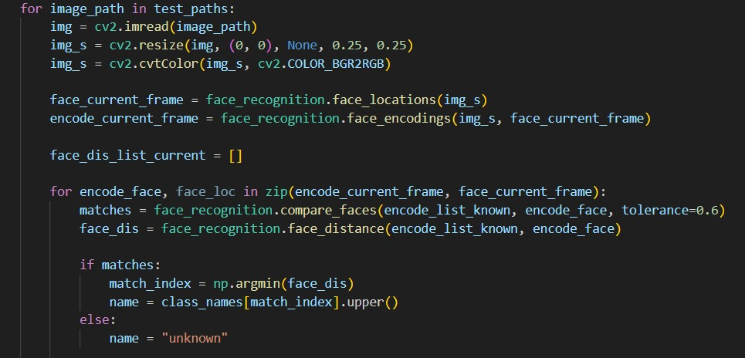

## 2.3 Evaluation:

The system generates a Receiver Operating Characteristic (ROC) curve by varying the threshold and plotting FMR against FNMR·

Equal Error Rate (EER) and its corresponding threshold are determined from the ROC curve·



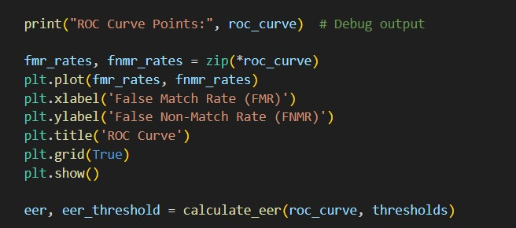

# 

# Evaluation Results:

## 3.1 ROC Curve:

The ROC curve plots the False Match Rate (FMR) against the False Non-Match Rate (FNMR) for different threshold values· This curve helps visualize the trade-off between FMR and FNMR·

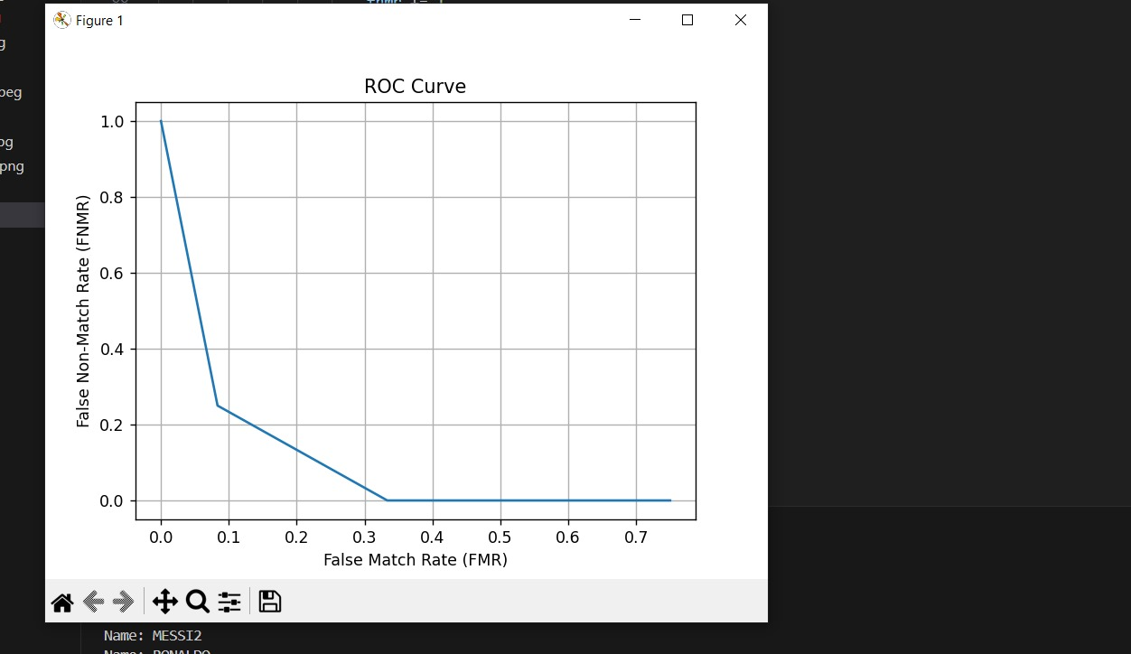

## 3.2 Equal Error Rate (EER):

The Equal Error Rate (EER) is the point on the ROC curve where FMR equals FNMR· It represents the threshold at which the system's performance is balanced in terms of false acceptance and false rejection·



# Discussion:

## 4.1 Factors Affecting System Performance:

4.1.1 Quality of Training Data: The accuracy of the system heavily depends on the diversity and quality of training images·

4.1.2 Face Detection and Encoding Accuracy: Variations in lighting, pose, and facial expressions can affect the accuracy of face detection and encoding·

4.1.3 Threshold Selection: Choosing an optimal threshold is crucial; a too high threshold might increase false rejections (FNMR), while a too low threshold could increase false acceptances (FMR)·

**4.2 Potential Improvements:**

4.2.1 Data Augmentation: Increasing the variety of training data can improve the robustness of the model·

4.2.2 Ensemble Techniques: Combining multiple classifiers or face recognition methods might improve overall performance·

4.2.3 Real-time Implementation: Optimizing the system for real-time performance, possibly using GPU acceleration, can enhance usability·