**HC-SR 04 Ultrasonic sensor is used to measure distance and the speed of movement of any object.**

**Project Description:**

HC-SR 04 Ultrasonic sensor is used to measure distance and the speed of movement of any object that is positive when the object move away from sensor and is negative when close from sensor.

**displaying distance and speed on LCD**

In Range 🡪 0 – 50 cm 🡪 G_LED Flashing

In Range 🡪 50 – 100 cm 🡪 R_LED Flashing

In Range 🡪 100 – 150 cm 🡪 Y_LED Flashing

In Range 🡪 150–200 cm 🡪 B_LED Flashing

Distance increase 🡪 Flashing Slower from (50ms) to (200ms)

**Applications:**

* **Radar that can measure speed of vehicles**
* **In Water Tank, we can measure time to fill the tank and observe water level.**
* **And more others application**

**Components required in this project:**

1. **Arduino uno**
2. **16×2 LCD Display**
3. **Ultrasonic sensor HC SR04**
4. **Green-Red-Yellow-Blue LEDs**
5. **Breadboard and jump wires**
6. **Resistor 1KOhm-4.7KOhm**
7. **Resistor 330 Ohm ×4 - 100Ohm ×1**
8. **USB cable type A/B.**
9. **Power Supply 9V-2A**

**Schematic**

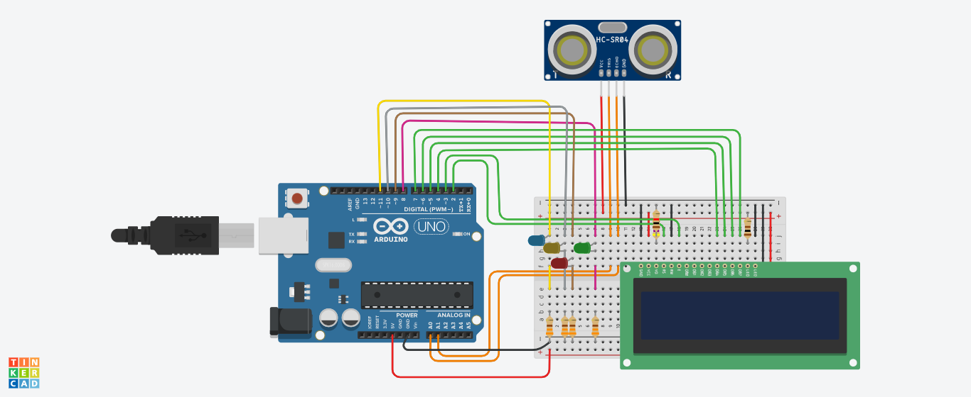

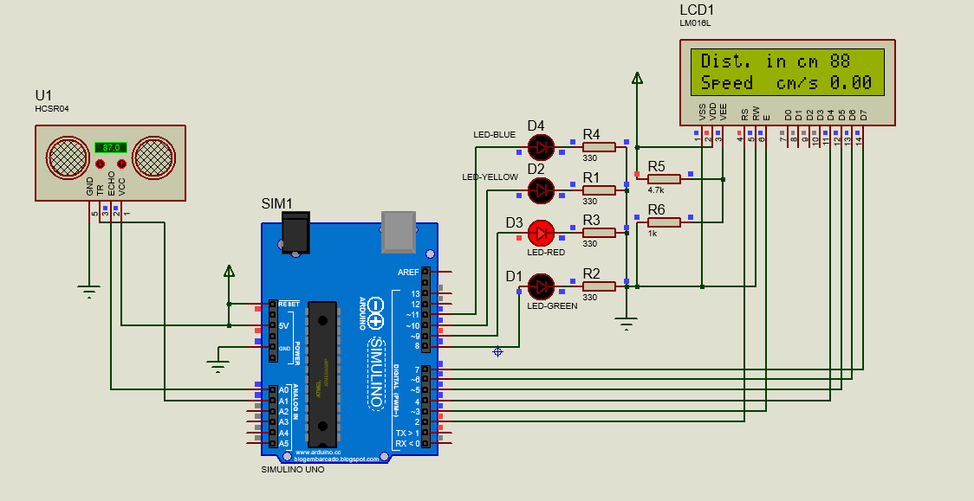

**ARDUINO UNO**

Arduino is an open-source electronics platform based on easy to use hardware & software.

**Pinout Diagram:**

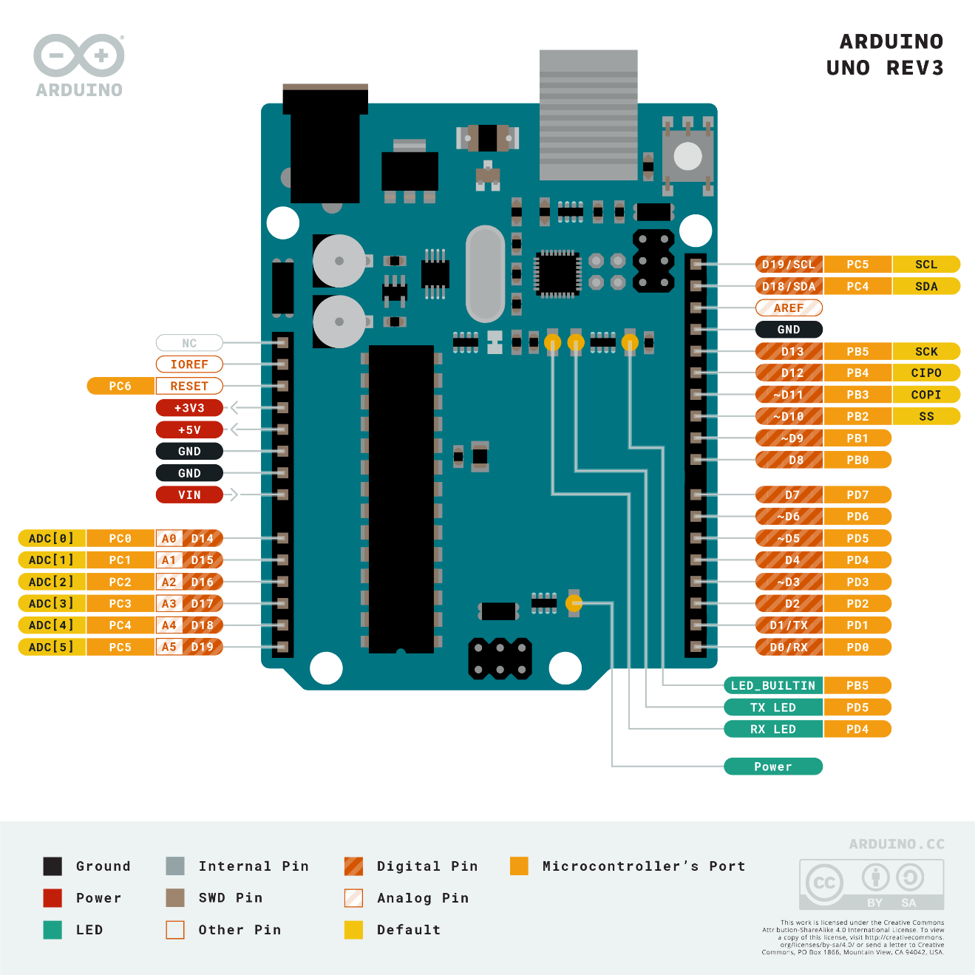

**ULTRASONIC SENSOR**

HC-SR 04 Ultrasonic sensor is most commonly used to measure distance.

* First off, we will start with the sensor. The HC-SR04 ultrasonic sensor uses sonar to determine the distance to an object. This sensor reads from 2cm to 400cm (0.8inch to 157inch) with an accuracy of 0.3cm (0.1inches), which is good for our project. In addition, this particular module comes with ultrasonic transmitter and receiver modules.

1. The ultrasonic sensor uses sonar to determine the distance to an object. Here is what happens:
2. The ultrasound transmitter (trig pin) emits a high-frequency sound (40 kHz).
3. The sound travels through the air. If it finds an object, it bounces back to the module.
4. The ultrasound receiver (echo pin) receives the reflected sound (echo).

The time between the transmission and reception of the signal allows us to calculate the distance to an object. This is possible because we know the velocity of the sound in the air. Here is the formula:

D= (speed of sound in air*time)/2 Given that speed of sound in the air at 20ºC = 343m/s.

**Now**, I will show how to measure the speed of movement of an object using this sensor.

For that purpose we need to take two distance measurements in a short time apart and we have:

distance2 - distance1 = distance speed at a given time

If we make the measurements in a time period of 1 second, then we get the speed of movement of the object in cm/s. The basic code is taken from the arduino cc forum and I just added an LCD display for a visual representation of the results.

The first row shows the distance, and the second row shows the speed if the object is moving.

**When the object is moving in the opposite direction, the speed represented on the display has a negative sign.**

**16×2 LCD Display**

* On the other hand, we will use a 16x2 LCD to show the distance , 16×2 LCD is a 32 digits display screen. This word comes from the liquid crystal and 16X2 represents its screen size. So, it will have (16×2=32) 32 characters in total and each character will be made of 5×8 Pixel Dots. The pinout:

**Pinout Diagram:**

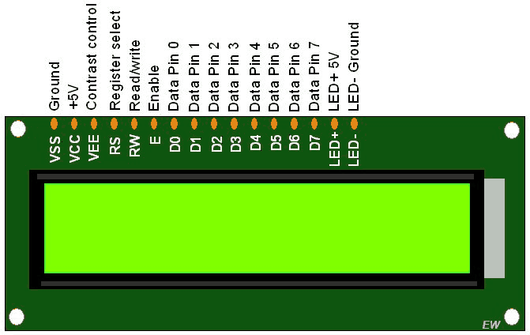

**The connection of the circuit:**

**We connect the components to the Arduino uno board as the following steps:**

1. **Ultrasonic sensor HC SR04**

|  |  |
| --- | --- |
| **Ultrasonic Sensor** | **Arduino Uno** |
| **VCC** | **5V** |
| **TRIG** | **Analog pin A1** |
| **ECHO** | **Analog pin A0** |
| **GND** | **GND** |

1. **LED Connection**

|  |  |
| --- | --- |
| **LEDs** | **Arduino Uno-Breadboard** |
| **Green LED** | **Digital pin 8** |
| **Resistror 330Ohm** | **GND** |
| **Red LED** | **Digital pin 9** |
| **Resistror 330Ohm** | **GND** |
| **Yellow LED** | **Digital pin 10** |
| **Resistror 330Ohm** | **GND** |
| **Blue LED** | **Digital pin 11** |
| **Resistror 330Ohm** | **GND** |

1. **Resistor 1KOhm-4.7KOhm**

|  |  |
| --- | --- |
| **4.7K** | **5V** |
| **First terminal of 1KOhm-4.7KOhm** | **V0 Pin 3 in LCD** |
| **1K** | **GND** |

1. **16×2 LCD Display**

|  |  |  |
| --- | --- | --- |
| **pins** | **LCD** | **Arduino Uno** |
|  | **GND** | **GND** |
|  | **VCC** | **5V** |
|  | **V0** | **Resistor 1K-4.7K** |
|  | **RS** | **Digital Pin 2** |
|  | **RW** | **GND** |
|  | **E** | **Digital Pin 3** |
|  | **DB0** | ---------------- |
|  | **DB1** | ------------------ |
|  | **DB2** | ------------------ |
|  | **DB3** | ------------------ |
|  | **DB4** | **Digital Pin 4** |
|  | **DB5** | **Digital Pin 5** |
|  | **DB6** | **Digital Pin 6** |
|  | **DB7** | **Digital Pin 7** |
|  | **BL LED** | **Resistor 100 – 5V** |
|  | **BL LED** | **GND** |