Question: Is it possible to do the neural network training offline and then provide the probability of the neural network predicate to the Problog program?

Answer: Yes, it is entirely possible to train a neural network offline and then use its output probabilities within a ProbLog program. In fact, this approach is a common and practical way to integrate neural and symbolic reasoning.
This "offline" or "pre-trained" model approach differs from the end-to-end, joint training of DeepProbLog, but it offers several distinct advantages.

How to use an offline-trained NN in ProbLog
To achieve this, you need to create an interface that allows your ProbLog program to call the pre-trained neural network. This is often done by leveraging ProbLog's ability to interface with external languages, like Python.
1. Train and save the neural network: First, train your neural network (e.g., using a framework like PyTorch or TensorFlow) on your dataset. Once training is complete, save the trained model weights to a file.

2. Create a Python wrapper: Write a Python script that loads the saved model and defines a function that takes an input and returns the network's predicted probabilities. You can use ProbLog's Python bridge to expose this function to your logic program.

3. Define the neural predicate in ProbLog: In your ProbLog program, you can then define a "flexible probability" predicate that calls the Python function to get its probability value.

Example: Using a pre-trained digit classifier
Following the example from the previous response, here is how you could implement it with an offline-trained network:
Step 1: The Python wrapper
Create a Python file, for instance nn_module.py, that loads a pre-trained digit recognition model (digit_model.pt) and defines a function to get its predictions.

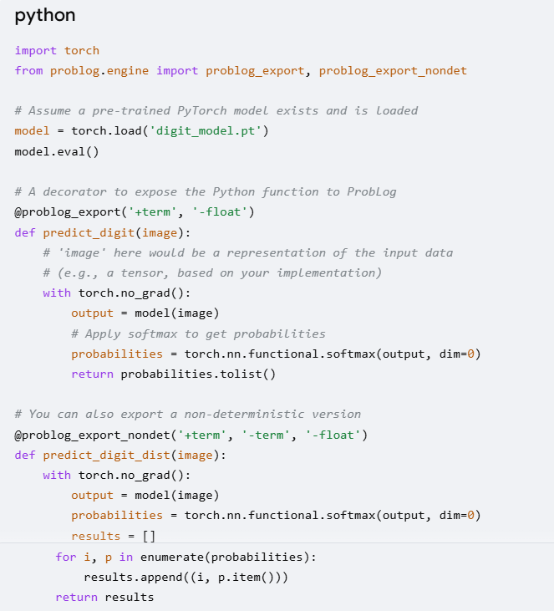
python
import torch
from problog.engine import problog_export, problog_export_nondet

# Assume a pre-trained PyTorch model exists and is loaded
model = torch.load('digit_model.pt')
model.eval()

# A decorator to expose the Python function to ProbLog
@problog_export('+term', '-float')
def predict_digit(image):
# 'image' here would be a representation of the input data
# (e.g., a tensor, based on your implementation)
with torch.no_grad():
output = model(image)
# Apply softmax to get probabilities
probabilities = torch.nn.functional.softmax(output, dim=0)
return probabilities.tolist()

# You can also export a non-deterministic version
@problog_export_nondet('+term', '-term', '-float')
def predict_digit_dist(image):
with torch.no_grad():
output = model(image)
probabilities = torch.nn.functional.softmax(output, dim=0)
results = []
for i, p in enumerate(probabilities):
results.append((i, p.item()))
return results
Step 2: The ProbLog program
Create your ProbLog program, loading the Python module and using the custom predicate.
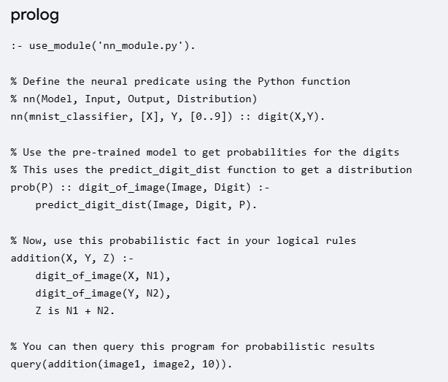
:- use_module('nn_module.py').

% Define the neural predicate using the Python function
% nn(Model, Input, Output, Distribution)
nn(mnist_classifier, [X], Y, [0..9]) :: digit(X,Y).

% Use the pre-trained model to get probabilities for the digits
% This uses the predict_digit_dist function to get a distribution
prob(P) :: digit_of_image(Image, Digit) :-
predict_digit_dist(Image, Digit, P).

% Now, use this probabilistic fact in your logical rules
addition(X, Y, Z) :-
digit_of_image(X, N1),
digit_of_image(Y, N2),
Z is N1 + N2.

% You can then query this program for probabilistic results
query(addition(image1, image2, 10)).

Advantages of offline training
- Modularity: It clearly separates the neural and symbolic components of the system. The neural network is a self-contained module that can be developed and updated independently.
- Reusability: The same pre-trained neural network can be used in different ProbLog programs, potentially serving as a perception module for various logical tasks.
- Efficiency: Inference is typically faster because ProbLog does not need to perform complex end-to-end backpropagation. It only needs to do a forward pass through the pre-trained network.
- Flexibility: You are not limited to the end-to-end training mechanisms of DeepProbLog. You can train your network using any technique and then integrate the results.
This approach allows you to harness the power of deep learning for specific perceptual tasks while relying on the expressive and interpretable nature of probabilistic logic programming for high-level reasoning.

