LINQ
LINQ(Language Integrated Query): is a Microsoft .NET Component That Provides Set of Technologies Based on the Integration of Query Capabilities Directly into the C# Language.
How to enable LINQ querying of your data source:
- In-memory data: if the data is of a type that implements IEnumerable<T>, you can query the data by using LINQ to Objects.
- Remote data : the best option for enabling LINQ querying of a remote data source is to implement the IQueryable<T> interface. However, this differs from extending a provider such as LINQ to SQL for a data source.

Query Expressions Overview:
- Query expressions can be used to query and to transform data from any LINQ-enabled data source. For example, a single query can retrieve data from a SQL database, and produce an XML stream as output.
- A query is not executed until you iterate over the query variable(Deferred Execution), for example, in a foreach statement.
- Query expressions can be compiled to expression trees or to delegates, depending on the type that the query is applied to. IEnumerable<T> queries are compiled to delegates. IQueryable and IQueryable<T> queries are compiled to expression trees.

Instead of creating our custom method :
public static IEnumerable<Employee> Filter(this IEnumerable<Employee> source, Func<Employee, bool> predicate)
{
foreach (var employee in source)
{
if (predicate(employee))
{
yield return employee;
}
}
}
We Can Rely on LINQ:
public static IEnumerable<TSource> Where<TSource>(this IEnumerable<TSource> source, Func<TSource, bool> predicate){}
In LINQ we can use Query Syntax and Method Syntax :
static void Main(string[] args)
{

List<int> numbers=new List<int> { 1, 2, 3, 4, 5, 6, 7, 8, 9 };
// Method Syntax
var EvenNumbersWithExtensionMethod =
numbers.Where(x => x % 2 == 0);
Console.WriteLine("With Extension Method");
foreach (var number in EvenNumbersWithExtensionMethod)
{
Console.WriteLine(number);
}
// Query Syntax
var EvenNumbersWithQuery =
from n in numbers
where n % 2 == 0
select n;

Console.WriteLine();
Console.WriteLine("With Query Syntax");
foreach (var n in EvenNumbersWithQuery)
{
Console.WriteLine(n);
}

}

Projection Operators:
Select: IEnumerable<TResult> Select<TSource, TResult>(
this IEnumerable<TSource> source, Func<TSource, TResult> selector){}
Project each element in a sequence into a new form
Implemented using Deferred Execution
Examples Using Method Syntax:
var result = numbers.Select(x => x * x);
var result = words.Select(x => x.ToUpper());
var result = employees.Select(x => {
return new EmployeeDto
{
Name = $"{x.FirstName} {x.LastName}",
TotalSkills = x.Skills.Count()
};
});
Examples Using Query Syntax:
var result02 = from n in numbers
select n * n;
var result02 = from word in words
select word.ToUpper();

SelectMany: IEnumerable<TResult> SelectMany<TSource, TResult>(this IEnumerable<TSource> source, Func<TSource, IEnumerable<TResult>> selector){}
Projects each element of a sequence to an IEnumerable and flattens the resulting sequences into one sequence . in general , you can use the SelectMany method whenever you have a collection of collections and you want to extract all the elements from the inner collections and combine them into a single sequence.
Implemented using Deferred Execution
Examples
Extension Method:
List<string> strings = new List<string> { "hello", "world", "linq" };

List<char> characters = strings.SelectMany(s => s).ToList();
Output is :
['h', 'e', 'l', 'l', 'o', 'w', 'o', 'r', 'l', 'd', 'l', 'i', 'n', 'q']
Query Syntax:
var characters = (
from s in strings
from c in s
select c ).ToList();

Zip: IEnumerable<TResult> Zip<TFirst, TSecond, TResult>(this IEnumerable<TFirst> first, IEnumerable<TSecond> second, Func<TFirst, TSecond, TResult> resultSelector)
Applies a specified function to the corresponding elements of two sequences, producing a sequence of the results.
Implemented using Deferred Execution
Method Syntax:
string[] colorName = { "Red", "Green", "Blue" };
string[] colorHEX = { "FF0000", "00FF00", "0000FF"};

var colors = colorName.Zip(colorHEX, (name, hex) => $"{name} ({hex})");
Query Syntax :
var ColorsNamesWithHex = from colors in colorName.Zip(colorHEX)
select $"{colors.First} ({colors.Second})";

Sorting Data:
OrderBy: OrderBy<TSource,TKey>(IEnumerable<TSource>, Func<TSource,TKey>)
Sorts the elements of a sequence in ascending order according to a key.
Implemented using Deferred Execution
string[] fruits = { "Apple", "Banana", "Mango", "Orange", "Watermellon" };
Method Syntax:
var FilterdFruitsASC = fruits.OrderBy(f => f );
Query Syntax:
var FruitsASC = from fruit in fruits
orderby fruit
select fruit;
OrderByDescending: OrderByDescending<TSource,TKey>(IEnumerable<TSource>, Func<TSource,TKey>)
Sorts the elements of a sequence in descending order according to a key.
Implemented using Deferred Execution
Method Syntax:
var FilterdFruitsASC = fruits.OrderByDescending(f => f );
Query Syntax:
var FruitsASC = from fruit in fruits
orderby fruit descending
select fruit;
OrderBy: IOrderedEnumerable<TSource> OrderBy<TSource, TKey>(this IEnumerable<TSource> source, Func<TSource, TKey> keySelector, IComparer<TKey>? comparer)
Sorts the elements of a sequence in descending order by using specified comparer.
Implemented using Deferred Execution
IOrderedEnumerable<Employee> OrderEmployees = employees.OrderBy(emp => emp,new EmployeeComparer());
Reverse: IEnumerable<TSource> Reverse<TSource>(this IEnumerable<TSource> source)
Inverts the order of the elements in a sequence.
Implemented using Deferred Execution
var reversedFruits = fruits.Reverse();
Note: it must be assigned to a variable to be applied , calling it without assignment will not reverse the order

ThenBy: IOrderedEnumerable<TSource> ThenBy<TSource, TKey>(this IOrderedEnumerable<TSource> source, Func<TSource, TKey> keySelector)
Performs a subsequent ordering of the elements in sequence in ascending order according to a Key.
Implemented using Deferred Execution
var storedEmployees= Employees.OrderBy(employee => employee.Name).ThenBy(employee => employee.Salary);
Data Partitioning:
Skip: IEnumerable<TSource> Skip<TSource>(this IEnumerable<TSource> source, int count)
Bypasses a specified number of elements in a sequence and then returns the remaining elements.
Implemented using Deferred Execution
var EmployeesList = List.Skip(10);// skip first 10 items and returns the remaining elements in a sequence
SkipWhile: IEnumerable<TSource> SkipWhile<TSource>(this IEnumerable<TSource> source, Func<TSource, bool> predicate)
Bypasses elements of a sequence as long as a specified condition is true then returns the remaining elements.
Implemented using Deferred Execution
var skipWhileList = List.SkipWhile(emp => emp.Salary != 172500);
// skip elements until found the employee with this salary then it stops skipping elements
SkipLast: IEnumerable<TSource> SkipLast<TSource>(this IEnumerable<TSource> source, int count)
Returns a new enumerable collection that contains elements of source with last count elements of the source collection omitted.
Implemented using Deferred Execution
var skipLast = List.SkipLast(10);// skip last 10 items in the collection
Take: IEnumerable<TSource> Take<TSource>(this IEnumerable<TSource> source, int count)
Returns a specified number of contiguous elements from the start of a sequence.
Implemented using Deferred Execution
var TakenList = List.Take(10);//Take First 10 items

TakeWhile: IEnumerable<TSource> TakeWhile<TSource>(this IEnumerable<TSource> source, Func<TSource,bool> predicate)
Returns elements of a sequence as long as a specified condition is true.
Implemented using Deferred Execution
var TakeWhileList = List.TakeWhile(emp => emp.Salary != 172500);
// Take Elements until found the employee with this salary
Chunk: IEnumerable<TSource[]> Chunk<TSource>(this IEnumerable<TSource> source, int size)
Split the elements of a sequence into chunks of size at most size, Each chunk except the last one will be of size. The last chunk will contain the remaining elements and may be of a smaller size.
Implemented using Deferred Execution
var ChunkedEmployees = employees.Chunk(10).ToList();
for(int i=0; i < ChunkedEmployees.Count; i++)
{
ChunkedEmployees[i].Print($"Chunk #{i + 1}");
}
Output:
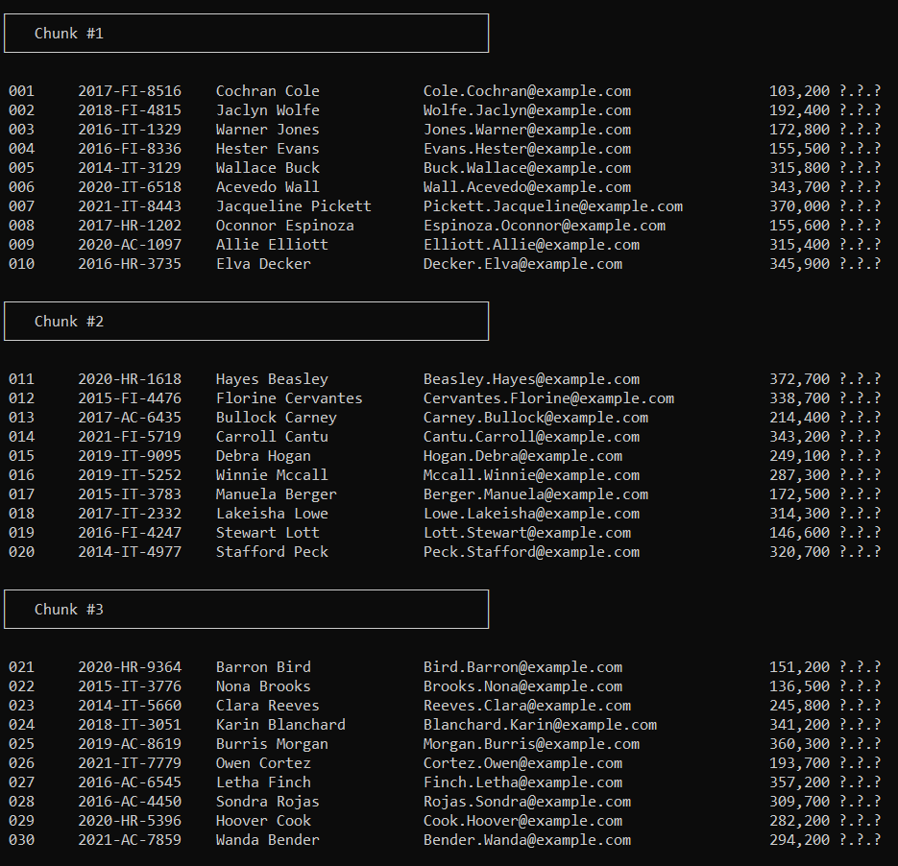

Quantifiers:
Any: bool Any<TSource>(this IEnumerable<TSource> source, Func<TSource, bool> predicate)
Determines whether any element of a sequence satisfies a condition.
var result = employees.Any(e => e.Name.StartsWith("jac"))
We can integrate any within a query to return a specific elements :
// Any with query syntax return the employees there have C# in their skills
var result = from employee in employees
where employee.Skills.Any(s=> s=="C#")
select employee;
// return employees with skills consists from 3 characters or more.
var result = from employee in employees
where employee.Skills.Any(s => s.Length>=3)
select employee;
All: bool All<TSource>(this IEnumerable<TSource> source, Func<TSource, bool> predicate)
Determines whether all elements of a sequence satisfy a condition.
// Determines whether all the employees have salary more than 20000
var resultt = employees.All(e => e.Salary > 20000);
Contains: bool Contains<TSource>(this IEnumerable<TSource> source, TSource value)
Determines whether a sequence contains a specified element by using the default equality comparer. If we compare reference type objects it will return false although the values are equal, but it requires override the equality method in the type itself.
// determines whether there are an employee have "ee" in his name
var result9 = employees.Any(e => e.Name.Contains("ee"));

Grouping Data:
GroupBy: IEnumerable<IGrouping<TKey, TSource>> GroupBy<TSource, TKey>(this IEnumerable<TSource> source, Func<TSource, TKey> keySelector)
Groups the elements of a sequence according to a specified key selector function
Implemented using Deferred Execution
Method Syntax:
// return groups of employees based on their departments
var GroupPerDepartment = employees.GroupBy(x => x.Department);
Query Syntax:
var GroupPerDepartment = from employee in employees
group employee by employee.Department;
ToLookup: ILookup<TKey, TSource> ToLookup<TSource, TKey>(this IEnumerable<TSource> source, Func<TSource, TKey> keySelector)
Creates Lookup<Tkey,Telement> from an IEnumerable<out T> according to a specified key selector function.
Implemented using Immediate Execution
// return groups of employees based on their departments
var GroupPerDepartment = employees.ToLookup(x => x.Department);
Join Operations:
Join: IEnumerable<TResult> Join<TOuter, TInner, TKey, TResult>(this IEnumerable<TOuter> outer, IEnumerable<TInner> inner, Func<TOuter, TKey> outerKeySelector, Func<TInner, TKey> innerKeySelector, Func<TOuter, TInner, TResult> resultSelector)
Correlates the elements of two sequences based on matching keys ,the default equality comparer is used to compare keys.
Method Syntax:
// here from employees and departments we construct a new type "EmployeeDepartment" based on matching emp.departmentId with dep.Id
var result = employees.Join(departments, emp => emp.DepartmentId, dep => dep.Id,
(employee, department) => new EmployeeDepartment
{ FullName = employee.FullName, DepartmentName = department.Name })
Query Syntax:
var result = from employee in employees
join department in departments on employee.DepartmentId equals department.Id
select new EmployeeDepartment
{
FullName = employee.FullName,
DepartmentName = department.Name
};
Group Join: IEnumerable<TResult> GroupJoin<TOuter, TInner, TKey, TResult>(this IEnumerable<TOuter> outer, IEnumerable<TInner> inner, Func<TOuter, TKey> outerKeySelector, Func<TInner, TKey> innerKeySelector, Func<TOuter, IEnumerable<TInner>, TResult> resultSelector)
Correlates the elements of two sequences based on equality of keys and groups the result, the default equality comparer is used to compare keys
Method Syntax:
// here we make a groups of employees based on their departments
var result = departments.GroupJoin(employees, department => department.Id, emp => emp.DepartmentId,(department, emps) => new Group
{
Department = department.Name,
NamesOfEmployees = emps.Select(emp => emp.FullName).ToList()
});
Query Syntax:
var result = from dept in departments
join emp in employees on dept.Id equals emp.DepartmentId
into empGroup
select empGroup;
Generation Operations:
Range: IEnumerable<int> Range(int start, int count)
Generates a sequence of integral numbers within a specified range.
Implemented using Deferred Execution
var range = Enumerable.Range(1, 10);
// we can gain the same result in the traditional way:
int[] range2 = new int[10];
for(int i=0,j=1; i< range2.Length; i++,j++)
{
range2[i] = j;
}
foreach(var item in range2)
{
Console.WriteLine(item);
}
Repeat: IEnumerable<TResult> Repeat<TResult>(TResult element, int count)
Generates a sequence that contains one repeated value.
// repeat the element 10 times and not create new 10 element but repeat the element itself
var questions = Enumerable.Repeat(question, 10);

Empty Opearators:
Empty: IEnumerable<TResult> Empty<TResult>() => EmptyPartition<TResult>.Instance;
Returns an empty IEnumerable<out T> That has specified type argument
IEnumerable<Question> s questions2 = Enumerable.Empty<Question>()
DefaultIfEmpty: Enumerable<TSource?> DefaultIfEmpty<TSource>(this IEnumerable<TSource> source) => DefaultIfEmpty(source, default);

Returns the elements of the specified sequence or the type parameters default value in a singleton collection if the sequence is empty

List<int> numbers = new List<int>();
foreach (int number in numbers.DefaultIfEmpty())
{
Console.WriteLine(number);
}
/*
This code produces the following output:
0
*/
DeafultIfEmpty():IEnumerable<TSource> DefaultIfEmpty<TSource>(this IEnumerable<TSource> source, TSource defaultValue)
Returns the elements of the specified sequence or the specified value in a singleton collection if the sequence is empty.
IEnumerable<Question> questions = questions2.DefaultIfEmpty(Question.DefaultValueByMe);
// if empty will contain what between barantheses that I was identified in the class itself as a property to be the default

Element Operations:

ElementAt: TSource ElementAt<TSource>(this IEnumerable<TSource> source, int index)
Returns the element at specified index in a sequence
Question questionAt10 = questions.ElementAt(10);// it will give an exception if the element doesn't exist

ElementAtOrDefault: TSource? ElementAtOrDefault<TSource>(this IEnumerable<TSource> source, int index)
Returns the element at a specified index in a sequence or a default value if the index is out of range
Question questionAt300 = questions.ElementAtOrDefault(300); );// it will not give an exception if the element doesn't exist
Single: TSource Single<TSource>(this IEnumerable<TSource> source)
Returns the only one element in a sequence , and throws an exception if there is not exactly one element in the sequence
Question question = questions.Single();
Single: TSource Single<TSource>(this IEnumerable<TSource> source, Func<TSource, bool> predicate)

Returns the only element in the sequence that satisfies a specific condition ,and throws an exception if more than one such element exist

Question question1 = questions.Single(x=> x.Title.Contains("#245"));

SingleOrDefualt: TSource? SingleOrDefault<TSource>(this IEnumerable<TSource> source, Func<TSource, bool> predicate)
Returns the only element of a sequence that satisfies a specified condition or a default value if no such element exists; this method throws an exception if more than one element satisfies the condition.
var question4 = questions.SingleOrDefault(x => x.Title.Contains("#255"));

SingleOrDefault: TSource? SingleOrDefault<TSource>(this IEnumerable<TSource> source)
Returns the only element of a sequence, or a default value if the sequence is empty; this method throws an exception if there is more than one element in the sequence.
var question3 = questions.SingleOrDefault();

First: TSource First<TSource>(this IEnumerable<TSource> source)
Returns the first element of a sequence
var question1 = questions.First()
First: TSource First<TSource>(this IEnumerable<TSource> source, Func<TSource, bool> predicate)
Returns the first element of a sequence that satisfies a specified condition
var question2 = questions.First(x=> x.Title== "Q #2: In the streaming");
FirstOrDefault: TSource? FirstOrDefault<TSource>(this IEnumerable<TSource> source)
Returns the first element of a sequence, or a default value if the sequence contains no elements
var question3 = questions.FirstOrDefault();
FirstOrDefault: TSource? FirstOrDefault<TSource>(this IEnumerable<TSource> source, Func<TSource, bool> predicate)
Returns the first element of the sequence that satisfies a condition or a default value if no such element is found
var question4 = questions.FirstOrDefault(x=> x.Title=="24157");

Last: TSource Last<TSource>(this IEnumerable<TSource> source)
Returns the last element of a sequence need to apply OrderBy on the data or the data be ordered
var question1 = questions.()
Last: TSource Last<TSource>(this IEnumerable<TSource> source, Func<TSource, bool> predicate)
Returns the last element of a sequence that satisfies a specified condition
var question2 = questions.Last(x=> x.Title== "Q #2: In the streaming");
LastOrDefault: TSource? LastOrDefault<TSource>(this IEnumerable<TSource> source)
Returns the last element of a sequence, or a default value if the sequence contains no elements
var question3 = questions.LastOrDefault();
LastOrDefault: TSource? LastOrDefault<TSource>(this IEnumerable<TSource> source, Func<TSource, bool> predicate)
Returns the last element of the sequence that satisfies a condition or a default value if no such element is found
var question4 = questions.LastOrDefault(x=> x.Title=="24157");

Equality :

SequenceEqual: bool SequenceEqual<TSource>(this IEnumerable<TSource> first, IEnumerable<TSource> second)
Determines whether two sequences are equal by comparing the elements by using the default equality comparer for their type.
var list1 = new List<Question>(new[] { q1, q2, q3 });
var list2 = new List<Question>(new[] { q1, q2, q3 });
var result = list1.SequenceEqual(list2);

SequenceEqual: bool SequenceEqual<TSource>(this IEnumerable<TSource> first, IEnumerable<TSource> second, IEqualityComparer<TSource>? comparer)
Determines whether two sequences are equal by comparing the elements by using a specified equality comparer.

Concatenation:
Concat: IEnumerable<TSource> Concat<TSource>(this IEnumerable<TSource> first, IEnumerable<TSource> second)
Concatenates two sequences
int[] ints = { 1, 2, 3, 4, 5 };
int[] ints2 = { 16, 17, 18, 19, 20 };
var ints3 = ints.Concat(ints2);

Aggregation Functions:
Aggregate: TSource Aggregate<TSource>(this IEnumerable<TSource> source, Func<TSource, TSource, TSource> func)
Applies accumulator function over a sequence.
string[] names = new[] { "Ali", "Ahmed", "Mahmoud", "Doaa", "Mohamed" };
// the following function will conctenates elements of the array within one string
var output = names.Aggregate((a, b) => $"{a},{b}");
// the output : "Ali,Ahmed,Mahmoud,Doaa,Mohamed"
EX:
IEnumerable<int> numbers = Enumerable.Range(1, 5);
// output = 15
var output = numbers.Aggregate((x, y) => x + y);
Aggregate: TAccumulate Aggregate<TSource, TAccumulate>(this IEnumerable<TSource> source, TAccumulate seed, Func<TAccumulate, TSource, TAccumulate> func)
Applies an accumulator function over a sequence , the specified seed is the initial accumulator value
var questions = QuestionBank.All
var FirstQuestionn = questions[0];
// return the longest question in the sequence
var LongestQuestion = questions.Aggregate(FirstQuestionn,(longest,next)=> longest.Title.Length < next.Title.Length? next:longest);

Count: int Count<TSource>(this IEnumerable<TSource> source)
Returns the number of elements in a sequence.
Console.WriteLine($"Questions Number : {questions.Count()}");

Count: int Count<TSource>(this IEnumerable<TSource> source, Func<TSource, bool> predicate)
Returns the number of elements in a sequence that satisfy a condition
Console.WriteLine($"Number of questions with one mark : {questions.Count(x => x.Marks == 1)}");

Min: TSource? Min<TSource>(this IEnumerable<TSource> source) => Min(source, comparer: null);
Returns the minimum value in a generic sequence
Console.WriteLine($"Smallest question: {questions.Min()}");
// it will throws an exception if this type not apply IComparable<>
Min: TResult? Min<TSource, TResult>(this IEnumerable<TSource> source, Func<TSource, TResult> selector)
Invokes a transform function on each element of a generic sequence and returns the minimum result value
Console.WriteLine($"Smallest Mark for a Question {questions.Min(x => x.Marks)}");

Min: TSource? Min<TSource>(this IEnumerable<TSource> source) => Min(source, comparer: null);
Returns the minimum value in a generic sequence
Console.WriteLine($"Smallest Mark question: {questions.Min(new QuestionComparer())}");
MinBy: TSource? MinBy<TSource, TKey>(this IEnumerable<TSource> source, Func<TSource, TKey> keySelector) => MinBy(source, keySelector, comparer: null);
Returns the minimum value in a generic sequence according to a specified key selector function
Console.WriteLine($"the question with the minimum mark :
{questions.MinBy(x => x.Marks)}");
MinBy: TSource? MinBy<TSource, TKey>(this IEnumerable<TSource> source, Func<TSource, TKey> keySelector, IComparer<TKey>? comparer)
Returns the minimum value in a generic sequence according to a specified key selector function

Max: TSource? Max<TSource>(this IEnumerable<TSource> source) => Max(source, comparer: null);
Returns the Maximum value in a generic sequence
Console.WriteLine($"Smallest question: {questions.Max()}");
// it will throws an exception if this type not apply IComparable<>
Max: TResult? Max<TSource, TResult>(this IEnumerable<TSource> source, Func<TSource, TResult> selector)
Invokes a transform function on each element of a generic sequence and returns the Maximum result value
Console.WriteLine($"Smallest Mark for a Question {questions.Max(x => x.Marks)}");

Max: TSource? Max<TSource>(this IEnumerable<TSource> source) => Max(source, comparer: null);
Returns the Maximum value in a generic sequence
Console.WriteLine($"Smallest Mark question: {questions.Max(new QuestionComparer())}");
MaxBy: TSource? MaxBy<TSource, TKey>(this IEnumerable<TSource> source, Func<TSource, TKey> keySelector) => MaxBy(source, keySelector, comparer: null);
Returns the Maximum value in a generic sequence according to a specified key selector function
Console.WriteLine($"the question with the Maximum mark :
{questions.MaxBy(x => x.Marks)}");
MaxBy: TSource? MaxBy<TSource, TKey>(this IEnumerable<TSource> source, Func<TSource, TKey> keySelector, IComparer<TKey>? comparer)
Returns the Maximum value in a generic sequence according to a specified key selector function
Average: decimal Average<TSource>(this IEnumerable<TSource> source, Func<TSource, decimal> selector)
Computes the average of sequence of decimal values that are obtained by invoking a transform function on each element of the input sequence
Console.WriteLine($"Average of Marks: {questions.Average(x => x.Marks).ToString("#.##")}");
Sum: decimal Sum<TSource>(this IEnumerable<TSource> source, Func<TSource, decimal> selector)
Computes the sum of sequence of decimal values that are obtained by invoking a transform function on each element of the input sequence
Console.WriteLine($"Sum of Marks: {questions.Sum(x=>x.Marks)}");

Set Operations :All of them (Implemented using Deferred Execution)
Union: IEnumerable<TSource> Union<TSource>(this IEnumerable<TSource> first, IEnumerable<TSource> second) => Union(first, second, comparer: null);
Provide the set union of two sequences by using the default equality comparer
var UniqueConcat = Meet1Participants.Union(Meet2Participants);// need override equality methods

another Ex:
int[] ints1 = { 1, 2, 3 };
int[] ints2 = { 3, 4, 5, 6 };
var union = ints1.Union(ints2);
Union: IEnumerable<TSource> Union<TSource>(this IEnumerable<TSource> first, IEnumerable<TSource> second, IEqualityComparer<TSource>? comparer)
Produces the set union of two sequences by using a specified IEqualityComparer<in T>
var UniqueConcat = Meet1Participants.Union(Meet2Participants,new Comparer);

UnionBy: IEnumerable<TSource> UnionBy<TSource, TKey>(this IEnumerable<TSource> first, IEnumerable<TSource> second, Func<TSource, TKey> keySelector) => UnionBy(first, second, keySelector, null);
Produces the set union of two sequences according to a specified key selector function
var UniqueConcatt = Meet1Participants.UnionBy(Meet2Participants,x=>x.EmployeeNo);

UnionBy: IEnumerable<TSource> UnionBy<TSource, TKey>(this IEnumerable<TSource> first, IEnumerable<TSource> second, Func<TSource, TKey> keySelector, IEqualityComparer<TKey>? comparer)
Produces the set union of two sequences according to a specified key selector function

Intersect: IEnumerable<TSource> Intersect<TSource>(this IEnumerable<TSource> first, IEnumerable<TSource> second) => Intersect(first, second, comparer: null);
Provide the set Intersection of two sequences by using the default equality comparer
var intersect = Meet1Participants.Intersect(Meet2Participants);// need override equality methods

another Ex:
int[] ints1 = { 1, 2, 3 };
int[] ints2 = { 3, 4, 5, 6 };
var Intersect = ints1.Intersect(ints2);
Intersect: IEnumerable<TSource> Intersect<TSource>(this IEnumerable<TSource> first, IEnumerable<TSource> second, IEqualityComparer<TSource>? comparer)
Produces the set Intersection of two sequences by using a specified IEqualityComparer<in T>
var UniqueConcat = Meet1Participants.Intersect(Meet2Participants,new Comparer);

IntersectBy: IEnumerable<TSource> IntersectBy<TSource, TKey>(this IEnumerable<TSource> first, IEnumerable<TSource> second, Func<TSource, TKey> keySelector) => IntersectBy(first, second, keySelector, null);
Produces the set Intersection of two sequences according to a specified key selector function
var UniqueConcatt = Meet1Participants.IntersectBy(Meet2Participants,x=>x.EmployeeNo);

IntersectBy: IEnumerable<TSource> IntersectBy<TSource, TKey>(this IEnumerable<TSource> first, IEnumerable<TSource> second, Func<TSource, TKey> keySelector, IEqualityComparer<TKey>? comparer)
Produces the set Intersection of two sequences according to a specified key selector function

Except: IEnumerable<TSource> Except<TSource>(this IEnumerable<TSource> first, IEnumerable<TSource> second) => Except(first, second, comparer: null);
Provide the set Difference of two sequences by using the default equality comparer
var Except = Meet1Participants.Except(Meet2Participants);// need override equality methods

another Ex:
int[] ints1 = { 1, 2, 3,3 };
int[] ints2 = { 3, 4, 5, 6 };
var Except = ints1.Except(ints2);
Except: IEnumerable<TSource> Except<TSource>(this IEnumerable<TSource> first, IEnumerable<TSource> second, IEqualityComparer<TSource>? comparer)
Produces the set Difference of two sequences by using a specified IEqualityComparer<in T>
var UniqueConcat = Meet1Participants.Except(Meet2Participants,new Comparer);

ExceptBy: IEnumerable<TSource> ExceptBy<TSource, TKey>(this IEnumerable<TSource> first, IEnumerable<TSource> second, Func<TSource, TKey> keySelector) => ExceptBy(first, second, keySelector, null);
Produces the set Difference of two sequences according to a specified key selector function
var UniqueConcatt = Meet1Participants.ExceptBy(Meet2Participants,x=>x.EmployeeNo);

ExceptBy: IEnumerable<TSource> ExceptBy<TSource, TKey>(this IEnumerable<TSource> first, IEnumerable<TSource> second, Func<TSource, TKey> keySelector, IEqualityComparer<TKey>? comparer)
Produces the set Difference of two sequences according to a specified key selector function

Distinct: IEnumerable<TSource> Distinct<TSource>(this IEnumerable<TSource> source) => Distinct(source, null)
Returns the distinct elements from a sequence by using the default equality comparer to compare values
var DistinctParticipants = meet1and2Participants.Distinct();// it will works if you make override for the equality methods

Distinct: IEnumerable<TSource> Distinct<TSource>(this IEnumerable<TSource> source, IEqualityComparer<TSource>? comparer)
Returns distinct elements from a sequence by using a specified IEqualityComparer<in T> to compare values
DistinctBy: IEnumerable<TSource> DistinctBy<TSource, TKey>(this IEnumerable<TSource> source, Func<TSource, TKey> keySelector) => DistinctBy(source, keySelector, null);
Returns distinct elements from a sequence according to a specified key selector function
var DistinctParticipantss = meet1and2Participants.DistinctBy(x => x.EmployeeNo);// doesn't need override for the equality methods
DistinctBy: IEnumerable<TSource> DistinctBy<TSource, TKey>(this IEnumerable<TSource> source, Func<TSource, TKey> keySelector, IEqualityComparer<TKey>? comparer)
Returns distinct elements from a sequence according to a specified key selector function

Epression&Delegate:
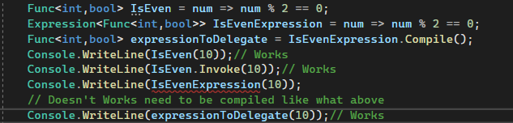

Decomposition of an Expression:
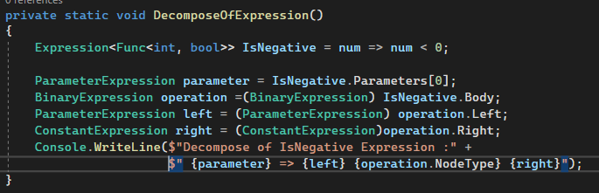
Construction of an expression:
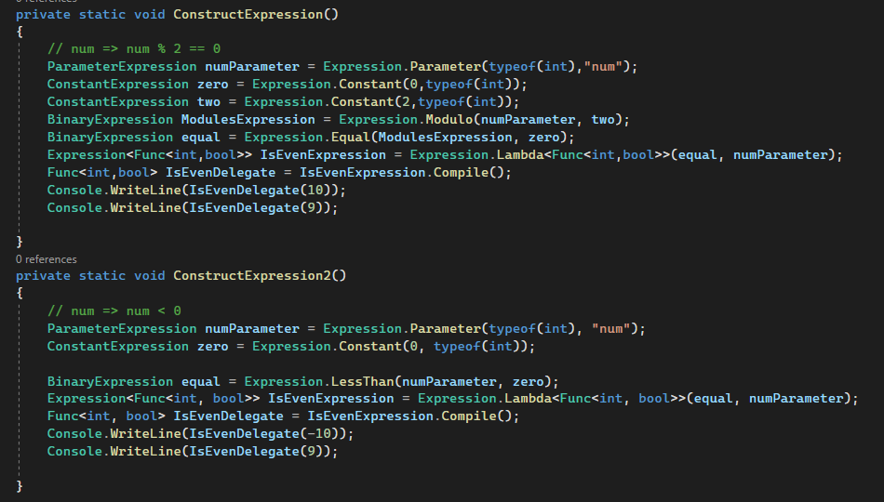

IQueryable&IEnumerable:
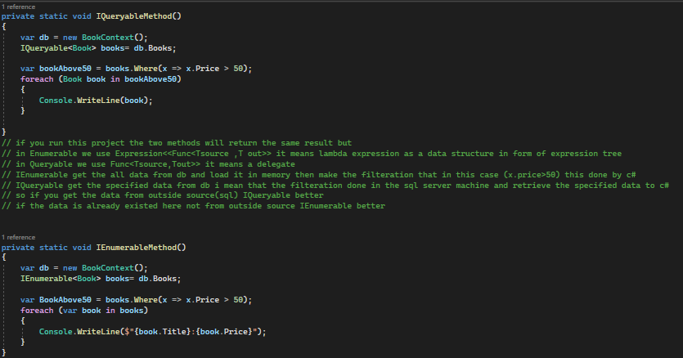

Converting Data types:
AsQueryable: IQueryable<TElement> AsQueryable<TElement>(this IEnumerable<TElement> source)
Converting a generic IEnumerable<out T> to a generic IQueryable<out T>
AsEnumerable : IEnumerable<TSource> AsEnumerable<TSource>(this IEnumerable<TSource> source) => source;
Returns the input typed as IEnumerable<out T>
OfType: IEnumerable<TResult> OfType<TResult>(this IEnumerable source)
Filters the elements of an system.collection.IEnumerable based on a specified type
Cast: IEnumerable<TResult> Cast<TResult>(this IEnumerable source)
Casts the elements of an system.collection.IEnumerable to a specified type
ToArray: TSource[] ToArray<TSource>(this IEnumerable<TSource> source)
Creates an array from IEnumerable<out T>
ToList: List<TSource> ToList<TSource>(this IEnumerable<TSource> source)
Creates a List<T> from IEnumerable<out T>
ToDictionary: Dictionary<TKey, TSource> ToDictionary<TSource, TKey>(this IEnumerable<TSource> source, Func<TSource, TKey> keySelector)
Creates a Dictionary<Tkey,TValue> from IEnumerable<out T> according to a specified key selector function
IEnumerable<Shipping> shippings = ShippingRepository.AllAsList;
Dictionary<string, Shipping> ShippingsDictionary = shippings.ToDictionary(x => x.UniqueId);
foreach (var item in ShippingsDictionary)
{
Console.WriteLine(item.Key);
Console.Write(item.Value) ;
}
ToLookup: ILookup<TKey, TSource> ToLookup<TSource, TKey>(this IEnumerable<TSource> source, Func<TSource, TKey> keySelector) =>
ToLookup(source, keySelector, null);
Creates a Lookup<Tkey,TElement> from IEnumerable<out T> according to a specified key selector function
var shippings = ShippingRepository.AllAsList;
var shippingsLookup = shippings.ToLookup(x => x.ShippingDate);
foreach ( var shippingGroup in shippingsLookup )
{
Console.WriteLine( shippingGroup.Key);
foreach(var shipping in shippingGroup)
{
Console.WriteLine(shipping.Description);
}
}
ToLookup: ILookup<TKey, TSource> ToLookup<TSource, TKey>(this IEnumerable<TSource> source, Func<TSource, TKey> keySelector, IEqualityComparer<TKey>? comparer)
Creates a Lookup<Tkey,TElement> from IEnumerable<out T> according to a specified key selector function and key comparer

