Palo Alto Networks Dual ISP Failover Lab Using Path Monitoring

Lab Overview
Introduction
In a dual-ISP deployment, it is common practice to configure two default routes with different metrics so that one ISP acts as the primary connection and the other as a backup. Many engineers assume that if the primary ISP experiences an outage, traffic will automatically fail over to the secondary ISP.
However, this is not always the case.
If the firewall can still reach the primary ISP's next-hop gateway, it considers the primary route healthy, even if the ISP has lost connectivity to the Internet. As a result, traffic continues to use the primary ISP, causing users to lose Internet access.
This lab demonstrates why Path Monitoring is an important feature in Palo Alto Networks firewalls and how it ensures reliable Internet failover.

Lab Objective
The objective of this lab is to demonstrate the difference between using static route metrics alone and using static route metrics combined with Path Monitoring.
After completing this lab, you will be able to:
- Configure a dual-ISP environment.
- Configure primary and backup default routes.
- Understand how route metrics influence path selection.
- Configure Path Monitoring on a static route.
- Simulate an ISP failure.
- Verify automatic failover to the backup ISP.

Lab Topology
The lab consists of one Palo Alto VM-Series firewall connected to two VyOS routers that simulate two separate Internet Service Providers (ISPs). A client workstation is connected to the firewall's LAN interface to generate traffic and verify Internet connectivity.

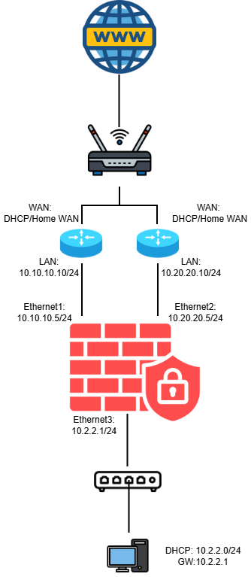
Lab Components
Device | Purpose
Palo Alto VM-Series | Edge firewall responsible for routing, NAT, and failover
VyOS Router 1 | Simulates the primary ISP
VyOS Router 2 | Simulates the backup ISP
Client PC | Generates traffic for connectivity testing
VMware ESXi | Hosts all virtual machines

Lab Credentials
Palo Alto VM-Series Firewall
Parameter | Value
Device | Palo Alto VM-Series Firewall
Management URL | https://<PaloAlto-Management-IP>
Username | admin
Password | O@123456@o

VyOS Router Credentials
VyOS ISP1 Router
Parameter | Value
Device | VyOS Router (Primary ISP Simulation)
Username | vyos
Password | vyos

VyOS ISP2 Router
Parameter | Value
Device | VyOS Router (Backup ISP Simulation)
Username | vyos
Password | vyos

Security Notice
These credentials are provided only for the lab environment.
For production deployments:
- Change all default passwords.
- Use strong administrator credentials.
- Disable unused accounts.
- Follow your organization's security policies.

Lab Scenario
The Palo Alto firewall is configured with two default routes.
Route | Next Hop | Metric
Primary ISP | ISP1 Gateway | 10
Backup ISP | ISP2 Gateway | 11
Because the primary route has the lower metric, it is selected as the preferred path for Internet traffic.

Scenario 1 – Without Path Monitoring
Under normal conditions, all traffic is forwarded through ISP1.
When ISP1 loses Internet connectivity but its gateway remains reachable, the firewall still considers the primary route operational because the next-hop gateway responds.
Since the default route remains in the routing table, traffic continues to use ISP1.
As a result:
- The firewall does not switch to ISP2.
- Internet access is lost.
- Users experience a service outage.
This demonstrates that reachability to the next-hop gateway does not necessarily indicate end-to-end Internet connectivity.

Scenario 2 – With Path Monitoring
Path Monitoring is then enabled on the primary default route.
Instead of checking only the ISP gateway, the firewall continuously monitors a reliable public IP address (for example, 8.8.8.8) through ISP1.
If the monitored destination becomes unreachable, the firewall determines that the primary Internet path has failed.
The firewall automatically:
- Removes the primary default route from the routing table.
- Promotes the backup default route.
- Redirects all traffic through ISP2.
Internet connectivity is restored without requiring manual intervention.

Expected Results
Scenario | Expected Behavior
Both ISPs operational | Traffic uses ISP1
ISP1 loses Internet connectivity (Gateway reachable) | Traffic remains on ISP1 if Path Monitoring is disabled
ISP1 loses Internet connectivity (Gateway reachable) | Traffic automatically switches to ISP2 when Path Monitoring is enabled
Key Learning Points
This lab highlights several important networking concepts:
- Static route metrics determine the preferred path.
- The firewall considers a static route active as long as the next-hop gateway is reachable.
- A reachable gateway does not guarantee Internet connectivity.
- Path Monitoring verifies connectivity beyond the ISP gateway.
- Path Monitoring enables reliable automatic failover during upstream ISP failures.

Conclusion
This lab demonstrates that relying solely on route metrics is not sufficient in a dual-ISP design. While route metrics determine which path is preferred, they do not verify whether that path provides actual Internet connectivity.
By enabling Path Monitoring, the Palo Alto firewall can detect failures beyond the next-hop gateway, remove the failed route from the routing table, and automatically redirect traffic through the backup ISP. This ensures higher availability and minimizes Internet outages for users.

