

AIN SHAMS UNIVERSITY

FACULTY OF ENGINEERING

ELECTRONICS & COMMUNICATION ENG. DEPT.

**4TH year**

FIRST SEMESTER 2019-2020

IC Technolog

CMOS fabrication using silvaco tool

**Submitted by : Ibrahim Kamal Ibrahim Mansour (1500024)**

**Mahmoud Ramzy Mohamed Elsaeed (1501345)**

Submitted to : prof / Hany Fakry

2/2/2020

**N-well : make N-well in p-substrate:**

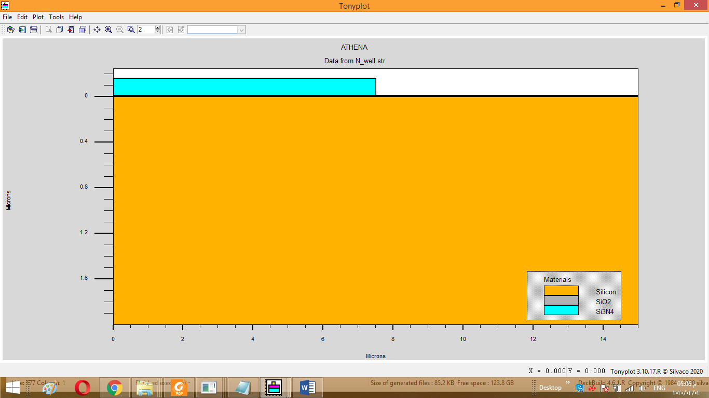

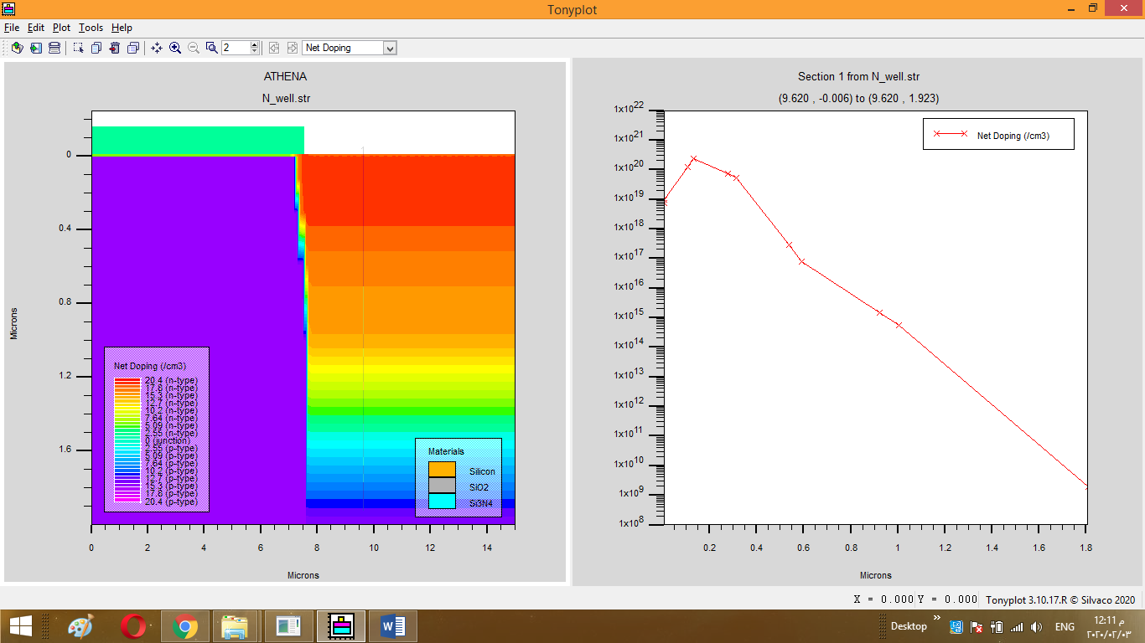

**P-well : make p-well in p-substrate:**

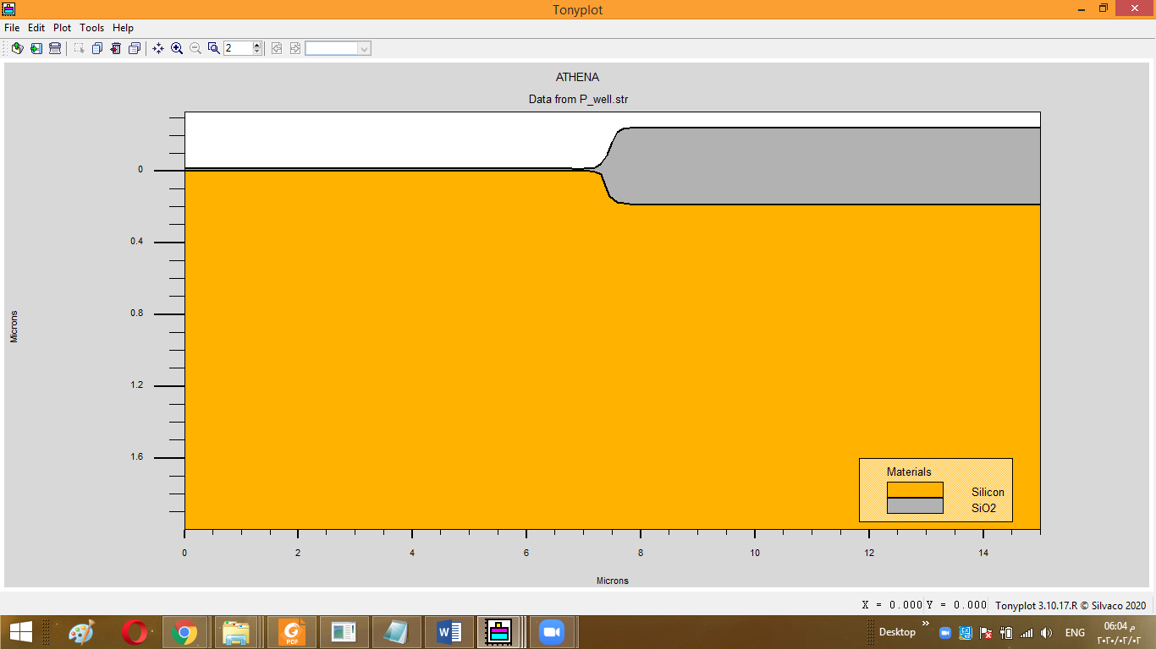

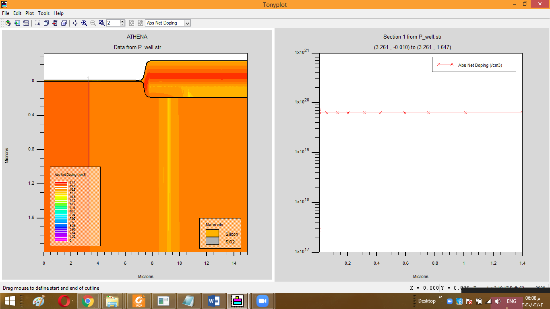

**FOX :**

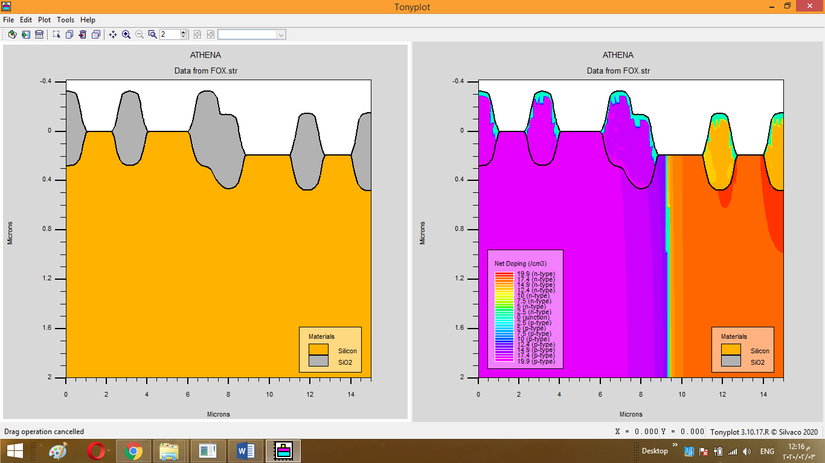

**PMOS Vth adjust:**

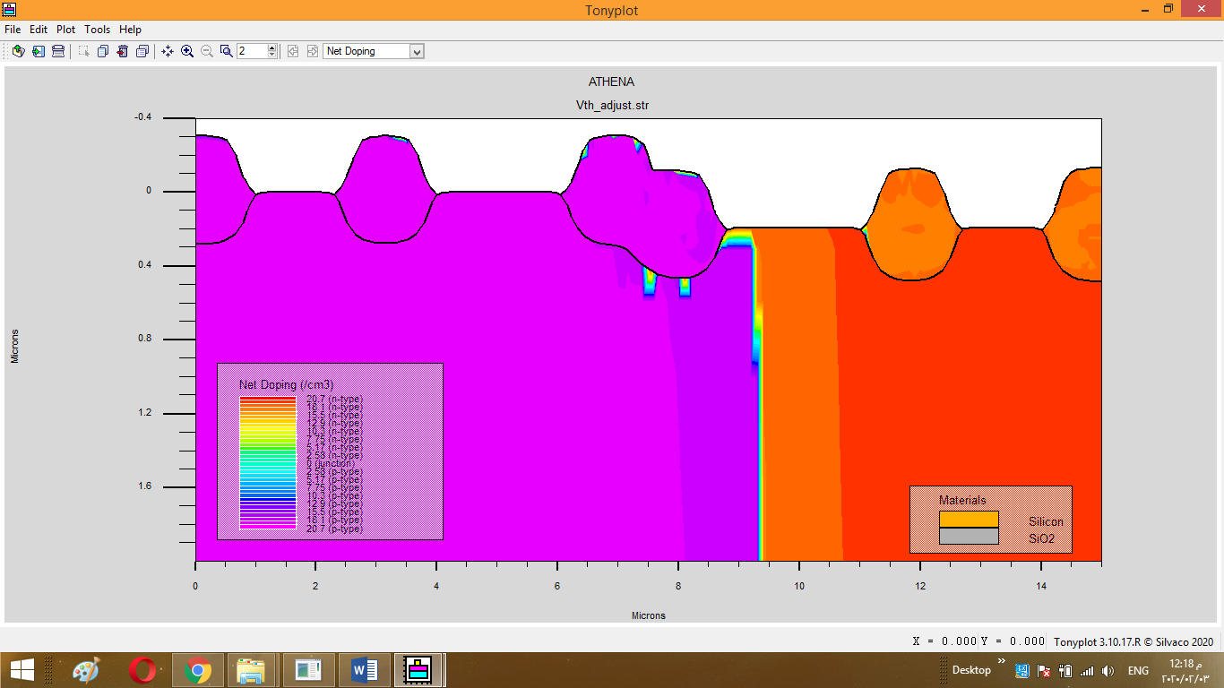

**Gate creation:**

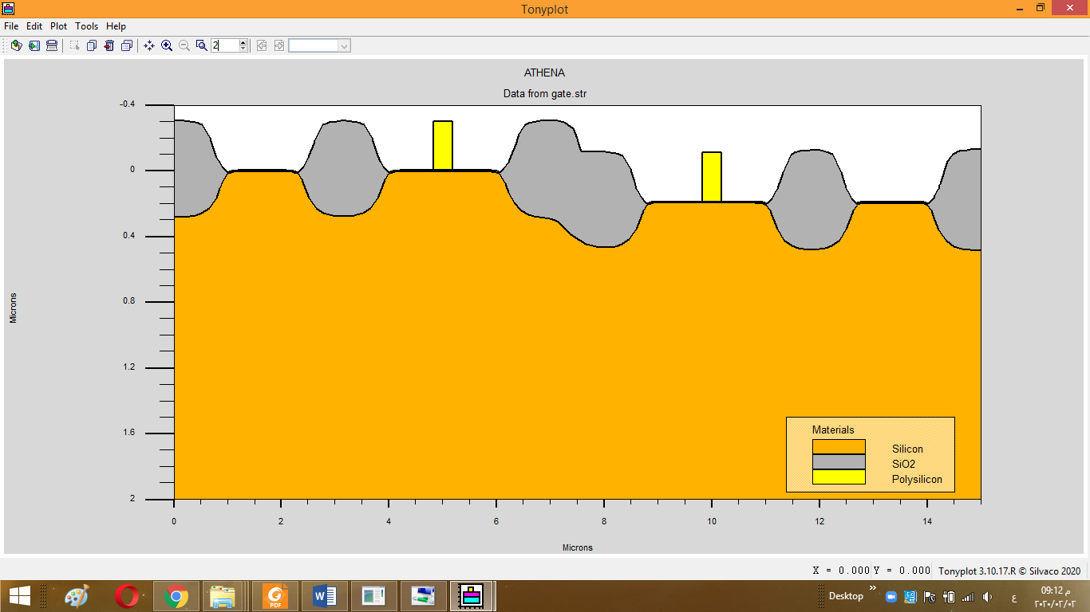

**For N-gate:**

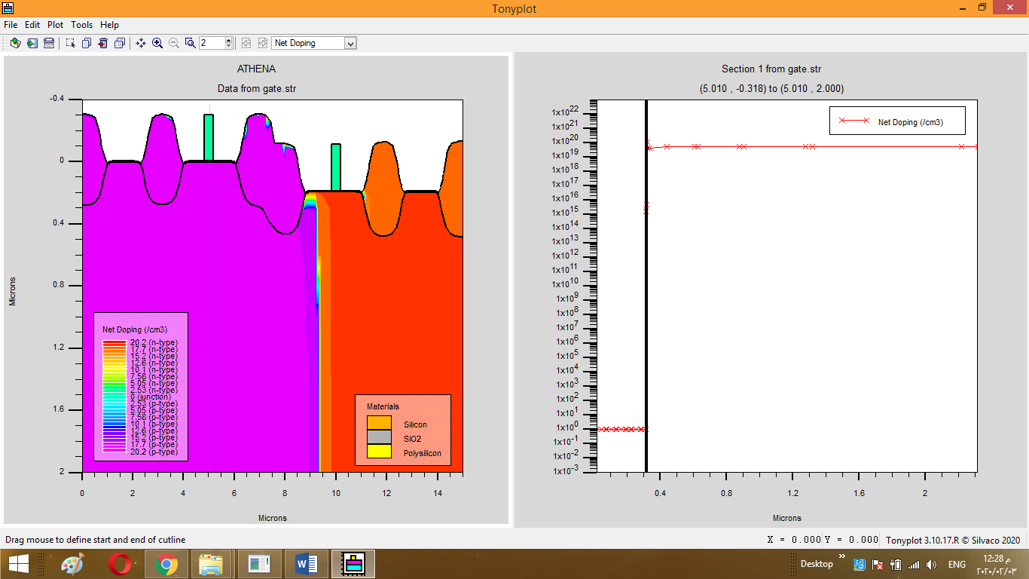

**P-gate:**

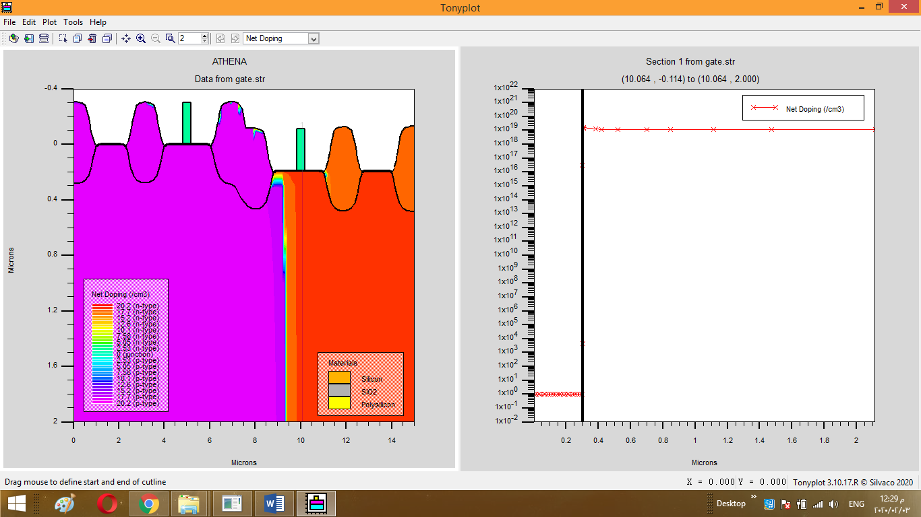

**N_LDD D/S:**

-The middle curve for source conc while the RHS one for drain conc.

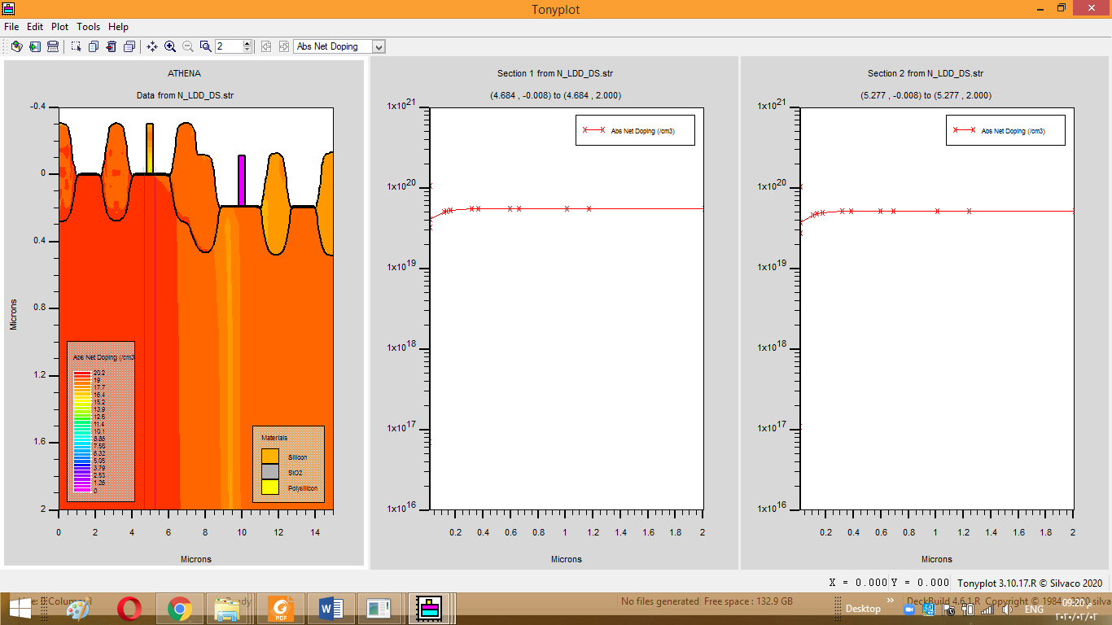

**P-LDD-D/S:**

-The middle curve for Drain conc while the RHS one for Source conc.

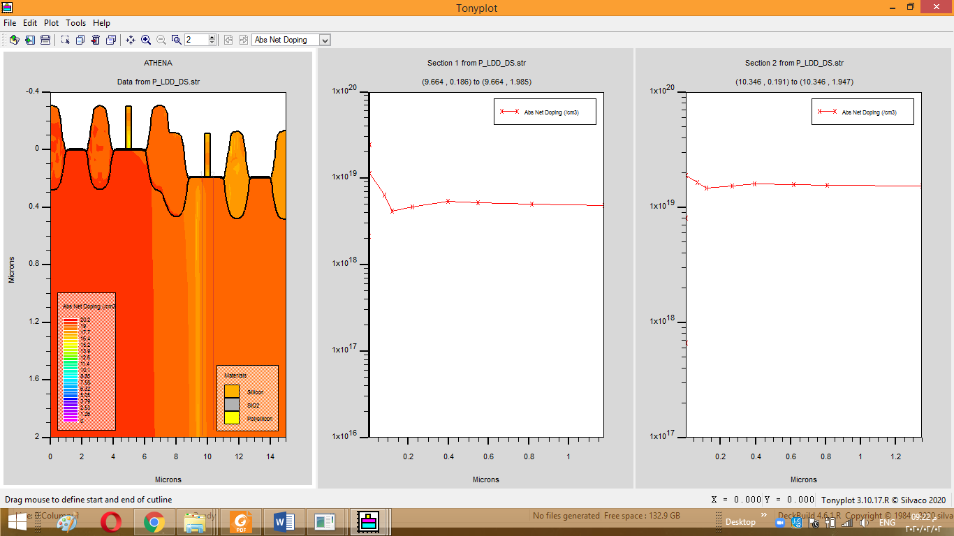

**Spacer:**

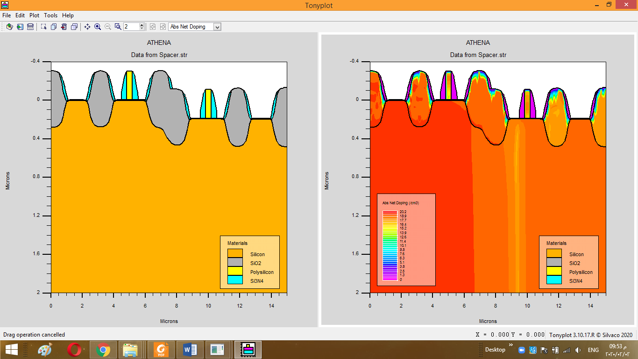

**N-Deep-D/S:**

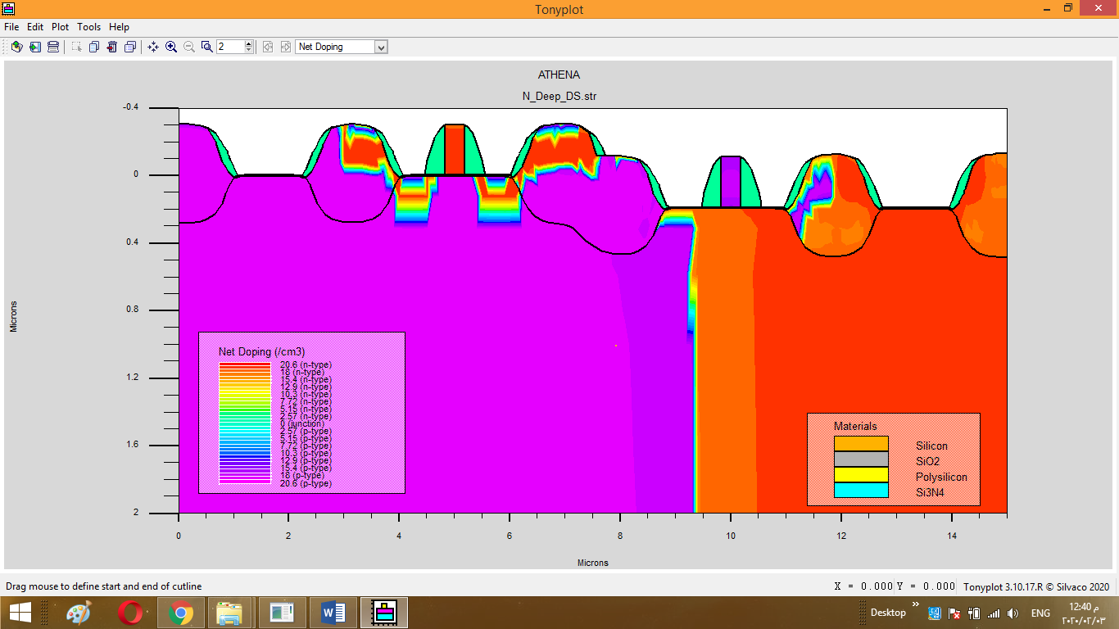

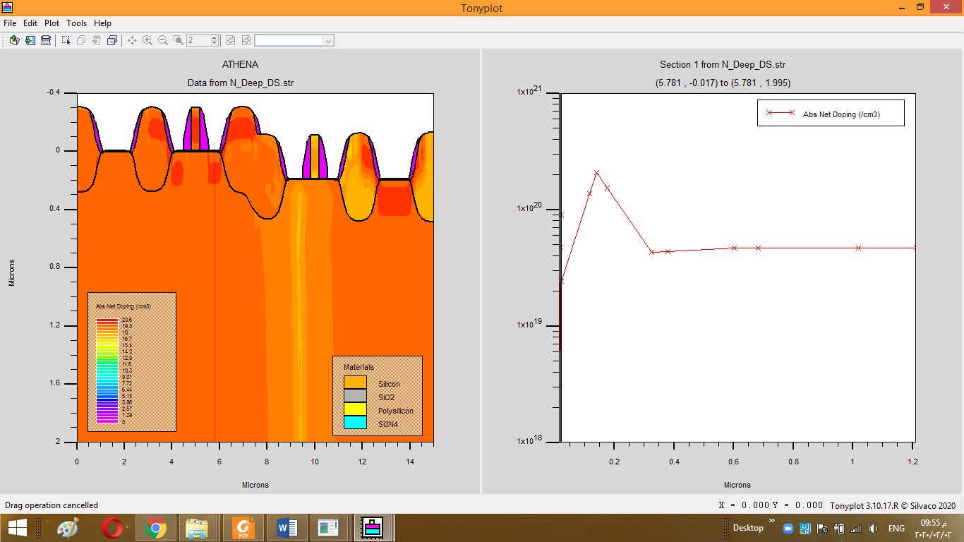

**P-Deep-D/S:**

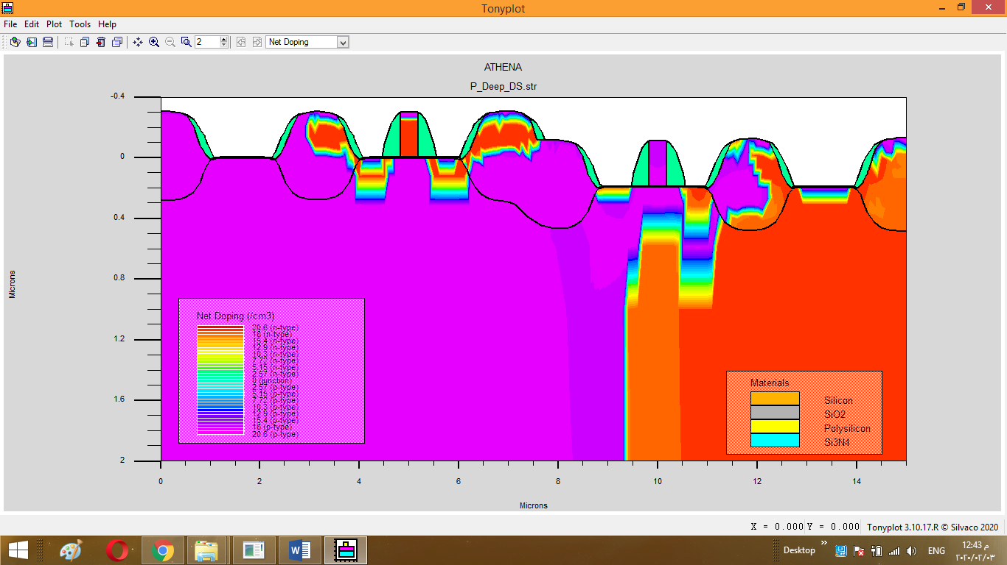

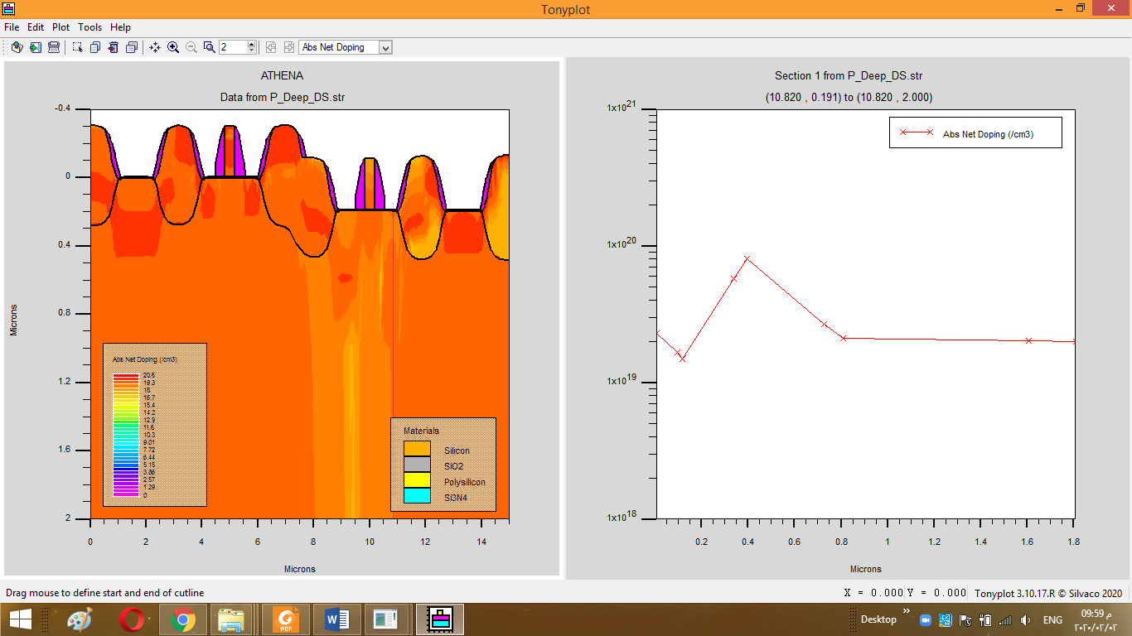

**Salicidation:**

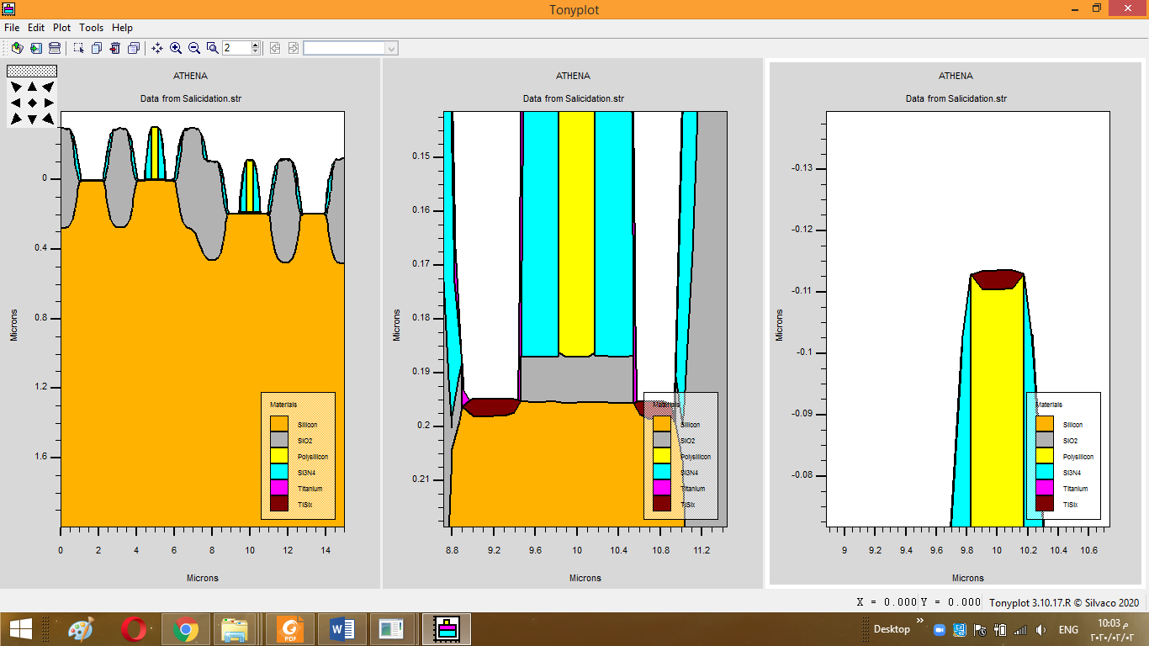

**Contacts Creation & Metalization:**

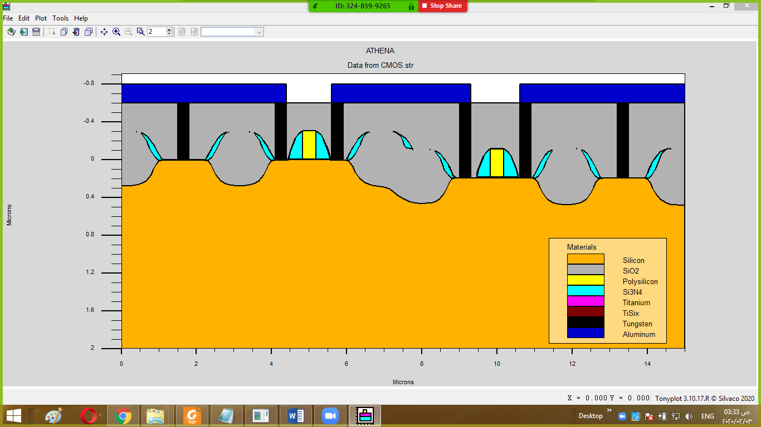

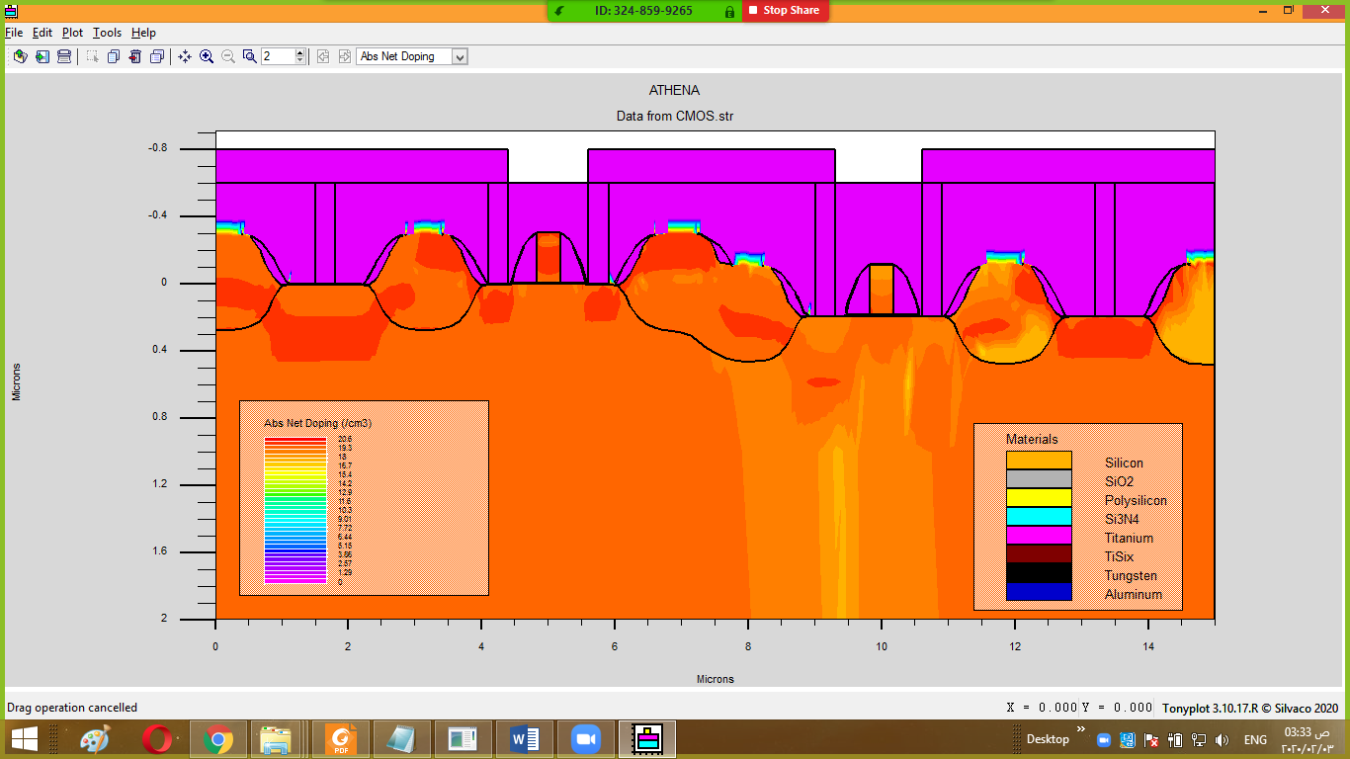

**Code explanation (Athena part):**

**-Defining Initial Rectangular Grid:**

go athena

#define and use a global shrnk variable...

set scalling=3

line x loc=0*$scalling spac=0.1

line x loc=2.5*$scalling spac=0.1

line x loc=5*$scalling spac=0.1

line y loc=0 spac=0.1

line y loc=1 spac=1

line y loc=2 spac=2

-------------------------------------------------------------------------------------------------------------------------

**-Defining the Initial Substrate:**

init silicon boron resistivity=10 orientation=100

-------------------------------------------------------------------------------------------------------------------------

**-N-well creation:**

# step 2 make thin buffer

deposit oxide thick=0.01 divisions= 1

# step 3 nitride deposition

deposit nitride thick=0.15 divisions= 5

# step 4 photo resist

deposit photoresist thick=0.5 divisions=2

#step 5 develop PR

etch photoresist right p1.x=2.5*$scalling

# step 5 etch nitride

etch nitride right p1.x=2.5*$scalling

# step 6 n-well implant

implant phosphor dose=6.8e15 energy=150 pear

strip

-------------------------------------------------------------------------------------------------------------------------

**-P-well creation:**

# step 7 locos mask

diffus time=30 minutes temp=1000 weto2

#step 8 etch nitride

etch nitride left p1.x=2.5*$scalling

# step 9 p-well implant

implant boron dose=1.6e16 energy=50 pear

# step 10 wells drive-in

diffus time=120 minutes temp=1200 nitro press=1

----------------------------------------------------------------------------------------------------------------**-FOX creation:**

#step 11 etch oxide

etch oxide all

#step 12 pad thermal oxide

deposit oxide thick=0.01 divisions=1

# step 13 nitride deposition

deposit nitride thick=0.15 divisions= 2

# mask 2

deposit photoresist thick=0.5 divisions=2

#step 14 & step 15 locos fox & etch nitride

#window of mask 2

etch photoresist left p1.x=0.2*$scalling

etch photoresist right p1.x=4.8*$scalling

etch nitride left p1.x=0.2*$scalling

etch nitride right p1.x=4.8*$scalling

#for tie window

etch photoresist start x=0.9*$scalling y=-2

etch cont x=0.9*$scalling y=2

etch cont x=1.2*$scalling y=2

etch done x=1.2*$scalling y=-2

etch nitride start x=0.9*$scalling y=-2

etch cont x=0.9*$scalling y=2

etch cont x=1.2*$scalling y=2

etch done x=1.2*$scalling y=-2

#for fox inbtn 2 devicies

etch photoresist start x=2.3*$scalling y=-2

etch cont x=2*$scalling y=2

etch cont x=2.8*$scalling y=2

etch done x=2.8*$scalling y=-2

etch nitride start x=2.3*$scalling y=-2

etch cont x=2*$scalling y=2

etch cont x=2.8*$scalling y=2

etch done x=2.8*$scalling y=-2

#for tie window

etch photoresist start x=3.8*$scalling y=-2

etch cont x=3.8*$scalling y=2

etch cont x=4.1*$scalling y=2

etch done x=4.1*$scalling y=-2

etch nitride start x=3.8*$scalling y=-2

etch cont x=3.8*$scalling y=2

etch cont x=4.1*$scalling y=2

etch done x=4.1*$scalling y=-2

etch photoresist all

## make channel stopper (to prevent parasitic channel may be formed due to invertion)

#step16 mask 3

deposit photoresist thick=0.5 divisions=2

# develope PR

etch photoresist left p1.x=2.5*$scalling

# step 17 channel stopper

implant boron dose=8.0e13 energy=100 pear

strip

# step 18 & 19 locos (fox )

method grid.oxide=0.05

diffuse temp=1200 time=30 wet

strip nitride

etch oxide dry thick=0.02

----------------------------------------------------------------------------------------------------------------

**-Pmos Vth adjust ( modified doping to cancel shifting in Vth):**

#step 20 sacrifical oxide growth

diffuse temp=900 time=10 dry

# step 21 threthold adjust

implant boron dose=7e11 energy=60 pear

# step 22 photo resist (mask4)

deposit photoresist thick=0.5 divisions=2

#step 22 develop PR

etch photoresist right p1.x=2.5*$scalling

# step 23 pmos vth threthold adjust

implant boron dose=2.6e12 energy=60 pear

# step 24 strip pR & etch sacrificial oxide

strip

etch oxide dry thick=0.02

-------------------------------------------------------------------------------------------------------------------------

**-Gate creation:**

#step 25 gate oxide

diffus time=1 minutes temp=1052 dryo2 press=1 hcl.pc=3

#

extract name="P_tox" thickness material="SiO~2" mat.occno=1 x.val=1.5*$scalling

extract name="N_tox" thickness material="SiO~2" mat.occno=1 x.val=2.967*$scalling

# step 26 poly dep

deposit polysilicon thick=0.3 divisions=10

#Mask 4

deposit photoresist thick=0.5 divisions=2

# P-gate

etch photoresist left p1.x=4.825

etch polysilicon left p1.x=4.825

#structure outf=P_gate.str

#tonyplot P_gate.str

# N-gate

etch photoresist right p1.x=10.175

etch polysilicon right p1.x=10.175

# in btn P&N-gate mask

etch photoresist start x=5.175 y=-2

etch cont x=9.825 y=-2

etch cont x=9.825 y=2

etch done x=5.175 y=2

etch polysilicon start x=5.175 y=-2

etch cont x=9.825 y=-2

etch cont x=9.825 y=2

etch done x=5.175 y=2

strip

-------------------------------------------------------------------------------------------------------------------------

**N_LDD D/S creation:**

#step 32 mask 6 n-select

deposit photoresist thick=0.5 divisions=2

# N-select mask

etch photoresist start x=1*$scalling y=-2

etch cont x=2.5*$scalling y=-2

etch cont x=2.5*$scalling y= 2

etch done x=1*$scalling y= 2

etch photoresist start x=12 y=-2

etch cont x=14.5 y=-2

etch cont x=14.5 y= 2

etch done x=12 y= 2

# step 33 N D/S LDD

implant phosphor dose=2.5e13 energy=60 tilt=10 fullrot crystal

# step 34

strip

-------------------------------------------------------------------------------------------------------------------------

**P_LDD D/S creation:**

#step 35 mask#7 p-select

deposit photoresist thick=0.5 divisions=2

# P-select mask

etch photoresist left p1.x=1*$scalling

etch photoresist start x=2.5*$scalling y=-2

etch cont x=12 y=-2

etch cont x=12 y= 2

etch done x=2.5*$scalling y= 2

# step 36&37 P D/S LDD

implant boron dose=4e13 energy=50 tilt=10 fullrot crystal

strip

-------------------------------------------------------------------------------------------------------------------------

**Spacer (to cover LDD to create deep D/S):**

deposit nitride thick=0.4 divisions=3

# Spacer nitride Etch

etch nitride dry thick=0.4

-------------------------------------------------------------------------------------------------------------------------

**N Deep D/S creation:**

deposit photoresist thick=0.5 divisions=2

# N-select mask again

etch photoresist start x=1*$scalling y=-2

etch cont x=2.5*$scalling y=-2

etch cont x=2.5*$scalling y= 2

etch done x=1*$scalling y= 2

etch photoresist start x=12 y=-2

etch cont x=14.5 y=-2

etch cont x=14.5 y= 2

etch done x=12 y= 2

# N Deep D/S

implant phosphor dose=4e15 energy=120 tilt=10 fullrot crystal

strip

-------------------------------------------------------------------------------------------------------------------------

**P Deep D/S creation:**

deposit photoresist thick=0.5 divisions=2

# P-select mask again

etch photoresist left p1.x=1*$scalling

etch photoresist start x=2.5*$scalling y=-2

etch cont x=12 y=-2

etch cont x=12 y= 2

etch done x=2.5*$scalling y= 2

#P Deep D/S

implant boron dose=2e15 energy=110 tilt=10 fullrot crystal

strip

-------------------------------------------------------------------------------------------------------------------------

**Salcidation: (to prevent the penetration of AL into the surface of active area):**

# step 46 etch damage oxide

etch oxide dry thick=0.01

# step 47salcidation

deposit titanium thick=0.03 divisions=2

# step 48 RTA ( to avoid affecting the previous junction depths)

method fermi

diffus time=1 sec temp=600 nitro press=1

etch titanium dry thick=0.03

-------------------------------------------------------------------------------------------------------------------------

**1St isolation:**

deposit oxide thick=0.8 divisions=10

#planarization

etch oxide above p1.y=-0.6

-------------------------------------------------------------------------------------------------------------------------

**contact cuts creation:**

#mask of CC

deposit photoresist thick=0.5 divisions=2

etch photoresist start x=0.5*$scalling y=-2

etch cont x=0.5*$scalling y=2

etch cont x=0.6*$scalling y=2

etch done x=0.6*$scalling y=-2

etch photoresist start x=4.1 y=-2

etch cont x=4.1 y=2

etch cont x=4.4 y=2

etch done x=4.4 y=-2

etch photoresist start x=5.6 y=-2

etch cont x=5.6 y=2

etch cont x=5.9 y=2

etch done x=5.9 y=-2

etch photoresist start x=3*$scalling y=-2

etch cont x=3*$scalling y=2

etch cont x=3.1*$scalling y=2

etch done x=3.1*$scalling y=-2

etch photoresist start x=10.6 y=-2

etch cont x=10.6 y=2

etch cont x=10.9 y=2

etch done x=10.9 y=-2

etch photoresist start x=4.4*$scalling y=-2

etch cont x=4.4*$scalling y=2

etch cont x=4.5*$scalling y=2

etch done x=4.5*$scalling y=-2

etch oxide start x=0.5*$scalling y=-2

etch cont x=0.5*$scalling y=2

etch cont x=0.6*$scalling y=2

etch done x=0.6*$scalling y=-2

etch oxide start x=4.1 y=-2

etch cont x=4.1 y=2

etch cont x=4.4 y=2

etch done x=4.4 y=-2

etch oxide start x=5.6 y=-2

etch cont x=5.6 y=2

etch cont x=5.9 y=2

etch done x=5.9 y=-2

etch oxide start x=3*$scalling y=-2

etch cont x=3*$scalling y=2

etch cont x=3.1*$scalling y=2

etch done x=3.1*$scalling y=-2

etch oxide start x=10.6 y=-2

etch cont x=10.6 y=2

etch cont x=10.9 y=2

etch done x=10.9 y=-2

etch oxide start x=4.4*$scalling y=-2

etch cont x=4.4*$scalling y=2

etch cont x=4.5*$scalling y=2

etch done x=4.5*$scalling y=-2

strip

# step 54 contacts

deposit tungsten thick=0.7 divisions=2

etch tungsten above p1.y=-0.6

-------------------------------------------------------------------------------------------------------------------------

**M1 creation:**

deposit aluminum thick=0.2 divisions=2

etch aluminum start x=4.4 y=-2

etch cont x=4.4 y=2

etch cont x=5.6 y=2

etch done x=5.6 y=-2

etch aluminum start x=3.1*$scalling y=-2

etch cont x=3.1*$scalling y=2

etch cont x=10.6 y=2

etch done x=10.6 y=-2

-------------------------------------------------------------------------------------------------------------------------

**Extraction (to control on the thickness of gate oxide and the junction depth):**

extract name="P_tox" thickness material="SiO~2" mat.occno=1 x.val=1.5*$scalling

extract name="N_tox" thickness material="SiO~2" mat.occno=1 x.val=2.967*$scalling

extract name="n++ xj"xj silicon mat.occno=1 x.val=3.658*$scalling junc.occno=1

extract name="P++ xj"xj silicon mat.occno=1 x.val=1.3315*$scalling junc.occno=1

-------------------------------------------------------------------------------------------------------------------------

**Biasing: (To enable biasing in the device simulator ATLAS):**

electrode name=gate x=5 y=-0.2

electrode name=gate x=10 y=-0.2

electrode name=drain x=5.7 y=-0.7

electrode name=drain x=9.1 y=-0.7

electrode name=source x=4.2 y=-0.7

electrode name=source x=10.7 y=-0.7

electrode name=bulk x=1.5 y=-0.7

electrode name=bulk x=13.3 y=-0.7

**For the required specs:**

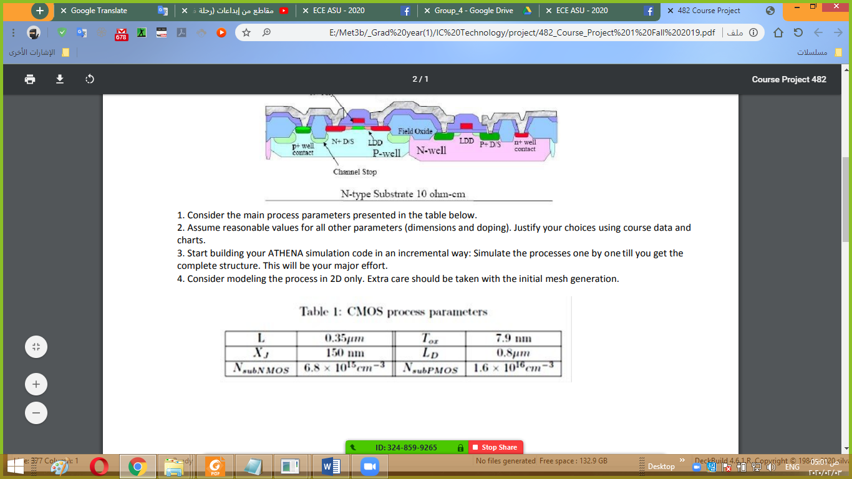

We had almost achieved them as shown below:

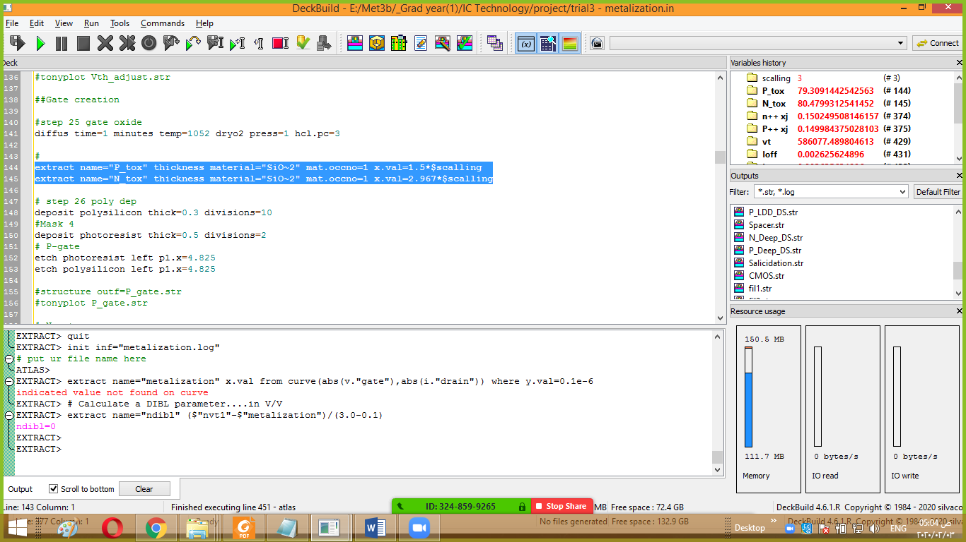

The output results after running the code in Angstrom for tox and um for xj

**Atlas code:**

go atlas

contact name=polysi workfunction=4.2

#select models

MODELS fermi bgn srh consrh conmob fldmob mosfet

#

solve init

output val.band con.band charge e.lines band.param PERMITTIVITY

#

save outf=fil1.str

#tonyplot fil1.str

#

# do IDVG characteristic

#

#method newton gummel

solve vdrain=0

solve vdrain=0.005

solve vdrain=0.01

solve vdrain=0.015

solve vdrain=0.02

solve vdrain=0.025

solve vdrain=0.03

solve vdrain=0.035

solve vdrain=0.05

solve vdrain=0.10

solve vdrain=0.25

solve vdrain=0.50

solve vdrain=1

output val.band con.band charge e.lines band.param PERMITTIVITY

save outf=fil2.str

#tonyplot fil2.str

#

# ramp gate voltage

log outf=metalization.log master

solve name=gate vstep=0.05 vfinal=1 ac direct frequency=1e06

output val.band con.band u.bbt charge e.lines band.param

save outf=fil3.str

#tonyplot fil3.str

#and this for vt

extract name="vt" (xintercept(maxslope(curve(v."gate",abs(i."drain")))) \

- abs(ave(v."drain"))/2.0)

#

extract name="Ioff" min(curve(v."gate", i."drain"))

extract name="Ion" y.val from curve(v."gate", i."drain") where x.val=1

extract name="Ion/Ioff" (y.val from curve(v."gate", i."drain") where x.val=1) / min(curve(v."gate", i."drain"))

# SS:

extract name="subvt" 1.0/slope(maxslope(curve(abs( v."gate"),log10(abs(i."drain") ))))

### P-channel DIBL Test : Returns Vt with 0.1 and 3 volts Vd ## and a DIBL Parameter ####

# extract the next device parameter wuth the drain now at 3 volts....

extract init inf="metalization.log"

# put ur file name here

extract name="metalization" x.val from curve(abs(v."gate"),abs(i."drain")) where y.val=0.1e-6

# Calculate a DIBL parameter....in V/V

extract name="pdibl" ($"pvt1"-$"metalization")/(3.0-0.1)

#### Nmos DIBL Test : Returns Vt with 0.1 and 3 volts Vd ####

# extract the next device parameter with the drain now at 3 volts....

extract init inf="metalization.log"

# put ur file name here

extract name="metalization" x.val from curve(abs(v."gate"),abs(i."drain")) where y.val=0.1e-6

# Calculate a DIBL parameter....in V/V

extract name="ndibl" ($"nvt1"-$"metalization")/(3.0-0.1)

------------------------------------------------------------------------------------------------------------------------

**Results:**

Unfortunately,the CMOS device doesn’t work well (that’s so obivous from output results)

this maybe because many factors:

-inaccurate doping levels

-FOX wasn’t effective enough

-Biasing process isn’t correct.

