**Name : محمود سمير على عبدالوهاب**

**B.N: 846**

**Date :**

**Topic:** **program languages**

**Github link :** [**https://github.com/Mahmoud-Samir55/ece001**](https://github.com/Mahmoud-Samir55/ece001)

**Github page :** [**https://mahmoud-samir55.github.io/ece001/**](https://mahmoud-samir55.github.io/ece001/)

**Application brief : The aim of these course notes is to show that notions and ideas from Category Theory can be useful tools in Computer Science- plications to the study of programming languages based on the principle notions by illustrating some recent of computation as monads The main ob jective is to propose a united approach to the denotational semantics of programming languages The category theoretic notions introduced in the course will be presented with speciel cpplications in mind so that they will not sound too abstract and guidelines for linking abstract and concrete concepts will be stressed**

**Screeshots code :**

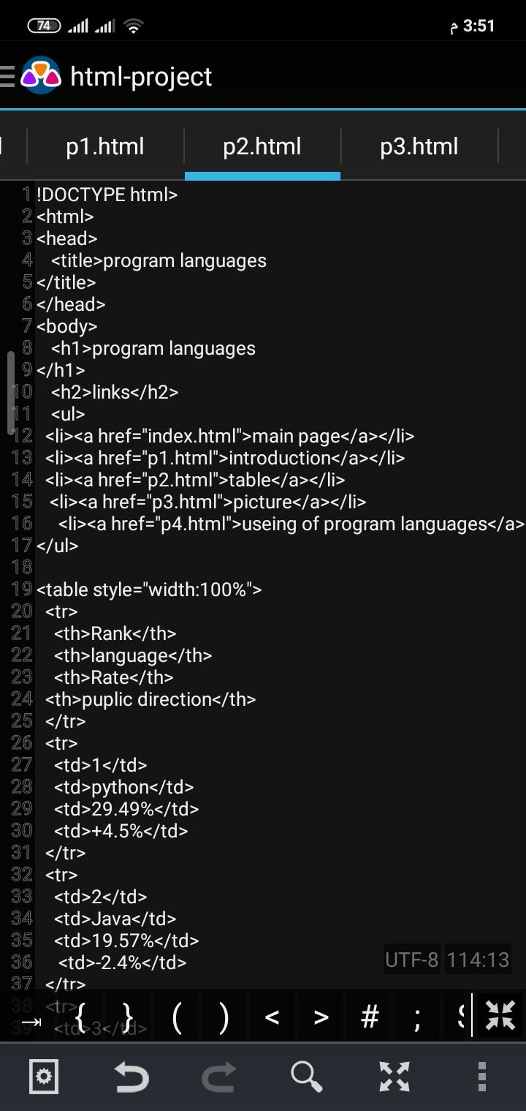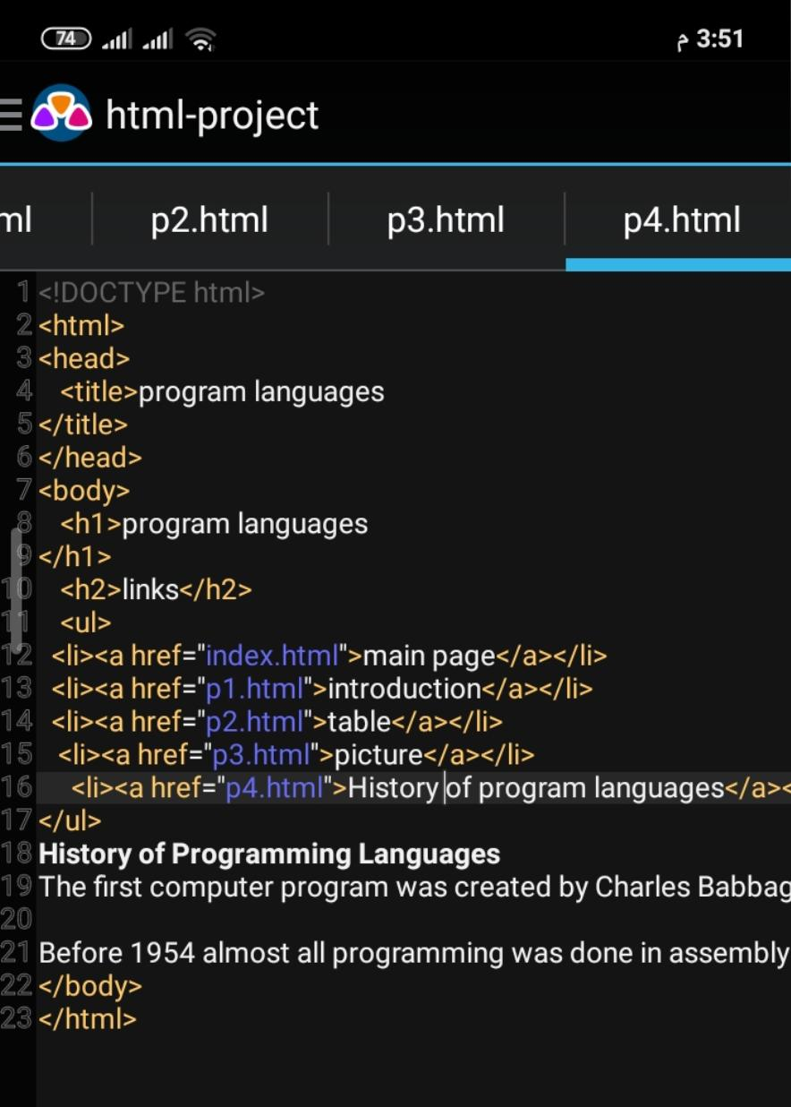

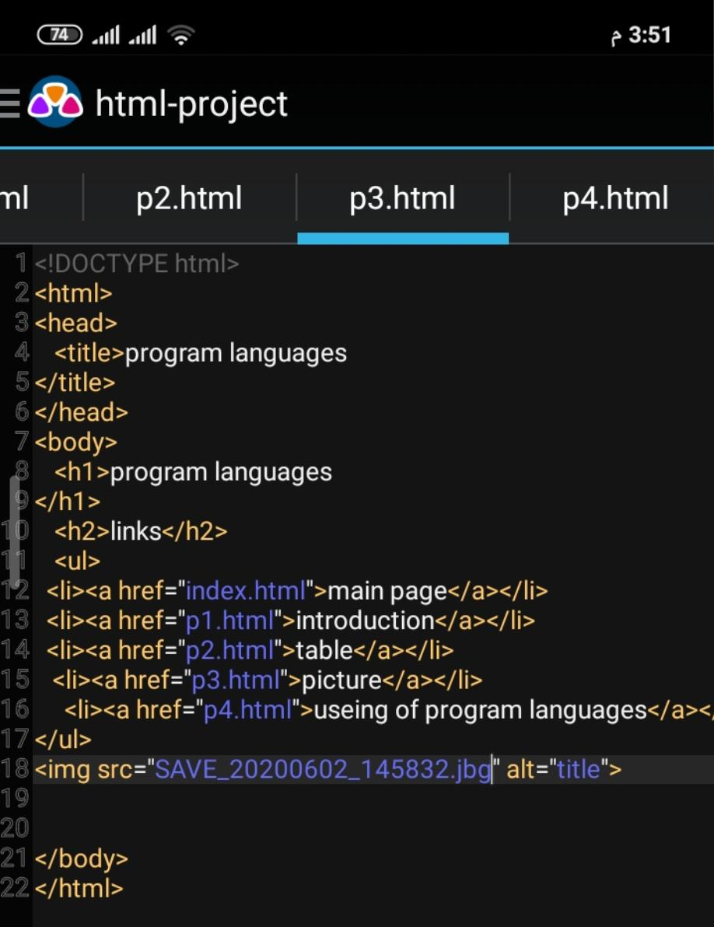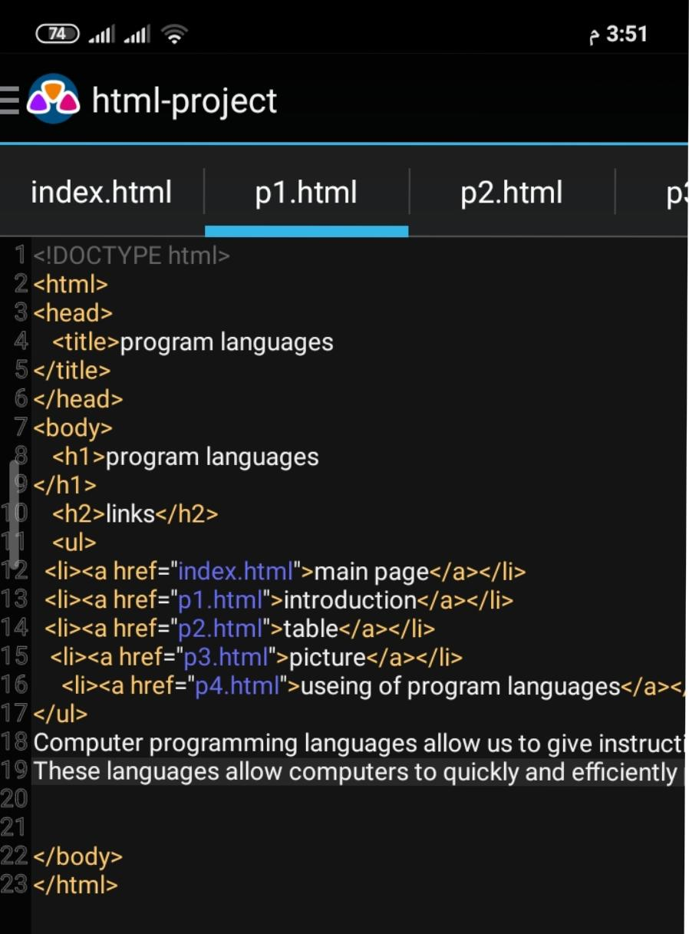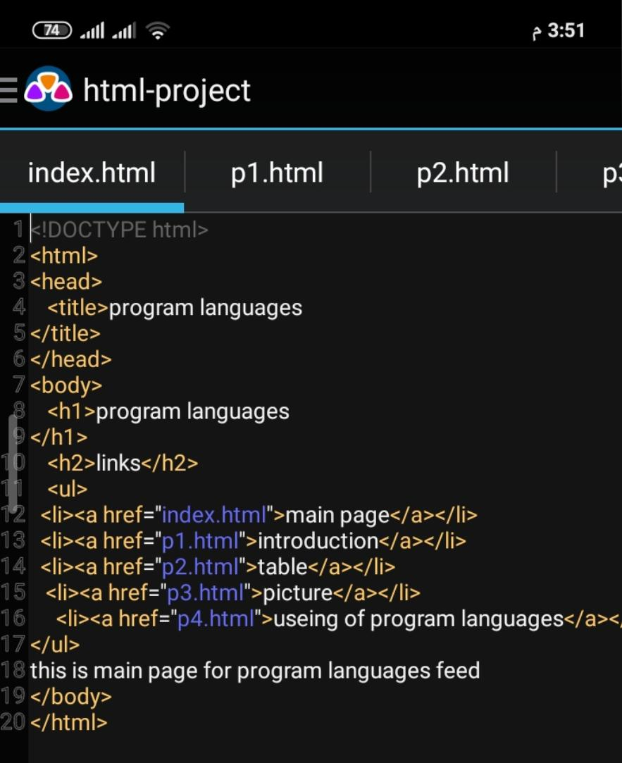

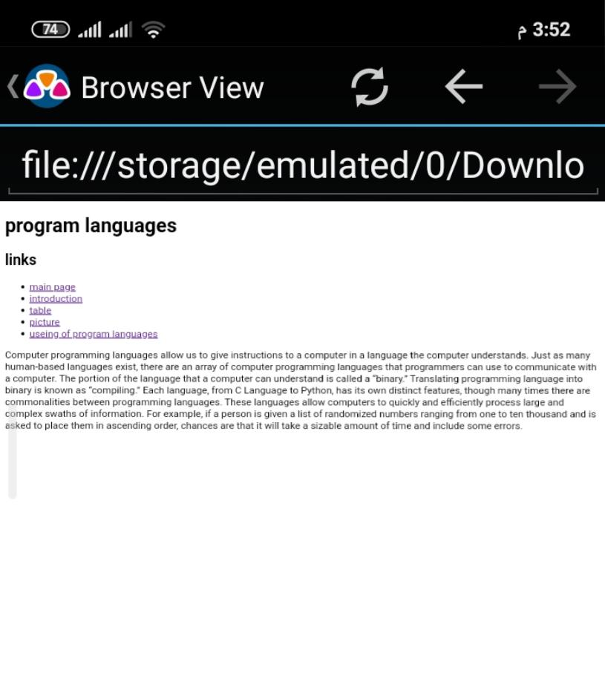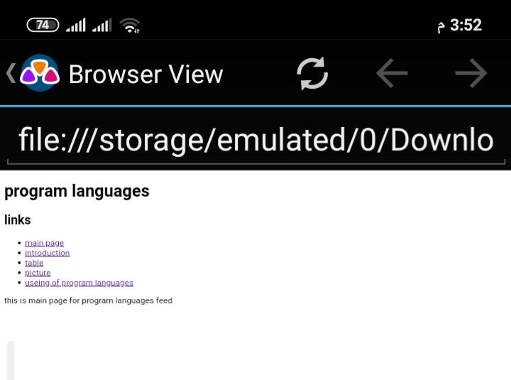**Screenshots project:**

