Freight Rate Prediction — Machine Learning Assessment
Modeling approach, temporal validation, data quality, and December forecast

1. Objective
Predict posted freight rates for all 12,000 loads in validation.csv and populate the supplied prediction template with exactly two columns: load_id and predicted_rate. A separate 31-day December input is scored to create the requested prediction chart.

2. Data exploration and quality checks
The labeled development data contains 48,000 rows and 14 columns, covering 1 January through 31 October 2025. The target posted_rate has a mean of $2,373.98, median of $2,030.76, standard deviation of $1,486.49, and range of $57.22–$25,533.00. Distance has a strong positive linear correlation with posted_rate (approximately 0.91), making it an important predictor.
Missing values were found in weight (300 rows) and market_index (374 rows). These numerical missing values were retained as missing because CatBoost can handle them natively. There were no missing target values and no duplicate load_id values in the labeled data. Validation has 165 missing weights and 249 missing market_index values. Eight pickup and eight delivery category values in validation were not present in the training categories; CatBoost can process unseen categorical values at inference time.
Rates are right-skewed with some large values, reflected in a substantially higher RMSE than MAE. This means occasional large misses have a material effect on squared-error metrics.

3. Feature engineering and model choice
CatBoostRegressor was selected because it handles categorical features directly and supports missing numeric values. Categorical features include pickup, delivery, equipment, and a combined origin-to-destination route. Numeric features include distance, weight, pickup/delivery coordinates, market_index, quote_signal, calendar components and cyclical month/day-of-week encodings, plus coordinate-difference and weight-per-distance features. load_id was excluded because it is an identifier, not a meaningful predictor.
The model uses MAE as its training loss, which is less sensitive to extreme target values than squared-error loss. Predicted rates are clipped at zero to avoid negative rates.

4. Validation design and results
A chronological split was used to reflect deployment: records before 1 October 2025 were used for fitting and October 2025 was held out. This avoids random mixing of earlier and later dates and tests whether the model generalizes forward in time. The holdout contained 4,853 rows; the fitting partition contained 43,147 rows. Early stopping selected the best iteration using the October holdout.
Metric | October holdout
MAE | 120.914
RMSE | 649.832
R² | 0.819
Best iteration | 183
MAE is the mean absolute difference between predicted and observed rate. RMSE penalizes larger misses more strongly. R² measures the proportion of target variance explained relative to a constant-mean baseline. These metrics are measured only on the October holdout, not on the unlabeled validation set.

5. Final predictions and December chart
After validation, the model was refit using all 48,000 labeled rows. It produced a non-missing predicted_rate for each of the 12,000 validation rows, preserving the template load_id order. The generated CSV contains exactly load_id and predicted_rate.
The supplied December chart inputs contain 31 daily rows, but do not include coordinates, market_index, or quote_signal. The chart therefore uses the model with those features missing; its values should be interpreted cautiously and are less fully informed than predictions for rows containing the complete feature set.
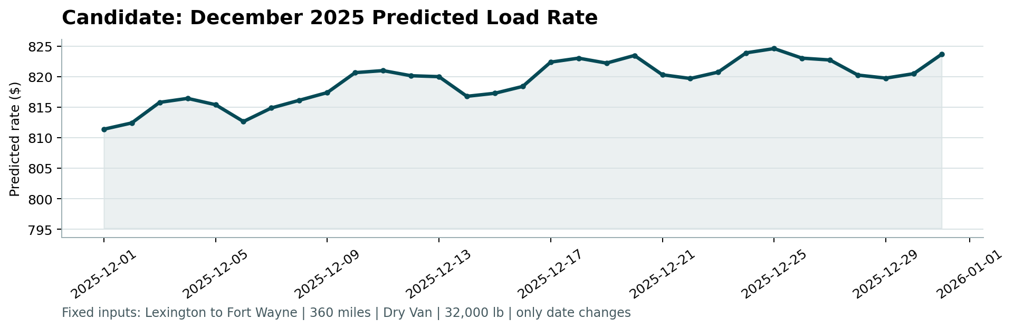
The supplied score.py was used to validate the final prediction file and generate this December chart. The script confirmed 12,000 unique expected load IDs with positive predictions and 31 valid daily December predictions for the fixed Lexington-to-Fort Wayne lane. Spotter calculates the final validation metrics after submission.

6. Reproducibility and limitations
Install dependencies from requirements.txt and run the command in README.md. The script saves the final CatBoost model, validation_predictions.csv, temporal metrics, December predictions, and plots. The supplied score.py is included and was run successfully against the completed predictions and fixed December inputs. Limitations include the single October temporal holdout, no labeled November/December data for direct evaluation, and missing market/coordinate inputs in the December chart dataset. A stronger next iteration would compare CatBoost against a simple distance-based baseline, run rolling-origin validation across multiple months, and inspect residuals by equipment and distance bands.

