# Landing Page Project

## Table of Contents

1. Description

2. Useage

3. A picture of the head of the page

4. Some features

## Description

This Landing Page was designed by udacity and completed as a project by Mahmoud Hesham .

This project was made by using 3 programming languages :

.HTML

.CSS

.Java Script .

The landing page is used to be an interface of a brand or a company .. so it has to be beautiful and fulled with colors and life .. by life i mean motion ! .

## Usage

HTML was used to shape the structure of the page and it contains the head and the body that contains the sections and paragraphs that contains the content of the page including the links for the section that made by java script and the go to top button .

Css was used to style the page by adding volors and movement as in the circles that moves all around the page and the classes necessary to shape up the page .

Java script was used to make the page alive !
that is by useing it's functions to make the logical events the make the scrolls and make the sections when we stop on it active and much more ! .

## A picture of the head of the page
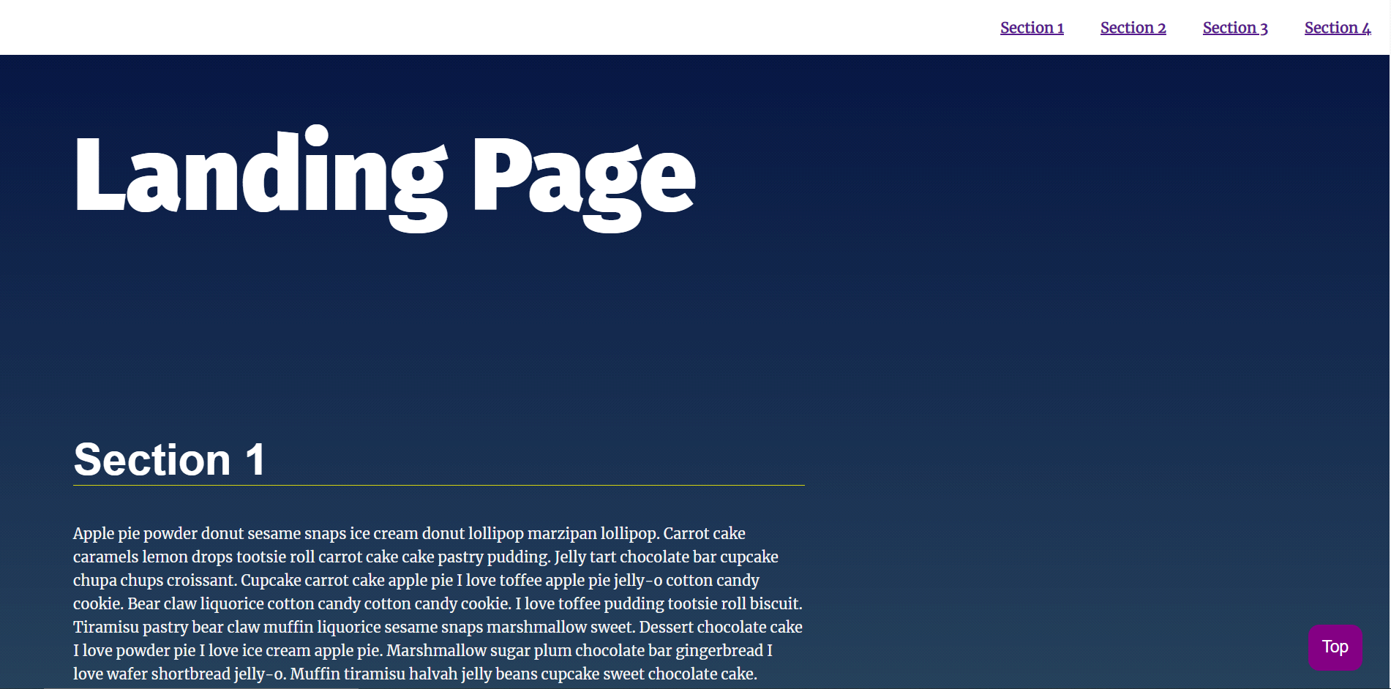

## Some features

It should be clear which section is being viewed while scrolling through the page.

Navigation is built dynamically as an unordered list. Start with empty ul and dynamically build navigation using Append, appendChild, and innerHTML.

When clicking an item from the navigation menu, the link should scroll to the appropriate section.

A scroll to top button is make to make it easier to go to the top quickly .

