1.   
https://github.com/Mahmoud2406/backend.git



Clone the project to a specific folder.

2.

Download Xammp including phpmyadmin.:

<https://www.apachefriends.org/index.html>

Activate Mysql, Apache.

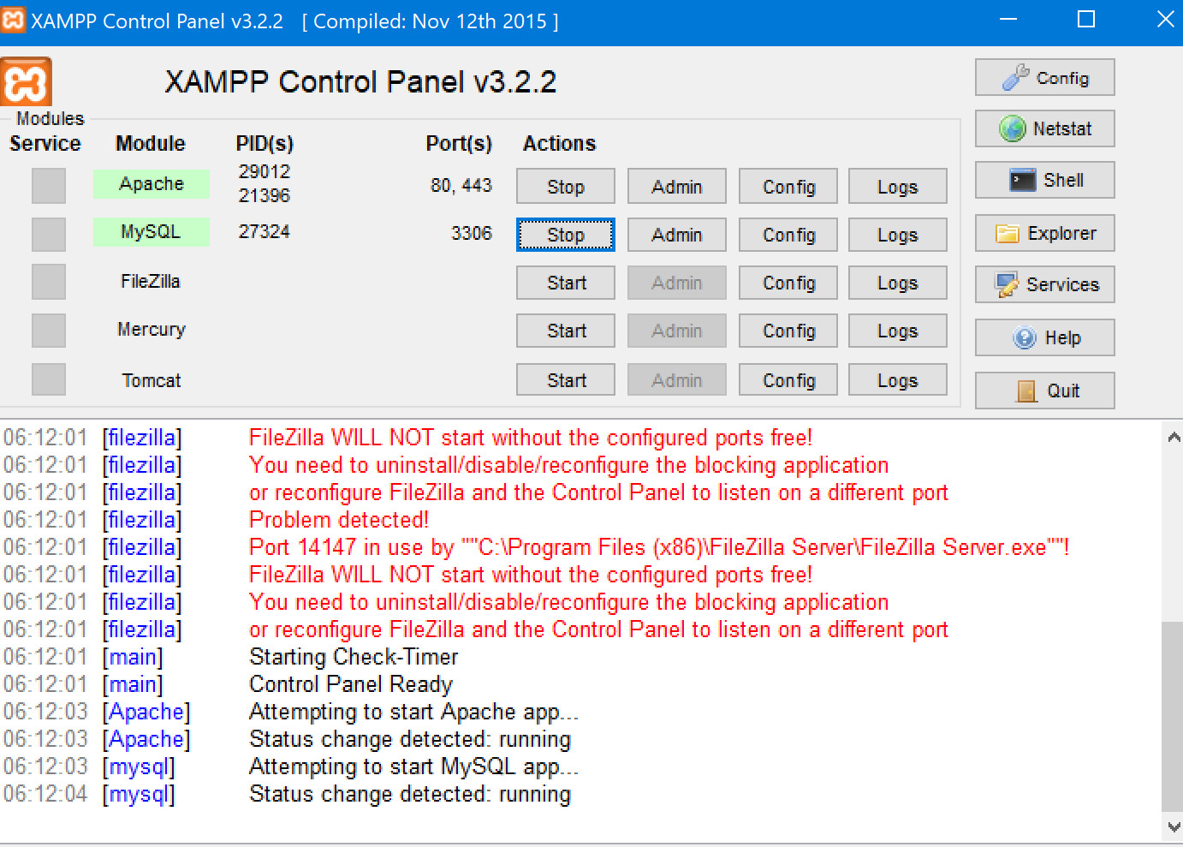

3.

go to localhost/phpmyadmin

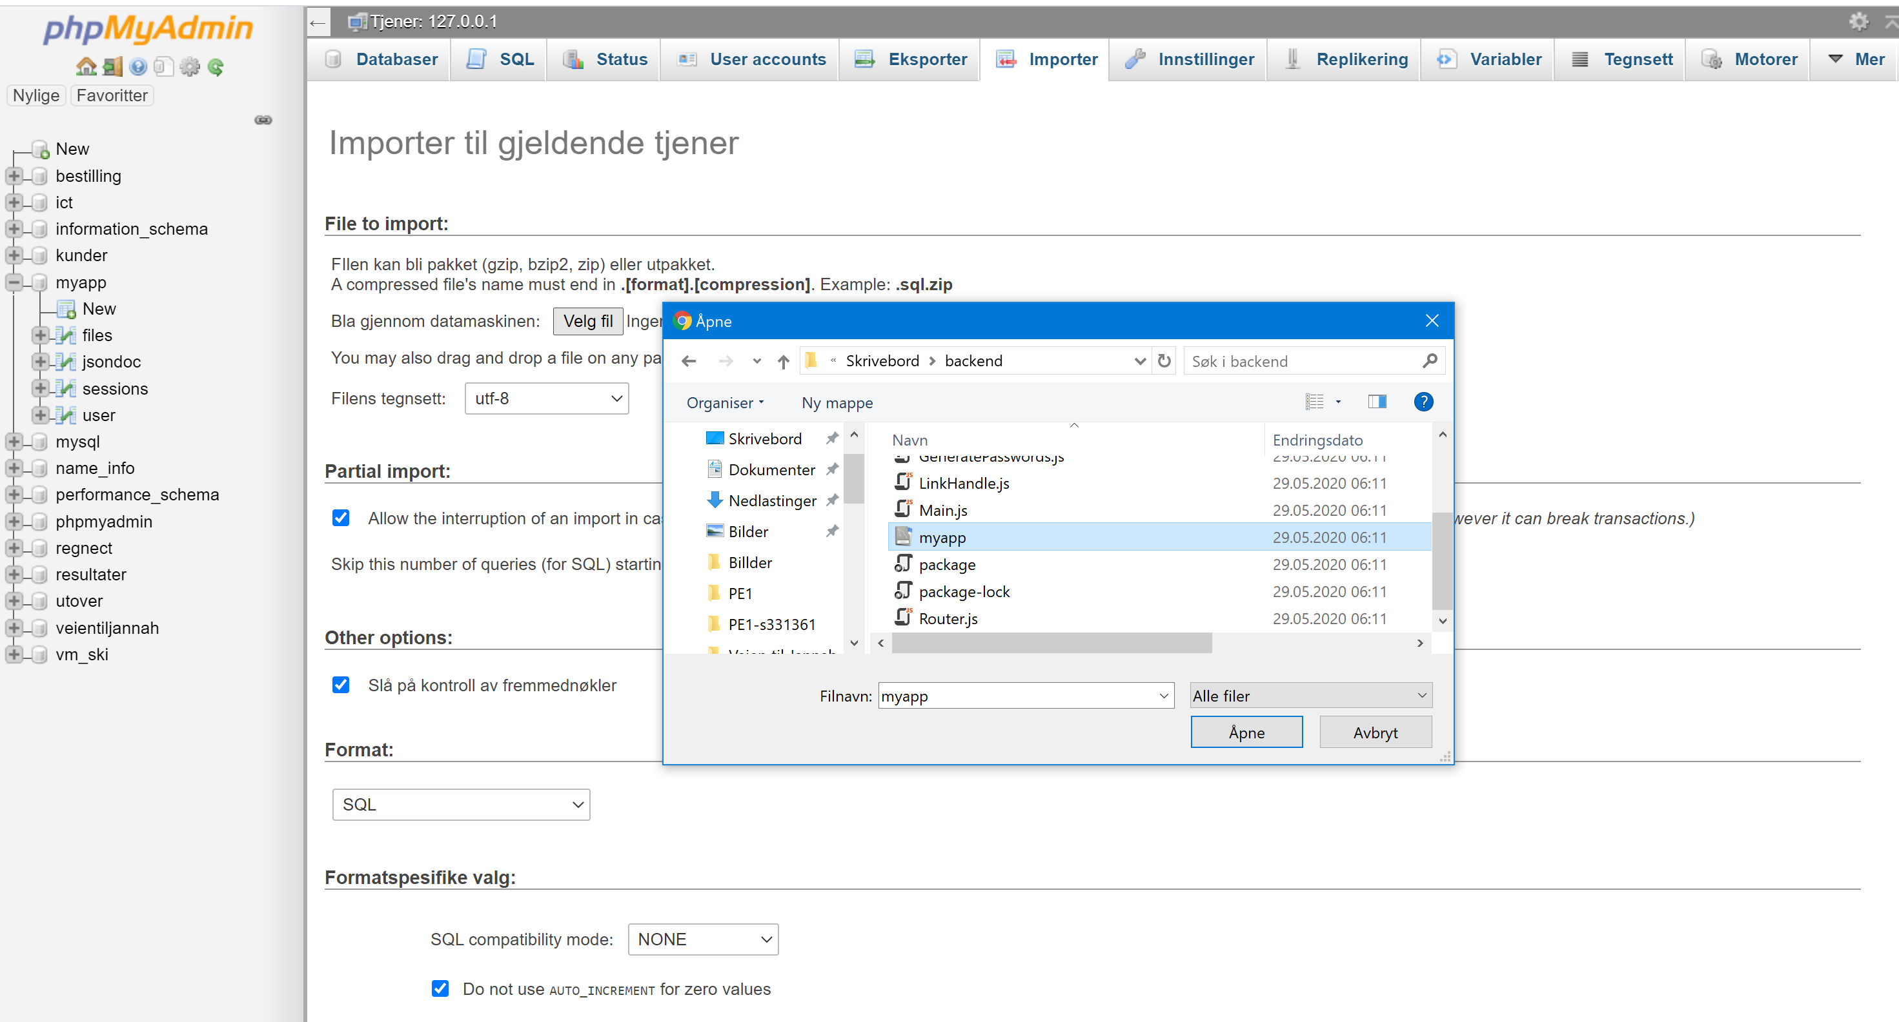

4. click on import and select the file «myapp.sql» from the cloned git directory.

5. When you confirm. You wil get the database with the required data.

6. Download NodeJs

<https://nodejs.org/en/download/>

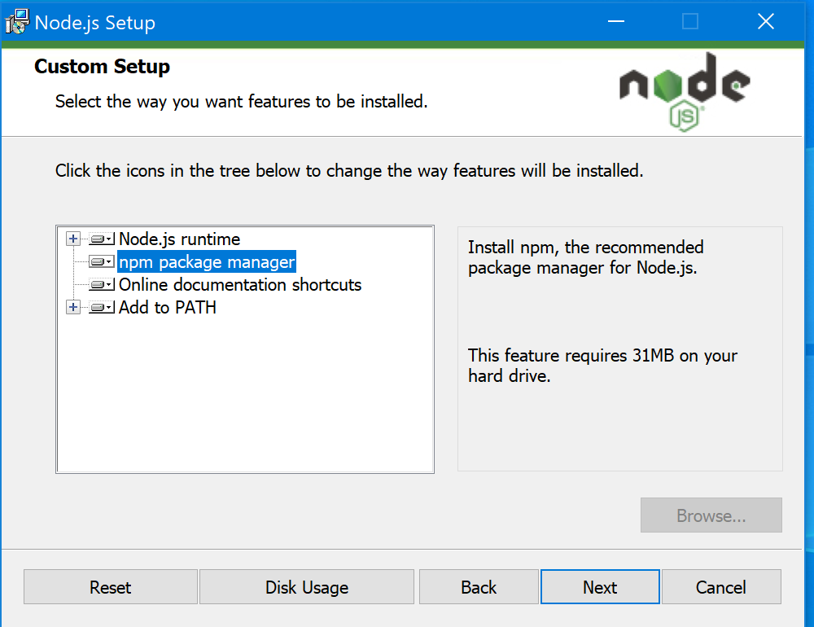

7. Select the npm package manager option. And click next on the rest.

8. install nodejs

9. Run cmd as an administrator

go to your project folder and write



Then after installing just write npm start

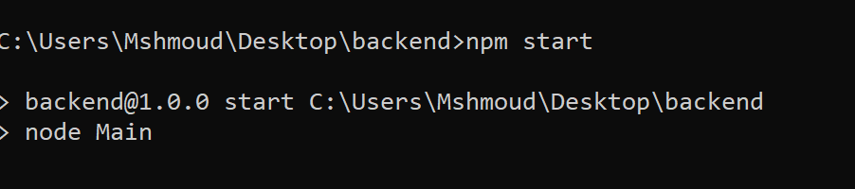

And your webpage will be loaded at

<http://localhost:4567/>

