

Cairo University Computer Engineering Department

Faculty of Engineering Third year

Communication Engineering Project



Team’s members

|  |  |  |
| --- | --- | --- |
| Name | Section | B.N. |
| Hussien Mostafa Hussien | 1 | 28 |
| Mahmoud El-Sayed Mahmoud | 2 | 18 |

January 2022

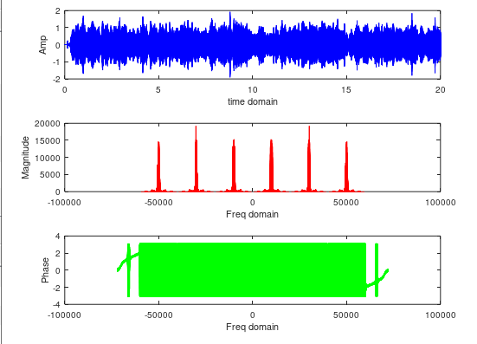

Modulated signal = signal1*cos(2*pi*fc1*t)+ signal2*cos(2*pi*fc2*t)+ signal3*cos(2*pi*fc3*t)

Where :

Fc1=10000 Hz , fc2=30000 hz , fc3=50000hz

BW=10000

**Demodulation**

1. Applying BPF to the modulated signal :

Signal(1) after passing the modulated signal to BPF

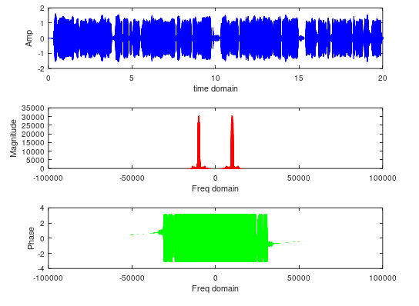

Signal(2) after passing the modulated signal to BPF

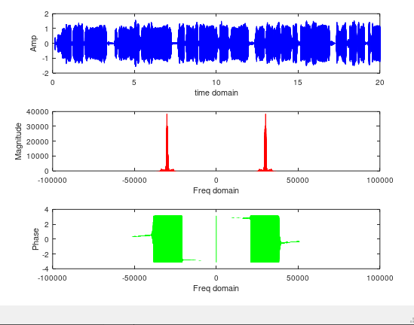

Signal(3) after passing the modulated signal to BPF

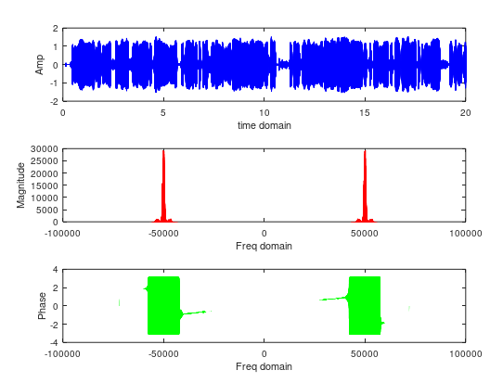

2-Multiplying by Cos(2*pi*fc*t) to return to Baseband

fc=fc1=10000 Hz

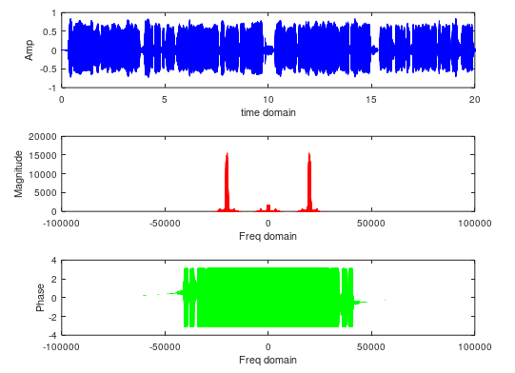

fc=fc2=30000 Hz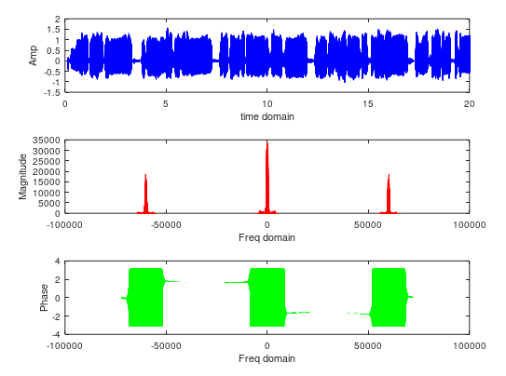

fc=fc3=50000 Hz

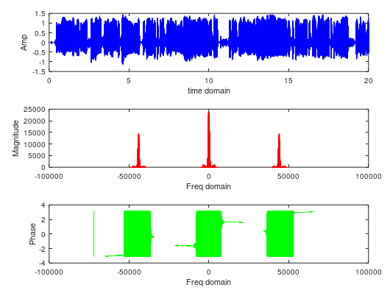

3-Applying LPF

fc=fc1=10000 Hz

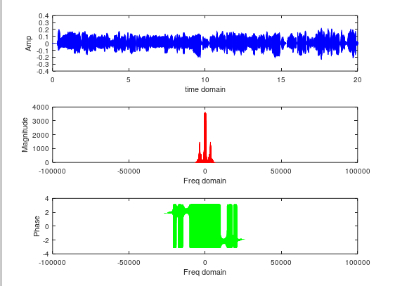

fc=fc2=30000 Hz

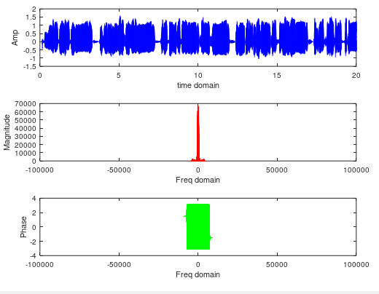

fc=fc3=50000 Hz

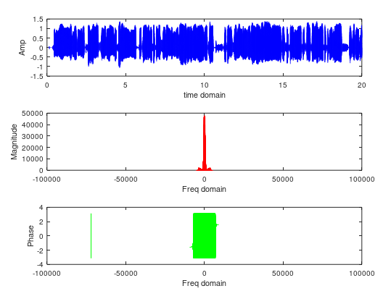

Original signals :

Baseband of first signal

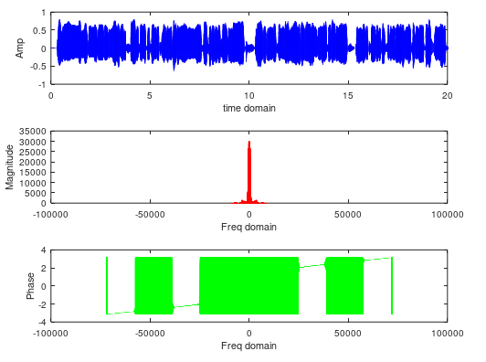

Baseband of second signal

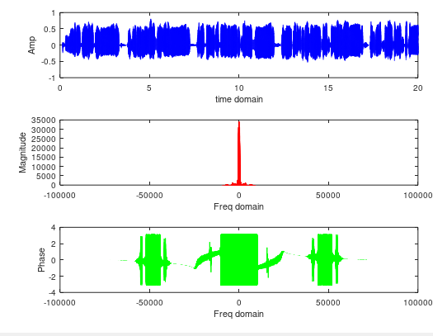

Baseband of third signal

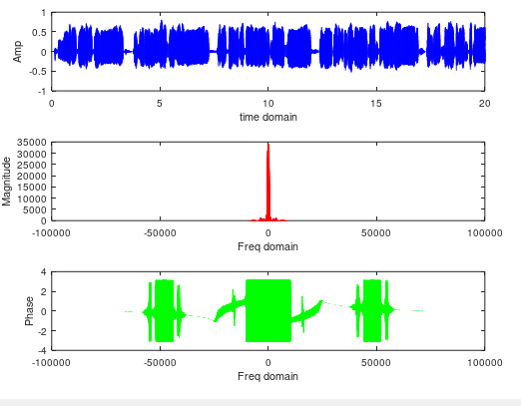

* The demodulated signals are almost as same as the original signals .
* The first and third modulated signal has little distortion
* (may be as the Bbf , Lpf are not ideal ).
* The second modulated signal as same as the original with little attenuation.

4)

Phase error = 10

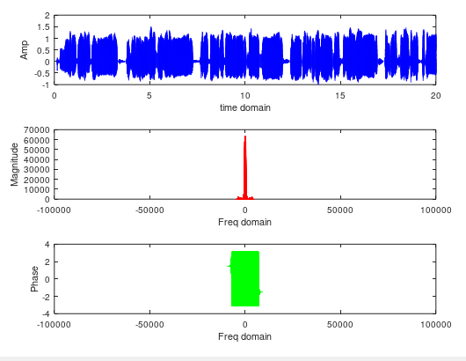

Phase error = 30

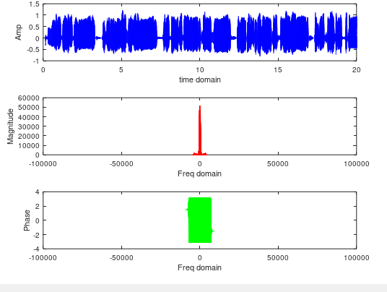

5)

frequency error = 2

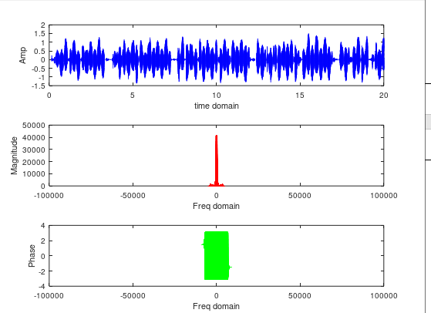

frequency error = 10

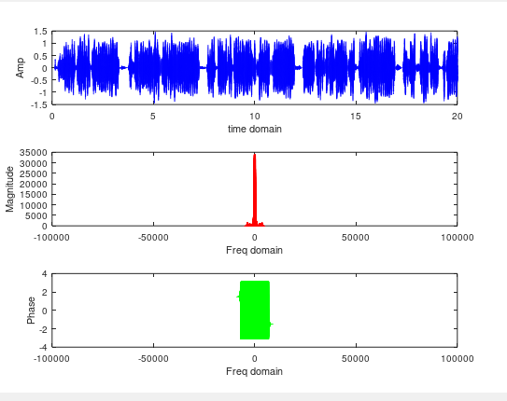

6)

* The phase error may cause attenuation of the output signal without causing distortionas long as it is constant.
* When phase error =10 , the magnitude of the spectrum decreases
* Less than in case of phase error =30.
* When phase error = 90 , the magnitude of the spectrum = zero and you should hear nothing.
* Octave might not be able to nullify the magnitude because the LBF , BPF are not ideal and it might fail to turn from deg to rad.
* When the output is multiplied by a low frequency

(frequency error)sinusoid, this causes attenuation and distortion

of the output signal.