**Name:** mahmoud hassan shahat Abd-El- Maaboud

**الاسم:** محمود حسن شحات عبدالمعبود

**B.N:** 838

Topic: programming languages.

**Github link:** [**https://github.com/Mahmoud513592/html-project-repository**](https://github.com/Mahmoud513592/html-project-repository)

**Github-page (published-website):** [**https://mahmoud513592.github.io/html-project-repository/**](https://mahmoud513592.github.io/html-project-repository/)

**Application brief:**

A programming language is a language used to develop programs, scripts, or other sets of instructions for computers to implement or mobile devices.

There are several different types programming languages, and each language has its own characteristics that distinguish it from its functions that it performs: **c , c# , c++ , java.**

I choose this topic because programming languages are more useful in this world and are indispensable at this time. Moreover, it is irreplaceable, as it is the basis for making websites, programs, games and all applications. It also plays a major role in the field of artificial intelligence, the database field, and many other fields.

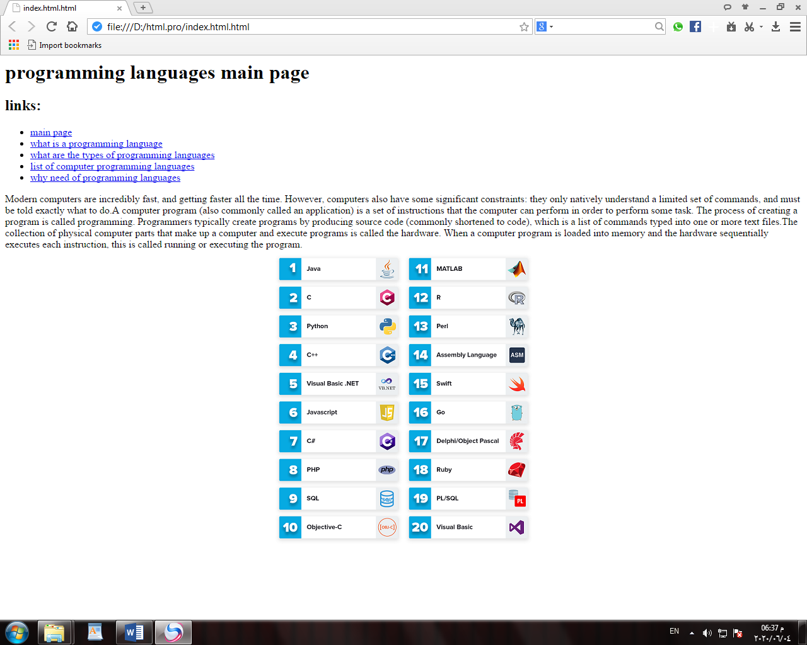**Screenshots:**

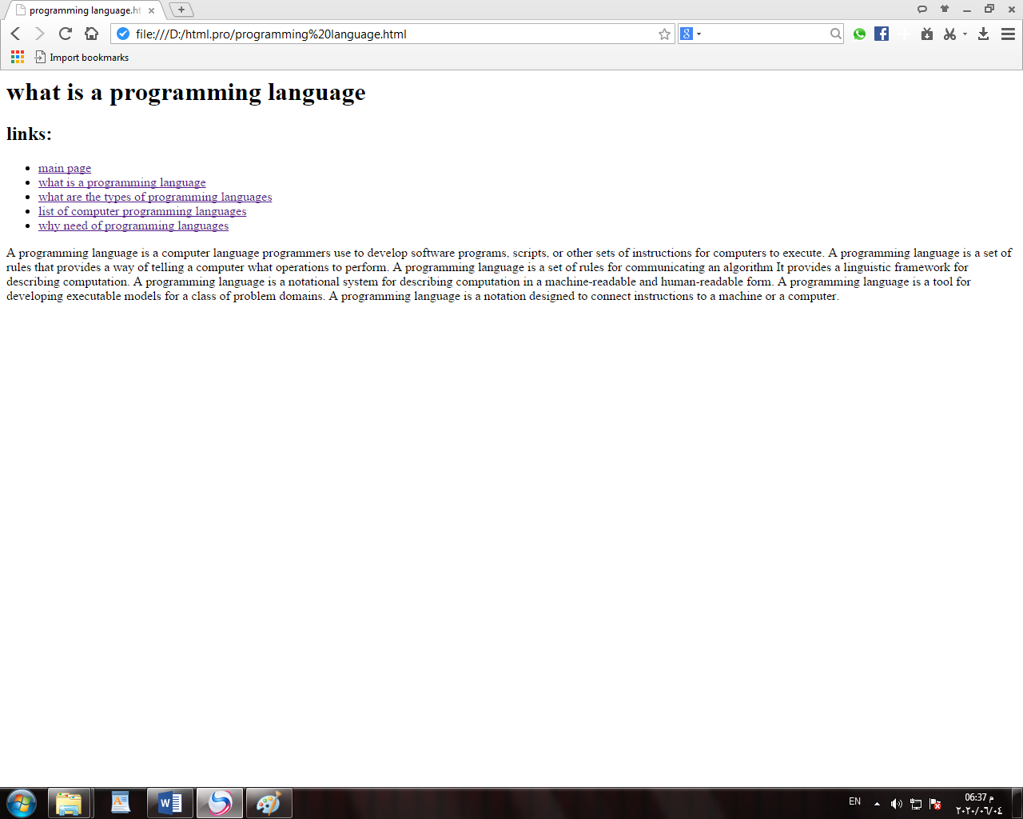

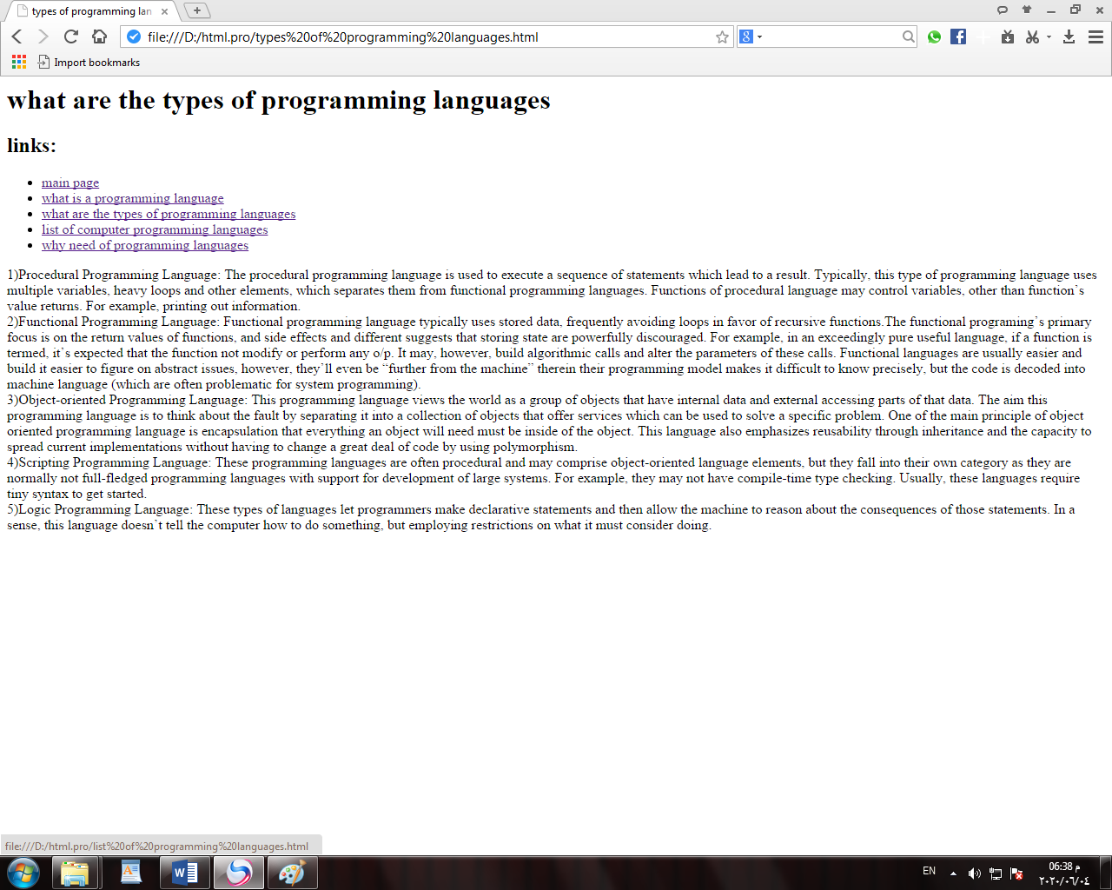

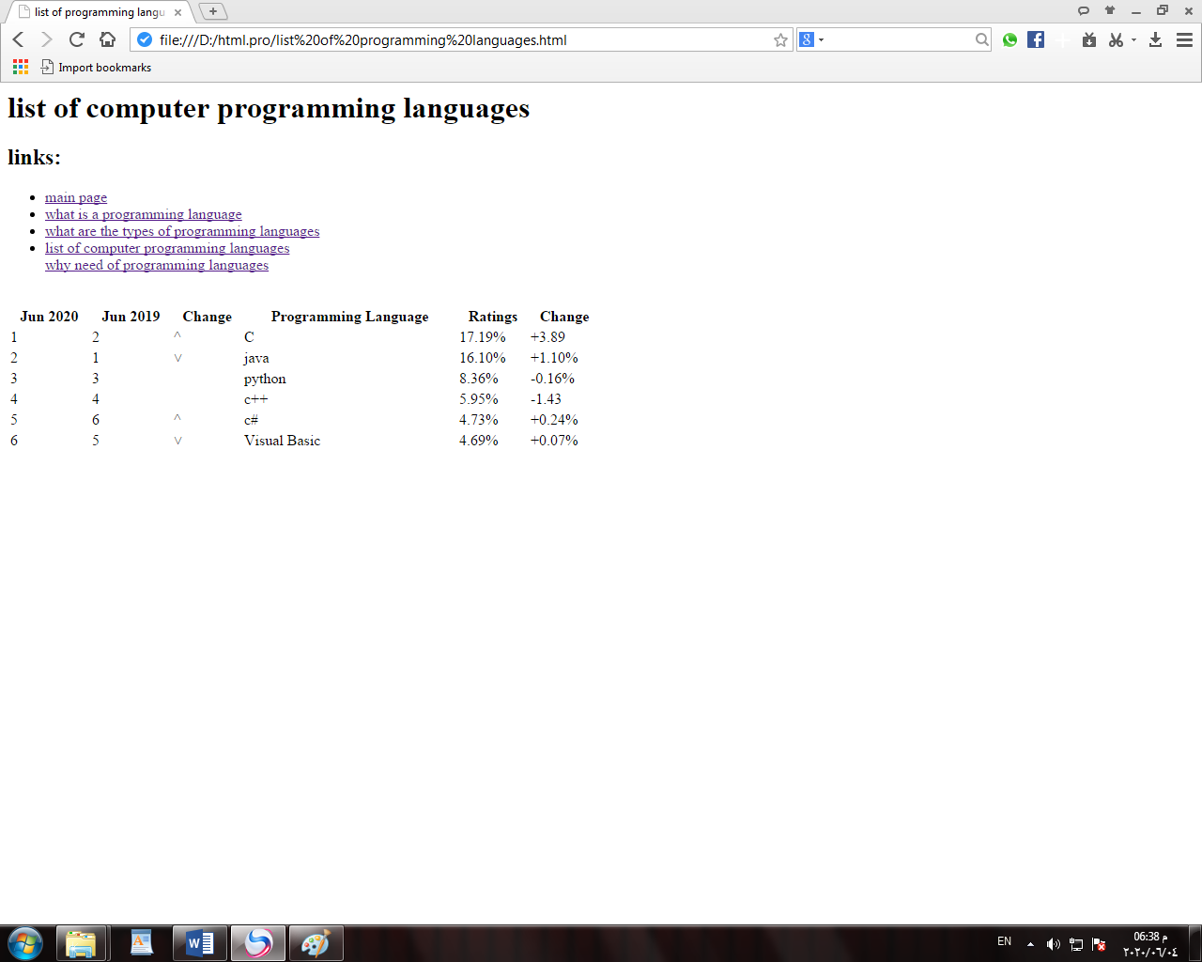

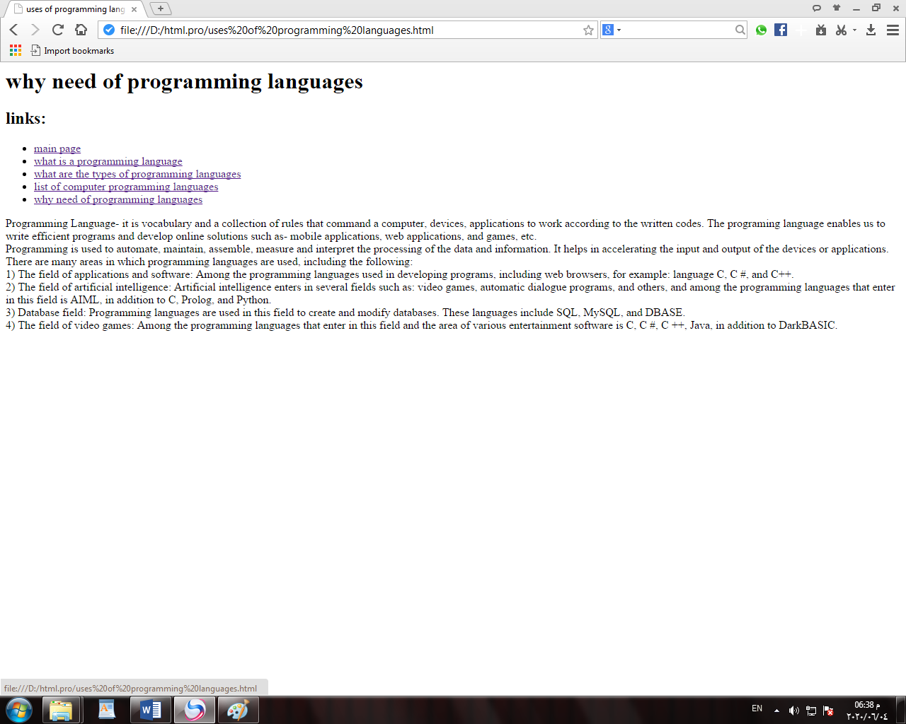

**Source code:**

