Module 1 Practice Quiz

What is the definition of de jure control?

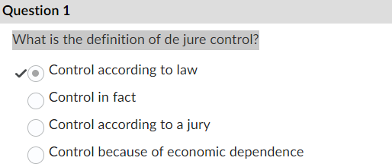

Who has de jure control based on the diagram?

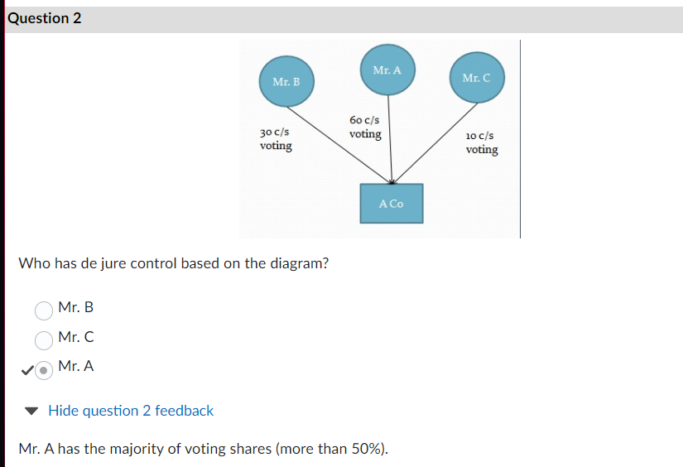

Who has de jure control based on the diagram?

Assume the trust is a discretionary trust.

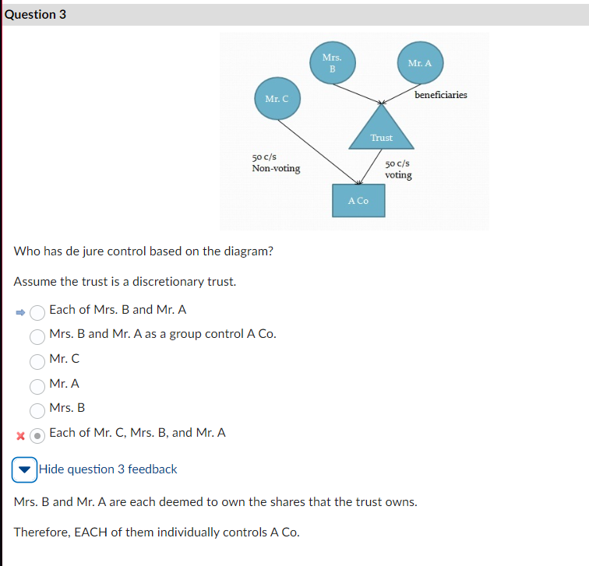

Siamese Incorporated (“Siamese”) is a public corporation owned by millions of individual and corporate shareholders. Ninety percent of their sales are to a sister corporation, called Fancy Feasties Ltd (“Fancy Feasties”). Siamese owes Fancy Feasties $400,000 in debt. They currently have $2 million in cash in their bank account.

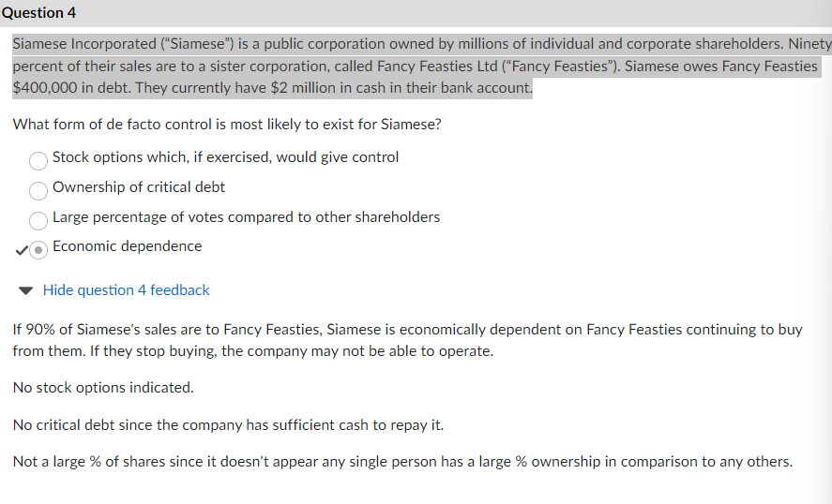

Based on the diagram, is A Co. a CCPC?

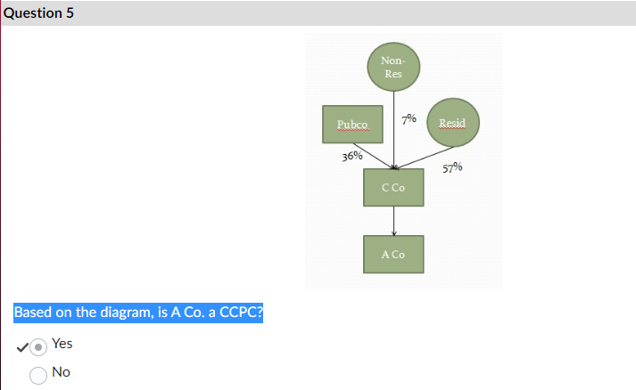

Based on the diagram, is A Co. a CCPC?

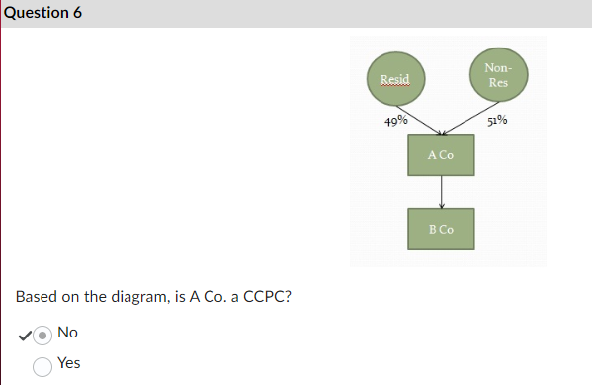

Testarksgk Limited is a CCPC that earns $700,000 in taxable income in 2014. All of the income comes from their operations in Nova Scotia. $600,000 is from active operations, and $100,000 is interest on long term investments. Calculate their taxes owing assuming that no corporations are associated with them and the provincial tax rate is 10% on all forms of income.

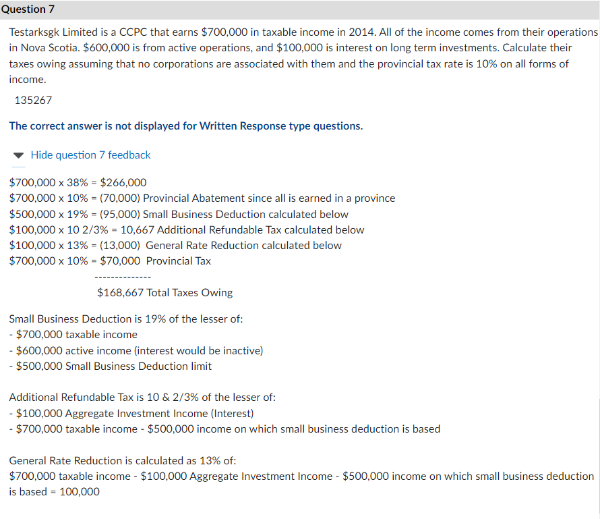

Birdcallington Ltd. is a CCPC that earns $200,000 in active taxable income in 2014, all of which   
is earned within Canada. Calculate their taxes owing assuming that no corporations are  
associated with them and provincial taxes are 8% on all forms of income  
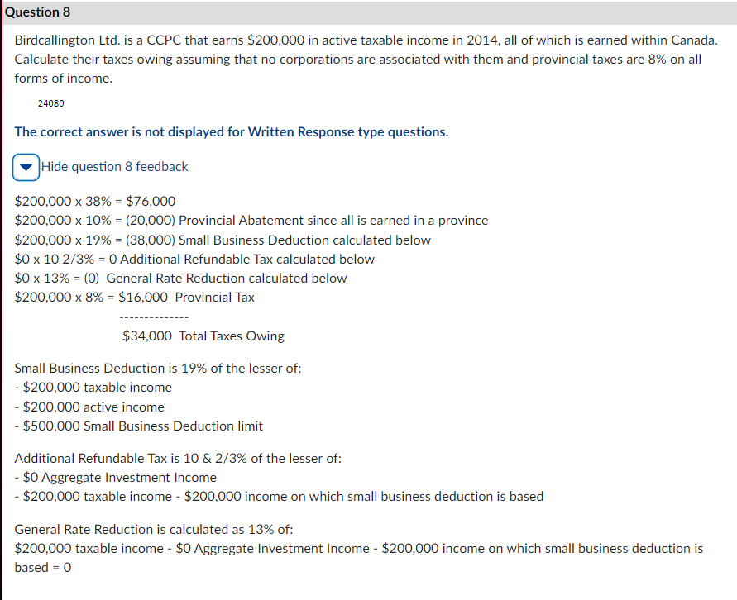

Module 2 Practice Quiz

Is Jackson related to his father, Jim?

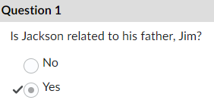

Is Claire related to her brother's wife, Sandra?

Is Dave related to his nephew, Cohen?

Based on the diagram, who is related to Son A?

Assume Mrs. A is his mother. Mrs. B is a friend of his mother’s.

Based on the diagram, who is related to B Co?

Assume Mr. A and Mrs. A are married. Mr. C is their neighbour.

Based on the diagram, who is associated with B Co?

Based on the diagram, is X Co associated with A Co?

What reason is NOT why association is important to determine?

Module 3 Quiz

$210,000 in dividends are received by A Co from their investment in TD Bank (a public corporation).

Calculate A Co’s taxes owing?

Calculate A Co’s RDTOH balance after the dividend if the balance before the dividend was $10,000.

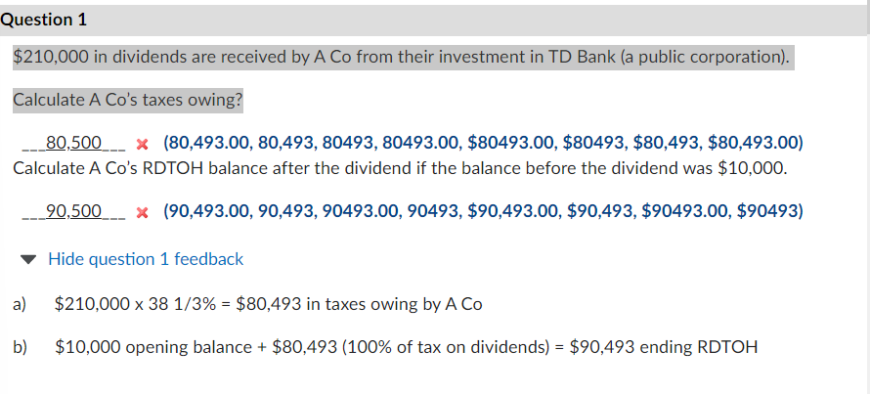

$120,000 in rental income is received by A Co from their investment in non-active rental properties.

Calculate A Co’s taxes owing?

Calculate A Co’s RDTOH balance after the income if the balance before the income was $0.

A Co pays dividends of $75,000 to Mr. X who owns 100% of the company. A Co has an RDTOH pool of $30,000.

Calculate A Co’s dividend refund.

Calculate A Co’s RDTOH balance after the dividend.

Apple Limited has an opening Capital Dividend Account of $15,000 from capital gains. During the year the corporation earns $60,000 in gross capital gains and receives $70,000 in life insurance proceeds because of the death of an employee.

Calculate Apple Limited’s Capital Dividend Account balance after these two transactions.

Apple Limited has an opening Capital Dividend Account of $80,000. During the year the corporation receives $50,000 in capital dividends from another corporation and pays $20,000 in capital dividends to its shareholders.

George Ukelele received a $60,000 capital dividend from his corporation, Ukelele Incorporated. How much must George include in his taxable income?

Based on the before and after diagrams, has an acquisition of control occurred?

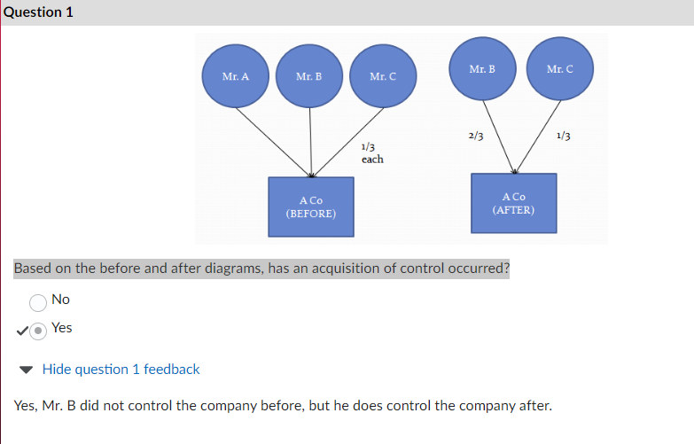

Which one IS NOT an impact of an acquisition of control?

What IS NOT a reason why a purchaser might want to acquire a corporation with built up loss pools?

Graken Corp has recently begun new operations in the train rail industry. To get this division started, Graken has hired 10 new welders, including 2 who are fresh out of welding college. Graken would like to be sure they take advantage of all tax incentives.

Sampler Incorporated is in the business of developing satellites for the Canadian Space Agency. Their CEO recently read about a new technology that he thinks will help their satellites last longer. Sampler has hired a UNB professor to investigate whether this technology can be used with their satellites.

In 2014, Jeremy purchased 100 newly issued common shares from Opco for $500 (this was the first time that Opco issued shares).

Banado Ltd. owns a yacht that it plans to distribute to its shareholder as a dividend in kind. The yacht cost $50,000 to purchase and is currently worth $80,000.

Calculate the amount of the actual dividend that its shareholder will receive.

Chilloodo Ltd. has decided to redeem 100 preferred shares held by its majority shareholder, Clarence Chill. The 100 shares have a total PUC of $50, a total ACB of $100, and a total FMV of $900.

Calculate the amount of the actual dividend that Clarence will receive because of this redemption.

