Kartik Srivastava

Student ID – 3668516

LAB 1

**lab1.java**

public class lab1

{

    public static void main(String args[])

    {

        System.out.println("Hello World");

    }

}

Output:

**lab1c.c**

#include <stdio.h>

int main()

{

    printf("Hello World");

    return 0;

}

Output:

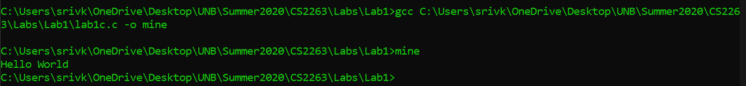

The C compiler compiles the source code into machine language. A Java compiler compiles it for the JVM into byte code. (<https://introcs.cs.princeton.edu/java/faq/c2java.html>) This is independent of the hardware platform on which it is going to run. This is why Java has a command to run program while C doesn’t.

**digitOnes.c**

#include <stdio.h>

#include <stdlib.h>

int main()

{

    int value;

    int iErr;

    printf("Value to examine: ");

    iErr = scanf("%d", &value);

    if(iErr != 1)

    {

        printf("Unable to read the value\n");

    }

    if(value <= 0)

    {

        printf("Invalid input");

        exit(0);

    }

    else

    {

        int numOnes = 0;

        while(value > 0)

        {

             if(value & 1)

                numOnes++;

             value >>= 1;

        }

    printf("Number of ones: %d\n", numOnes);

    return EXIT_SUCCESS;

    }

}

Output:

**Directory:**

