Deliverable 1

Take a screenshot of your app running (on any device or emulator).

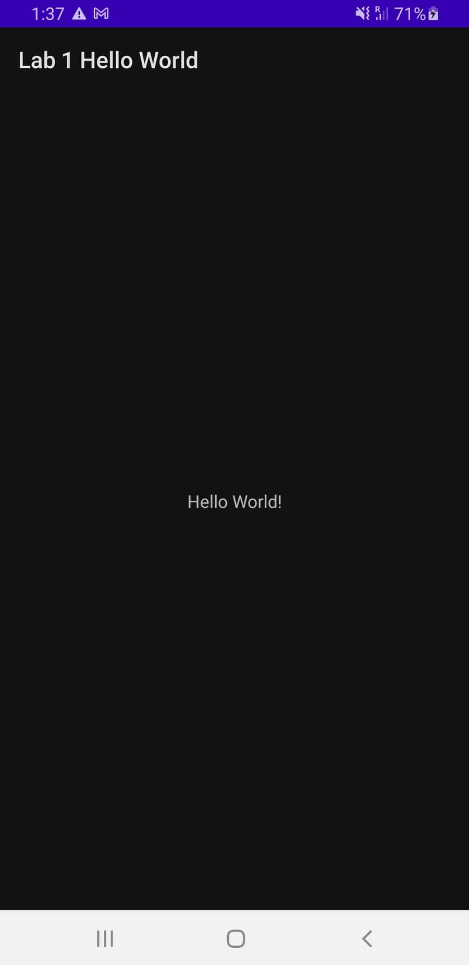

Deliverable 2

The application theme is also described in this AndroidManifest file; provide the attribute tag that describes this.  
  
 android:theme="@style/Theme.Lab1HelloWorld"

Deliverable 3

Describe what the setContentView() method call accomplishes for your application.

It sets the activity content from a layout resource which will be inflated, adding all top-level views to the activity.

Deliverable 4

1. What are the three common layout types?
   1. Linear Layout
   2. Relative Layout
   3. Web View
2. Why is it important to define IDs for view objects, especially when using RelativeLayout?

It is important to uniquely identify the View within the tree. In RelativeLayout, it is important because sibling views can define their layout relative to another sibling view, which is referenced by the unique ID.

Deliverable 5

Take screenshots of your application with French and Spanish translations and save them. Then set the language of the emulator back to your preferred language.

French

Spanish  
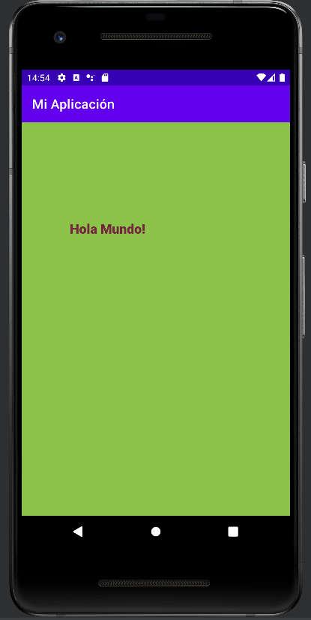

Deliverable 6

Take and save a screenshot of the log message window.

