Mahmoud Moustafa Hands-On2

FROM TASK 1
i) Schema of your table custab (output of: show table custab)
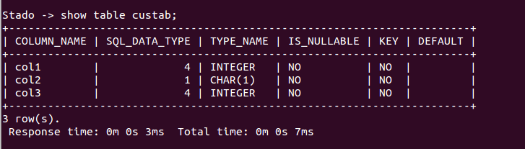

ii) Output of the query: SELECT * FROM custab
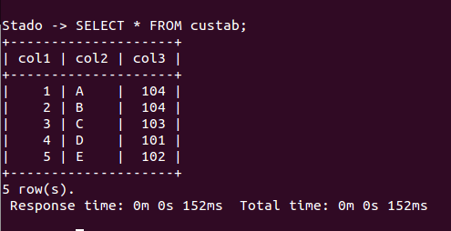

iii) Schema of your table provtab (output of: show table provtab)

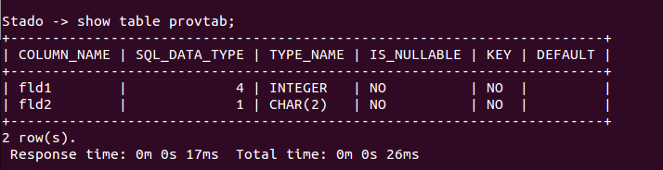

iv) Output of the query: SELECT * FROM provtab

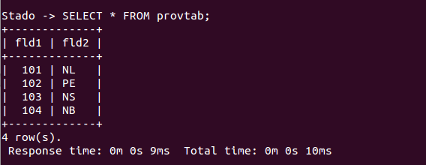
b. From Task2
i. Stado:
Q1 Run times:
Warm1: 0m 10s 950ms
Warm2: 0m 9s 935ms
Average: 10 seconds 442.5 milliseconds

Q3 Run times:
Warm1: 0m 10s 426ms
Warm2: 0m 9s 952ms
Average: 10 seconds 189 milliseconds

Q14 Run times:
Warm1: 0m 4s 74ms
Warm2: 0m 3s 624ms
Average: 03 seconds 849 milliseconds
ii.
Q1 Run times:
Warm1: 53780.138 ms
Warm2: 53719.893 ms
Average: 53 seconds : 749.5 milliseconds

Q3 Run times:
Warm1: 21262.396 ms
Warm2: 19913.536 ms
Average: 20 seconds : 587.5 milliseconds

Q14 Run times:
Warm1: Time: 11226.120 ms
Warm2: Time: 11588.044 ms
Average:11 seconds : 407 milliseconds

iii.
Q1:
Stado: 10 seconds 442.5 milliseconds
Single instance: 53 seconds : 749.5 milliseconds
Speedup: 5.147186976 Seconds
Q3:
Stado: 10 seconds 189 milliseconds
Single Instance: 20 seconds : 587.5 milliseconds
Speedup: 2.19678084
Q14:
Stado: 03 seconds 849 milliseconds
Single Instance:11 seconds : 407 milliseconds
Speedup: 2.963626916

