DevOps Final Project
Architecture Implementation & Observability

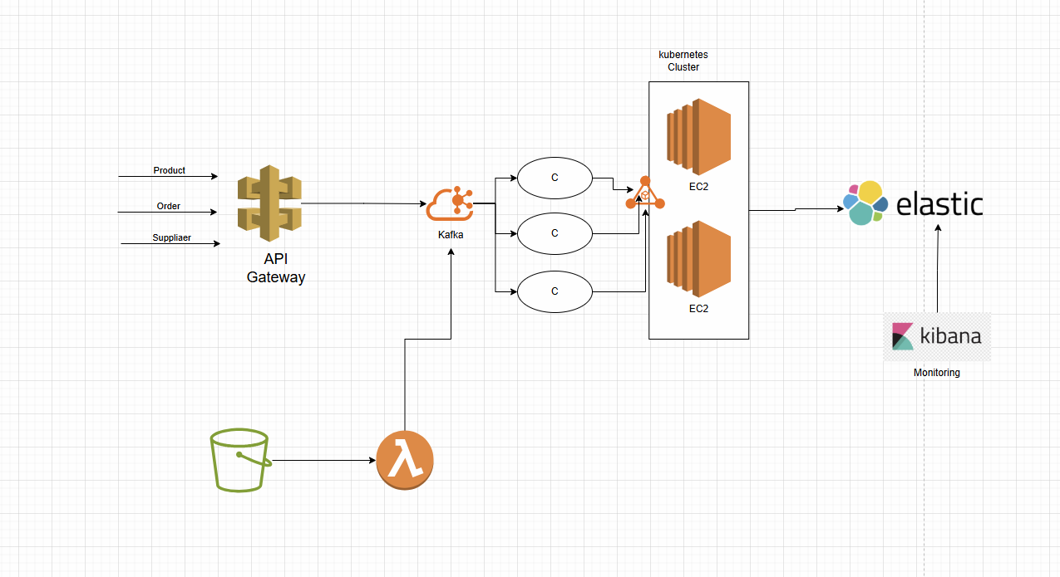

1. Introduction
This document defines the final project for the DevOps course.
The project assesses students’ ability to design, deploy, and document a cloud-based, event-driven architecture using industry-standard DevOps tools and practices.

This is a practical, hands-on project that simulates real-world DevOps responsibilities.

Important Scope Limitation:
Continuous Integration / Continuous Deployment (CI/CD) pipelines and container registries are explicitly excluded from this project.

2. Learning Objectives
- Apply Infrastructure as Code principles using Terraform
- Deploy and operate Kubernetes workloads on AWS
- Implement event-driven systems using Kafka
- Integrate AWS managed services
- Implement centralized logging and observability
- Produce professional technical documentation

3. Architecture Overview
Students are required to implement an event-driven architecture with the following components:

• API Gateway serving as the external entry point
• Apache Kafka as the messaging backbone
• Kubernetes cluster running on EC2 instances
• Kafka consumers deployed as Kubernetes workloads
• AWS S3 triggering AWS Lambda functions
• Centralized logging using Elasticsearch and Kibana

All components must work together according to the provided architecture diagram.

4. Technology Stack
Students must use the following technologies:

• AWS (EC2, VPC, IAM, API Gateway, S3, Lambda)
• Kubernetes
• Apache Kafka
• Terraform
• Elasticsearch
• Kibana

5. Project Requirements
5.1 Infrastructure Provisioning
All infrastructure must be provisioned using Terraform.

Required resources include:
• VPC, subnets, and security groups
• EC2 instances for Kubernetes nodes
• API Gateway
• S3 bucket
• Lambda function
• IAM roles and policies

Manual creation of infrastructure without Terraform is not allowed.

5.2 Kubernetes Deployment
Kafka consumer applications must be deployed into Kubernetes using Deployments and Services.
Applications must be scalable and generate application logs.

5.3 Kafka Integration
Kafka must receive messages from API Gateway and Lambda.
Students must define topics and consumer groups and document their design.

5.4 S3 and Lambda Integration
Uploading a file to S3 must trigger a Lambda function.
The Lambda function must publish an event to Kafka.

5.5 Logging and Observability
All application logs must be forwarded to Elasticsearch and visualized in Kibana.
Students must demonstrate filtering and searching capabilities in Kibana.

6. Required Deliverables
Students must submit the following:

• Terraform configuration files
• Screenshots from the AWS Console showing deployed resources
• Screenshots from Kibana demonstrating log ingestion
• A README.md file describing architecture, deployment steps, and assumptions

7. Grading Rubric
Infrastructure as Code (Terraform): 30%
Kubernetes Deployment: 20%
Kafka Integration: 15%
AWS Service Integration: 15%
Logging and Observability: 10%
Documentation Quality: 10%

8. Academic Integrity and Rules
All submitted work must be original.
Plagiarism or sharing solutions will result in a failing grade.
All manual steps must be clearly documented.
Architectural deviations must be justified.

9. Submission Instructions
Students must submit a single ZIP archive containing all project files and screenshots.
Late submissions may be penalized according to course policy.

10. Final Remarks
This project represents a real-world DevOps deployment scenario.
Evaluation will focus on correctness, clarity, architectural understanding, and professional documentation standards.

