|  |
| --- |
| **DoodLe PAint Program** |
| **Object Oriented Programming** |
| **Drawing and Painting Application** |
|  |
| **Amr Tarek 2946**  **Caroline Raif Dib 3082**  **Gehad Gamal 2628**  **Hana Hefny 2831**  **Mahmoud AbdelRazik 2870**  **C:\Users\Mahmoud\Desktop\icon256.png** |
|  |

1. **Class Diagram**

Attached with the zip file.

1. **Use Case Diagram**

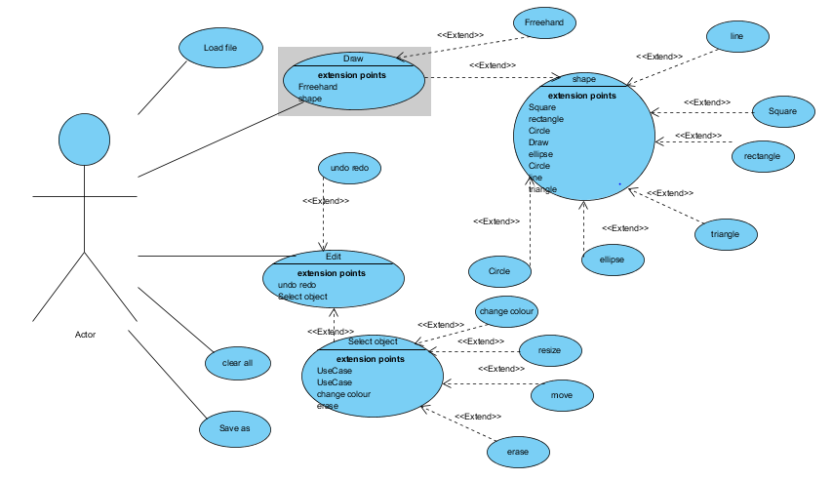

1. **State Diagram**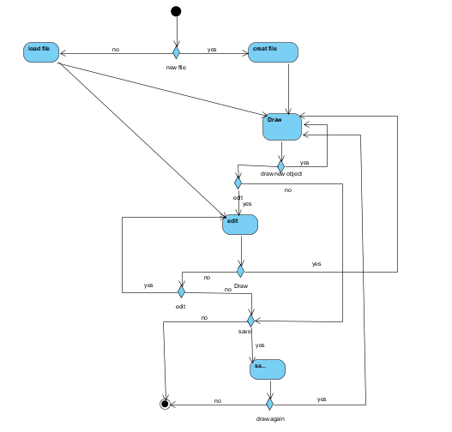
2. **Design Patterns used**

In this program we used **Singleton Design Pattern**. The singleton pattern is a [design pattern](https://en.wikipedia.org/wiki/Design_pattern_(computer_science)) that restricts the [instantiation](https://en.wikipedia.org/wiki/Instantiation_(computer_science)) of a class to one object, in this program the object was 1 canvas. This is useful when exactly one object is needed to coordinate actions across the system. The concept is sometimes generalized to systems that operate more efficiently when only one object exists, or that restrict the instantiation to a certain number of objects. Another pattern used was **Memento Design Pattern**. The memento pattern is a [software design pattern](https://en.wikipedia.org/wiki/Design_pattern_(computer_science)) that provides the ability to restore an object to its previous state ([undo](https://en.wikipedia.org/wiki/Undo) via rollback).The memento pattern is implemented with three objects: the originator, a caretaker and a memento. The originator is some object that has an internal state. The caretaker is going to do something to the originator, but wants to be able to undo the change. The caretaker first asks the originator for a memento object. Then it does whatever operation (or sequence of operations) it was going to do. To roll back to the state before the operations, it returns the memento object to the originator. The memento object itself is an [opaque object](https://en.wikipedia.org/wiki/Opaque_data_type) (one which the caretaker cannot, or should not, change). When using this pattern, care should be taken if the originator may change other objects or resources - the memento pattern operates on a single object. And this pattern was used in the redo and undo.

**5)User Guide**

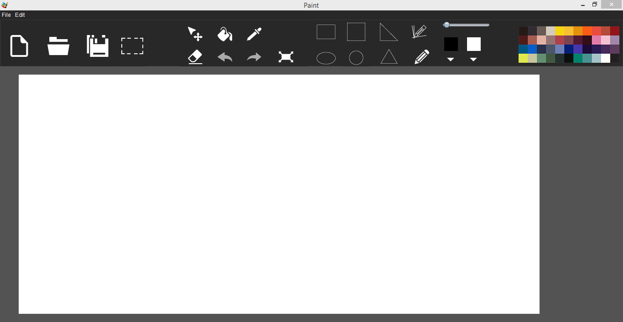

The application without doing any actions

The application allows the user to draw several shapes (rectangle, triangle, ellipse, circle, triangle and line) also to draw free hand. The border color of the shapes can be changed and the shapes can also be filled using a color picker wheel. The filling color of the intersected areas can also be changed. The thickness of the line can also be changed as desired.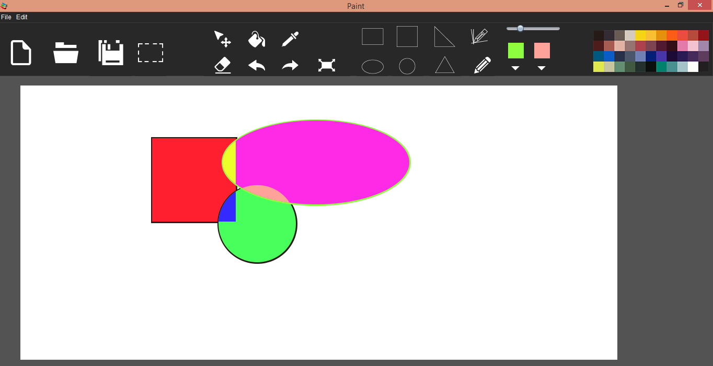

The user can also select multiple shapes and resize them, move them or delete them (by pressing the delete key on keyboard).

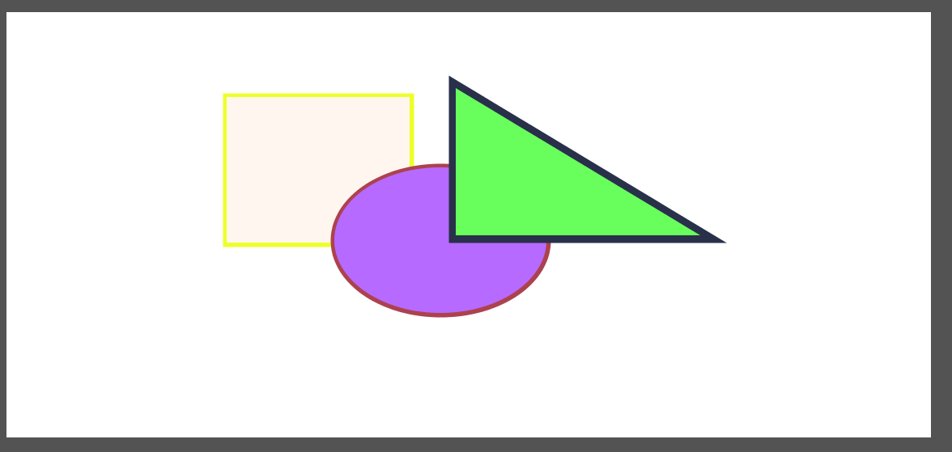

Figure : Before

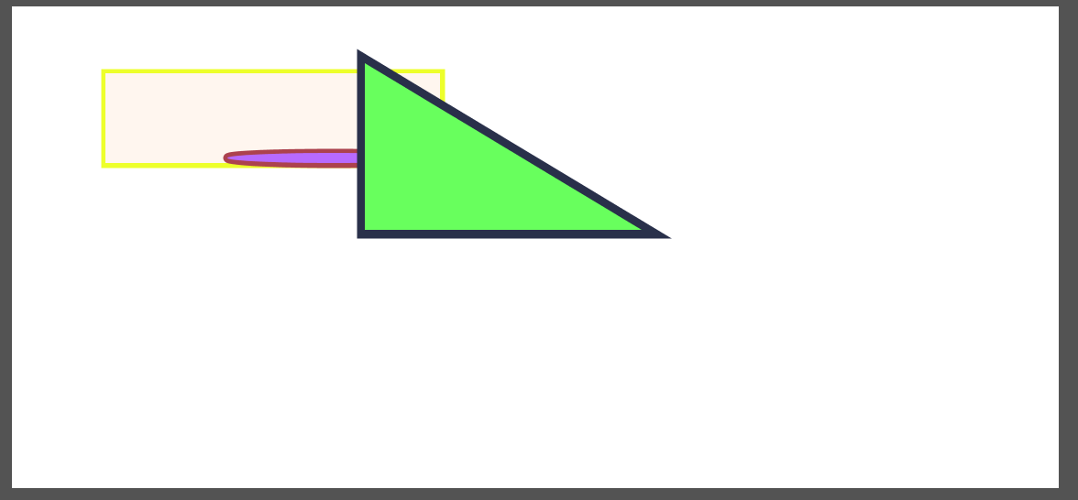

Figure : After

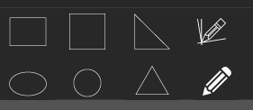

These are the buttons responsible for picking the shape type the user wants to use.

C:\Users\Caroline\Pictures\Capture4.PNG This Slider is responsible for choosing the thickness of the shapes.



The first color box is responsible for choosing the color for the border of the shapes while the second one is for the filling color.

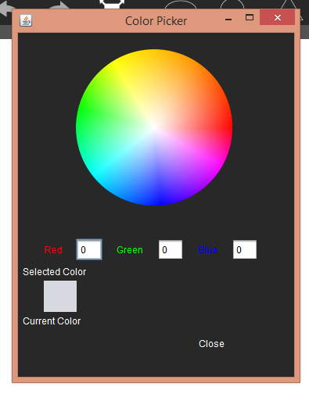When clicking on one of them a color picker wheel appears for more color options.

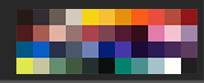This color palette is only for choosing the border color.



This button clears all the activities that are on the canvas.



One can load earlier saved projects done using the same application by clicking on this button or clicking CTRL+O.

One can save the activities done on the canvas using this button or by clicking CTRL+S.

The selecting of one or several shapes is done using this button.

This button is responsible for moving the selected objects.

C:\Users\Caroline\Pictures\Capture12.PNGFilling the shapes with a color is done using this button.

C:\Users\Caroline\Pictures\Capture9.PNGC:\Users\Caroline\Pictures\Capture13.PNG

When clicking this button then clicking on a color filled shape the button responsible for filling color is automatically changed the this color.

C:\Users\Caroline\Pictures\Capture11.PNGThis button is for erasing.

C:\Users\Caroline\Pictures\Capture10.PNG

These two buttons are responsible for the UNDO and REDO.

(you can also undo or redo using CTRL+Z or CTRL+Y respectively)

C:\Users\Caroline\Pictures\Capture14.PNG This button is responsible for resizing the selected shapes.

The user can also save the activities done on a PNG (CTRL+P) or GIF (CTRL+G) file.