1-Reserved_Keywords

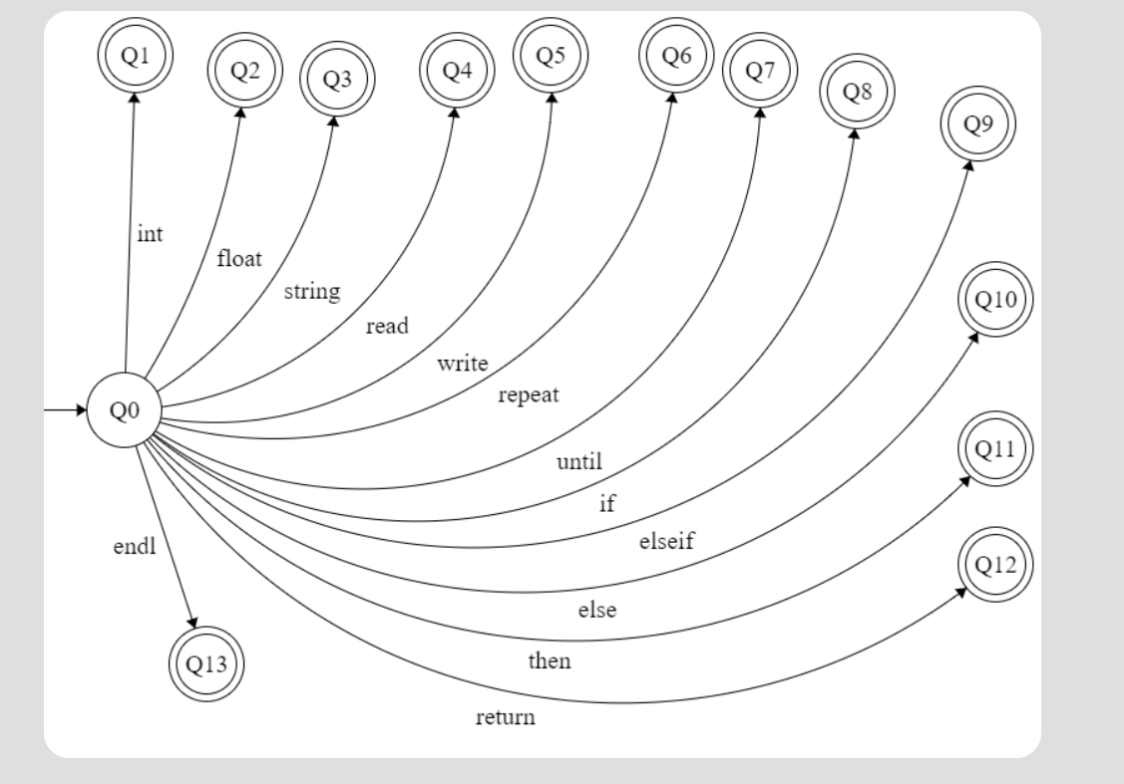

2- Operators

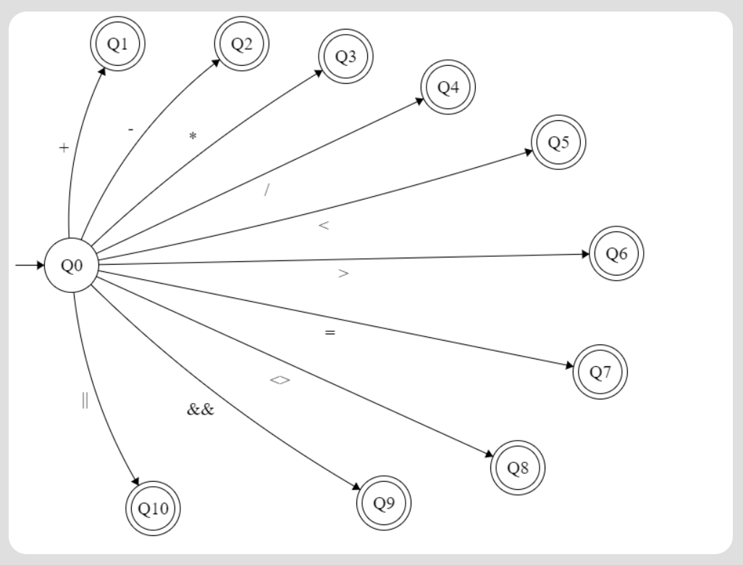

3- String

4- Number

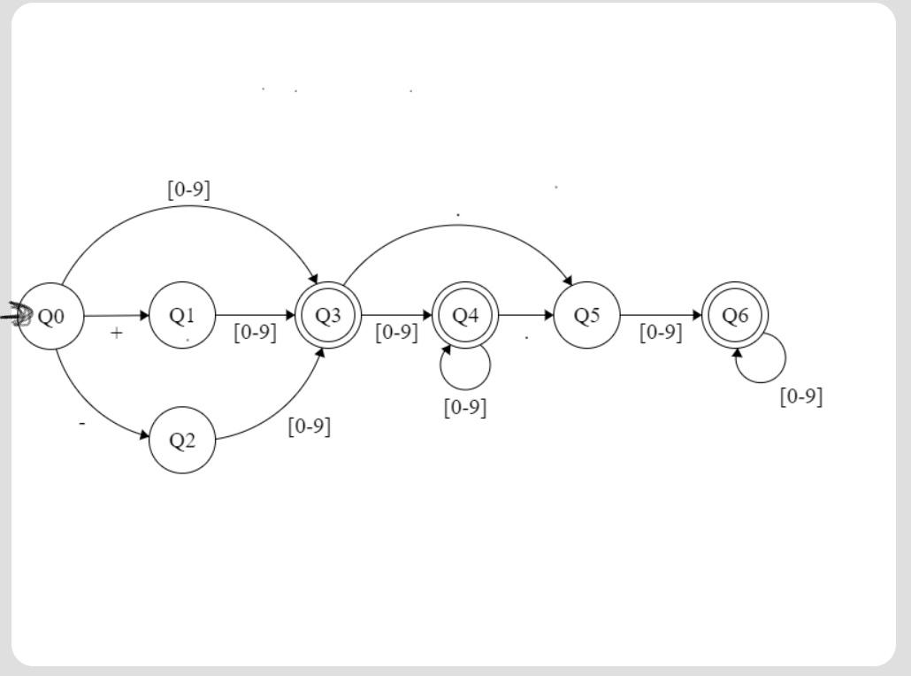

5-Identifiers

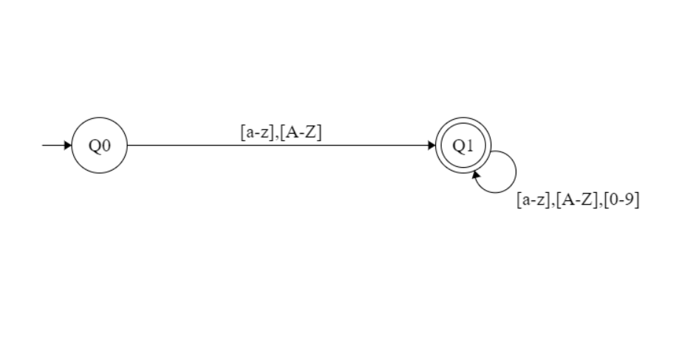

6-Comments

